European Innovation Council – Support Scheme Application Form

XJENZAMALTA
VILLA BIGHI, DAWRET FRA GIOVANNI BICHI
KALKARA, KKR 1320
+356 2360 2200
XJENZAMALTA.MT

Contents
Section One: Applicant’s Details 1
Section Two: Application Form 3
Option A: 3
For Pathfinder: 5
For Transition: 7
For Pathfinder, Transition and Accelerator: 8
Option B 11
For Option C: 16
For Accelerator: 17
For Accelerator and Transition: 18
SECTION THREE: DECLARATION BY APPLICANTS 21

PLEASE READ THE APPLICATION FORM AND EIC SCHEME GIUDANCE CAREFULLY, AND ONLY FILL IN THE RELEVANT SECTIONS IN THIS FORM. IF YOU HAVE ANY DOUBTS PLEASE CONTACT THE NATIONAL CONTACT POINT.

Section One: Applicant’s Details
Please fill in all section of the form.

Applicant Details
Name
Designation
Type of entity
VAT Number (if applicable):
Email
Tel. Number
PIC Number

Please indicate whether you are applying under State Aid or Non State Aid rules:
__ State Aid de minimis Rules
__ Non State Aid Rules
In addition to the current application form, applicants must submit the relevant annex (State Aid de minimis applicants OR Non State Aid applicants), available at: https://mcst.gov.mt/resource-page/

Select which Support Scheme option you are applying to, and indicate which EIC Program (Pathfinder, Transition or Accelerator), which modality (Open or Challenges), and in the case of Accelerator, which stage (1st or 2nd stage) you are applying to. Please also specify the Challenge you are applying to if applying under the Challenge modality.

Kindly specify which Option you are applying for – please refer to the image below and the call guidelines for guidance on which options are suitable for you
Option A: EIC Consultant & Proposal Writer Support
Option B: Business Coach Support
Option C: Pitch Coach Support
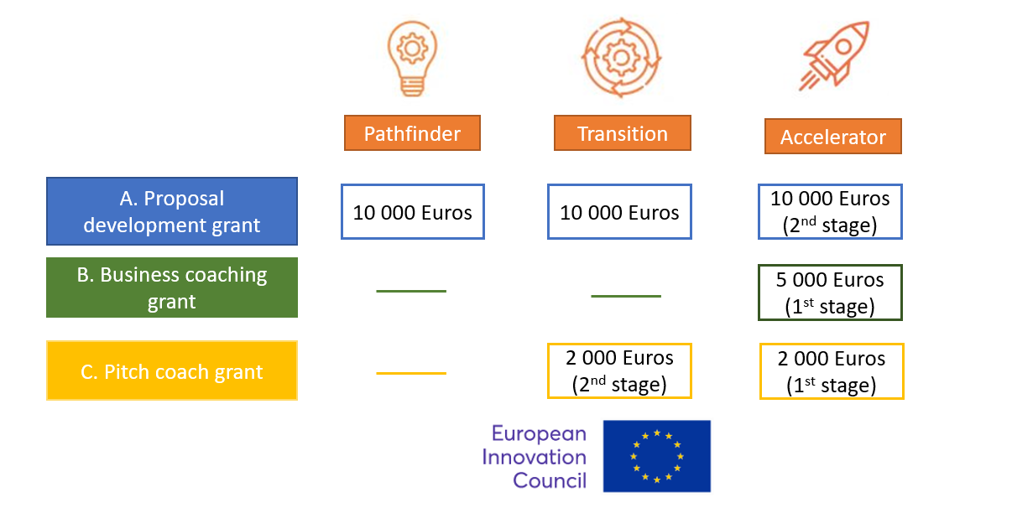

Section Two: Application Form

Option A:
Development and submission of a Full EIC proposal by engaging the services of proposal writer/s or consulting services of proven track record in proposal writing/consulting in the EIC.

Consulting/Proposal Writer Entity 1 Details:
(Please include details of the contact person from the entity proposed for the proposal development)
Name of Consultancy Firm
Contact Details | Name: | Designation:
 |  | Email:
 | Address: | Tel. No.:
 |  | Mob. No.:

Consulting/Proposal Writer Entity 2 Details:
(Please include details of the contact person from the entity proposed for the proposal development)
Name of Consultancy Firm
Contact Details | Name: | Designation:
 |  | Email:
 | Address: | Tel. No.:
 |  | Mob. No.:

Consulting/Proposal Writer Entity 3 Details:
(Please include details of the contact person from the entity proposed for the proposal development)
Name of Consultancy Firm
Contact Details | Name: | Designation:
 |  | Email:
 | Address: | Tel. No.:
 |  | Mob. No.:

Proposed Project title:

Intended submission deadline:

For Pathfinder:
Describe project objectives, and to what extent the proposed work is ambitious and goes beyond the state-of-the-art. Describe the proof of having a technology with TRL Level 1 to 3-4

In this section you are required to present your research idea and what objectives you plan to reach by implementing this project. Describe how your research project goes beyond the state of the art of current technology and research initiatives (max. 1000 words) (Weighting: 35%)
Please describe the pathways towards the potential outcomes and impacts (societal, economical, environmental, economic) that the technology is expected to contribute towards

Describe how your technology is expected to contribute to positive outcomes and how it can have a societal impact. This should be done with a credible assessment of how the technology can contribute to these outcomes (max. 1000 words) (Weighting: 35%)
Describe the project consortium and how each member brings the necessary expertise, and capabilities to bring the project idea from lab to business opportunity

In this section you are required to present your project partners and what expertise their bring to the project. Make sure all partners bring significant skills to the project (max. 600 words) (Weighting: 20%)
Describe what measures will be taken to contribute to make the project outcomes investment ready (including through IP protection, partnership or market validation)
In this section you are required to present your plans to make your innovative results investment ready (max. 600 words) (Weighting: 10%)

For Transition:
Describe the innovativeness of the proposed project idea (project brief) compared to alternative solutions and technologies, with proof of having a technology with TRL Level 3-4 to 6

In this section you are required to present your technology and innovation. Make sure that the breakthrough, innovative aspect of your project is clear, and describe how the excellence such that your product, process or service makes it potentially disruptive in the market(s) of interest (max. 1000 words) (Weighting: 35%)
Please describe the potential outcomes and impacts (societal, economical, environmental, economic) are expected a) within the project life, and b) beyond. Also describe the potential market demand for the solution.

Describe the targeted users or customers of the innovation, how their needs may be addressed, why the users or customers identified will want to use or buy the product, service or business model, compared to what is currently available. Indicate total potential market size and growth-rate, competitors and competitive offerings, key stakeholders, clear identification of opportunities for market introduction (max. 1000 words) (Weighting: 35%)
Describe the project consortium and how each member brings the necessary expertise, and capabilities to bring the project idea from lab to business opportunity

In this section you are required to present your project partners and what expertise their bring to the project. Make sure all partners bring significant skills to the project (max. 600 words) (Weighting: 20%)
Describe what measures will be taken to contribute to make the project outcomes investment ready (including through IP protection, partnership or market validation)
In this section you are required to present your plans to make your innovative results investment ready (max. 600 words) (Weighting: 10%)

For Pathfinder, Transition and Accelerator:
Track record of the proposed consultants and relevance to project as well as coaching plan including objectives and activities. Please indicate which consultant you have selected.

Please include a list of relevant EIC projects that the service providers have supported in the past. Services providers with successful proposals/projects in the EIC option (Pathfinder, Transition or Accelerator) selected by the applicant will be favourably considered. (max. 1500 words) (Weighting: 50%)

Include also a coaching plan with specific activities and objectives (max. 1000 words) (Weighting: 50%)

Total Amount of Funds Requested through Support Option A (in €)
(Please keep in mind that funding for any one proposal is capped at €10,000)
Breakdown of Costs covered through this Support Scheme (estimate in €)

Kindly provide an estimated breakdown of costs such as, the amount you plan to use on consultant fees etc. It is advisable that in the case of consultant’s fees, forecasted costs and expenses are based on recent quotations.

Item | Description | Total Cost inclusive of VAT (€) | Total Eligible Cost Exclusive of VAT  (€)

Option B
Application to recruit a business coach matching the specific industry and market context for EIC Accelerator 1st stage applicants.

Business Coach 1 Details:
(Please include details of the contact person from the entity proposed for the proposal development)
Contact Details | Name: | Designation:
 |  | Email:
 | Address: | Tel. No.:
 |  | Mob. No.:

Business Coach 2 Details:
(Please include details of the contact person from the entity proposed for the proposal development)
Contact Details | Name: | Designation:
 |  | Email:
 | Address: | Tel. No.:
 |  | Mob. No.:

Business Coach 3 Details:
(Please include details of the contact person from the entity proposed for the proposal development)
Contact Details | Name: | Designation:
 |  | Email:
 | Address: | Tel. No.:
 |  | Mob. No.:

Proposed Project title:
Intended submission deadline:

Describe the innovativeness of the proposed project idea (project brief) with proof of having a technology with TRL Level 5 or above.

In this section you are required to present your technology and innovation. Make sure that the innovative aspect of your project is clear, and describe the excellence such that your product, process or service is disruptive in the market(s) of interest, and that it has the potential to change the dynamic of the market and possibly to address a societal challenge (max. 1000 words) (Weighting: 35%)
Business and Market Potential of your Product.

Describe the targeted users or customers of the innovation, how their needs may be addressed, why the users or customers identified will want to use or buy the product, service or business model, compared to what is currently available. Indicate total potential market size and growth-rate, competitors and competitive offerings, key stakeholders, clear identification of opportunities for market introduction (max. 1000 words) (Weighting: 35%)
Track record of the proposed business coaches and relevance to project as well as coaching plan including objectives and activities. Please indicate which consultant you have selected.

Please include track record of business coaches including track record in coaching senior management, track record in coaching organisations and business leaders, experience in innovation management and relevance of business coaches in supporting the EIC project.
Include also a coaching plan with specific activities and objectives. (max. 1500 words) (Weighting: 30%)

Total Amount of Funds Requested through Support Option B (in €)
(Please keep in mind that funding for any one proposal is capped at €5,000)
Breakdown of Costs covered through this Support Scheme (estimate in €)

Kindly provide an estimated breakdown of costs such as, the amount you plan to use on consultant fees etc. It is advisable that in the case of consultant’s fees, forecasted costs and expenses are based on recent quotations.

Item | Description | Total Cost inclusive of VAT (€) | Total Eligible Cost Exclusive of VAT  (€)

For Option C:
Application to recruit a pitch coach in preparation for the short and/or full application stage.

Pitch Coach 1 Details:
(Please include details of the contact person from the entity proposed for the proposal development)
Contact Details | Name: | Designation:
 |  | Email:
 | Address: | Tel. No.:
 |  | Mob. No.:

Pitch Coach 2 Details:
(Please include details of the contact person from the entity proposed for the proposal development)
Contact Details | Name: | Designation:
 |  | Email:
 | Address: | Tel. No.:
 |  | Mob. No.:

Pitch Coach 3 Details:
(Please include details of the contact person from the entity proposed for the proposal development)
Contact Details | Name: | Designation:
 |  | Email:
 | Address: | Tel. No.:
 |  | Mob. No.:

Proposed Project title:

Intended submission deadline:

For Accelerator:
Describe the innovativeness of the proposed project idea (project brief) with proof of having a technology with TRL Level 5 or above.

In this section you are required to present your technology and innovation. Make sure that the innovative aspect of your project is clear, and describe the excellence such that your product, process or service is disruptive in the market(s) of interest, and that it has the potential to change the dynamic of the market and possibly to address a societal challenge (max. 1000 words) (Weighting: 35%)
Business and Market Potential of your Product.

Describe the targeted users or customers of the innovation, how their needs may be addressed, why the users or customers identified will want to use or buy the product, service or business model, including compared to what is currently available. Indicate total potential market size and growth-rate, competitors and competitive offerings, key stakeholders, clear identification of opportunities for market introduction (max. 1000 words) (Weighting: 35%)

For Accelerator and Transition:

Track record of the proposed pitch coaches and relevance to project. Please indicate which consultant you have selected.

Please include track record of pitch coaches including track record in coaching senior management, track record in coaching organisations and business leaders, experience with both established and start-up organizations and relevance of pitch coaches in supporting the EIC project. (max. 1500 words) (Weighting: 30%)

Total Amount of Funds Requested through Support Option C (in €)
(Please keep in mind that funding for any one proposal is capped at €2,000)
Breakdown of Costs covered through this Support Scheme (estimate in €)

Kindly provide an estimated breakdown of costs such as, the amount you plan to use on consultant fees etc. It is advisable that in the case of consultant’s fees, forecasted costs and expenses are based on recent quotations.

Item | Description | Total Cost inclusive of VAT (€) | Total Eligible Cost Exclusive of VAT  (€)

SECTION THREE: DECLARATION BY APPLICANTS

Declaration by Private Entity:

I confirm that:  The information given on this form is accurate to the best of my knowledge. I understand that if it is later established that I misrepresented myself and I am not eligible for this Scheme I will not be reimbursed by Xjenza Malta EIC Support Scheme. | I agree
I accept and confirm that the personal data and project/activities proposal content information can be passed on to Xjenza Malta to be used solely for the purposes of administering, processing, and reviewing of the application. | I agree
I confirm that I have submitted the relevant State Aid de minimis OR Non State Aid relevant annexes together with the application form (available at https://mcst.gov.mt/resource-page/
I accept and confirm that the personal data and proposal content information can be shared with third parties i.e. the Partner Organisation/s with whom I will be carrying out this project, solely for scope of the carrying out of the said project/activities, and that any misuse of the data or provision of data to parties outside this agreement will incur legal action. | I agree
For Option A:
I confirm that my intention is to submit an EIC Accelerator proposal for the full application stage, or EIC Pathfinder or Transition first stage proposal, and submit proof of submission as well as the submitted proposal to Xjenza Malta by no later than 60 DAYS after submission. | I agree
I confirm that I will share an advanced draft digital copy of the EIC project proposal to the Framework Programme Unit at Xjenza Malta for their review. This shall be sent by no later than two weeks before the intended submission of the proposal to the EIC. | I agree
I confirm that the full company profiles/consultants have been attached to this application form. | I agree
EIC Accelerator: I confirm and attach proof to this application form of having received positive evaluation from the European Commission and invited to submit a full proposal to the | I agree
For Option B:
I confirm that my intention is to submit an EIC Accelerator proposal for the short application stage, and submit proof of submission as well as the short application proposal to Xjenza Malta by no later than the next EIC cut-off date after the end of the grant period. | I agree
I confirm that in the event of successful submission and shortlist to the full application stage, I am expected to submit a full proposal to the EIC and submit evidence of submission and a copy of the proposal to Xjenza Malta no later than 60 days after submitting the full application. | I agree
I confirm that the full CVs of the business coaches have been attached to this application form. | I agree
I confirm that I will share an advanced draft digital copy of the EIC project proposal to the Framework Programme Unit at Xjenza Malta for their review. This shall be sent by no later than one (1) month before the intended submission of the proposal to the EIC. | I agree
I confirm that I will submit timesheets, a coaching report as well as a 20-slide Investor Deck covering key elements of the business plan including the problem/solution, value proposition, technology, business model, go-to-market, team and financial plan no later than 60 DAYS after submission to the EIC. Failure to do so will bar me from requesting reimbursement. | I agree
For Option C:
I confirm that my intention is to submit an EIC Accelerator proposal for the short application stage, or Transition full proposal and submit proof of submission as well as the short application proposal for Accelerator to Xjenza Malta by no later than one month after submission. | I agree
I confirm that in the event of successful submission and shortlist to the full application stage, I am expected to submit a full proposal to the EIC and submit evidence of submission and a copy of the proposal to Xjenza Malta no later than 60 days after submitting the full application. | I agree
I confirm that the full CVs of the pitch coaches have been attached to this application form. | I agree
I confirm that I will share an advanced draft digital copy of the EIC project proposal to the Framework Programme Unit at Xjenza Malta for their review. This shall be sent by no later than one (1) month before the intended submission of the proposal to the EIC. | I agree
I confirm that I will submit timesheets, a pitch-deck of up to 10 slides and a video pitch of up to 3 minutes with the core members of the team no later than 60 days after submission to EIC. Failure to do so will prohibit me from requesting reimbursement. | I agree

Applicant full name and position:  The applicant needs to have sufficient authority to ensure the adequate degree of commitment and support for the activities. | Date:  Signature:

N.B. All applicants are kindly asked to fill in the State Aid form which is marked Appendix 1 on a separate attachment.

