Horizon Europe Networking Support Scheme (NET2HE)

Rules for Participation –State Aid
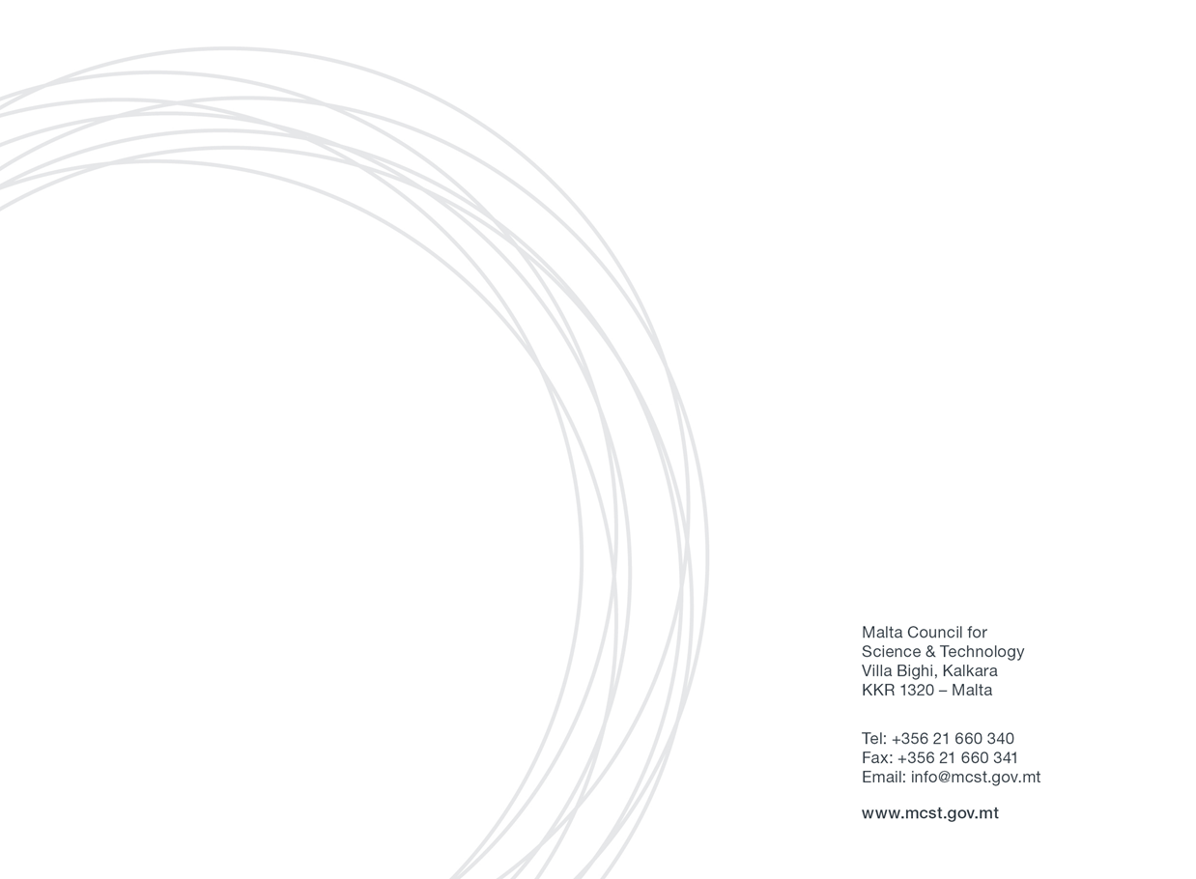

Malta Council for Science & Technology
Framework Programme Unit

Contents
1. Introduction 3
2. Definitions 4
3. Eligibility Criteria 5
4. Financing 7
Eligible costs: 7
5. Submission of Application Form 8
Reporting documents: 8
6. Selection Process 8
7. Award Duration 9
8. Correspondence 9
9. State aid Rules 10
12. Further Information 12

1. Introduction

The Malta Council for Science and Technology (MCST) is receiving proposals under the Horizon Europe Networking Support Scheme (NET2HE).
NET2HE is offering stakeholders from Malta the financial support to attend Horizon Europe networking and brokerage events held overseas in a bid to increase the uptake in Horizon Europe proposal submissions. The aim is to incentivise Maltese participation in brokerage sessions and networking events. Info Days organised by the European Commission will also be taken into consideration.
The aim of the scheme is to support networking activities that generate long-term outcomes leading to the formation of the consortia and/or participation in consortia capable of applying for the Horizon funding.

2. Definitions

- Applicant means anyone eligible to apply in terms of these Rules for Participation and who consequently applies for funding under this scheme.
- Council refers to the Malta Council for Science and Technology.
- Partner is defined as a partner in a consortium of a funded project.
- Eligible undertakings are all those entities that carry out an economic activity within the meaning of Article 107 TFEU and are eligible to apply for the Horizon Europe programme and the relevant Partnerships listed for this Scheme. The term refers to undertakings planning to carry out Fundamental Research, Industrial Research and/or Experimental Development projects and must either be:
  - a partnership constituted under the Companies Act, being a partnership en nom collectif, en commandite or a limited liability company; or
  - be duly registered as a co-operative society under the Co-Operative Societies Act,
  - professional body;
  - NGOs;
  - Non-profit making entities (including Foundations).

- Single Undertaking includes all enterprises having at least one of the following relationships with each other:
i. One enterprise has a majority of the shareholders’ or members’ voting rights in another enterprise;
ii. One enterprise has the right to appoint or remove a majority of the members of the administrative, management or supervisory body of another enterprise;
iii. One enterprise has the right to exercise a dominant influence on another enterprise pursuant to a contract entered into with that enterprise or to a provision in its memorandum or articles of association;
iv. One enterprise, which is a shareholder in or member of another enterprise, controls alone, pursuant to an agreement with other shareholders in or members of that enterprise, a majority of shareholders’ or members’ voting rights in that enterprise.
Enterprises having any of the relationships referred to in points (i) to (iv) above through one or more other enterprises shall be considered to be a single undertaking.
- Undertaking covers any entity engaged in an economic activity within the meaning of Article 107 TFEU, regardless of its legal status and the way in which it is financed.

3. Eligibility Criteria

The applicant must be an eligible undertaking (as defined in Section 2) that carries out an economic activity within the meaning of Article 107 TFEU.
Applicants who have other funded projects with the Council and are in default, and/or have gone beyond the timelines of the project, are not eligible to participate.
Any application submitted by or including the participation of any legal person or legal entity having, in totality or in majority ownership, the same shareholders, partners or persons holding and / or exercising a controlling power in any other legal entity which will have, at any time prior to such application, been declared as non-compliant or defaulting on any other contract or agreement entered into with the Council, shall be automatically declared as inadmissible.
Funding under this scheme is made available on the basis that the Applicant has not benefited and will not benefit from any other grant or financial incentive of whatever nature, applied for and/or utilised for the same scope as that subject of the funding requested under this scheme.
The attendance of Horizon Europe networking and brokerage events is supported through this scheme. It is important that the same applicant benefitting from this scheme would be directly involved in the activities of the consortium applying for Horizon funding. The scheme will also consider funding for information days organised by the European Commission on a case-by-case basis. NET2HE will support travel happening within European Member States and Associated Countries only. Events happening in third countries are not eligible for funding. Only flights that depart from Malta and return to Malta are eligible. Applications should be endorsed by the entity’s legal representative..
It is important that networking activities generate long-term outcomes leading to the formation of the consortium capable of applying for the Horizon funding.
The Council will support the attendance of events that do not exceed 5 days and funding no more than 5 nights.
Individual applicants are to submit the Application Form for participating in a European/international brokerage event or an info day. The grant is limited to one representative per event per organisation, however, the entity may benefit from multiple grants for different events. The same individual cannot be supported by this scheme for more than 3 times per year. Individual applicants are to submit the Application Form for participating in an international brokerage event or an info day at least 15 working days prior to the event. The reporting documents must be sent in no later than 1 month after the event.
It is the responsibility of the applicant to ensure the timely and correct delivery of the Application Form to MCST. It should be noted that emails larger than 6MB will be automatically rejected by the mail system. In that case the applicant may alternativaley consider uploading his/her documents via cloud as Google Documents and share the link via email
Failure to provide the requested documents in time allows MCST to withhold any reimbursements. Late or incomplete applications will not be considered.

4. Financing
Each applicant is invited to provide a breakdown of the anticipated costs to carry out the proposed activities as part of the Application Form.
Award holders will be responsible for arranging all relevant activities including travel plans, accommodation, logistics planning and insurance coverage for any participant who will be travelling.
The applicant must confirm that there has not been any approval or has been granted any public funding, financing, or fiscal benefit in respect to the cost items included in this request for aid and will not seek funding or fiscal benefits for these cost items through other National and/or European Union measures.

Eligible costs:
Applicants will receive a reimbursement upon receipt of reporting documents.
Eligible costs are:

- Flights for travel related to the event (the total amount for each flight should be estimated as costing no more than €750 for both EU Member States and for Associated Countries and should be an economy class ticket, this capping also covers the travel insurance).
- Subsistence allowance of €150 flat rate per night (The flat rate will reflect the duration of the event and the number of nights required).
The flight capping and subsistence rate will remain the same and applicable to all European Member States and Associated Countries. Only flights that depart from Malta and return back to Malta are eligible. Furthermore, supplementary or match-funding from other funding sources is allowed and encouraged, this should be done only if it does not finance the same activities (no double funding) that will be funded through the Horizon Europe Networking Support Scheme (NET2HE).
Participants will be funded if the amount they request falls within the allowable quota for aid under the de minimis regime, which is a maximum of €300,000 (over 3 years per single undertaking, in line with Article 3(2) of the de minimis Regulation).
Applicants will be required to submit a signed de minimis declaration form.

5. Submission of Application Form
Interested parties are to submit their Application Form electronically to nethorizon.mcst@gov.mt with “Networking 2024” as a subject heading by not later than 15 working days before the networking event.
All submissions must be signed and dated. Late or incomplete applications will not be considered.
Submissions should include the following documents to satisfy the eligibility criteria:
➢ The ‘Application Form for Horizon Europe Networking Support Scheme’ provided by MCST
➢ Proof that the organiser has confirmed your registration
➢ Agenda of event (cannot exceed more than 5 days)
➢ (Recommended) Proof of planning of at least three meetings

Reporting documents:
- Travel Report (a template is available on MCST website)
- Boarding Passes
- Air ticket and travel insurance (including their receipts)

6. Selection Process
The Horizon Networking Support Scheme will run until the Call funds are exhausted. The Council, upon its discretion reserves the right to close the calls.
The selection of the awardees will be based on an administrative check of the application. The administrative check is based on section “3. Eligibility Criteria” and “5. Submission of the application form”. MCST will notify the applicant if their application was successful or not within 10 working days.
The scheme will remain open throughout 2024 until funds are exhausted, although trips may be completed up to 6 months after being notified that your application has passed all eligibility checks. Payment will be affected following the presentation of the reporting documents. Beneficiaries are to hand in the requested documents no later than 1 month after the event. The Council retains the right to request further proof of expenditure. Failure to do so allows MCST to withhold any reimbursements.
Any requests for an extension or change of use of the award should be addressed in writing to nethorizon.mcst@gov.mt with “NET2HE Modification” as a subject heading. Such request needs to receive consent from MCST prior to being affected. The Council will review the letter and a reply should be given within 10 working days. Only one request for modification is allowed for each application. Applicants are reminded of the importance of retaining all documents proving expenditure of the awarded funds for submission with the final report.

7. Award Duration
Applicants can submit their application as early as 6 months before the start of the event and are encouraged to make the necessary travel arrangements upon notification from the Council that the applicant has passed all eligibility checks. Upon completion of the activities, the applicant is to submit a final report within 1 month according to a standard template developed by MCST. The final report will need to be accompanied by all relevant documentation.
The Scheme will support the networking of applicants from Maltese legal entities, furthermore applicants are always encouraged to attend HE events, training by MCST and meet NCPS.
If the beneficiary is not able to complete the activities, MCST shall be entitled to take any action it deems necessary, including, but not limited to, the withdrawal of funding for the activities. A similar course of action may be followed if a project is in default because of not meeting one or more of its obligations. However, MCST will provide a notice indicating a rectification period of one month.
If the event is postponed to a later date the applicant may request an extension of the award in writing to nethorizon.mcst@gov.mt with “NET2HE Modification” as a subject heading.

8. Correspondence
Successful applicants will be required to inform MCST at nethorizon.mcst@gov.mt within the Framework Programme Unit regularly of any direct or indirect outputs resulting from this award during and beyond the lifetime of the award.
Reference to this award should be made on any publication, marketing or PR material that is generated in relation to the relevant project or activity undertaken.

9. State aid Rules

Assistance provided under these Rules for Participation is in line with the terms and conditions of Commission Regulation EU 2023/2831 of 13 December 2023 on the application of Articles 107 and 108 of the Treaty on the Functioning of the European Union to de minimis aid (OJ L, 2023/2831, 15.12.2023) (hereinafter referred to as the de minimis Regulation (link below)).
The de minimis Regulation stipulates that a single undertaking cannot receive more than €300,000 in de minimis aid over 3 years, including de minimis aid from schemes offered by entities other than the Council. This period covers the year concerned as well as the previous two years.
Any de minimis aid received more than the established threshold will have to be recovered, with interest from the undertaking receiving the aid.
Assistance approved under this aid scheme is NOT:
i. Aid granted to undertakings active in the primary production of fishery and aquaculture products.
ii. Aid granted to undertakings active in the processing and marketing of fishery and aquaculture products, where the amount of the aid is fixed on the basis of price or quantity of products purchased or put on the market.
iii. Aid granted to undertakings active in the primary production of agricultural products.
iv. Aid granted to undertakings active in the processing and marketing of agricultural products, in one of the following cases:
  - Where the amount of the aid is fixed on the basis of the price or quantity of such products purchased from primary producers or put on the market by the undertakings concerned;
  - Where the aid is conditional on being partly or entirely passed on to primary producers.
v. Aid granted to export-related activities towards third countries or Member States, namely aid directly linked to the quantities exported, the establishment and operation of a distribution network or other current expenditure linked to the export activity.
vi. Aid contingent upon the use of domestic good and services over imported goods and services.
Where an undertaking is active in the sectors referred to in points (i), (ii), (iii) or (iv) above, and is also active in one or more of the other sectors falling within the scope of the de minimis Regulation or has other activities falling within the scope of the de minimis Regulation, the de minimis Regulation shall apply to aid granted in respect of the latter sectors or activities, provided that the Council ensures, by relying on appropriate means such as separation of activities or separation of accounts, that the activities in the sectors excluded from the scope of this Regulation do not benefit from the de minimis aid granted in accordance with this Regulation.
The rules on cumulation of aid as outlined in Article 5 of the de minimis Regulation (link below) will be respected.
In line with Article 6(1) of the de minimis Regulation, as of 1 January 2026, information on de minimis aid granted under this scheme shall be made publicly available in the central register at national or Union Level.

MCST shall retain the following records:
• the identification of the beneficiary,
• the aid amount,
• the granting date,
• the aid instrument, and
• the sector involved on the basis of the statistical classification of economic activities in the Union (‘NACE classification’).
More information on the de minimis Regulation can be found on the following link: https://eur-lex.europa.eu/eli/reg/2023/2831
10. Interpretation of the Rules
This document endeavours to establish comprehensive and unambiguous rules governing participation in this initiative. However, should circumstances arise where the rules are inadequate, unclear, ambiguous, or conflicting, the Council shall exercise its discretion in the interpretation of the rules through the setting up of an ad hoc committee.

11. Confidentiality of Submissions
Unless otherwise indicated, all application submissions shall be treated in strict confidence.
The data collected by the Council via the application for the aid and its subsequent processing by the Council to evaluate data subject’s request for aid under the Scheme is in line with:

- The National Rules for Participation;
- COMMISSION REGULATION (EU) 2023/2831 of 13 December 2023 on the application of Articles 107 and 108 of the Treaty on the Functioning of the European Union to de minimis aid (the de minimis Regulation);
- Data Protection Act, Chapter 586 of the Laws of Malta and Regulation (EU) 2016/679 of the European Parliament and of the Council of 27 April 2016 on the protection of natural persons with regard to the processing of personal data and on the free movement of such data, and repealing Directive 95/46/EC (General Data Protection Regulation).
- The legitimate basis to process personal data submitted by the data subject by virtue of his/her written application for aid is Regulation 6 (1)(b) of the General Data Protection Regulation (“GDPR”), as ‘processing is necessary in order to take steps at the request of the data subject prior to entering into a contract’.

12. Further Information
For further information please contact nethorizon.mcst@gov.mt and CC Horizon.malta@gov.mt and tamara.b.schembri@gov.mt
Tel: +356 2360 2200

Mrs Tamara Schembri
Executive
Framework Programme Unit
The Malta Council for Science and Technology
Tel: +356 2360 2133 or 2360 2000
Email: tamara.b.schembri@gov.mt

https://ec.europa.eu/info/funding-tenders/opportunities/docs/2021-2027/common/guidance/list-3rd-country-participation_horizon-euratom_en.pdf
Brokerage sessions and networking events..
In case of Higher Education Establishments (HES) , the grant is limited to one representative per event per department/institute
Including Vat and Taxes
De Minimis declaration form can be found on MCST resources page : https://mcst.gov.mt/resource-page/
Applicants are strongly advised not to wait until the last day to submit their applications since heavy internet traffic or a fault with the internet connection could lead to difficulties in submission.
The following documents are solely used for administrative and eligibility checks.
https://mcst.gov.mt/horizon-europe/horizon-europe-national-contact-points/

