Horizon Europe Networking Support Scheme (NET2HE)

Rules for Participation – Non-State Aid
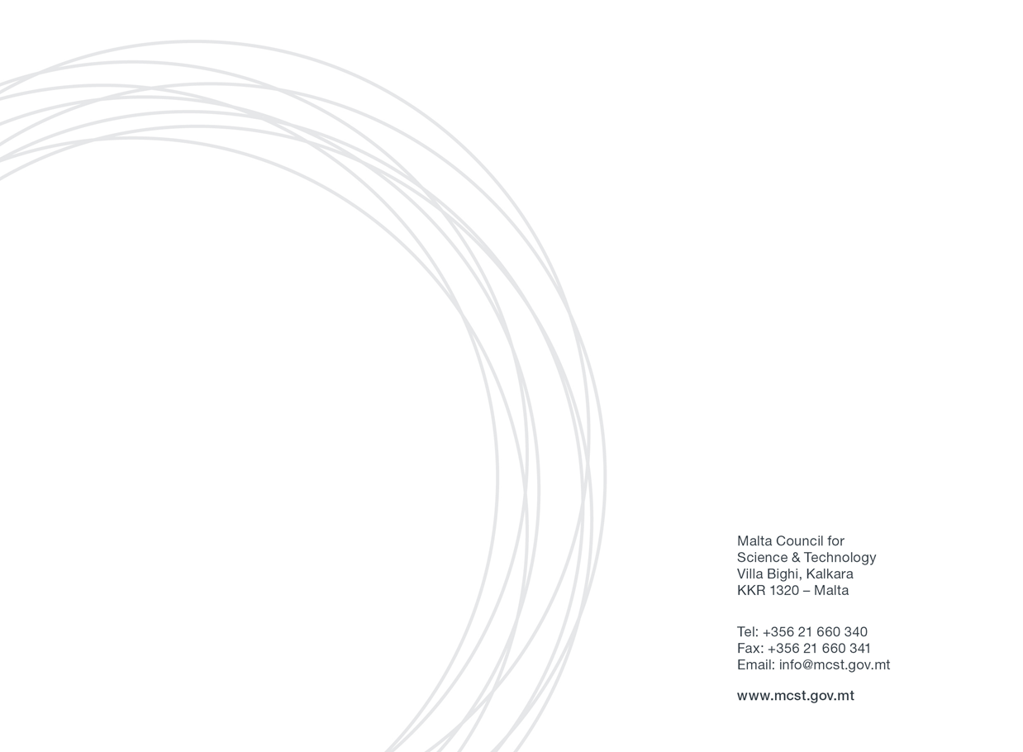

Malta Council for Science & Technology
Framework Programme Unit

Contents
1
1. Introduction 3
2. Definitions 3
3. Eligibility Criteria 4
4. Financing 5
Eligible costs: 6
5. Submission of Application Form 6
Reporting documents: 7
6. Selection Process 7
7. Award Duration 7
8. Correspondence 8
10. Confidentiality of Submissions 8
11. Further Information 9

1. Introduction

The Malta Council for Science and Technology (MCST) is receiving proposals under the Horizon Europe Networking Support Scheme (NET2HE).
NET2HE is offering stakeholders from Malta the financial support to attend Horizon Europe networking and brokerage events held overseas in a bid to increase the uptake in Horizon Europe proposal submissions. The aim is to incentivise Maltese participation in brokerage sessions and networking events. Info Days organised by the European Commission will also be taken into consideration.
The aim of the scheme is to support networking activities that generate long-term outcomes leading to the formation of the consortia and/or participation in consortia capable of applying for the Horizon funding.

2. Definitions

- Applicant means anyone eligible to apply in terms of these Rules for Participation and who consequently applies for funding under this scheme.
- Council refers to the Malta Council for Science and Technology.
- Partner is defined as a partner in a consortium of a funded project.
- Public Entity is any Ministry, Department, Entity, Authority, Public Commission, Public Sector Foundation, or similar organisation that does not carry out an economic activity within the meaning of Article 107 TFEU and that exercises public power, or else acts in its own capacity as public authority, where the activity in question forms part of the essential function of the State or is connected with those functions by its nature, its aim and the rules to which it is subject. However, the classification of a particular entity as an undertaking depends entirely on the nature of its activities, and the overriding criterion of consideration is whether it carries out an economic activity or not, e.g. an entity that is formally part of the public administration may nevertheless have to be regarded as an undertaking within the meaning of Article 107(1) of the Treaty. Thus, an entity that carries out both economic and non-economic activities is to be regarded as an undertaking only with regards to the former. In this case, if the economic activity can be separated from the exercise of public powers, then that entity acts as an undertaking in relation to that activity and the financing, the costs and the revenues of that economic activity shall be accounted for separately from the other non-commercial activities.
If an economic activity cannot be separated from the exercise of public power, the activities exercised by that entity as a whole, remain connected with the exercise of those public powers and therefore fall outside the notion of an undertaking.
- Research and knowledge-dissemination organisation means an entity (such as universities or research institutes, technology transfer agencies, innovation intermediaries, research-oriented physical or virtual collaborative entities), irrespective of its legal status (organised under public or private law) or way of financing, whose primary goal is to independently conduct fundamental research, industrial research or experimental development or to widely disseminate the results of such activities by way of teaching, publication or knowledge transfer. Where such entity also pursues economic activities the financing, the costs and the revenues of those economic activities must be accounted for separately. Undertakings that can exert a decisive influence upon such an entity, in the quality of, for example, shareholders or members, may not enjoy preferential access to the results generated by it.

3. Eligibility Criteria

The applicant entity must be registered as one of the following:
i. Public research and knowledge-dissemination organisation whose main activities are education which is not offered for remuneration and independent research whose results are widely disseminated on a non-discriminatory basis
ii. Public entity that does not offer goods or services on a market for remuneration
Applicants who have other funded projects with the Council and are in default, and/or have gone beyond the timelines of the project, are not eligible to participate.
Any application submitted by or including the participation of any legal person or legal entity having, in totality or in majority ownership, the same shareholders, partners or persons holding and / or exercising a controlling power in any other legal entity which would have, at any time prior to such application, been declared as non-compliant or defaulting on any other contract or agreement entered into with the Council, shall be automatically declared as inadmissible.
Funding under this scheme is made available on the basis that the Applicant has not benefited and will not benefit from any other grant or financial incentive of whatever nature, applied for and/or utilised for the same scope as that subject of the funding requested under this scheme.
The attendance of Horizon Europe networking and brokerage events is supported through this scheme. It is important that the same applicant benefitting from this scheme would be directly involved in the activities of the consortium applying for Horizon funding. The scheme will also consider funding for information days organised by the European Commission on a case-by-case basis. NET2HE will support travel happening within European Member States and Associated Countries only. Events happening in third countries are not eligible for funding. Only flights that depart from Malta and return to Malta are eligible. Applications should be endorsed by the entity’s legal representative.
It is important that networking activities generate long-term outcomes leading to the formation of the consortium capable of applying for the Horizon funding.
The Council will support the attendance of events that do not exceed 5 days and funding no more than 5 nights.
Individual applicants are to submit the Application Form for participating in a European/international brokerage event or an info day. The grant is limited to one representative per event per organisation, however, the entity may benefit from multiple grants for different events. The same individual cannot be supported by this scheme for more than 3 times per year. Individual applicants are to submit the Application Form for participating in an international brokerage event or an info day at least 15 working days prior to the event. The reporting documents must be sent in no later than 1 month after the event.
It is the responsibility of the applicant to ensure the timely and correct delivery of the Application Form to MCST. It should be noted that emails larger than 6MB will be automatically rejected by the mail system. In that case the applicant may alternatively consider uploading his/her documents via cloud as Google Documents and share the link via email
Failure to provide the requested documents in time allows MCST to withhold any reimbursements. Late or incomplete applications will not be considered.

4. Financing
Each applicant is invited to provide a breakdown of the anticipated costs to carry out the proposed activities as part of the Application Form.
Award holders will be responsible for arranging all relevant activities including travel plans, accommodation, logistics planning and insurance coverage for any participant who will be travelling.
The applicant must confirm that there has not been any approval or has been granted any public funding, financing, or fiscal benefit in respect to the cost items included in this request for aid and will not seek funding or fiscal benefits for these cost items through other National and/or European Union measures.

Eligible costs:
Applicants will receive a reimbursement upon receipt of reporting documents.
Eligible costs are:

- Flights for travel related to the event (the total amount for each flight should be estimated as costing no more than €750 for both EU Member States and for Associated Countries and should be an economy class ticket, this capping also covers the travel insurance).
- Subsistence allowance of €150 flat rate per night (The flat rate will reflect the duration of the event and the number of nights required).
The flight capping and subsistence rate will remain the same and applicable to all European Member States and Associated Countries. Only flights that depart from Malta and return back to Malta are eligible. Furthermore, supplementary or match-funding from other funding sources is allowed and encouraged, this should be done only if it does not finance the same activities (no double funding) that will be funded through the Horizon Europe Networking Support Scheme (NET2HE).

5. Submission of Application Form
Interested parties are to submit their Application Form electronically to nethorizon.mcst@gov.mt with “Networking 2024” as a subject heading by not later than 15 working days before the networking event.
All submissions must be signed and dated. Late or incomplete applications will not be considered.
Submissions should include the following documents to satisfy the eligibility criteria:
➢ The ‘Application Form for Horizon Europe Networking Support Scheme’ provided by MCST
➢ Proof that the organiser has confirmed your registration
➢ Agenda of event (cannot exceed more than 5 days)
➢ (Recommended) Proof of planning of at least three meetings

Reporting documents:
- Travel Report (a template is available on MCST website)
- Boarding Passes
- Air ticket and travel insurance (including their receipts)

6. Selection Process
The Horizon Networking Support Scheme will run until the Call funds are exhausted. The Council, upon its discretion reserves the right to close the calls.
The selection of the awardees will be based on an administrative check of the application. The administrative check is based on section “3. Eligibility Criteria” and “5. Submission of the application form”. MCST will notify the applicant if their application was successful or not within 10 working days.
The scheme will remain open in 2024 until funds are exhausted. Although trips may be completed up to 6 months after being notified that your application has passed all eligibility checks.
Payment will be affected following the presentation of the reporting documents. Beneficiaries are to hand in the requested documents no later than 1 month after the event. The Council retains the right to request further proof of expenditure. Failure to do so allows MCST to withhold any reimbursements.
Any requests for an extension or change of use of the award should be addressed in writing to nethorizon.mcst@gov.mt with “NET2HE Modification” as a subject heading. Such request needs to receive consent from MCST prior to being affected. The Council will review the letter and a reply should be given within 10 working days. Only one request for modification is allowed for each application. Applicants are reminded of the importance of retaining all documents proving expenditure of the awarded funds for submission with the final report.

7. Award Duration
Applicants can submit their application as early as 6 months before the start of the event and are encouraged to make the necessary travel arrangements upon notification from the Council that the applicant has passed all eligibility checks. Upon completion of the activities, the applicant is to submit a final report within 1 month according to a standard template developed by MCST. The final report will need to be accompanied by all relevant documentation.
The Scheme will support the networking of applicants from Maltese public entities and public research and knowledge-dissemination organisations, furthermore applicants are always encouraged to attend HE events, training by MCST and meet NCPS.
If the beneficiary is not able to complete the activities, MCST shall be entitled to take any action it deems necessary, including, but not limited to, the withdrawal of funding for the activities. A similar course of action may be followed if a project is in default because of not meeting one or more of its obligations. However, MCST will provide a notice indicating a rectification period of one month.
If the event is postponed to a later date the applicant may request an extension of the award in writing to nethorizon.mcst@gov.mt with “NET2HE Modification” as a subject heading.

8. Correspondence
Successful applicants will be required to inform MCST at nethorizon.mcst@gov.mt within the Framework Programme Unit regularly of any direct or indirect outputs resulting from this award during and beyond the lifetime of the award.
Reference to this award should be made on any publication, marketing or PR material that is generated in relation to the relevant project or activity undertaken.
9. Interpretation of the Rules
This document endeavours to establish comprehensive and unambiguous rules governing participation in this initiative. However, should circumstances arise where the rules are inadequate, unclear, ambiguous, or conflicting, the Council shall exercise its discretion in the interpretation of the rules through the setting up of an ad hoc committee.

10. Confidentiality of Submissions
Unless otherwise indicated, all application submissions shall be treated in strict confidence.
The data collected by the Council via the application for the assistance and its subsequent processing by the Council to evaluate data subject’s request for assistance under the Scheme is in line with:
- The National Rules for Participation;
- Data Protection Act (CAP 586 of the Laws of Malta) and Regulation (EU) 2016/679 of the European Parliament and of the Council of 27 April 2016 on the protection of natural persons with regard to the processing of personal data and on the free movement of such data and repealing Directive 95/46/EC (General Data Protection Regulation).
- The legitimate basis to process personal data submitted by the data subject by virtue of his/her written application for assistance is Regulation 6 (1)(b) of the General Data Protection Regulation (“GDPR”), as ‘processing is necessary in order to take steps at the request of the data subject prior to entering into a contract’.

11. Further Information

For further information please contact nethorizon.mcst@gov.mt and CC Horizon.malta@gov.mt and tamara.b.schembri@gov.mt
Tel: +356 2360 2200
Mrs Tamara Schembri
Executive
Framework Programme Unit
The Malta Council for Science and Technology
Tel: +356 2360 2133 or 2360 2000
Email: tamara.b.schembri@gov.mt

https://ec.europa.eu/info/funding-tenders/opportunities/docs/2021-2027/common/guidance/list-3rd-country-participation_horizon-euratom_en.pdf .
Brokerage sessions and networking events.
In case of Higher Education Establishments (HES) , the grant is limited to one representative per event per department/institute
Including Vat and Taxes
Applicants are strongly advised not to wait until the last day to submit their applications since heavy internet traffic or a fault with the internet connection could lead to difficulties in submission.
The following documents are solely used for administrative and eligibility checks.
https://mcst.gov.mt/horizon-europe/horizon-europe-national-contact-points/

