Horizon Europe Networking Support Scheme (NET2HE)
Framework Programme Unit
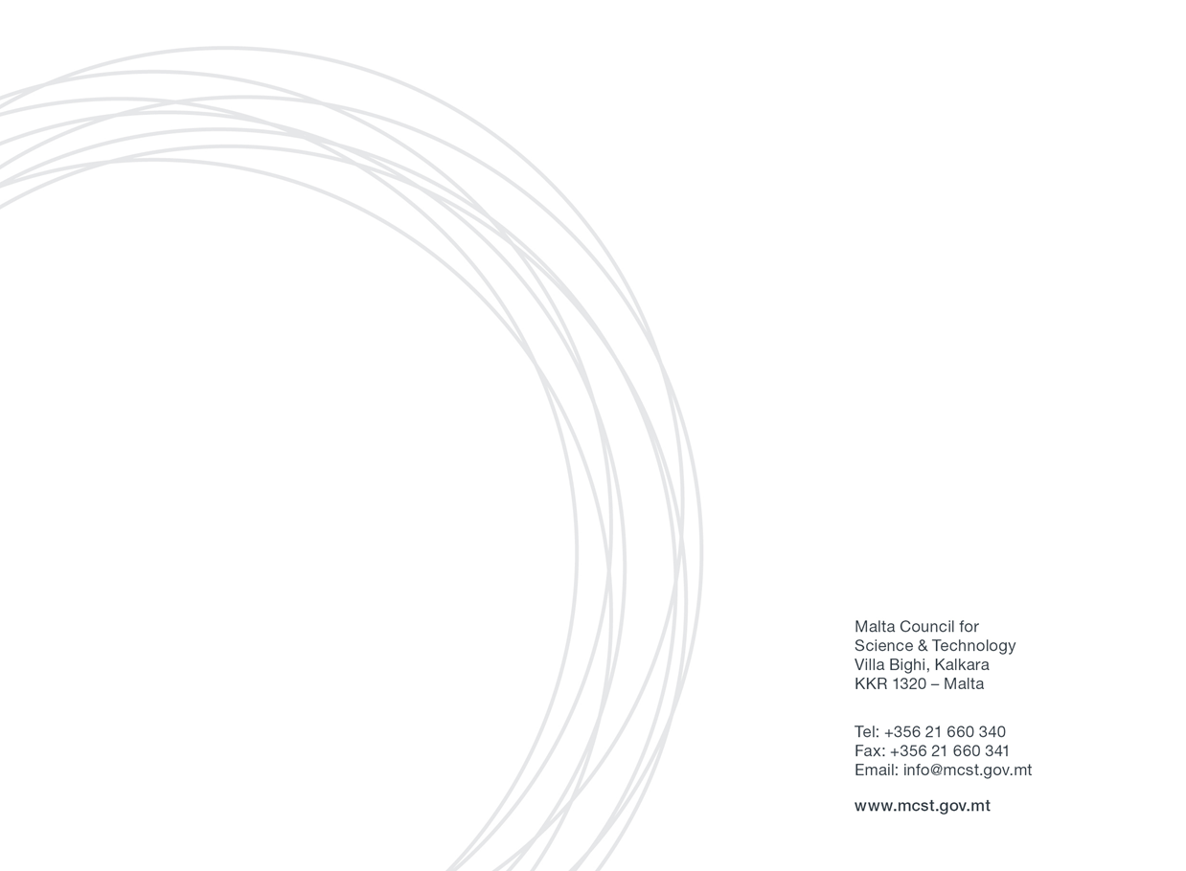
Application Form:

Please fill in all sections of the form.
Section 1: Applicant’s Details

Applicant Details
(Please include details of the Malta-based entity applying for the Scheme)
Name
Designation
Legal name of Undertaking/Entity
Name of Department/Institute/Centre
(if applicable)
Company Number/Registration/Identification number (not applicable for public entities)
Business Activity
[please state NACE code; a list of NACE Codes may be accessed here]
Email
Tel. Number

Section 2: Details of the networking/brokerage event/info day

Event title
Organised by
Location
Dates

Section 3: Horizon Europe proposal related information

Have you participated in any Horizon Europe or Horizon 2020 projects to date?
If yes, kindly provide details such as project name, thematic area and approximate duration.
Have you been a partner in a Horizon Europe or Horizon 2020 proposal submission which was not funded?
If yes, please give details (project name, thematic area).
Kindly indicate your qualifications, expertise, research experience or other elements which would qualify you to participate in Horizon Europe projects.
Have you previously participated in networking events? Kindly list any relevant events and indicate whether any of these were funded by the European Commission or the MCST, or by any other national funding bodies
Which area/s of the Horizon Europe programme are you interested in?

Mandatory additional documents required:

- Agenda/activities of the event (PDF)
- Proof that your registration has been accepted by the organiser.
- 3 flight quotations (preferably direct flights if available)

Other additional documents required (if attending a brokerage event):

- (Recommended) Proof of planning meetings with at least 3 different partners

Section 4 - State Aid Rules

For applicants that qualify as undertakings that carry out an economic activity within the meaning of Article 107 TFEU, the NET2HE scheme will be implemented in line with the de Minimis Regulation (Commission Regulation (EU) 2023/2831 of 13 December 2023 on the application of Articles 107 and 108 of the Treaty on the Functioning of the European Union to de minimis aid). More information is provided in the rules for participationand the Council can also be contacted for further clarifications.
If you deem that State Aid is not applicable, a justification will need to be provided. If the activities undertaken by the applicant are found to have State Aid implications, the applicant would need to follow State Aid rules. Refer to the resources page on the MCST website.
Please provide justification below:
Justification

Section 5: Declaration

5.1 Personal Data Protection
- Contact email address of the Data Protection Officer: dpo.mcst@gov.mt
- The legal basis and purpose of processing:
The personal data collected by the Malta Council for Science and Technology (hereinafter ‘the Council’) via this written application for the aid and its subsequent processing by the Council to evaluate data subject’s request for aid under the Scheme is in line with:
- The relevant Rules for the Scheme;
- COMMISSION REGULATION (EU) 2023/2831 of 13 December 2023 on the application of Articles 107 and 108 of the Treaty on the Functioning of the European Union to de minimis aid (the de minimis Regulation), where applicable;
- Data Protection Act (CAP. 586 of the Laws of Malta) and
- Regulation (EU) 2016/679 of the European Parliament and of the Council of 27 April 2016 on the protection of natural persons with regard to the processing of personal data and on the free movement of such data, and repealing Directive 95/46/EC (General Data Protection Regulation).
The legitimate basis to process personal data submitted by the data subject by virtue of his/her written application for aid is Regulation 6 (1)(b) of the General Data Protection Regulation (“GDPR”), as ‘processing is necessary in order to take steps at the request of the data subject prior to entering into a contract’.
- Data retention period:
The data collected by the Council as submitted by the data subject via this written application for aid will be retained for a period of ten (10) years from the date on which the aid was granted to the Entity represented by the data subject in relation to this written application for aid, in line with the Scheme Rules for Participation and Article 6 of the de minimis Regulation (where applicable).
- Pursuant to General Data Protection Regulation (GDPR), you have the right to access the personal data, rectify inaccurate personal data, request to erase personal data and request the Council to restrict the processing of personal data.
- To exercise such rights, you are to submit a written request to the Data Protection Officer via the contact e-mail address.
- Any erasing and/or rectification of personal data and/or restriction of processing as referred to above may:
- Render one or more cost items or the Entity ineligible for assistance under the Scheme or render void the Letter of Intent issued in favour of the Entity for assistance under the Scheme in relation to this written application for aid;
- Lead the Council to enforce a recovery of aid granted to the Entity as part of this written application for aid.
- Sharing of data where strictly necessary and required by law:
For the purpose of processing this written application for aid in line with the Rules for Participation and the de minimis Regulation (where applicable), the Council may share the data provided via this application with other Government Entities, subject that such processing satisfies at least one of the grounds listed under the Regulation of the GDPR.
- For the purpose of monitoring of State aid in line with Article 6 of the de minimis Regulation or where legally required, any data provided as part of this written application for aid may be shared with the European Commission.
- If you feel that your data protection rights have been infringed, you have the right to lodge a complaint with the Information and Data Protection Commissioner.
- Authorisation to engage with the Council on matters related to this application.
I the undersigned, as legal representative of the Applicant Entity, authorise the following Legal Bodies and/or Natural Persons to act on my behalf with the Council with respect to matters related to this written application for aid and any subsequent documentation exchanged between the two parties in relation to the same written application for aid.

Name of Legal Entity | Name and Surname of Natural Person granted authorisation⁽¹⁾ | E-mail address of party granted authorisation⁽²⁾

Note 1: Leave empty if authorisation is intended to any natural person engaged with the Legal Entity. Otherwise specify the name and surname of the person(s) working for the Legal Entity to whom the authorisation is intended.
Note 2: Written communication with the Legal Entity and/or Natural Person granted authorisation via email will only be accepted via the email address specified in the table above. The Undersigned should be copied (via the email address specified in this application) in any communication between the Council and the Person granted authorisation as per above table.
Name and Surname of person giving authorisation:
E-mail address of person giving authorisation:
Signature of person giving authorisation:
Designation:
Date:
The person giving authorisation should correspond to the data subject of personal data contained in this application as well as represent the Applicant Entity as its legal representative.
5.2 Cumulation of Aid (where State aid rules apply)
The undersigned declares that aid approved under this incentive is in line with the terms and conditions set out in the Rules for Participation and in line with the rules on cumulation outlined in Article 5 of the de minimis Regulation.
5.3 Double Funding
Funding under this scheme is made available on the basis that the Applicant has not benefited and will not benefit from any other grant or financial incentive of whatever nature, applied for and/or utilised for the same scope as that subject of the funding requested under this scheme.
5.4 Monitoring and Reporting Obligations
By submitting this application, I hereby acknowledge that the Council shall abide with any applicable monitoring and reporting obligations and may publish and make available to third parties’ information as required by such rules.
As from 2026 onwards, in line with Article 6(1) of the de minimis Regulation, as of 1 January 2026, information on de minimis aid granted under de minimis schemes shall be made publicly available in the central register at national or Union Level.
MCST would have to retain the following records:
- the identification of the beneficiary,
- the aid amount,
- the granting date,
- the aid instrument, and
- the sector involved on the basis of the statistical classification of economic activities in the Union (‘NACE classification’).

5.5 Additional declarations:
Declaration by Maltese applicant:

I confirm that the information given on this form is accurate to the best of my knowledge. I understand that if it is later established that I misrepresented myself and I am not eligible for this Scheme the Council is allowed to withhold any reimbursements. | I agree
I accept and confirm that the personal data and activities/meeting information can be passed on to the Malta Council for Science and Technology to be used solely for the purposes of administering, processing, and review of the application. | I agree
I have read and I accept the terms and conditions stipulated within the declarations above and the NET2HE Rules for Participation 2024. | I agree
I confirm that I have attached all other required documentation such as agenda/activities of the event (PDF), proof that my registration has been accepted by the organiser and 3 flight quotations. | I agree
I confirm that there is no double financing through other schemes. | I agree
I confirm that my entity has a Gender Equality Plan or will have it by the time of deadline of the Horizon Europe call ( Applying only to public bodies, research organisations and higher education institutions, from EU Member States and associated countries, must have a GEP or equivalent strategy in place to be eligible for funding). | I agree
I confirm that I will participate actively in the activities suggested by MCST. | I agree
I confirm that my intention is to submit a Horizon Europe/Partnership proposal together with a consortium. | I agree
I have never been disqualified or excluded from participation in any Public and/or European Union funding scheme. | I agree
I have never been disqualified or excluded from participation in any Public Tender either by the Government of Malta or by the European Union or by any public entity in Malta. | I agree
I have never been found guilty by any competent Court in Malta or elsewhere of any crime and that I have never been adjudged bankrupt or insolvent by, or filed an application for insolvency before, any competent Court in Malta or elsewhere. | I agree

Signature of the Applicant:  The applicant needs to have sufficient authority to ensure the adequate degree of commitment and support for the activities. | Date:  Sign:

Signature of Director:  Applications should be endorsed by the applicant’s Director. | Date:  Sign:

