LIST OF SUGGESTED EVENTS ELIGIBLE FOR THE NET2HE SCHEME

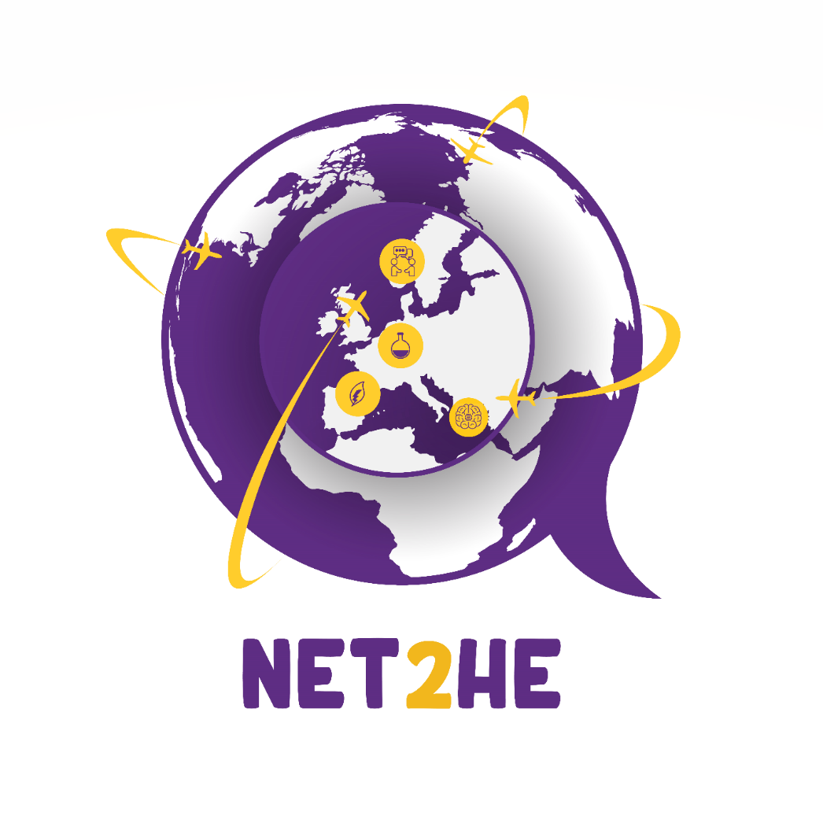

NB : The NET2HE application should be submitted no later than 15 working days before the start of the event. Most events require mandatory registration, please provide proof that your registration has been accepted with your application. More information can be found on the application form and rules for participation documents.
Event Name | Location | Dates | Thematic Area/s | More info here
Restore our waters – Baltic Sea Region perspective | Brussels, Belgium | 17 – 18 April | Ocean Mission | https://www.lmt.lt/en/events/2558/matchmaking-event-restore-our-waters-baltic-sea-region-perspective/r257
SMI2G - Security Mission Information & Innovation Group Event 2023 - Paris | Paris, France | 10 May 2023 | Security | https://www.cmine.eu/events/107590?fbclid=IwAR0mkPlBzfmqvGTJVL_zUpJhy2XwNmSqi_KrE3eMPNHaqFFM96h8MLFgXko
EU Agricultural Research and Innovation Conference | Brussels, Belgium | 31ST May – 1st June 2023 | Common agricultural policy, EU green deal, agriculture, forestry, rural areas | https://agriculture.ec.europa.eu/events/eu-agricultural-research-and-innovation-conference-2023-05-31_en

Register by the 30th of March 2023

