LIST OF SUGGESTED EVENTS ELIGIBLE FOR THE NET2HE SCHEME

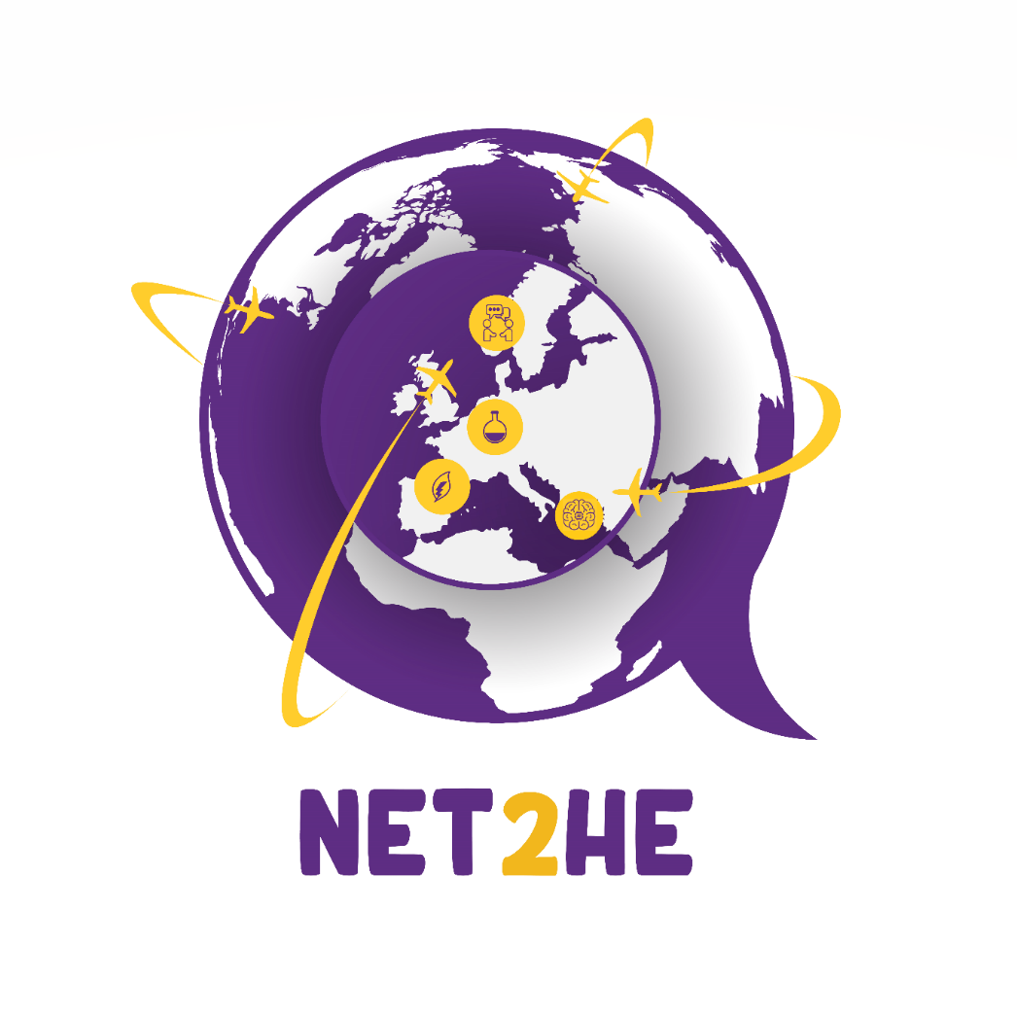
Event Name | Location | Dates | Thematic Area/s | More info here
European Innovation Council Summit | Brussels,  Belgium | 7-8 December | European Innovation Council. | https://eic.ec.europa.eu/events/european-innovation-council-summit-2022-78-december-2022-2022-12-07_en?mtm_campaign=nwl_06_2022
The EU CAP Network Brokerage event | Sofia, Bulgaria | 17-18 January 2023 | Agriculture, and rural areas | https://ec.europa.eu/eip/agriculture/en/event/eu-cap-network-brokerage-event?fbclid=IwAR1blAWfJe6nrTPVwV6Xcx2P2ITP9qlyPTa2i2oG_JzDi7bOWZ09xK3dY7c

NB : Last application should be submitted not later than the 15th of November 2022

