Horizon Europe Networking Support Scheme (NET2HE)

Rules for Participation –State Aid
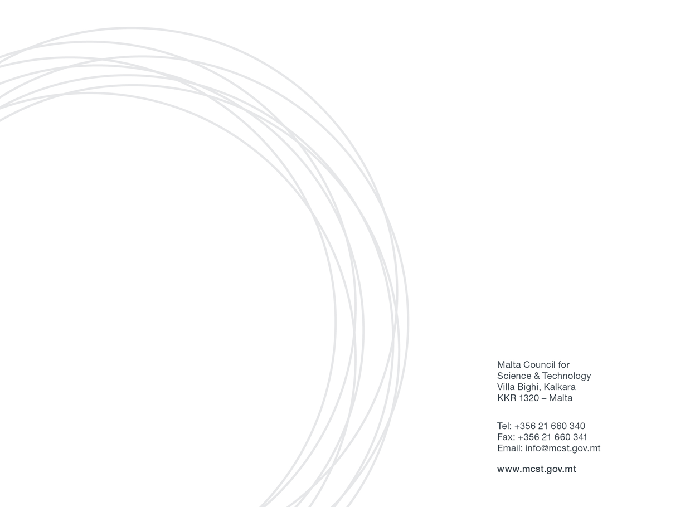

Malta Council for Science & Technology
Framework Programme Unit

Contents
_Toc106719971
1. Introduction: 3
2. Definitions 3
3. Eligibility Criteria 4
4. Financing 6
Eligible costs: 6
5. Submission of Application Form 7
Reporting documents: 7
6. Selection Process 7
7. Award Duration 8
8. Correspondence 9
9. Confidentiality of Submissions 9
10. Further Information 9

1. Introduction:
The Malta Council for Science and Technology (MCST) is receiving proposals under the Horizon Europe Networking Support Scheme (NET2HE).
NET2HE is offering stakeholders from Malta the financial support to attend Horizon Europe networking and brokerage events held overseas in a bid to increase the uptake in Horizon Europe proposal submissions. The aim is to incentivise Maltese participation in brokerage sessions and networking events. Info Days organised by the European Commission will also be taken into consideration.
The grant is limited to one representative per event per organisation, however, the entity may benefit from multiple grants for different events. Individual applicants are to submit the Application Form for participating in an international brokerage event or an info day at least 15 working days prior to the event.
The aim of the scheme is to support networking activities that generate long-term outcomes leading to the formation of the consortia and/or participation in consortia capable of applying for the Horizon funding.

2. Definitions

- Applicant means anyone eligible to apply in terms of these Rules for Participation and who consequently applies for funding under this scheme.
- Council refers to the Malta Council for Science and Technology.
- Undertakings are defined as undertakings planning to carry out research and innovation projects that are eligible to apply for assistance under this scheme. To be eligible, applicants must additionally satisfy the following criteria. They must be either: a) a partnership constituted under the Companies Act (CAP 386 of the Laws of Malta), being a partnership en nom collectif, or en commandite; or b) a limited liability company; c) professional body; d) NGOs; e) Nonprofit making entities (including Foundations). ‘Professional Body’ may be an organisation, an association, a chamber, society, institute or a group of professional persons not being enrolled or registered in terms of The Voluntary Organisations Act (CAP. 492 of the Laws of Malta) or not being otherwise recognised in terms of Law, and which is generally recognised and acknowledged by the professional persons it seeks to represent as their representative Body. For the purposes of this Definition, a professional person is one who has undergone a period of study at a university or a recognised institution of higher learning and has obtained the formal qualification entitling the person to practise the respective profession; and who provides a specialised service to the public, based primarily on a fiduciary relationship between herself/himself and the party to whom s/he provides such service on his own personal credibility and responsibility. ‘NGO’ means any Voluntary or Non-Governmental Organisation set up in accordance with the Voluntary Organisations Act (CAP. 492 of the Laws of Malta). ‘Non-profit making’ is an entity where (a) the statute of the entity contains an express exclusion of the purpose to make profits; and (b) there is express provision in the statute defining the purposes of the entity which do not include the promotion of private interests, other than a private interest which is a social purpose; and (c) no part of the income, capital or property is available directly or indirectly to any promoter, founder, member, administrator, donor or any other private interest. Provided that if a promoter, founder, member, administrator or donor is another enrolled non-profit making organisation, the limitation in paragraph (c) shall not apply provided the availability of such income, capital or property is subject to conditions which are consistent with the general purposes of the grantor entity: Provided further that an organisation shall continue to be deemed as non-profit making notwithstanding that:(i) it obtains a pecuniary gain from its activities when such gain is not received or credited to its members but is exclusively utilised for its established purposes; (ii) it buys or sells or otherwise deals in goods or services where such activities are exclusively related to its principal purposes; (iii) it is established for the general entertainment, pastime, education or other similar benefit only of its members; or (iv) it is established for the promotion of the social role, ethics, education and values of a trade or profession provided it does not promote the private interests of its members.
- Partner is defined as a partner in a consortium of a funded project.

3. Eligibility Criteria

The Scheme will provide assistance to undertakings that carry out an economic activity within the meaning of Article 107 TFEU and will be implemented in line with Commission Regulation (EU) No. 1407/2013 of 18th December 2013 on the application of Articles 107 and 108 of the Treaty on the Functioning of the European Union to de minimis aid, as amended by Commission Regulation (EU) 2020/972 of 2 July 2020 amending Regulation (EU) No 1407/2013 as regards its prolongation and amending Regulation (EU) No 651/2014 as regards its prolongation and relevant adjustments.
Applicants who have other funded projects with the Council and are in default, and/or have gone beyond the timelines of the project, are not eligible to participate.
Any application submitted by or including the participation of any legal person or legal entity having, in totality or in majority ownership, the same shareholders, partners or persons holding and / or exercising a controlling power in any other legal entity which will have, at any time prior to such application, been declared as non-compliant or defaulting on any other contract or agreement entered into with the Council, shall be automatically declared as inadmissible.
Funding under this scheme is made available on the basis that the Applicant has not benefited and will not benefit from any other grant or financial incentive of whatever nature, applied for and/or utilised for the same scope as that subject of the funding requested under this scheme.
The attendance of Horizon Europe networking and brokerage events is supported through this scheme. It is important that the same applicant benefitting from this scheme would be directly involved in the activities of the consortium applying for Horizon funding. The scheme will also consider funding for information days organised by the European Commission on a case-by-case basis. NET2HE will support travel happening within European Member States and Associated Countries only. Events happening in third countries are not eligible for funding. Applications should be endorsed by the entity’s legal representative.
It is important that networking activities generate long-term outcomes leading to the formation of the consortium capable of applying for the Horizon funding.
The Council will support the attendance of events that do not exceed 5 days.
Individual applicants are to submit the Application Form for participating in a European/international brokerage event or an info day. The same applicant cannot apply more than 3 times per year. The Application Form should be submitted at least 15 working days prior to the event.
The reporting documents must be sent in no later than 1 month after the event.
The applicant is responsible to keep abreast with the entry rules of their chosen country. Re-open EU and national authorities provide information on the various travel measures in place, including on quarantine and testing requirements for travelers.
It is the responsibility of the applicant to ensure the timely and correct delivery of the Application Form to MCST. It should be noted that emails larger than 6MB will be automatically rejected by the mail system. In that case the applicant may alternativaley consider uploading his/her documents via cloud as Google Documents and share the link via email
Failure to provide the requested documents in time allows MCST to withhold any reimbursements. Late or incomplete applications will not be considered.

4. Financing
Each applicant is invited to provide a breakdown of the anticipated costs to carry out the proposed activities as part of the Application Form.
Award holders will be responsible for arranging all relevant activities including travel plans, accommodation, logistics planning and insurance coverage for any participant who will be travelling.
The applicant must confirm that there has not been any approval or has been granted any public funding, financing, or fiscal benefit in respect to the cost items included in this request for aid and will not seek funding or fiscal benefits for these cost items through other National and/or European Union measures.

Eligible costs:
Applicants will receive a reimbursement upon receipt of reporting documents.

- Flights for travel related to the project (the total amount for each flight should be estimated as costing no more than €750 for both EU Member States and for Associated Countries and should be an economy class ticket, this capping also covers the travel insurance).
- Subsistence allowance of €150 flat rate per night (The flat rate will reflect the duration of the event and the number of nights required).
The flight capping and subsistence rate will remain the same and applicable to all European Member States and Associated Countries.
Furthermore, supplementary or match-funding from other funding sources is allowed and encouraged, this should be done only if it does not finance the same activities (no double funding) that will be funded through the Horizon Europe Networking Support Scheme (NET2HE).

5. Submission of Application Form
Interested parties are to submit their Application Form electronically to nethorizon.mcst@gov.mt with “Networking 2022” as a subject heading by not later than 15 working days before the networking event.
All submissions must be signed and dated. Late or incomplete applications will not be considered.
Submissions should include the following documents to satisfy the eligibility criteria:
➢ The ‘Application Form for Horizon Europe Networking Support Scheme’ provided by MCST
➢ Partner search form duly filled in
➢ Agenda of event (cannot exceed more than 5 days)
➢ (Recommended) Proof of planning of at least three meetings

Reporting documents:
- Travel Report (a template is available on MCST website)
- Boarding Passes
- Air ticket and travel insurance (including their receipts)

6. Selection Process
The Horizon Networking Support Scheme will run until the Call funds are exhausted.
The Council, upon its discretion reserves the right to close the calls.
The selection of the awardees will be based on an administrative check of the application. The administrative check is based on section “3. Eligibility Criteria” and “5. Submission of the application form”. MCST will notify the applicant if their application was successful or not within 10 working days.
The rolling scheme will open on the 21st of June 2022 and the last application will be accepted on the 15th of November 2022 although trips may be completed up to 28th of February 2023.
Payment will be affected following the presentation of the reporting documents. Beneficiaries are to hand in the requested documents no later than 1 month after the event. The Council retains the right to request further proof of expenditure. Failure to do so allows MCST to withhold any reimbursements.
Any requests for an extension or change of use of the award should be addressed in writing to nethorizon.mcst@gov.mt (and CC tamara.b.schembri@gov.mt ) with “NET2HE Modification” as a subject heading. Such request needs to receive consent from MCST prior to being affected. The Council will review the letter and a reply should be given within 10 working days. Only one request for modification is allowed for each project. Applicants are reminded of the importance of retaining all documents proving expenditure of the awarded funds for submission with the final report.

7. Award Duration
All activities funded through this Scheme would need to be completed by 6 months from the signature of the grant agreement, although the beneficiary may attend the event at any point within the 6-month time frame. Upon completion of the activities, the applicant is to submit a final report within 1 month according to a standard template developed by MCST. The final report will need to be accompanied by all relevant documentation.
The Scheme will support the networking of applicants from Maltese legal entities, furthermore applicants are always encouraged to attend HE events, training by MCST and meet NCPS.
If the beneficiary is not able to complete the activities, MCST shall be entitled to take any action it deems necessary, including, but not limited to, the withdrawal of funding for the activities. A similar course of action may be followed if a project is in default because of not meeting one or more of its obligations. However, MCST will provide a notice indicating a rectification period of one month.
If the beneficiary is not able to complete the activities due to COVID-19 related cancellations, the applicant shall seek compensation through their travel insurance.
If the event is postponed to a later date the applicant may request an extension of the award in writing to nethorizon.mcst@gov.mt ( and CC tamara.b.schembri@gov.mt ) with “NET2HE Modification” as a subject heading.

8. Correspondence
Successful applicants will be required to inform MCST at nethorizon.mcst@gov.mt (and CC tamara.b.schembri@gov.mt) within the Framework Programme Unit regularly of any direct or indirect outputs resulting from this award during and beyond the lifetime of the award.
Reference to this award should be made on any publication, marketing or PR material that is generated in relation to the relevant project or activity undertaken.

9. Confidentiality of Submissions
Unless otherwise indicated, all application submissions shall be treated in strict confidence.
The data collected by the Council via the application for the assistance and its subsequent processing by the Council to evaluate data subject’s request for assistance under the Scheme is in line with:
- The National Rules for Participation;
- Data Protection Act (CAP. 586 of the Laws of Malta) and Regulation (EU) 2016/679 of the European Parliament and of the Council of 27 April 2016 on the protection of natural persons with regard to the processing of personal data and on the free movement of such data and repealing Directive 95/46/EC (General Data Protection Regulation).

- The legitimate basis to process personal data submitted by the data subject by virtue of his/her written application for assistance is Regulation 6 (1)(b) of the General Data Protection Regulation (“GDPR”), as ‘processing is necessary in order to take steps at the request of the data subject prior to entering into a contract’.

10. Further Information

For further information please contact nethorizon.mcst@gov.mt and CC tamara.b.schembri@gov.mt
Tel: +356 2360 2200

https://ec.europa.eu/info/news/updates-association-third-countries-horizon-europe_en#:~:text=As%20per%2022%20September%202021,%2C%20Georgia%2C%20Moldova%20and%20Ukraine.
Brokerage sessions and networking events..
https://reopen.europa.eu/en
Including Vat and Taxes
Applicants are strongly advised not to wait until the last day to submit their applications since heavy internet traffic or a fault with the internet connection could lead to difficulties in submission.
The following documents are solely used for administrative and eligibility checks.
https://mcst.gov.mt/horizon-europe/horizon-europe-national-contact-points/

