Horizon Europe Networking Support Scheme (NET2HE)
Framework Programme Unit
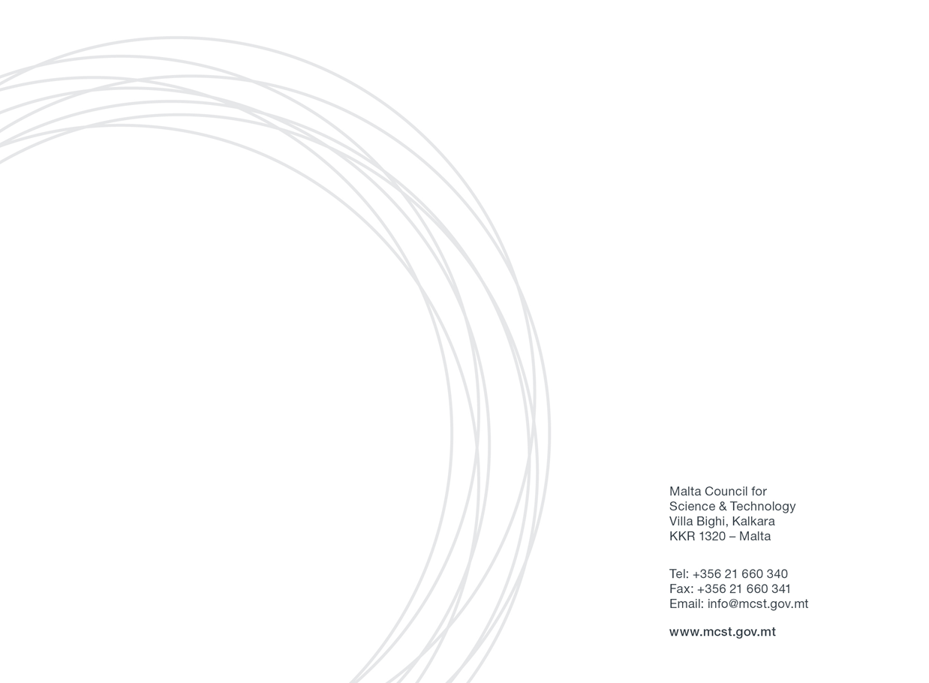
Application Form:

Introduction

The Malta Council for Science and Technology (MCST) is receiving proposals under the Horizon Europe Networking Support Scheme (NET2HE).
NET2HE is offering stakeholders from Malta the financial support to attend Horizon Europe networking and brokerage events held overseas in a bid to increase the uptake in Horizon Europe proposal submissions. The aim is to incentivise Maltese participation in brokerage sessions and networking events. Info Days organised by the European Commission will also be taken into consideration.
The grant is limited to one representative per event per organisation, however, the entity may benefit from multiple grants for different events
Interested parties are to submit their Application Form electronically to nethorizon.mcst@gov.mt ( and CC tamara.b.schembri@gov.mt ) with “Networking 2022” as a subject heading by not later than 15 working days before the start of the networking event.
Applicants are strongly advised not to wait until the last day to submit their applications since heavy internet traffic or a fault with the internet connection could lead to difficulties in submission.
All submissions must be signed and dated. Late or incomplete applications will not be considered.
More information can be found on the rules for participation document.

Please fill in all sections of the form.
Section 1: Applicant’s Details

Applicant Details
(Please include details of the Malta-based entity applying for the Scheme)
Name
Designation
Name of Organisation
Name of Department/Institute/Centre
(if applicable)
Email
Tel. Number

Section 2: Details of the networking/brokerage event/info day

Event title
Organised by
Location
Dates

Section 3: Horizon Europe proposal related information

Have you participated in any Horizon Europe or Horizon 2020 projects to date?
If yes, kindly provide details such as project name, thematic area and approximate duration.
Have you been a partner in a Horizon Europe or Horizon 2020 proposal submission which was not funded?
If yes, please give details (project name, thematic area).
Kindly indicate your qualifications, expertise, research experience or other elements which would qualify you to participate in Horizon Europe projects.
Have you previously participated in networking events? Kindly list any relevant events and indicate whether any of these were funded by the European Commission or the MCST, or by any other national funding bodies
Which area/s of the Horizon Europe programme are you interested in?

Section 4 - State Aid Regulation:

For applicants that qualify as undertakings that carry out an economic activity within the meaning of Article 107 TFEU, the NET2HE scheme will be implemented in line with the de Minimis Regulation (Commission Regulation (EU) No 1407/2013 of 18 December 2013 on the application of Articles 107 and 108 of the Treaty on the Functioning of the European Union to de minimis aid, as amended by Commission Regulation (EU) 2020/972 of 2 July 2020 amending Regulation (EU) No 1407/2013 as regards its prolongation and amending Regulation (EU) No 651/2014 as regards its prolongation and relevant adjustments). More information is provided in the rules for participation and the Council can also be contacted for further clarifications.
If you deem that State Aid is not applicable, a justification will need to be provided. If the activities undertaken by the applicant are found to have State Aid implications, the applicant would need to follow State Aid regulations (See appendix 1).
Please provide justification below:
Justification

Section 5: Declaration

5.1 Personal Data Protection
- Contact email address of the Data Protection Officer: dpo.mcst@gov.mt
- The legal basis and purpose of processing:
The personal data collected by the Malta Council for Science and Technology (hereinafter ‘the Council’) via this written application for the aid and its subsequent processing by the Council to evaluate data subject’s request for aid under the Scheme is in line with:
- The relevant National Rules for the Scheme;
- COMMISSION REGULATION (EU) No 1407/2013 of 18 December 2013 on the application of Articles 107 and 108 of the Treaty on the Functioning of the European Union to de minimis aid, as amended by Commission Regulation (EU) 2020/972 of 2 July 2020 amending Regulation (EU) No 1407/2013 as regards its prolongation and amending Regulation (EU) No 651/2014 as regards its prolongation and relevant adjustments (de minimis Regulation), where applicable;
- Data Protection Act (CAP. 586 of the Laws of Malta) and Regulation (EU) 2016/679 of the European Parliament and of the Council of 27 April 2016 on the protection of natural persons with regard to the processing of personal data and on the free movement of such data, and repealing Directive 95/46/EC (General Data Protection Regulation).
The legitimate basis to process personal data submitted by the data subject by virtue of his/her written application for aid is Regulation 6 (1)(b) of the General Data Protection Regulation (“GDPR”), as ‘processing is necessary in order to take steps at the request of the data subject prior to entering into a contract’.
- Data retention period:
The data collected by the Council as submitted by the data subject via this written application for aid will be retained for a period of ten (10) years from the last aid granted to the Entity represented by the data subject in relation to this written application for aid, in line with the Scheme National Rules for Participation and Article 6 of the de minimis Regulation (where applicable).
- Pursuant to General Data Protection Regulation (GDPR), you have the right to access the personal data, rectify inaccurate personal data, request to erase personal data and request the Council to restrict the processing of personal data.
- To exercise such rights, you are to submit a written request to the Data Protection Officer via the contact e-mail address.
- Any erasing and/or rectification of personal data and/or restriction of processing as referred to above may:
- Render one or more cost items or the Entity ineligible for assistance under the Scheme or render void the Letter of Intent issued in favour of the Entity for assistance under the Scheme in relation to this written application for aid;
- Lead the Council to enforce a recovery of aid granted to the Entity as part of this written application for aid.
- Sharing of data where strictly necessary and required by law:
For the purpose of processing this written application for aid in line with the National Regulation for the Call and the ‘de minimis Regulation’ (where applicable), the Council may share the data provided via this application with other Government Entities, subject that such processing satisfies at least one of the grounds listed under the Regulation of the GDPR.
- For the purpose of monitoring of aid in line with Article 6 of the de minimis Regulation or where legally required, any data provided as part of this written application for aid may be shared with the European Commission.
- If you feel that your data protection rights have been infringed, you have the right to lodge a complaint with the Information and Data Protection Commissioner.
- Authorisation to engage with the Council on matters related to this application.
I the undersigned, as legal representative of the Applicant Entity, authorise the following Legal Bodies and/or Natural Persons to act on my behalf with the Council with respect to matters related to this written application for aid and any subsequent documentation exchanged between the two parties in relation to the same written application for aid.

Name of Legal Entity | Name and Surname of Natural Person granted authorisation⁽¹⁾ | E-mail address of party granted authorisation⁽²⁾

Note 1: Leave empty if authorisation is intended to any natural person engaged with the Legal Entity. Otherwise specify the name and surname of the person(s) working for the Legal Entity to whom the authorisation is intended.
Note 2: Written communication with the Legal Entity and/or Natural Person granted authorisation via email will only be accepted via the email address specified in the table above. The Undersigned should be copied (via the email address specified in this application) in any communication between the Council and the Person granted authorisation as per above table.
Name and Surname of person giving authorisation:
E-mail address of person giving authorisation:
Signature of person giving authorisation:
Designation:
Date:
The person giving authorisation should correspond to the data subject of personal data contained in this application as well as represent the Applicant Entity as its legal representative.
5.2 Cumulation of Aid (where State aid rules apply)
The undersigned declares that aid approved under this incentive is in line with the terms and conditions set out in the National Rules for Participation and in line with the rules on cumulation outlined in Article 5 of the de minimis Regulation.
5.3 Double Funding
The undersigned confirms that there has not been any approval or has been granted any public funding, financing or fiscal benefit in respect to the cost items included in this request for aid and will not seek funding or fiscal benefits for these cost items through other National and/or European Union measures.
5.4 Transparency Obligations
By submitting this application, I hereby acknowledge that the Council shall abide with any applicable transparency rules and may publish and make available to third parties’ information as required by such rules.

Declaration by Maltese applicant:

I confirm that the information given on this form is accurate to the best of my knowledge. I understand that if it is later established that I misrepresented myself and I am not eligible for this Scheme the Council is allowed to withhold any reimbursements. | I agree
I accept and confirm that the personal data and activities/meeting information can be passed on to the Malta Council for Science and Technology to be used solely for the purposes of administering, processing, and review of the application. | I agree
I confirm that I have attached a full Agenda of the networking event that I will be attending | I agree
I confirm that I have attached a Partner Search form and that it has been duly filled in. | I agree
I confirm that there is no double financing through other schemes. | I agree

Signature of the Applicant: | Date:  Sign:

Signature of Director: | Date:  Sign:

Additional documents required:

- Agenda/activities of the event (PDF)

Other additional documents required (if attending a brokerage event):

- (Recommended) Proof of planning meetings with at least 3 different partners

Appendix I - Non-State Aid Applications shall need to abide by either or of the below justifications:
Non-State Aid justifications for – PUBLIC RESEARCH AND KNOWLEDGE DISSEMINATION ORGANISATIONS
Eligibility
Eligible public research and knowledge dissemination organisations (RO) are those whose main activities are education which is not offered for remuneration and independent research whose results are widely disseminated on a non-discriminatory basis.
Justifications
The entity is aware of the requirements of Article 107 of the Treaty on the Functioning of the European Union in connection with state aid, and hereby declares that the activities being undertaken by it under this application for funding do not, by their nature, constitute an economic activity, in view of the fact that the entity is hereby procuring services hereunder, and is not providing a service/product for remuneration to third parties.
The eventual planned research is to be carried out in the context of its activities as a “research and knowledge dissemination organisation” as defined in the Commission Framework for State aid for research and development and innovation (2014/C 198/01) paragraph 15(ee), which carries out a non-economic activity in line with the following:
- primary activities of research organisations and research infrastructures, in
particular:
- education for more and better skilled human resources which is not offered for remuneration.
- independent R&D for more knowledge and better understanding, including collaborative R&D where the research organisation or research infrastructure engages in effective collaboration;
- wide dissemination of research results on a non-exclusive and non-discriminatory basis, for example through teaching, open-access databases, open publications or open software;

- knowledge transfer activities, where they are conducted either by the research organisation or research infrastructure (including their departments or subsidiaries) or jointly with, or on behalf of other such entities, and where all profits from those activities are reinvested in the primary activities of the research organisation or research infrastructure. The non-economic nature of those activities is not prejudiced by contracting the provision of corresponding services to third parties by way of open tenders.

The Entity will intend to:
- publicise widely the results of the research;
- license on non-discriminatory terms any Intellectual Property Rights (IPRs) resulting from the research at the market price for the said IPR;
- any income from the licensing of IPR shall be reinvested in the primary educational and research activities of the Beneficiary;
- appropriate procedures shall be established to prevent the direct or indirect support of economic activities within the meaning of chapter 2 of the Commission Notice on the notion of State aid as referred to in Article 107(1) of the Treaty on the Functioning of the European Union (2016/C 262/01).
The Entity understands that, should the eventual R&I activities be found to be in breach of the conditions for being exempt from State Aid rules, the Managing Authority will enforce the retrieval of funds provided under the NET2HE scheme with interest, in part or in full, as the case may necessitate.
The Beneficiary undertakes to comply faithfully and immediately with any decision of the European Commission or a Maltese judicial authority declaring Article 107(1) TFEU to be applicable to this Agreement.

______________________________
Name of Entity

________________________________ ___________________
Signature & Stamp of CEO / Date
Chairman / Head of Department of Applicants Entity:

Non-State Aid Justifications for public entities whose activity DOES NOT CONSTITUTE AN ECONOMIC ACTIVITY IN THE MEANING OF ARTICLE 107 OF THE TREATY ON THE FUNCTIONING OF THE EUROPEAN UNION (EXCLUDING PUBLIC RESEARCH AND KNOWLEDGE DISSEMINATION ORGANISATIONS)

Eligibility
Eligible public entities are those that do not offer goods or services on a market for remuneration.
Justifications
Any secondary economic activities of the public entity must consume exactly the same inputs (such as material, equipment, labour and fixed capital) as the non-economic activities and the capacity allocated each year to such economic activities must not exceed 20% of the relevant entity’s overall annual capacity. Where this is not the case, and the same entity carries out activities of both economic and non-economic nature, the public funding of the non-economic activities will not fall under Article 107(1) of the Treaty if the two kinds of activities and their costs, funding and revenues can be clearly separated so that public funding of non-economic activities does not cross-subsidise any economic activities.
The eventual planned research being undertaken is claimed by the public entity not to constitute an economic activity within the meaning of Article 107 of the Treaty on the Functioning of the European Union.
The public entity will intend to:
a) publicise widely the results of the research;
b) ensure that no funds provided by this Agreement cross-subsidises any economic activities that may be carried out by the Beneficiary, other partners in the project, or third parties.

The public entity understands that, should the eventual R&I activities be found to be in breach of the conditions for being exempt from State Aid rules, the Managing Authority will enforce the retrieval of funds provided under the NET2HE scheme with interest, in part or in full, as the case may necessitate.
The public entity also undertakes to comply faithfully and immediately with any decision of the European Commission or a Maltese judicial authority declaring Article 107(1) TFEU to be applicable to this Agreement.
The amount of funding provided is at least equal to the market price and has been established by means of an open, transparent and non-discriminatory competitive procurement procedure.

.

___________________________
Name of Entity

________________________________ ___________________
Signature & Stamp of CEO / Date
Chairman / Head of Department of Applicants Entity:

Partner Search form

Title of Horizon Europe call you are interested in | For example HORIZON-CL6-2022-FARM2FORK-02-02-two-stage: Emerging and future risks to plant health
Description of your legal entity | Explain how your entity profile matches the tasks in the proposal
Name and email address of the person in charge of the proposal preparation
Summary of the partner search | For example:  Our department is studying biodiversity and epidemiology of plant viruses and diagnostics of plant viruses of important crops. Another direction of our efforts is focused on biological protection of plants against bacterial diseases using viruses of bacteria.  We are looking for organisations working closely with farmers to pilot our research.

