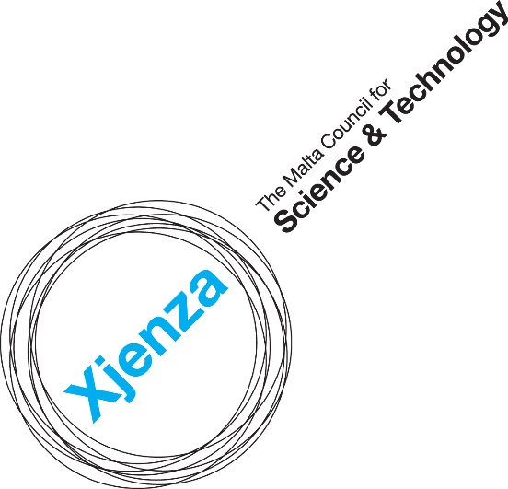

Marine Environmental Professional for a Joint Research Cruise under the JPI Oceans Joint Action “Science for Good Environmental Status”
Expression of Interest - Application Form

Version: 1
Issue Date: May 2022

Notes to Applicants
- This Application Form should be filled in with reference to the rules, terms and conditions listed in the Expression of Interest, as found on the Malta Council for Science and Technology (hereinafter ‘the Council’) website. Kindly refer to the Expression of Interest to ensure eligibility of participation.

- The Application Form and any attached documents will be treated as confidential throughout and after the appraisal process.

- Only Application Forms which are complete and that include all relevant supporting documents will be evaluated.

- Only electronically filled in Application Forms will be accepted. Should the application be hand-written or should the format of the application form be altered, the application form will not be evaluated.

- All responses must be clearly explained and substantiated.

- A complete Application Form must be submitted to the Malta Council for Science and Technology (MCST) via email on international.mcst@gov.mt

- The submission deadline for this Expression of Interest is Thursday 26th May 2022 (23:59 CET). Any submissions received after the respective date will be rejected.

- This Application Form will be evaluated as per the eligibility and evaluation criteria, as outlined in the Call for Expression of Interest for a Marine Environmental Professional. The Council reserves the right to request further information should this be required.

Applicant Details
Full Name
Email
Contact Number

Applicant Education

Qualifications
Year of graduation | Degree obtained and Name of Institution |  | Field of study/Thesis title
Licenses & Certifications
(if applicable)

Applicant Scientific Experience

Please provide the relevant information on this evaluation criterion (approximately 500 words)

- Clear background or interest in the monitoring of the state of health of the sea, with special focus on related aspects of study (e.g., physical dynamics, contaminants, ecosystem dynamics and marine observations);
- Track record of excellence in a relevant R&I field/s, highlighting involvement in marine environmental monitoring (if applicable), and indicating the number of years’ experience in the area;
- Main achievements and international collaborations in the relevant R&I fields.

Expected Impact

Please provide the relevant information on this evaluation criterion (approximately 500 words)

Elaborate on the expected outcomes of participating in the Joint Research Cruise, such as:
- Increasing collaboration in transnational activities;
- Complementarities and sharing of expertise;
- Deploying lessons learnt for the evaluation of the marine environmental status at the national level.

Applicant Supporting Documents

A detailed Scientific Curriculum Vitae (CV), including a personal profile summarising and justifying the years of experience claimed against the scientific areas, a chronicle of research projects undertaken and any associated research publications, conferences, presentations, teaching experience, and skill set.

Certificates for each degree qualification claimed (preferably in English).

Declaration
Personal Data Protection
- Contact email address of the Data Protection Officer: dpo.mcst@gov.mt
- The legal basis and purpose of processing:
The personal data collected by the Council via this Expression of Interest, and its subsequent processing by the Council to evaluate data subject’s interest in this opportunity, is in line with Data Protection Act, Chapter 586 of the Laws of Malta and Regulation (EU) 2016/679 of the European Parliament and of the Council of 27 April 2016 on the protection of natural persons with regard to the processing of personal data and on the free movement of such data, and repealing Directive 95/46/EC (General Data Protection Regulation).
- Data retention period:
The data collected by the Council as submitted by the data subject via this Expression of Interest will be retained for a period of ten (10) years from the date that the S4GES Joint Action ends.
- Pursuant to General Data Protection Regulation (GDPR), you have the right to access the personal data, rectify inaccurate personal data, request to erase personal data and request the Council to restrict the processing of personal data.
- To exercise such rights, you are to submit a written request to the Data Protection Officer via the contact e-mail address.
- Any erasing and/or rectification of personal data and/or restriction of processing as referred to above may:
- Render the application void and the individual ineligible for support under this Expression of Interest or render void the Contract signed between the individual and the Council this Expression of Interest;
- Lead the Council to enforce a recovery of support provided to the individual as part of this Expression of Interest.
- Sharing of data where strictly necessary and required by law.

Transparency Obligations
By submitting this application, I hereby acknowledge that the Council shall abide with any applicable transparency rules and may publish and make available to third parties’ information as required by such rules.

Additional declarations:
I confirm that:  The information given on this form is accurate to the best of my knowledge. I understand that if it is later established that I misrepresented myself and I am not eligible then I will be required to pay for the support received. | I agree
I accept and confirm that the personal data is being passed on to the Malta Council for Science and Technology and shared with third parties such as evaluators, to be used solely for the purposes of administering, processing, and reviewing of the application. | I agree
I confirm that the supporting documents have been attached to this Application Form. | I agree

Applicant Signature | Date:  Sign:

