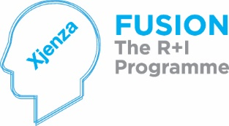
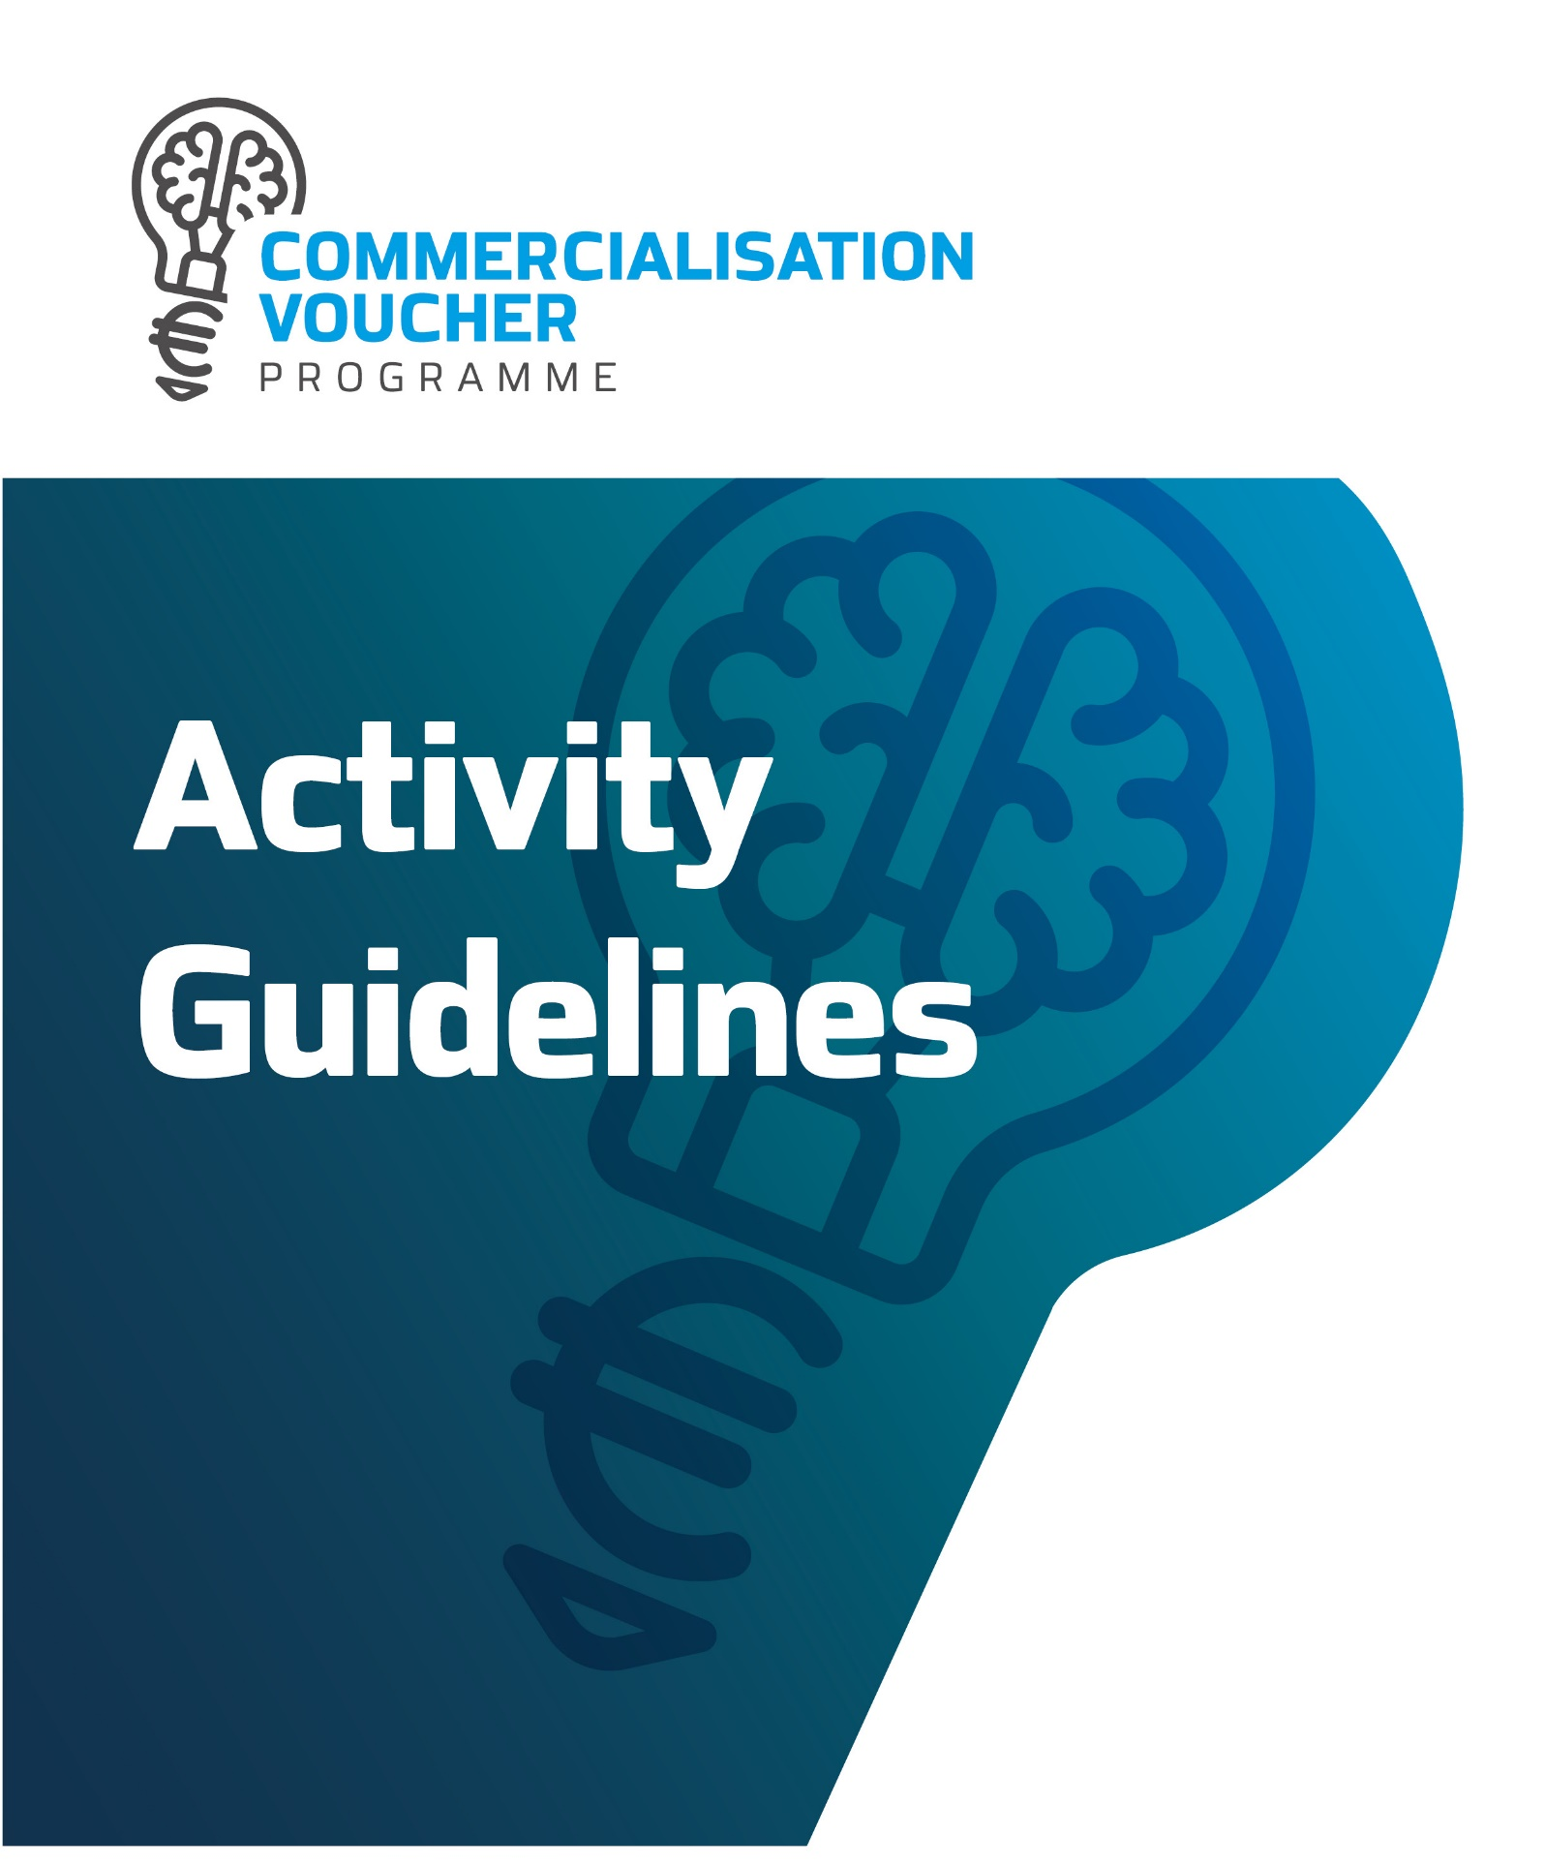

The Commercialisation Voucher Programme

The Commercialisation Voucher Programme is intended to support researchers, micros, and SMEs to seek the commercial potential of their research or to start new or accelerate innovative activities and enhance their competitiveness through collaboration with R&D institutions or others.

The Commercialisation Voucher Programme is a competitive call for proposals which will be evaluated via an evaluation procedure and is subject to rules and regulations and to availability of funds.

This Programme is primarily intended to assist prospective applicants of the Technology Development Programmes in order to prepare themselves better in terms of project proposal and validation. It could also assist beneficiaries of previous or current National R&I Programmes.

Each report should include a 1-2-page Executive Summary with the following sections:

    - Introduction to the report and key conclusions
    - Methodology and/or workings
    - Main findings
    - Future recommendations

Activity 1 - IP Check
Objective: The idea of an IP Check is to determine whether the technology has any IP potential. Through this check the Service Provider would provide a scientific and validation opinion of the technology. Such an analysis would enable an assessment of the ability to protect the idea if this would be the case.
The IP Check includes the following considerations:
- Capturing the new technology
- Establishing the IP position
Before carrying out any IP checks, it is important to capture the technology, and obtain information relating to the inventors and competitor information, for example. An Inventor Disclosure form should be filled in by the technologists as completely as possible and used to facilitate the IP check and also the process of preparing and filing a patent application once it has been decided that this would be appropriate.
The following should be covered through an IP Check:
- Understanding of the technology by reviewing the completed Information Disclosure Statement, and where appropriate, through meetings, both one to one or over internet, with the technologist/s and evaluation of the IP potential of the project proposal. Through this meeting it would be possible to get access to any information in possession of the inventor.

This would enable the selection of keywords related to the purpose, use and composition of the invention. This should be done through searching of the keywords on various sources in order to find potential class / subclasses. The U.S. and European Patent Office provide free online databases. In addition, one can make use of free online databases such as PubMed including any abstracts available. In this regard one can search using keywords or phrases that describe the invention under consideration by looking for common terms describing the invention and its function, effect, end-product, structure, and use. Given a Manual of Classification, verify the relevancy of the class/subclasses. Also, commercial databases could be used.
- Further search on existing patents and published applications: Searching through the issued Patents and any published applications databases and access their full text. Reviewing all claims, specifications and drawings of documents retrieved for relevancy, as well as all the relevant references.
- Assess the ability of protecting the idea by primarily analysing
  - what, if any, information has already been disclosed [Disclosure]
  - if this is a completely new idea [Novelty Factor]
  - if this idea is building on something which has already been developed and/or protected [Prior Art]
At the end of the exercise, a validation and scientific option will be provided, identifying clearly whether the project proposal should:
- Proceed to the next step of the Voucher Programme including technical recommendations for improvement, if any; or
- Be rejected, including the reasons thereto to be communicated with the applicant.

Activity 2 – Commercialisation and Feasibility

Section A - Market Research

The market research should identify whether there is a market for the technology itself, or from other technologies, products and services that might be derived from it. The market research should assess the potentially relevant needs, characterized by customer segments and geographical location. The research should also assess the ease of access to the potential market, focusing on the intensity of competition, regulatory and tax barriers, and customer readiness among other factors.
- A thorough understanding of the product/service/technology being proposed by:
  - Undertaking a primary market research to understand what the possible applications of the proposed idea might be and in which type of market it would fit. Through such an analysis it is important to capture the potential impact of the new idea to the market, given other new market ideas and existing products / services / technologies on the market.
  - Undertaking an assessment of the perceived differentiating factors and USPs of the product / service / technology. This would enable the establishment of the potential market/markets for the technology, and for products / services / technologies which can be derived from it, categorised in relevant segments for further analysis.

- Provision of indications of the potential sizes and growth rates of markets and market segments identified in Step (1).
- Identification of a geographical market.
- Identify the potential for access to the markets and market segments identified, considering regulatory issues, extent of competition and customer readiness.
- Capture the relevant technology trends to provide details on how different sectors are investing in technological products; Such trends should seek input from:
  - Data from several technology market research reports (depending on the sector) such as Gartner, Forrester, IDC, Hoover's database of businesses, Ovum, Zenith International as well as industry trade associations; Such sources are being provided only as an example one is free to use other technology market research reports as it deems appropriate.
  - Data from online qualified industry surveys, blogs and publications, for sources of news, trends and market information with a declared methodology, such as the US Census Bureau which publishes annual technology surveys; Such sources are being provided only as an example one is free to use other technology market research reports as it deems appropriate.
- Delineate the potential life cycle of the technology and of derivative technologies/products and services leading to the development of a demand forecast based on sound methodological approaches, including indications of pricing and revenue generation; This should indicate if there is an existing demand or whether it can be created.
- Document the competitive landscape to identify and recommend target country markets, thus establishing the geographical market.
- Undertake a risk assessment with respect to the market situation, and how this may impinge upon demand, pricing, and revenue.
- Review of the environmental forces (political, economic, societal, and technological) that could influence the success of the product. Identify and quantify barriers to entry and any relevant legislation or restrictions.
- Market Research should consider gender balance in terms of the end-user of the product or service.

Section B - Estimation of Costs and revenue generation:
The estimation of costs and revenue generation report should include the cost involved to get the technology being developed onto the market through a defined product / service. Such costing should also cover any technology transfer to be undertaken by the industry acquiring the technology. The following should be covered through the analysis:
The identification and estimation of the costs involved in the production and supply of the identified product, service, or technology.
- An assessment of the dependence of such costs on critical factors, such as the use of essential inputs, and transport to different markets, amongst other things. An identification of direct and indirect, fixed, and variable costs.
- An analysis of the extent to which unit costs depend on scale of production, including an assessment of the technological likelihood that a minimum efficient scale is achieved.
- The undertaking of a risk assessment to highlight the principal risks to which cost estimates are subject, and their potential effects.
- Where possible, identify the direct costs, which refer to the direct costs involved in the production of the product / service under consideration. Such costs may include material and process selection as well as labour costs.
- Where possible, identify the overhead costs, which refer to the indirect costs that are still related to the cost object, but cannot be directly related to the actual production of the product/service. These may include environmental impact costs and regulatory/certification costs, health and safety costs, water and electricity, general administration costs, quality control, and general maintenance. Overhead costs can be either treated as a lump-sum or else they can be allocated to the products and services.
- Establish the minimum breakeven level that would need to be achieved to fully absorb the identified fixed costs.
At the end of the exercise, a report including an analysis of market potential and detailed costings including all the costs involved to produce the product/service as a result of the proposed technology should be presented. The report should include a concluding expert opinion on whether the technology proposed is recommended for further considerations or not, thus identifying clearly whether the project proposal should:
Proceed to the next step of the Voucher Programme, including technical recommendations for improvement, if any. Be rejected, including the reasons thereto to be communicated with the applicant.

Section C: Financial, economic and welfare assessment:
The aim of this analysis is to examine the potential effect of the proposed technology on the local economy. In this regard the financial, economic and welfare analysis should measure the potential effect of the outcome of the technology in terms of changes in economic growth (output or value added) and associated changes in jobs (employment) and income (wages). Thus, this would enable the assessment of the economic potential of that technology by comparing the level of economic activity occurring at a given time with the presence of the technology, compared to what would be expected if the technology were not developed.

The Financial, economic and welfare analysis should include the following elements:
- Identify the potential different effects of financial, economic and welfare impact through:
  - Direct production effects.
  - Downstream and Upstream effects along the supply chain through supply-use effects.
  - Indirect and Induced effects through the expenditure multipliers.

- Estimate the potential financial, economic and welfare impacts of the proposed technology on output, incomes, employment, and productivity, highlighting where relevant the nature and sectoral distribution of jobs created.
- Drive an estimate of the overall contribution to the local economy and interpret the results by showing the potential contribution of the technology in terms of economic growth, jobs generated and income.
- Identify the potential welfare effects emerging from external benefits and costs, focusing especially on environmental, resource use, social and human capital creation effects.
- Provide estimates of relevant potential external benefits and costs.
- The analysis should be based on a discounted cash flow approach based on the time horizon over which economic effects from the technology can be expected to materialise.
- The economic effects should consider elements of investment and output generation.
- Scenario effects - In situations where the market value of a technology cannot be discussed in a credible way through a single scenario, the study can be based on multiple scenarios, with a discussion of their relative likelihood of realisation.

Section D: Risk Profile

The RP should determine the critical risks associated with the eventual technology development. It should also determine the critical risks associated with the eventual commercialisation and implementation of the resultant product/service. It should determine the level of risk involved if an investor had to decide to invest in the research proposal. Risk profiling is necessary to determine if an investment is suitable for an investor or otherwise, as it is a method which is applied to identify the risk involved if one had to undertake such an investment.
The risk profile should:
- Identify the drivers and pressures that are likely to constitute sources of risk to the project.
- Identify, preferably through statistical modelling and analysis, the sensitivity of the project to specific shocks to determine the critical risk variables.
- Identify the probability of risks occurring and the impact should they occur. Mitigation plans should also be briefly outlined for each risk.
- Scenario analysis should be undertaken to quantify the effects of pre-determined shocks, and to identify the extent of shocks required to completely remove the benefits of the project. The analysis should focus on single shocks and consider the effects of joint shocks.

At the end of the exercise, a detailed report including all the necessary data and information detailing the incremental effect of the proposed proposal on the local economy and risk register (with risks evaluated as high, medium, or low impact and probability) should be presented. The results should enable a technology development lead and/or an investor to evaluate the risk to which a portfolio is exposed and make buy and sell decisions based on this risk and their willingness to accept risk. In addition, this report should include an expert’s opinion on whether the technology proposed is recommended for further considerations or not, thus identifying clearly whether the project proposal should:
  - Proceed to the next step of the Voucher Programme, including technical recommendations for improvement, if any.
  - Be rejected, including the reasons thereto to be communicated with the applicant.

Activity 3 – Intellectual Property Registration

Objective: Through the Intellectual Property Registration an inventor/technologist will have the opportunity to pursue intellectual property protection for the invention described and claimed in that application. The ultimate scope is to initialise and facilitate the process of registering an intellectual property.

Those who want to register an Intellectual Property right should know that there are several levels of protection that be obtained. The first level is the national one, meaning that any citizen or resident of Malta, but also companies incorporated in Malta or abroad can register an intellectual property with the Malta Industrial Property Registration – Commerce Department.

It is also possible to register an IP right at a European Union level, as Malta is a Member State of the EU. IP registration at EU level will imply the filing of an application form with the European Union Intellectual Property Office (EUIPO). The advantage of EU registration is that a trademark or other IP right will benefit from enhanced protection and recognition on the territories of all Member States.

An intellectual property right obtained in Malta can also be registered at an international level with the World Intellectual Property Organization (WIPO). The main requirement for obtaining world recognition of a Maltese trademark or other IP right is to first have it registered in Malta.

Trademark protection

A trademark is any graphic sign intended to distinguish products or services from others. Any letter, word or combination of words, numbers, colours, or shapes can be considered a trademark. The author of a trademark has exclusive rights in using it. Usually, Maltese companies use trademarks for marketing purposes.

Copyright protection

In Malta, any literary work and audio-visual work is considered intellectual property and falls under the legislation of the Copyright Act. In Malta, artistic work receives copyright protection even if it was not previously registered, sufficing to be made public. Copyright offers its authors moral and economical rights. Copyrights are available for 70 years after the death of its author.

Patent protection

An invention will be considered a patent in Malta if it brings novelty and if it can find applicability in the industrial sector. In Malta, biological inventions can be patented if certain moral requirements are met. Patents have a 20-year period of validity from the application date and a maintenance fee will be collected starting the third year. The owner of a Maltese patent will use it exclusively and, only with his or her authorization, the patent will be used by third parties..

The intention of the Commercialisation Voucher Programme is to cover the expenses involved for the initial patent application together with the drafting and patent attorney fees as well as the overall management of the process. Then, depending on the ultimate outcomes of the application and the level of requested funding, the Voucher could potentially cover also the expenses involved for the eventual grant of the patent and the entering the national stage at a second phase.

The European Patent Office puts forward the following process:

- Initiating the process
- Patent attorney needs to provide documentation consisting of:
- A request for a patent.
- Details of the applicant/inventor.
- A description of the invention.
- Claims.
- Drawings (if any).
- An abstract.

- Filing and Formalities Examination
Following the filing of the application, assuming the required documents have been filed, the application is given a filing date, also known as the priority date. In this regard, after an application is filed there will a formalities examination to ensure that the documentation is correct and complete.
At any time up to the anniversary of the filing date, it is possible for the applicant to file the patent application protection in other countries, and/or to file an international (PCT) application, and have those later filings treated as if they had been filed on the priority date.

- Search
A search report is drawn up by the EPO listing, including copies of all prior art documents found by an experienced examiner and regarded as relevant to the invention. The search is based mainly on the claims for novelty, but the description provided, and any drawings will also be considered. The report will often include an initial opinion on the patentability of the invention. The search can be done either on European or on international level.

- Publication of Application and Search Report
The application is published 18 months after the filing date. The invention will appear in databases accessible to anyone around the globe. It will act as prior art against any future patent applications from other inventors or companies for similar inventions.
The publication of the search report provides an additional six months for an inventor to make two decisions:
  - Whether to continue with the application? You indicate ‘yes' by requesting a more thorough (‘substantive') examination.
  - Which countries to designate in the patent protection? In this respect Designation fees must be paid.
After a patent is granted, an applicant may, under certain circumstances, claim damages for infringements originating as far back as the publication date of the application. However, to enjoy such a right in some countries it may be necessary to file a translation of the claims with their national IP office and have the claims published in the translated language.

- Substantive examination
If a request for substantive examination is made, then the EPO must decide whether the invention and the application meet the requirements of the European Patent Convention particularly with regard to novelty and inventive step. This stage will often involve dialogue between the examiners and the inventor’s patent attorney, which may result in the re-drafting of key parts of the application. The patent attorney will defend the application. Although the application may be amended in response to objections raised by an examiner, no new information may be added into the application.

- Translation of Claims into the other two official languages
If the examiners decide to grant a patent, the EPO will issue an intention to grant communication (the R71(3) communication). This communication will set a 4-month deadline for completing the European grant phase of the application by paying a grant fee and filing translations of the claims in French and German (if English has been the language used).

- Decision to grant a patent
Once the grant phase is complete, the decision to grant and all fees have been paid and any claims translations filed, the decision is reported in the European Patent Bulletin. The decision to grant takes effect on the date of publication of the decision.

- Validation
After the EPO decision to grant is published, the patent must be validated in each designated state, in which patent protection is required, within a specific time limit. If this is not done, the patent may not be enforceable in that state. In some states, validation may include having to file (and pay for) a translation of the whole patent, or just a translation of the granted claims.

In terms of the Commercialisation Voucher Programme, the expenses covered will be the official fees to be paid in terms of the first 5 steps above together with the drafting and patent attorney fees and the overall management of the process.

At the end of the exercise, a detailed report should be presented with the outcome of the initial patent application. If the EPO provides positive feedback re the patentability of the invention, a copy of all official documentation should be enclosed. In the case of the contrary a sound justification should be provided.

Intellectual Property Registration Stages and Timeframes:

Stage 1: Updated IP Check Report – This stage will consist of a maximum of 5 weeks following the acceptance meeting held at MCST between the beneficiary and the MCST approved service provider. At the end of this stage, an updated IP search report must be presented to the Council. The updated IP Check report must contain an executive summary at the start of the report highlighting whether they can proceed to drafting a patent application or not. Upon successful completion of Stage 1, the project should directly proceed to Stage 2. In case of failure, the project can go through Stage 1 again utilising the remainder of the existing funds. Reimbursement to the beneficiary will only be granted when an official payment receipt is presented.

Stage 2: Drafting of Patent – This stage will entail a maximum of 15 weeks for the drafting of the patent. MCST reserves the right to approve / neglect any further timeframe extension based on justifiable reason. Reimbursement to the beneficiary will only be granted when an official payment receipt is presented.
Stage 3: Filing in country jurisdictions. Reimbursement to the beneficiary will only be granted when an official payment receipt is presented. As per Technology Development rules and participation Mandatory Deliverable Section 9.3.1, the TDP consortium should, “within 12 months from the end of the Project register at least one (1) patent on the work carried out throughout the Project in Malta and with at least one other national jurisdiction which issues an international search report as approved by the Council.”

Budget: maximum of €15,000
This Budget is all inclusive and covers all official fees to arrive at the Substantive Examination stages of the initial patent application, any drafting and patent attorney expenses as well as management fees and must be utilised within the 12-month period indicated above.

Expected Consultants’ Criteria
- Relevant qualifications of named consultants and/or associates should include a post graduate academic qualification with specialisation in IP. If the consultants working on the project are not Patent Attorney themselves, then they need to be affiliated with a qualified European Patent Attorney.
- When necessary, the team working on the project should include members which have the relevant academic background and experience in the relevant scientific discipline.
- Minimum 3 years’ post qualification experience in IP protection, including the preparation and filing of patent applications; prosecution of the applications worldwide and access to a network of patent experts around the world, searches and registration as well as access to licensing specialists.
- Identification of the Patent Attorney and any associates and/or subcontractors working on the project and the associated experience and qualifications.

The main consultants, associates or subcontractor working on this activity should be identified and a profile should be provided. These can be then adapted according to the project in question and communicated to the Council prior to the actual undertaking of the activity.

Activity 4 - Business Plan

Objective: The aim of a business plan is to establish clearly which goals and objectives must be achieved for the business to succeed. It will enable entrepreneurs to strategically plan for unforeseen events as well as new competitors that enter the marketplace. The idea is to create a set of planning objectives that effectively outline how the business will be run, potential risk factors and effective marketing strategies.

Considering the studies previously undertaken, a comprehensive business plan should include the following:

- Executive Summary

- The Team
This section should provide an overview of the Research Team which have developed the idea as well as their business concepts and the type of investor which is necessary.

- The Business Concept
This section should describe the opportunity, the business which needs to be created focusing primarily on the product and the market it will serve as well as its structure. It should identify what will be sold, to whom, where and why the business will hold a competitive advantage. A description of the products as well as the industry should be provided including the present outlook as well as future possibilities. In addition, it should hold information on all the relevant markets within the industry, including any new products or developments that will benefit or adversely affect your business should be also included.

- Marketing Strategies
This section should provide an understanding of the industry including its size, marketing trends and growth rates, as well as the target group of customers which most likely purchase the product or service. The Market Research Study which has been undertaken should be used as a primary input, although a quick update would need to be made. The business plan should include an assessment of the most relevant marketing activities for each specific project and outline a marketing plan to introduce the product or service; costs and timing of which should be reflected in the financial plan. This would be explored in more detail during the investors’ meeting activities.

- The Competitors
This section should identify the potential competition which the product will face and the business strategy which will be adopted to face such competition, if any. Through a Competitive Analysis one should determine the strengths and weaknesses of the competitors within the relevant market, strategies that will provide a distinct advantage, the barriers that can be developed in order to prevent competition from entering the market, and any weaknesses that can be exploited within the product development cycle.
In this regard the barriers would refer to the product’s competitive advantage and strengths which will discourage the introduction of competing products, while weaknesses are the weaknesses in the competitors’ products which can be used as an advantage for the product resulting from the technology.

- The Estimation of costs and revenue generation plan
The purpose of the plan section is to provide investors with a description of the product's design, chart its development within the context of production, marketing, and the company itself, and create a development budget that will enable the company to reach its goals. The Estimation of costs and revenue generation study should be used as an input for this section.

- Operations & Management Plan
The operations and management plan is designed to describe just how the business functions on a continuing basis. The operations plan will highlight the logistics of the organization such as the various responsibilities of the management team, the tasks assigned to each division within the company, and capital and expense requirements related to the operations of the business.

- The Financial Profile
This section should include the following:
- The Financial Requirements
Clearly stating the capital needed to start the business and to expand. It should detail how the capital will be used, and the equity, if any, that will be provided for funding. If the source of funds for initial capital will be based on loans instead of equity, one should also specify the source of collateral.
- The Level of Sales and Profits
- Cash Flows
- Return on investment.

- Major achievements
This section should detail any developments which have happened, or are required, in order to for the business to be a success. Major achievements include items like patents, prototypes, location of a facility, any crucial contracts that need to be in place for product development, or results from any test marketing that has been conducted.

NB: It is of utmost importance that the invention is not disclosed since at this point in time it is not yet protected. In case that it would be difficult to carry out the above exercises without disclosing details of the invention which may result in the invention being stolen, the Service Providers needs to inform the Council to decide the best way forward. The Service Provider is herewith being held responsible for safeguarding of the interest of the inventor.

Budget: €5,000 – This Budget must be utilised within twelve (12) months from the end of the Technology Development Project.

Timeframes: 10 weeks

Expected Consultants’ Criteria
  - Relevant qualifications of named consultants and associates should include a multi- disciplinary team comprising of a Bachelor of Commerce, business administration or similar; preferably coupled with industry knowledge and commercialisation experience
  - The lead consultant should hold substantive local and overseas markets and putting together reports as detailed above.
  - Full time consultant outfits are preferred to ensure the necessary availability to collaborate with the technologists and timeliness of report delivery.

The main consultants, associates or subcontractor working on this activity should be identified and a profile should be provided. These can be then adapted according to the project in question and communicated to the Council prior to the actual undertaking of the activity.

Activity 5 - Investors’ Meetings

Objective: The aim of this activity is to help the Technology Development (TDP) Beneficiary in finding the right opportunities through which the technology/product can be showcased, as well as preparing the beneficiary with the right tools when meeting potential investors.
The Service Provider, together with the beneficiary should identify potential investors and the most appropriate means through which to target such investment. The latter can include but is not limited to; participating in an event where the technology/product can be showcased, building a communication platform, finding, and securing different investment such as angel investors, venture capitalists as well as fundraising advisers. The organisation and coordination of meetings with interested investors, locally and/or abroad, are highly encouraged. Through this activity, the service provider will help the beneficiary in tailoring the right business presentation to achieve maximum investor engagement. Examples include evidence of product competitive advantage, financial aspects and exit options. These should be strong enough to potentially attract the interest of an investor.

NB: If the invention is not yet protected through IP, it is of utmost importance that the invention is safeguarded and not disclosed.
Investors’ Meeting Stage Activity and Timeframe:
Prior to the acceptance meeting, the beneficiary shall be required to send a breakdown of the services requested to be funded through the optional voucher. It shall then be at the Council’s discretion to decide which products and/or services will be eligible for funding. All the services must be carried out by the service provider. If sub-contracting is required, this must also take place through the service provider. An acceptance meeting shall thereafter be held at the MCST between the beneficiary and the MCST-approved service provider. After the acceptance meeting, both parties are allowed a 7-day period within which they agree to collaborate or otherwise.
The duration of this stage shall be a maximum of 12 weeks and will commence to run from the date when both parties mutually agree to collaborate. On the 12-week period deadline, a report must be presented to MCST. Reimbursement to the beneficiary will only be granted on presentation of both the said report and an official receipt proving that payment has been affected.

Expected Service Providers’ Criteria:

- The lead consultant must possess a minimum of 3 years’ experience in organising such activities both local and overseas markets.
- The Council requires a proof of previous related activities and experience in this specific activity and the success therein.
The main consultants, associates or subcontractor working on this activity should be identified and a profile should be provided. These can then be adapted according to the project in question and communicated to the Council prior to the actual undertaking of the activity.

Budget: €4,000
This Budget must be utilised within twelve (12) months from the end of the TDP.

