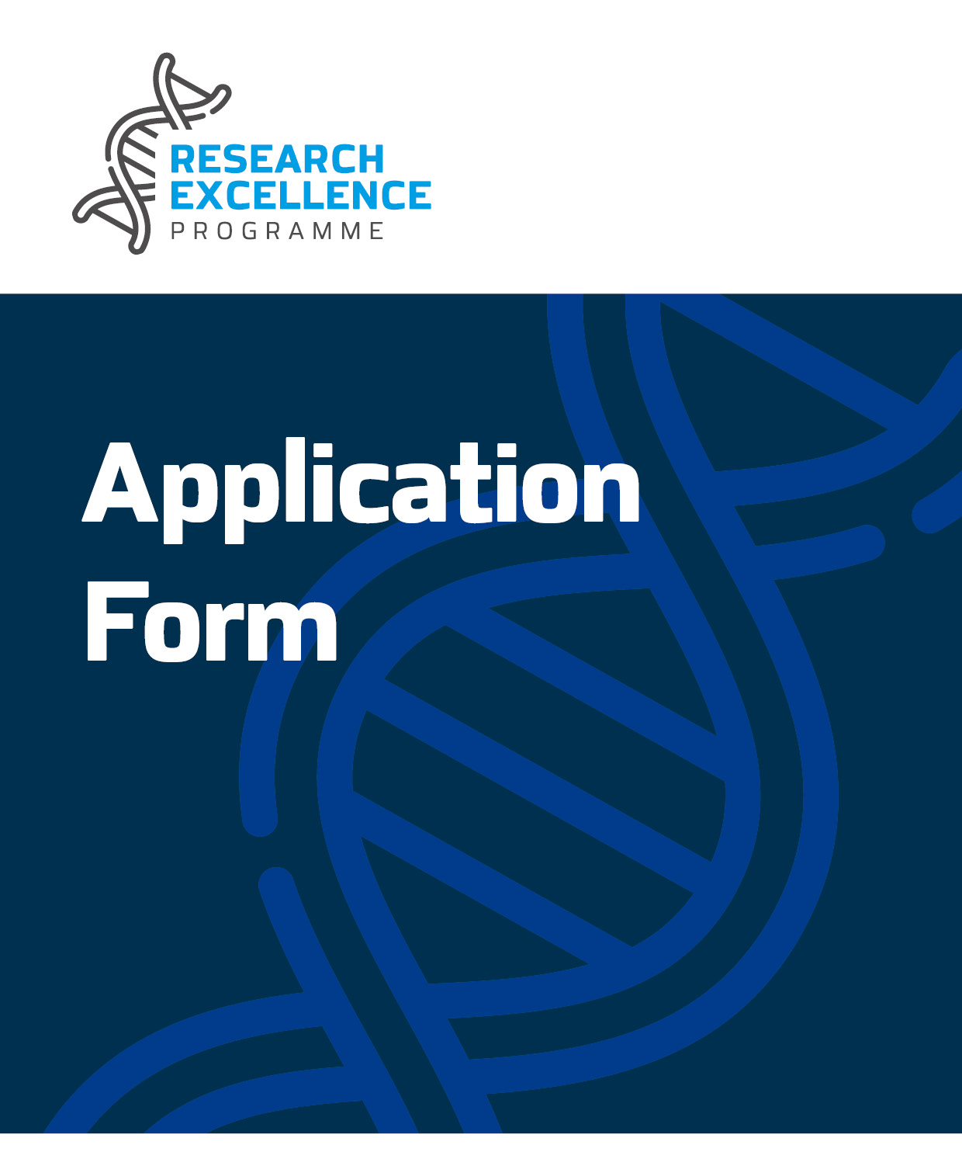
Malta Council for Science & Technology,
Villa Bighi,
Kalkara, KKR 1320, Malta

Tel: +356 2360 2200
Email: rep.mcst@gov.mt

For Official Use Only
Application No:
SECTION ONE: APPLICANT’S DETAILS

Details of Entity
Name of Entity |  | Department/ Institute/Centre  Name  (where applicable)
Type of Entity | Make sure that the entity is either a public entity, a public research and knowledge dissemination organisation or one of the eligible undertakings (as defined in Option A) | N.A.C.E Code (where applicable)
Contact Details: | Name and Surname | Title
 | ID Card No./ Passport No.
E-mail |  | Tel. No.
 |  | Mobile No.
Address:
(Please provide full postal address and website)
No. of employees  (FTE)  (where applicable) |  | Turnover of business in last financial year  (where applicable)

Provide a profile of the entity, including the principal activities and resources, relevant to the project | Make sure that throughout the entity’s profile, the relevance to the project is clearly highlighted i.e., what resources are readily available which will facilitate the execution of the project, what activities which are currently being carried out would be of benefit to the proposed project etc …
Proposed Funding Route  Please note that this section is compulsory | Please tick whether your application falls under State Aid de minimis Regulation or State Aid Not Applicable.  Applicants may only opt for one option. Selecting more than one option, or the wrong option, will make the application administratively non-compliant.  State Aid de minimis – Please fill in de minimis Appendix 1  State Aid Not Applicable – Please fill in Appendix 2 (Public Research and Knowledge Dissemination Organisation that does not carry out an economic activity) or Appendix 3 (Public Entity that does not carry out an economic activity).  Make sure that the proposed funding route is in accordance with the Rules for Participation. In case of queries regarding state aid, kindly contact the Council for clarifications.  In the following space, please provide a justification if you selected the “State Aid Not Applicable” Option

SECTION TWO: PROPOSAL DETAILS
Proposal Title and Acronym
Hypothesis Question
Abstract  Kindly provide a non-confidential summary of the project including a brief background, the problem to be resolved or the opportunity to be exploited and the approach to be undertaken. | Within the abstract, make sure to clearly highlight the scientific aspect of the project, provide a brief general background of the project, and the problem to be resolved or otherwise the opportunity to be exploited. The approach to be undertaken should have a clear scientific basis.
Area of Study – Refer to Appendix 4 (Scientific Areas as specific areas of Research)  Kindly include one specific scientific area of research, and the most applicable subarea/s (which do not necessarily pertain to the specific area selected, and should not exceed three different subareas) E.g. Health – Medical Devices, by referring to the attached Appendix 4. | To include one specific scientific area of research, and the most applicable subarea/s (which do not necessarily pertain to the specific area selected and should not exceed three different subareas) by referring to the attached Appendix 4.
Keywords | To include between three and five keywords to describe this proposal
Potential Technology Readiness Level Advancement  (where applicable)  Kindly include an indication (where applicable) of the start and end TRLs. | - With regards to the context of this programme, it is important that the project falls between TRLs 1 and 4, and do not exceed the latter (Technology Readiness Levels are a type of measurement system used to assess the maturity level of a particular technology. Kindly refer to Appendix 1 within the Rules for Participation for further information on TRLs)
Other Issues:

If applicable, briefly identify any gender considerations, ethical or legal issues that may be connected with the proposed project. Otherwise enter “N/A”.

- SCIENTIFIC EXCELLENCE

- What is the current relevant research in the field and how will your research go beyond it? Make reference to and distinguish your proposal from previous work / projects within the area. Highlight the scientific basis and research methodology to be conducted. (1 page limit)

Make sure that an extensive literature review is carried out with proper referencing in order to highlight how this proposal can be distinguished from other research within the field.

The research to be conducted should have clear scientific basis and a clear scientific approach has to be used.

- What are the specific aims and objectives of the project? (1 page limit)

Make sure that the aims and objectives of the project are clear, achievable, and not over ambitious within the timeframe proposed.

A clear distinction between the aims and the objectives has to be made.

Moreover, in terms of scientific principles, the proposal must be practical i.e., the proposed aims and objectives should be scientifically and technologically possible, especially when considering the size of the grant.

With regards to the context of the programme, in case where commercial applicability can be envisaged, it is important that the project falls between TRLs 1 and 4, and if this is not the case, the research proposed should be basic research and early-stage.

- Will the project make use of innovative research, applications, theories, etc. as part of its method? (1 page limit)

Make sure that enough detail is present to substantiate the innovative aspects behind the project (i.e., whether the project is novel as a whole, whether some components of the project are novel or otherwise if novel methods are going to be implemented)

- Describe how the project has the potential to develop the organisation’s research base. Will the project upskill current or existing researchers? (1 page limit)

Make sure that if new personnel are going to be recruited throughout the project, clearly highlight how they are going to be trained and whether new experience will be gained on any novel research methods.

In case that there will be existing personnel, clearly highlight how this existing cohort of researchers is going to gain new skills and experiences throughout the project.

Gentle reminder to attach the CVs of the existing personnel and in case of recruitment, highlight the skills which are going to be considered as an asset. It is important that the CVs are relevant to the skills to be used in the proposed project.

- IMPACT

- Describe the potential impact of the proposed research. Will the research result in a disciplinary or interdisciplinary advancement? (1 page limit)

Make sure to clearly highlight the scientific fields which are being addressed within the project and illustrate the significant importance associated. Moreover, clearly emphasise on how the proposed research will push the boundaries on these proposed fields.

In this section, it is also important to elaborate on any expected tangible results in any of the fields.

It is also crucial to clearly highlight how the research being proposed integrates information, techniques, tools, perspectives as well as concepts from different disciplines in order to advance fundamental understanding or otherwise solve issues whose solutions are beyond the scope of one single discipline.

- Does the project address National, European Union or Global Priorities? What influences and impacts can the research have on possible end-users, other researchers, or society at large? (1 page limit)

Make sure to include specific laws, legislations, priorities or policies throughout the proposal.

Also, clearly identify the impact in terms of the end users and the society i.e., with respect to the scientific community, the industry etc …

1.

- What is the mechanism for assessing success and evaluating outcomes? In the case of positive outcomes, please describe the strategy for further research. (1 page limit, excluding Gantt Chart when included)

Kindly note that a Gantt Chart can be included in order to visually represent the proposed way forward after the lifetime of the project.

Make sure to clearly identify a mechanism following the lifetime of the project in case the results obtained are promising i.e., what would be the next step for the research?

- Outline potential impacts generated from any dissemination measures and describe in detail the possibility of journal publications. (1 page limit)

Make sure to describe a clear dissemination plan while considering diverse methods to have successful reach and engagement.

For applicants applying under Option B (Non-state aid route) the dissemination plans are crucial in justifying your eligibility for that route. It is important that the plan is detailed, and the results are widely disseminated. This is not necessarily the case for Option A (State Aid De Minimis) where they are at liberty not to focus on the research results themselves, but general awareness.

In case that Intellectual Property is in view, it is important to consider methods of dissemination that would not put at risk the ability to protect it.

3. IMPLEMENTATION
  - Deliverables
The proposed deliverables should be coherent with the proposed work plan. Moreover, these should be specific and focused sufficiently to deliver the technical and scientific excellence.

List the deliverables of the proposed project, specifying the month of completion relative to start of project e.g. Month 6, Month 12 etc. Note that the deadline for any deliverable would be the end of the respective Month specified.
The deliverables should be:
- Tangible outcomes of the project and they must be submissible.
- Specific to the project, for example tangible events and/or reports related to installation, testing, implemented procedures and so on
- Throughout the lifetime of the project
Kindly note that the ‘mandatory deliverables’ required by the Council as per the Rules for Participation are:
- Midway Project Meeting with the Council
- Reports to be submitted to the Council:
  - End of Project Audited Financial Report
  - End of Project Technical Report
- At least one article in public media (e.g., local newspapers or magazines) to raise public awareness, including an acknowledgement to the Council
Deliverables | Date
Dbrian warrington. Meeting with the MCST, which includes delivering a Presentation | Month 6
Dbrian warrington. Article in local, public media (replicate as necessary) | Month brian warrington
Dbrian warrington. End of Project Technical Report | Month 12
Dbrian warrington. End of Project Audited Financial Report | Month 14*
Dbrian warrington. brian warrington | Month brian warrington
Dbrian warrington. brian warrington | Month brian warrington
Add as required | Add as required

* Kindly note that this is the only deliverable allowed to exceed the project lifetime as per Rules for Participation.
  - High Level Project Plan
The workplan proposed should meet the aims and objectives which have been set out for the project and these should be feasible within the one-year timeline.
Moreover, it must be ensured that risk are properly identified in each work packages and feasible mitigation strategies are proposed.
This section should include a list of deliverables and activities (tasks) that the applicant is responsible for, the start date, end date, and duration of the task.

There is one mandatory work package: Project Management, and will be Work Package 1. For the following Work Packages, add as required.
  - Work Packages

Work Package Description | Start Date | End Date | Duration
Overall Project | Month brian warrington | Month brian warrington | Month brian warrington
Work Package Number: 1  Work Package Leader: <Enter Name of Individual>  Work Package Title: Project Management  Work Package Description:  (max 100 words)  brian warrington  Deliverables pertaining to this Work Package:  (insert the number of the deliverable, ex. D1, and the description i.e.:  D1 Progress meetings with the Council  D2 Progress monitoring and coordination with partner  D3 Recruitment  D4 Reporting)  brian warrington  Activities pertaining to this Work Package:  (provide a brief explanation on each activity – max. 50 words per activity)  brian warrington  Risks and mitigation strategies pertaining to this Work Package:  (provide a brief description on each activity – max. 200 words per work package)  brian warrington | Month 1 | Month brian warrington | Months  brian warrington
Work Package Number: brian warrington  Work Package Leader: <Enter Name of Individual>  Work Package Title: brian warrington  Work Package Description: brian warrington  Deliverables pertaining to this Work Package:  brian warrington  Activities pertaining to this Work Package:  brian warrington  Risks and mitigation strategies pertaining to this Work Package:  brian warrington | Month brian warrington | Month brian warrington | Month brian warrington
  - Gantt Chart
The project Gantt chart should be inserted here. It should include a list of the work packages, deliverables and related activities on the left and a suitable time scale along the top. Each deliverable and/ or activity should be represented by a bar. The position and length of the bars should reflect start dates, duration and end dates. The dates when all reports should be submitted should also be noted.

brian warrington

  - Detailed information on experts who will work on the project

The CVs attached should reflect the activities which are going to be performed throughout the proposal. In the case of recruitment of new personnel, the required skills should be clearly highlighted.

This section should provide an overview of the applicant, and the concerned research team, and thus establish their ability to carry out the project (e.g. track record, skills and competencies, etc.). Applicants should use this space to promote their expertise to external evaluators. Kindly submit the CV of the Individuals working on the project as an Appendix.

Relevant information on the individual should be submitted in order to show:
- If any of the individuals worked on a previous R&I Project that was successfully completed.
- If any of the individuals published any scientific papers or supervised graduates or post graduates as an outcome of an R&I Project in a related field.

Should there be any changes to the key researchers highlighted herein, the Council must be notified in writing with immediate effect. If a key researcher has not been employed prior to the submission of this application form, a profile of the expertise required should be noted herein.

Applicant | Organisation  brian warrington
Brief Profile of the Applicant, including concerned research team
brian warrington
CVs of the Individuals working on the Project are to be submitted as an Appendix
CVs of key researchers are provided as Appendix brian warrington

  - Collaborations

In case of collaborations, the co-collaborators suggested should be complimentary to the nature of the project and add value. A letter of intent is crucial, specifying the activities which will be carried out to support the project.

If collaborations are not identified, the applicant should clearly possess the necessary skills to carry out all the mentioned activities.

If support is to be given from other entities, please provide the information in the table below. A specific letter of intent must also be submitted as evidence of support. Please replicate the table if more than one collaboration will be present throughout the project.

Collaborator | Organisation  brian warrington
Profile of Organisation
brian warrington

Brief Outline of Expected Contribution to Project
brian warrington

If support is not to be given from other entities, please fill in the table above with N/A and kindly submit a justification below (e.g. highlighting that the necessary skills and competencies required for the project are already present within the organisation etc.).

If no Collaborators are required | Provide justification in case of no Collaborators are required.  brian warrington

  - Budget Section
It is important that the project matches the requested funding. Moreover, an appropriate amount of time should be dedicated to execute the project by the personnel. Refer to the Rules for Participation for more information regarding capping of individual line items, and also to the Budget Example.
- Budget Summary
 | Eligible Direct Costs € | Eligible Indirect Costs € | Total Eligible Costs € | Requested Funding €
Lead Partner  brian warrington | brian warrington | brian warrington | brian warrington | brian warrington
- Budget Detail by Organisation
Give an estimate of the project budget in Euros (€). A document is uploaded on the website together with the application form in order to be used as an example for this section. Kindly make sure that detailed information and specifications are provided for individual line items.
- Eligible Direct Costs:
  - Personnel
Give details of position, hourly rate, duration in number of hours, in the format of: Research Assistant x €18.76/hour x 100 hours.
Kindly note that total hours per annum cannot exceed 1,760 hours. Hourly rates should include National Insurance and Inland Revenue and allowances. Please specify if existing or new, and if Management, Researcher or Assistant. In case of existing personnel, kindly specify the name and surname of the personnel concerned and submit their CV as an appendix.
  - Travel capped at €2,000 (including Indirect Costs)
  - Consumables
  - Equipment
  - Subcontracted Activities
  - Scientific Information
  - Other
- Eligible Indirect Costs are calculated at 10% of the direct costs.
- Audit fees must form part of the indirect costs and therefore should not be input as a separate budget line item.
- Total Eligible Cost is the sum of Eligible Direct and Indirect Costs.
- Requested Funding is calculated as a percentage of the Total Eligible Costs.
  - Maltese Public Entity or Maltese Public Research and Knowledge Dissemination Organisations, that do not carry out an economic activity, applying under the non-state aid route, at 100%
  - Maltese undertakings that carry out an economic activity applying under the De minimis, route at 90%

- All figures should be provided to the nearest Euro.

Applicant  brian warrington | Eligible Direct Costs € | Eligible Indirect Costs € | Total Eligible  Costs € | Requested Funding €
Personnel
(give details of position, duration, rate)
e.g. Researcher x 100 hours x €18.76/hr
brian warrington | brian warrington | brian warrington | brian warrington | brian warrington
Equipment (Purchase/Lease)  brian warrington | brian warrington | brian warrington | brian warrington | brian warrington
Subcontracting  brian warrington | brian warrington | brian warrington | brian warrington | brian warrington
Travel  brian warrington | brian warrington | brian warrington | brian warrington | brian warrington
Scientific Information  brian warrington | brian warrington | brian warrington | brian warrington | brian warrington
Consumables  brian warrington | brian warrington | brian warrington | brian warrington | brian warrington
Other  brian warrington | brian warrington | brian warrington | brian warrington | brian warrington
Total | brian warrington | brian warrington | brian warrington | brian warrington

- Summary of Disbursements

Disbursements | Requested Funding (€)
Pre-Financing (75% of Total Requested Funding) | brian warrington
Retention (25% of Total Requested Funding) | brian warrington
Total | brian warrington

SECTION THREE: DECLARATIONS

- PERSONAL DATA PROTECTION

The contact email address of the Data Protection Officer: dpo.mcst@gov.mt

The legal basis and purpose of processing:

The personal data collected by the Malta Council for Science and Technology (hereinafter ‘the Council’) via this written application for the aid and its subsequent processing by the Council to evaluate the data subject’s request for aid under the scheme is in line with:

- The relevant FUSION R&I: Research Excellence Programme Rules for Participation
- The European Commission’s regulations applicable to state aid
- The Data Protection Act (Chapter 586 of the Laws of Malta), including any subsidiary legislation made thereunder.
- Regulation (EU) 2016/679 of the European Parliament and of the Council of 27 April 2016 on the protection of natural persons with regard to the processing of personal data and on the free movement of such data, and repealing Directive 95/46/EC (the General Data Protection Regulation – “GDPR”).
- The legitimate basis to process personal data submitted by the data subject by virtue of his/ her written application for aid is Regulation 6 (1)(b) of the General Data Protection Regulation (“GDPR”) as ‘processing is necessary in order to take steps at the request of the data subject prior to entering into a contract’.

Regarding the Data retention period, the data collected by the Council as submitted by the data subject via this written application for aid will be retained for a period of ten (10) years from the last aid granted to the Entity represented by the data subject in relation to this written application for aid, in line with the programme rules for participation, the GDPR and the applicable European Commission regulations pertaining to state aid.

Data Subject Rights are as follows:
- A data subject has the right to access his personal data, rectify inaccurate personal data, request to erase personal data and to request the Council to restrict the processing of personal data.
- To exercise the aforementioned rights, a data subject is to submit a written request to the Data Protection Officer via the contact e-mail address.
- Any erasing and/ or rectification of personal data and/or restriction of processing as referred to above may:

- Render one or more cost items or the Entity ineligible for assistance under the Programme

- Render void the Grant Agreement issued in favour of the Entity for assistance under the Programme in relation to this written application for aid

- Lead the Council to enforce a recovery of funds disbursed to the Entity as part of this written application

Sharing of data where strictly necessary and required by law:
- For the purpose of processing this written application for aid in line with the regulations for the call and state aid regulations, the Council may share the data provided via this application with other Government Entities, subject to the requirement that such processing satisfies at least one of the grounds listed under the General Data Protection Regulation. The use of the Scarlet database owned by JobsPlus shall also be used to aid in the interpretation of the ‘de minimis declaration’ forms.
- For the purpose of monitoring compliance with state aid regulations where legally required, any personal data provided hereunder or on submission of the Project proposal may be shared with the European Commission.
- If any member of staff, officer, representatives, or appointee of the Beneficiary/ies feel that his data protection rights have been infringed, he has the right to lodge a complaint with the Information and Data Protection Commissioner.

- ADDITIONAL DECLARATIONS

DECLARATION BY APPLICANTS
A legal representative of the Research Institution or the Company should complete this Declaration.
I confirm that:  The information given in this form is accurate to the best of my knowledge. I understand that if it is later established that the information is misrepresented, the application or funded project may be ineligible or terminated respectively and I will be required to pay for the services received up to that date. | I agree
I have read, fully understood and accept the terms and conditions stipulated within the Rules for Participation in FUSION: R&I Research Excellence Programme and confirm that I agree with eventual publication of personal data and project proposal content information of successful applicants, including the name of the entity, project contacts, title of proposal and abstract. | I agree
I accept and confirm that my personal data and proposal content information can be used by the Malta Council for Science and Technology for the purposes of  administering this application. | I agree
I have never been found guilty by any competent Court in Malta or elsewhere of any crime and that I have never been adjudged bankrupt or insolvent by, or filed an application for insolvency before, any competent Court in Malta or elsewhere. | I agree
I have never been disqualified or excluded from participation in any Public Tender either by the Government of Malta or by the European Union or by any public entity in Malta. | I agree
I have never been disqualified or excluded from participation in any Public and/ or European Union funding scheme. | I agree
Name of Legal Representative:

Position in Entity:

Contact Details:

Signature of Legal Representative + Entity Stamp: | Date:

This Declaration does not extend to any traffic related offences where these have been made.
This Declaration does not extend to disqualification of any tender proposal due to technical reasons.
This Declaration does not extend to disqualification of any tender proposal due to technical reasons.

