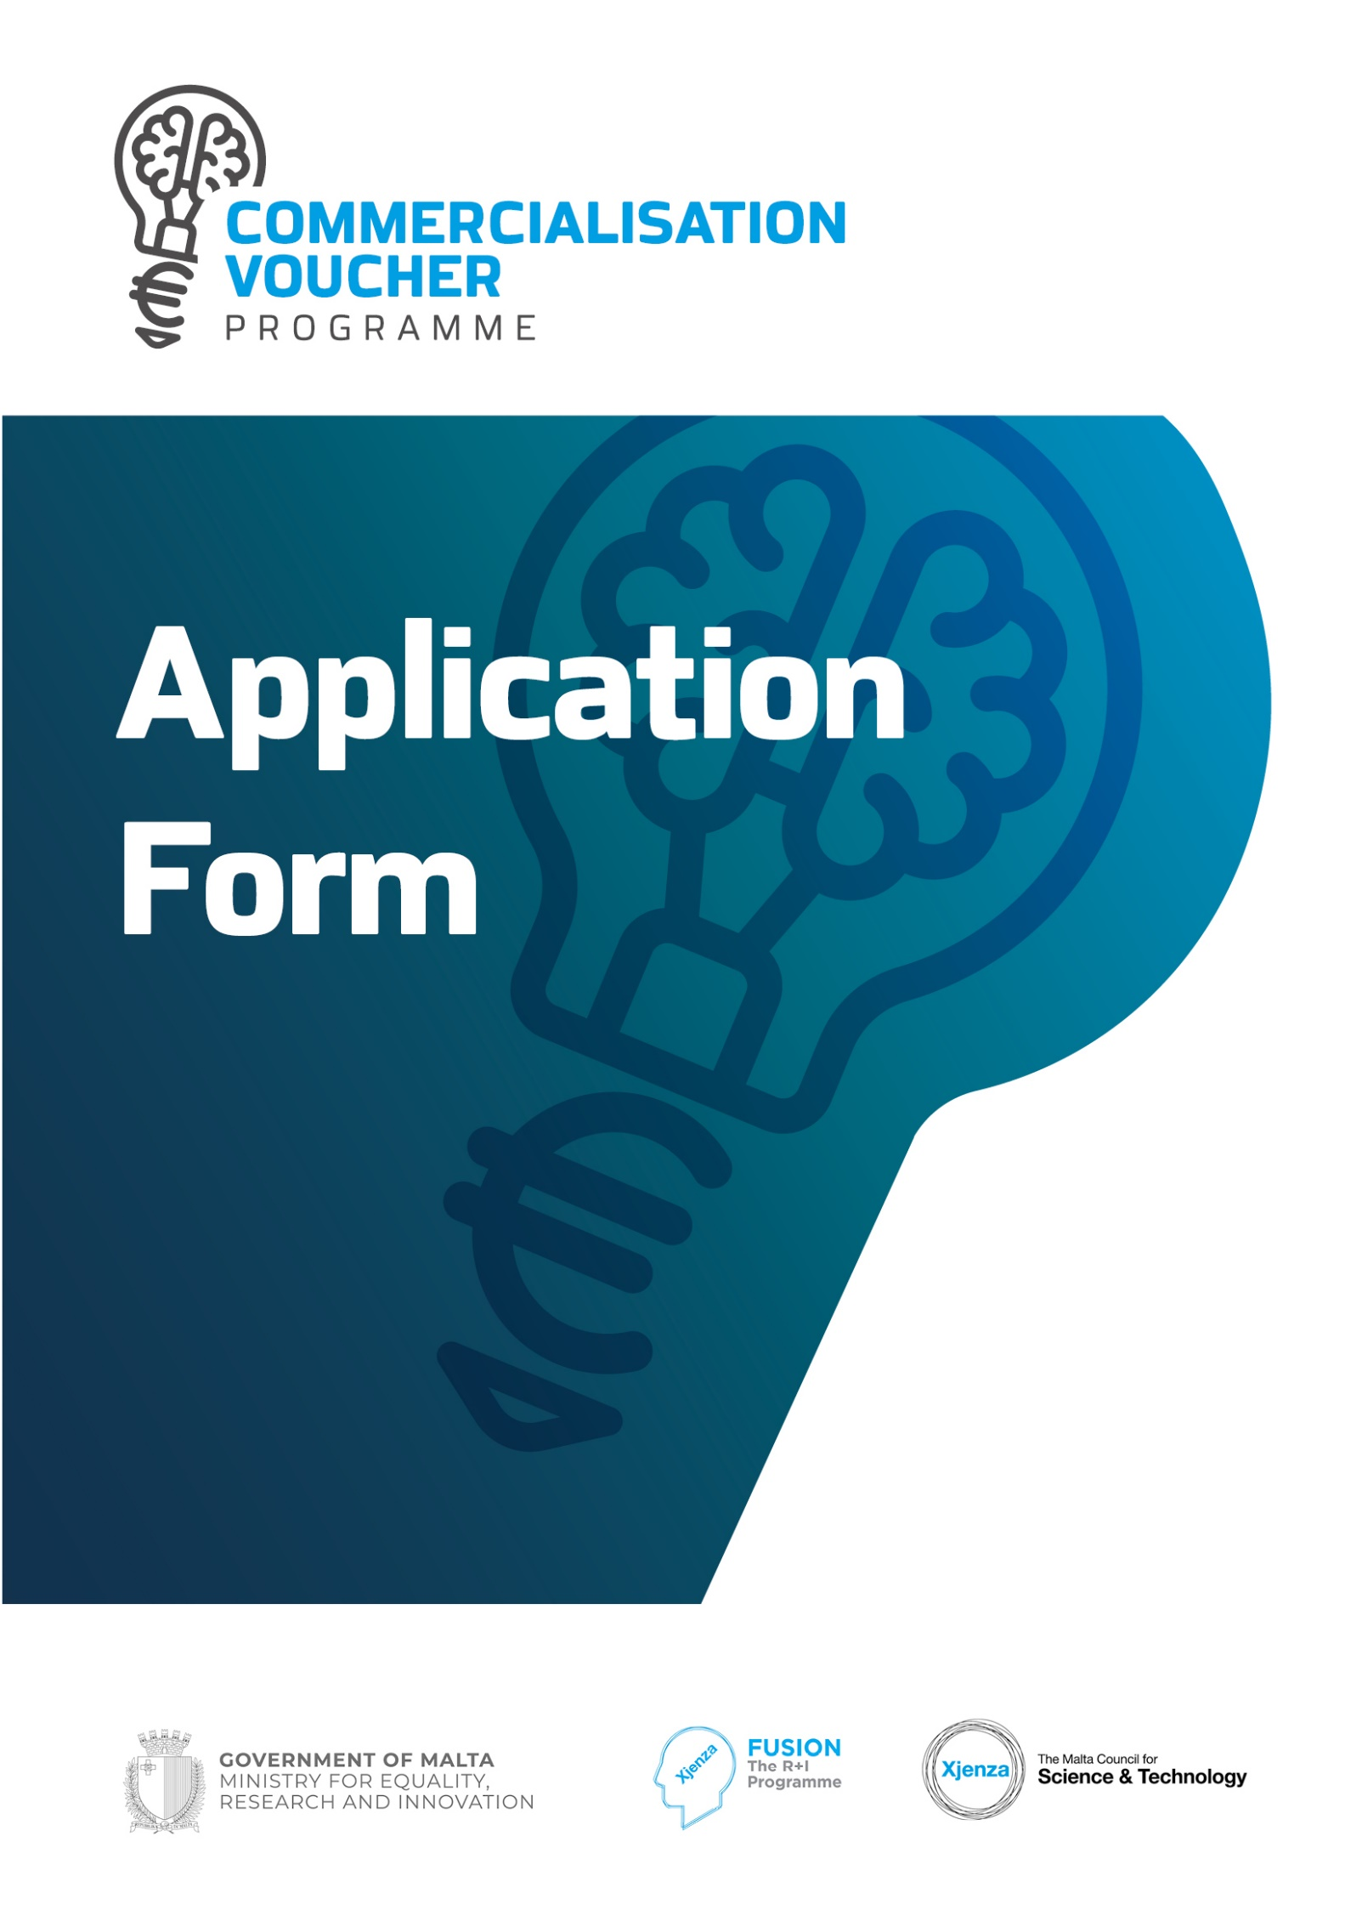

SECTION ONE: APPLICANT’S DETAILS

Details of Entity
Name of Entity |  |  | Department/ Institute/Centre  Name (where applicable)
Type of Entity | Make sure that the entity is either a Maltese Public Entity, a Maltese Research and Dissemination Organisation or one of the eligible undertakings as defined in the rules for participation. |  |  | N.A.C.E Code  (Where applicable)
Contact Details: | Full Name of Applicant |  | Title:
 | ID Card No.
E-mail Address: |  |  | Tel. No.
 |  |  | Mobile No.
Address:
(Please provide full postal address and website)
No. of employees  (FTE) (where applicable) |  | Turnover of business in last financial year  (Where applicable)
Provide a profile of the entity, including the principal activities and  resources, relevant to the project  Proposed funding Route | Please tick whether your application falls under State Aid de minimis Regulation or State Aid Not Applicable
Please note that this section is compulsory  Make sure that the proposed funding route is in accordance with the Rules for Participation. In case of queries regarding state aid, kindly contact the Council for clarifications. | Applicants may only opt for one option. Selecting more than one option, or the wrong option, will make the application administratively non-compliant.  State Aid de minimis (Please fill in de minimis Appendix 1)  State Aid Not Applicable (Please fill in Appendix 2 or Appendix 3)  (A Research and Dissemination Organisation that does not carry an economic activity) or Appendix 3 (Public Entity that does not carry an economic activity)  In the space below, please provide a justification if you selected the  “State Aid Not Applicable” option

SECTION TWO: PROPOSAL DETAILS
Title of Proposal
Acronym of Proposal
Proposal Abstract

Within the abstract, provide a concise, generic, non-confidential summary of the project. Make sure to clearly highlight the scientific aspect of the project and the problem to be resolved or otherwise the opportunity to be exploited.

Smart Specialisation Areas  Additional information on the SMART Specialisation Areas may be found on the Council’s website.  Only one area should be indicated. Please select that area which is most applicable to your project. | SMART Specialisation Area:
- EXCELLENCE

Determine the current state of the art by providing a comprehensive literature review which characterizes the current state of the art.

Tangibly demonstrate how your proposed technology is expected to go beyond the current state of the art baseline (It is highly recommended that you use diagrams and pictorial representations in Annex 1 provided to illustrate both stances)

Give examples of the current State of the art product/service/technology available and highlight how your proposal will go beyond – explain the quantum leap your proposal will take
What are the specific project objectives?

The objectives must be Specific, Measurable, Achievable, Realistic and Time-bound (SMART).

(The objectives should be consistent with the expected exploitation and impact of the project).

Demonstrate how our proposal is expected to contribute towards maximizing national, economic, social, and environmental goals

Explain also how your solution solves a possible problem or how it avails of the business opportunity verification, market replication encouraging the involvement of end users and potential clients, research etc.)

Describe the project concept and approach

Explain the current stage of development of the project and characterize it with the key performance indicators, preferably of a quantitative nature, milestones that have led to it, or similar indications of results

What approach will you be using to bridge the gap between the project’s current TRL and the proposed stages?

What National or EU challenges or obligations will your project address and how will it contribute towards achieving them? (The use of SDG indicators could be useful in highlighting your project’s contribution)

Describe and explain the concept and the approach/ activities that you will implement during this project (e.g., demonstration, testing, prototyping, pilot lines, scale-up studies, organisation, design, performance, verification, market replication, encouraging the involvement of end users and potential clients, research etc.)

What market needs will your approach satisfy? Explain how the concept and objectives for the project fit into the plan to reach the market

Describe how your project intends to develop something new that addresses EU-wide challenges

- IMPACT
What is the current Technology Readiness level (TRL)of the technology/product/service being proposed?

Describe the positioning of the project according to the TRL table in Appendix 4

Describe and where possible, quantify the potential economic, social, and environmental impact of the proposed technology, product or service which will result from the proposal

Describe the expected performance / impact on defined needs, when in use,
including improvement potential over time, regarding costs, environmental benefits, ease of use and any other relevant benefit and /or added value for end users and/or potential clients compared to alternatives solving the same or similar problems.

What are the main advantages of your solution with respect to competing solutions?

Provide a needs analysis which demonstrates who will be using the technology/service/product and which tangible and intangible benefits it is expected to deliver

Describe the expected key market application (s) extracted from the results already achieved, that differentiates your project and provides the highest added value for potential customers

Who do you foresee your product/service/technology to be targeted to – potential users? Would it attract both the National and International market?

Highlight potential end-users locally and on an international scale and explain why this product/service/technology would be useful

Dissemination & Exploitation of Results and Communication of measures to promote the project idea

Describe the measures which will maximize the impact of your proposed technology/product or services:

- Identify the different audiences and describe how you intend to reach out to your different audiences
- Demonstrate the different media and messages that will apply to each identified audience

- Explain which stakeholders are vital for a successful commercial exploitation.

A brief description on the dissemination and exploitation measures to access the full range of potential users should also be provided

3. IMPLEMENTATION
Demonstrate that the entity/consortium has the skills, background, and competences to ensure the successful implementation of the project (up to 200 words)

Explain the entity’s plans with regards to.

- Technical skills and commercial awareness to ensure the successful implementation of the project
- Management structure to implement the project
- Technical infrastructure tailored to the needs of the project

Highlight the key Risks and mitigation actions proposed (up to 200 words)  Describe any critical risks, relating to the project implementation.  Highlight any potential risk mitigation measures within the table below  Description of Risk | Proposed risk-mitigation measures
Outline any previous funding that has been awarded for the background research, if any.

Highlight potential synergies with, or built up from other projects

1.
DECLARATION BY APPLICANTS
A legal representative of the Research Institution or the Company should complete this Declaration.
I confirm that:  The information given on this form is accurate to the best of my knowledge. I understand that if it is later established that I misrepresented this or related documentation and do wish to pursue this Programme then I will be required to pay for the services received up to that date. I have also read and fully understood the Rules for Participation in Fusion and the Guidelines for Applicants. | I agree
I accept and confirm that my personal data and proposal content information can be used by the Malta Council for Science and Technology for the purposes of administering this application. | I agree
I accept and confirm that my personal data and proposal content information can be passed on to a third party i.e.:  - The proposal Evaluator/s and Voucher Evaluator/s for the review of the proposal and each stage in the Programme.  - The Service Provider/s for the eventual undertaking of the activities | I agree
Name of Authorised Officer | Date
Stamp and Signature

APPENDIX 1

STATE AID DECLARATION (DE MINIMIS)

Commercialisation Voucher Programme

If the submitted application is approved, the Project will benefit from de minimis State aid in line with the Commission Regulation (EU) No. 1407/2013 of 18 December 2013 on the application of Articles 107 and 108 of the Treaty on the Functioning of the European Union to the de minimis aid, as amended by Commission Regulation (EU) 2020/972 of 2 July 2020 amending Regulation (EU) No 1407/2013 as regards its prolongation and amending Regulation (EU) No 651/2014 as regards its prolongation and relevant adjustments.

Commission Regulation (EU) No 1407/2013 allows a ‘single undertaking’ to receive an aggregate maximum amount of de minimis aid of EUR 200, 000 under all de minimis aid measures, over a period of three ‘fiscal years. This aggregate maximum threshold applies in principle to all economic sectors except for a ‘single undertaking’ performing road freight transport for hire and reward for which a lower de minimis threshold of EUR 100,000 over any period of three ‘fiscal years’ applies. The agriculture and fisheries sectors are subject to different thresholds and criteria. For the purpose of this declaration, the term ‘single undertaking’ shall have the meaning as established in Commission Regulation (EU) No 1407/2013. Moreover, ‘fiscal year’ means the fiscal year as used for tax purposes by the undertaking concerned.

This maximum threshold would include all State aid granted under this scheme and any other State aid measure granted under the de minimis rule¹. Any de minimis aid received exceeding the established threshold will have to be recovered, with interest, from the undertaking receiving the aid.

The following is an indicative list of the possible forms of State Aid:
- Grants from public bodies
- Loans or loan guarantees at favourable rates
- Tax benefits
- Waiving or deferral of fees or interest normally due
- Marketing and advertising assistance
- Consultancy, training, and other support provided either free or at a reduced rate
- Aid for investment in environmental projects or research and development assistance
- Purchase rent or lease of immovable property at less than market rate.

Potentially any assistance from a public body may constitute State Aid. Should you have any doubts whether any public assistance received constitutes de minimis aid, you should contact the agency or department from which the assistance was received to ascertain this.

DECLARATION

I declare that a comprehensive amount of de minimis aid received to date during the current fiscal year and the previous two fiscal years is:

Fiscal Year 2019 | Fiscal Year 2020 | Fiscal Year 2021 | TOTAL
€ | € | € | €

A breakdown of the source, type, and amount of all de minimis aid received as well as that applied for from any State aid grantor, is presented overleaf.
An updated State Aid (de minimis) Declaration form is to be submitted upon the signing of the Grant Agreement should the project be selected for funding.

RULE

Business Undertaking (Full Legal Name) |  | VAT Registration Number
Name and Surname (BLOCK CAPITALS) |  | Position in Establishment
Signature |  | Date

Detailed Information Concerning Applicable State Aid Under the De Minimis Rule For Fiscal Years 2019, 2020, 2021
Section 1 – De Minimis State Aid Awarded
Date | Source/  Grantor | Type of State Aid  (Name of Measure) | Awarded  To | Amount  in €
Total (A1)

Section 2 – De Minimis State Aid Still Pending For Approval
Date | Source/  Grantor | Type of State Aid  (Name of Measure) | Awarded  To | Amount  in €
Total (A2)

Section 3 – De Minimis State Aid Requested in This Application
Date | Source/  Grantor | Type of State Aid  (Name of Measure) | Amount in € (A3)
 | MCST

TOTAL of Sections 1,2 and 3 above  (A1 + A2 + A3) | €

APPENDIX 2 : DECLARATIONS WHERE STATE AID IS NOT APPLICABLE

PUBLIC RESEARCH AND KNOWLEDGE DISSEMINATION ORGANISATIONS THAT DO NOT CARRY OUT AN ECONOMIC ACTIVITY WITHIN THE MEANINIG OF ARTICLE 107 TFEU

Project Application: _____________________________

The Applicant, __________________________________, declares the following:

The planned research is to be carried out in the context of its activities as a “research and knowledge dissemination organization” as defined in the Commission Framework for State aid for research and development and innovation (2014/C 198/01) paragraph 15ee, which carries out a non-economic activity in line with the following:
(a)Primary activities of research organisations and research infrastructures, in
particular:
- education for more and better skilled human resources.
- independent R&D for more knowledge and better understanding, including collaborative R&D where the research organisation or research infrastructure engages in effective collaboration.
- wide dissemination of research results on a non-exclusive and non-discriminatory basis, for example through teaching, open-access databases, open publications, or open software.

(b) knowledge transfer activities, where they are conducted either by the research organisation or research infrastructure (including their departments or subsidiaries) or jointly with, or on behalf of other such entities, and where all profits from those activities are reinvested in the primary activities of the research organisation or research infrastructure. The non-economic nature of those activities is not prejudiced by contracting the provision of corresponding services to third parties by way of open tenders.

The Applicant intends to:
- Publicise widely the results of the research.
- License on non-discriminatory terms any Intellectual Property Rights (IPRs) resulting from the research at the market price for the said IPR.
- Any income from the licensing of IPR shall be reinvested in the primary educational and research activities of the Beneficiary.
- Appropriate procedures shall be established to prevent the direct or indirect support of economic activity in the meaning of Article 107of the Treaty on the Functioning of the European Union

The Applicant understands that, should it be found to be in breach of the conditions for being exempt from State Aid regulations, the Managing Authority will enforce the retrieval of funds with interest, in part or in full, as the case may necessitate.
The Applicant also undertakes to comply faithfully and immediately with any decision of the European Commission or a Maltese judicial authority declaring Article 107(1) TFEU to be applicable to this Agreement.

________________________________
Legal Representative

________________________________
Date
APPENDIX 3: DECLARATIONS WHERE STATE AID IS NOT APPLICABLE

PUBLIC ENTITIES WHOSE ACTIVITY DOES NOT CONSTITUTE AN ECONOMIC ACTIVITY WITHIN THE MEANING OF ARTICLE 107 OF THE TREATY ON THE FUNCTIONING OF THE EUROPEAN UNION (EXCLUDING PUBLIC RESEARCH AND KNOWLEDGE DISSEMINATION ORGANISATIONS)

Project Application: _____________________________

The Applicant, __________________________________, declares the following:

State Aid within the meaning of Article 107 TFEU is not applicable to the Applicant and/or the type of research being undertaken is claimed by the Applicant not to constitute an economic activity within the meaning of Article 107 of the Treaty on the Functioning of the European Union.

The Applicant intends to:
- Publicise widely the results of the research.
- License on non-discriminatory terms any Intellectual Property Rights (IPRs) resulting from the research at the market price for the said IPR.
- Any income from the licensing of IPR shall be reinvested in the primary educational and research activities of the Beneficiary.
- Ensure that no funds provided by this Agreement cross-subsidises any economic activities that may be carried out by the Beneficiary, other partners in the project, or third parties.

The Applicant understands that, should it be found to be in breach of the conditions for being exempt from State Aid regulations, the Managing Authority will enforce the retrieval of funds with interest, in part or in full, as the case may necessitate.

The Beneficiary undertakes to comply faithfully and immediately with any decision of the European Commission or a Maltese judicial authority declaring Article 107(1) TFEU to be applicable to this Agreement.

________________________________
Legal Representative

________________________________
Date

APPENDIX 4

TECHNOLOGY READINESS LEVELS (TRLS)

TRLs are a means to define endpoints of projects along the innovation axes from basic research to the market, ranging from 1 (basic concept) to 9 (market entrance).

Readiness Level | Definition | Explanation
TRL 1 | Basic principles observed and reported. | Lowest level of technology  readiness. Process concept with basic scientific foundation
TRL 2 | Technology concept and/or application formulated. | Scientific research begins to be translated into applied research and development. Applications are  speculative and may be unproven.
TRL 3 | Analytical and experimental critical function and/or characteristic proof-of-concept. | Active research and development is initiated, including analytical / laboratory studies to validate  predictions regarding the technology.
TRL 4 | Scientific & process validation in laboratory environment. | Basic technological components are integrated to establish that they will  work together.
TRL 5 | Scientific & process validation in intended environment. | The basic technological components are integrated with reasonably realistic supporting  elements so it can be tested in a simulated environment.
TRL 6 | System / subsystem model or prototype demonstration in an intended environment (ground or  space). | A representative model or prototype system is tested in an intended environment.
TRL 7 | System (full-scale) prototype demonstration in a real operational environment at pre-commercial  scale. | A prototype system that is at the planned operational system.
TRL 8 | Actual system completed and validated as capable commercial system. | In an actual system, the technology has been proven to work in its final form and under expected  conditions.
TRL 9 | Full commercial application and technology available for consumers | The system incorporating the new technology in its final form has been used under actual mission  conditions.

