Individual Fellowship Training Scheme for Incoming Postdocs to Malta (IF2MT)
Application Form: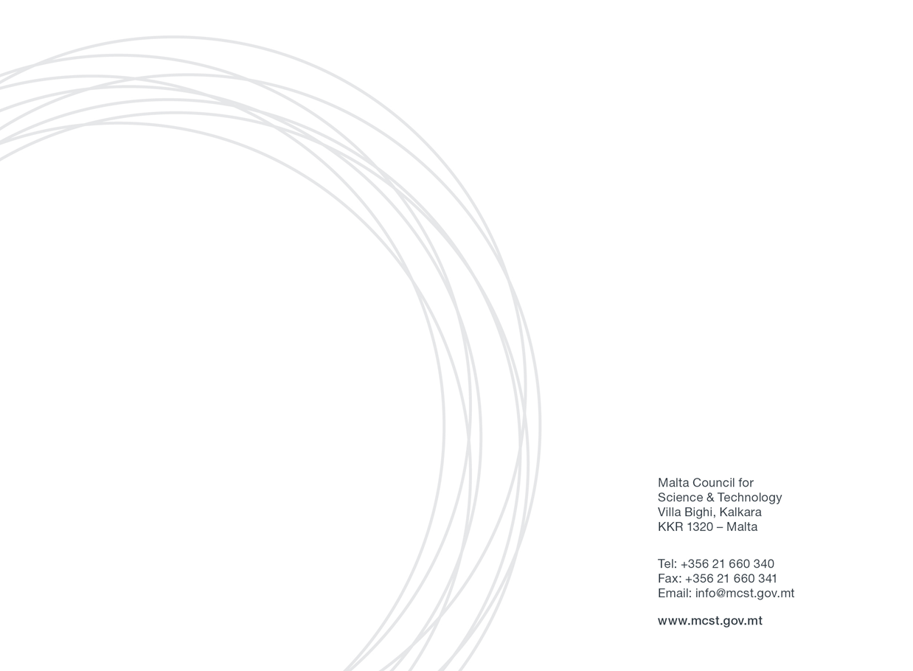

Section One: Applicant’s Details
Applicant Details

Name and Surname
Designation
Country of residence
Residing/living/working in Europe, EU Member State/Associated Country | Yes/No
Email
Mob. Number

Type (selected panel) of MSCA Individual Fellowship the applicant intends to submit

(please select the panel which is most applicable to your project - tick one option only)

Standard Fellowship

Career Restart panel

Reintegration panel

Society and Enterprise panel

Details of the host entity/beneficiary:

Name of host entity/beneficiary
Contact Details of the Supervisor | Name and Surname: | Designation:
 |  | Email:
 |  | Tel. No.:
 |  | Mob. No. (optional):

Kindly note that MCST will contact the host entity/supervisor in order to confirm their intentions.
If a host entity has been identified but a supervisor has not been confirmed by the date of presentation of this application, kindly provide details of your intentions and strategy for finding relevant supervisor (maximum 200 words).

SECTION TWO: PROJECT DETAILS
Proposed Project title (if known already):

Proposed project idea (project brief) (maximum 500 words)

SECTION THREE: DECLARATION BY APPLICANTS
Declaration by Researcher

I confirm that:  The information given on this form is accurate to the best of my knowledge. I understand that if it is later established that I misrepresented myself and I am not eligible for this Scheme, I will be required to pay for the services received. | I agree
I accept and confirm that the personal data and project/activities proposal content information can be passed on to the Malta Council for Science and Technology to be used solely for the purposes of administering, processing, and reviewing of the application. | I agree
I confirm that full and updated Curriculum Vitae (CV) is attached to this application form. | I agree
I confirm that I comply with the Individual Fellowship eligibility and mobility rules of the Marie Sklodowska Curie Actions of the Horizon 2020 programme. | I agree
I confirm that my intention is to submit a MSCA Individual Fellowship (IF) proposal for the call with deadline 9th September 2020 and I will provide proof of submission of proposal to MCST. | I agree
I confirm that I will share a draft digital copy of the MSCA IF project proposal to the Horizon 2020 unit at MCST for their review. This shall be sent by not later than 1 month before the submission deadline. | I agree

Signature & Stamp of the Applicant: | Date:  Sign:

