The Malta Council for Science and Technology

FUSION: The R&I Programme
The Commercialisation Voucher and Technology Development Programmes

Call for Expression of Interest for Service Providers

The Malta Council for Science and Technology is seeking services in the following areas:
- IP Check;
- Market Research and Product Development Costing;
- Economic Impact and Risk Profile;
- Intellectual Property Registration;
- Business Plan; and
- The setting up and liaison for Investors Meetings.

DEADLINE: midnight 18th November 2019

This measure falls under the Service Providers category under the FUSION Programme. FUSION is supported through Malta Government funds and is managed by the Malta Council for Science and Technology, on behalf of the Foundation for Science and Technology.
Call for Expression of Interest for Service Providers
1.0 General
This is a Call for Expression of Interest for the provision of advisory support to researchers and industry players in preparation for the commercialisation of their ideas within local and/or foreign markets, through the framework of the FUSION Commercialisation Voucher Programme and the Technology Development Programme.
This expression of interest is open to Service Providers specialising in the following areas:
- IP Check;
- Market Research and Product Development Costing (as a joint offering);
- Economic Impact and Risk Profile (as a joint offering);
- Intellectual Property Registration;
- Business Plan; and
- Setting up of Investors Meetings
This call primarily aims to assist local researchers and industry players by providing invaluable knowledge and skills that would allow them to meet the challenges, which may result from developing their ideas to meet market requirements, leading to commercially viable developments. It is therefore fundamental that all services are tailored to the unique and specific requirements of the beneficiaries, within the local context, and, as necessary, within the international arena.
The final objectives are:
- To raise the level and profile of locally funded research;
- To ingrain research and innovation at the heart of the Maltese economy;
- To spur knowledge-driven and value-added growth; and
- To sustain improvements in the quality of life

These objects are sought to be achieved by translating research ideas into commercially viable activities that result in a multiplier effect on the economy at large.
2.0 Background
FUSION presents a funding programme that supports Research and Innovation with the goal of promoting and supporting local research and innovation, as well as providing the necessary handholding in order to enable researchers and innovators to transform their innovative ideas into a market ready reality. In so doing, it provides the fora in which public and private entities can invest in more innovative, eco-efficient products and services. FUSION enables the Maltese economy to become more resource-efficient, competitive and attractive to foreign investors. The programme prioritises projects which fall within the Smart Specialisation Areas.
FUSION is composed of two main programmes: the FUSION R&I Commercialisation Voucher Programme (CVP) and the FUSION R&I Technology Development Programme (TDP). The former consists of three stages (and hence three Vouchers), supporting the assessment of commercialisation potential prior to the actual undertaking of any research and development under the Technology Development Programme. The FUSION programme helps inventors, researchers and industry players assess the commercial and market potential of their idea.
The Technology Development Programme, widely referred to as the TDP provides state financing in the form of grants for research, development and innovation in the realms of science and technology. The TDP funds the actual development of the research and innovation proposal with the possibility of having a prototype of the proposed solution. To further supplement the research, the beneficiaries of the FUSION programme may avail themselves of additional optional vouchers which tap into IP Registration, business plan; and investors meetings. These may be utilised during the duration of the project or within two years from the end of the project.
The diagram below provides a detailed step by step approach for FUSION, together with the related timelines for each stage as well as the cost of the activities (excl. VAT):

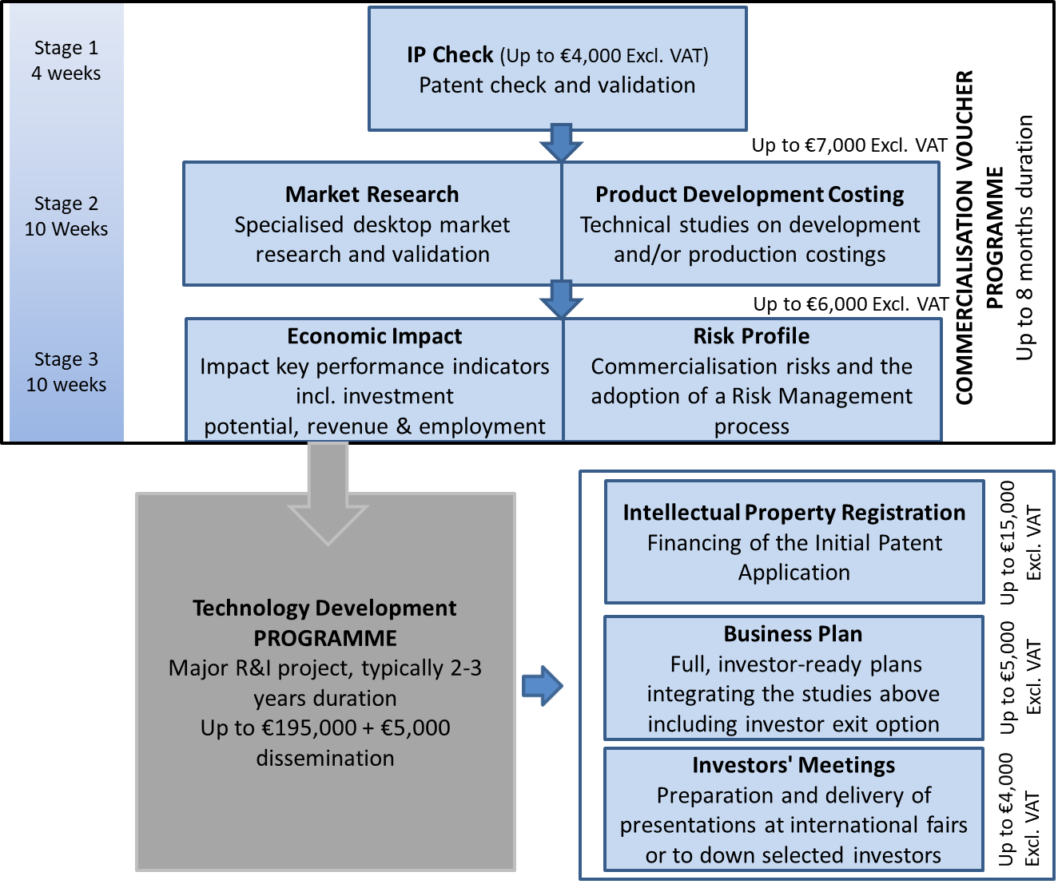

3.0 Service Requirements
3.1 Service Providers are expected to assist beneficiaries of the FUSION R&I Programmes in order to better prepare themselves in terms of project proposal and validation.
3.2 The services that may be allocated to persons or entities registering under this call shall consist of all those tasks necessary to conduct and conclude the Stage assigned.
3.3 The selected Service Providers shall be either an individual(s) or an organisation(s) with a proven track record relevant to IP Check; Market Research and Product Development Costing; Economic Impact and Risk Profile; Intellectual Property Registration; Business Plan or the setting up of Investors Meetings.
3.4 Service Providers shall be expected to work on their own initiative but in an iterative manner with the beneficiary. Applicants must be able to deliver the entire product of each stage applied for, and within the stipulated timeframes.
4.0 Duration of Contract and Conditions
4.1 The General Conditions applicable to Government Contracts for Service shall not apply to this Call. The justification for this is that the Service Provider will be paid directly by the Beneficiary to whom the Council awards the R&I project and not by the Council.
4.2 The Council does not bind itself to accept any Expression of Interest submitted under this Call.
4.3 Service Provider/s shall bind themselves to conduct such assignments in accordance with the terms of this Call.
4.4 Any additional information or clarification, as may be requested by MCST, shall be deemed to form an integral part of the original assignment.
4.5 Applicants for Stage 2 (Market Research & Product Development Costing) must also be able to provide services for Stage 3 (Economic Impact & Risk Profile). Applicants should have a proven and successful track record of work in the respective fields.
4.6 Post-selection allocation of assignments under this Call will not be the responsibility of the Council. The FUSION Beneficiary will be requested to put the Service Providers in his/her order of preference. The beneficiaries will then be assigned their preferred choice, provided that the Service Provider has not been allocated a task already. The list of approved service providers will be put online.
4.9 The selected Service Providers will be expected to sign a formal contractual undertaking for the provision of services within two weeks from being notified of the conclusion of the adjudication process and placing in an order of merit by the Council. The order of merit will be based on two sections of equal weight for each Stage Activity; Relevant Entity Activity Experience and Lead consultant and team Experience.
4.10 Service Provider/s shall, with exception to information that is already in the public domain, not disclose to any third party any of the information obtained in the course of this Call; or, in the event of a service allocation, during the course of service delivery without the prior written consent of the Council and the Beneficiary. Moreover, the Service Provider/s must ensure that employees and any other persons who may be engaged to assist them in the course of this Call shall similarly be bound. Information must be protected and used in accordance to the provisions of the Data Protection Act 2001. Service Providers will be expected to sign a Non-disclosure Agreement.
4.11 Service Providers must identify a Contact Person. The contact person(s) shall be the only point of reference between the Council and the Service Provider. Communication from third parties shall not be recognised.
4.12 The agreement shall run for a period of one year between 1st January 2020 and 31st December 2020.
4.13 Once the Stage assignment carried out by the Service Provider is positively evaluated by the expert independent evaluator/s appointed by the Council, payment will be directly affected by the Beneficiary of the FUSION Programme.
4.14 A Service Provider might be blacklisted and / or contract terminated, if services are not delivered within the time frames stipulated by the Council and noted below. The timeframes start from the day of the MCST voucher letter sent to beneficiary.
4.15 A Service Provider may not participate in more than one (1) consultancy service per call per stage, unless otherwise stated by the Council. This to ensure that the beneficiaries are provided with the best possible service, unless otherwise stated by the Council.
4.16 If any disagreement or dispute arises out of the contract signed between the selected Service Providers and the Council, such matter may be referred to arbitration under the Arbitration Rules and Procedures established by the Laws of Malta
4.17 The Council requests that interested Service Providers submit their Expressions of Interest for the following activities which are financed through FUSION.

Activity | Minimum Qualifications | Description | Maximum Duration | Budget (Excl. VAT)
IP Check | Bachelor of Laws (HONS). A Postgraduate Certificate or LLM in intellectual property law. | Includes: Patent check, validation and scientific opinion and preliminary registration. | 4 weeks | €4000
Market Research and Product Development Costing | ACCA/ Bachelor of Commerce (Accountancy Major), a degree in Marketing or Bachelor of Commerce in Accountancy and Marketing or Bachelor of Commerce in Banking, Finance and Marketing or Bachelor of Commerce in Economics and Marketing or equivalent. | Includes: desktop market research; specialised research data; primary source data including transcripts and analysis with potential technology buyers; analysis of different production options including costings; analysis of resources, plant and equipment; and logistics. | 10 weeks | €7000
Economic Impact and Risk Profile | Bachelor of Commerce in Accountancy and Economics or Bachelor of Commerce in Banking and Finance and Economics or Bachelor of Commerce in Economics and Management or equivalent. | Includes: analysis of economic bearing; key performance indicators; investment potential; revenue, employment; and the assessment of the different types and levels of risk involved if the technology were to be commercialised. | 10 weeks | €6000
Intellectual Property Registration | Bachelor of Laws (HONS). A Postgraduate Certificate or LLM in intellectual property law. | Covers 3 sub-stages:  (i) Updated IP Check Report – 5 weeks;  (ii) Drafting of IP – up to 15 weeks; and  (iii) Filing in Country Jurisdictions | The 3 sub-stages shall be made use of as per the TDP project timelines | €15,000
Business Plan | Bachelor of Commerce in Accountancy and Economics or Bachelor of Commerce in Banking and Finance and Economics or Bachelor of Commerce in Economics and Management or Business Administration or equivalent. | Includes: full investor ready plans, integrating Stages 1 to 3 and including an investor exist option. | 10 weeks | €5000
Investor’s Meetings | Bachelor of Commerce or Business Administration or equivalent. | Includes: preparation and delivery of presentations at international fairs, with potential investors or with technology purchasers. | 12 weeks | €4000

5.0 Instructions and Application
Service Providers are to submit one (1) copy of their response clearly marked “Calls for Expression of Interest for the Provision of Consultancy Services in [select preferred area(s)]”.
Applicants are to ensure that their submissions fully comply with the submission checklist under Annex 01.
Interested service providers are requested to submit their response and all relevant documentation (mentioned in points 1 -10) below in electronic format, by not later than midnight on 18th November 2019 to voucher.mcst@gov.mt. All documents submitted should be initialised or stamped on each page by the legal representative of the entity or, by the applicant in the case of self-employed registrants. Failure to provide any or all of the documents stipulated in points 1-10 below, would render the application administratively non-compliant.
During the preparation, submission and any other process relevant to the submission and adjudication of this Call, potential Service Providers shall be guided by the following requirements:
- A covering letter clearly listing the areas applied for and a profile of the entity;
- A detailed Euro pass Curriculum Vitae of the Personnel who will be assigned work on the allocated projects;
- A copy of the relevant Education certificates of the Personnel who will be assigned work on the allocated projects;

- A Copy of the VAT certificate;
- A copy of the Company registration certificate (if applying as an entity);
- Two recent trade references (an exemption is made in the case of IP Check and Intellectual Property Registration only);
- Annex 01;
- Annex 02 (Enterprises only);
- Annex 03;
- Annex 04.
It is the responsibility of the applicant to ensure that they are provided with a written confirmation of receipt of their application.
Data Protection Clause: The information collected through this Call shall be processed in accordance to the Data Protection Act 2001. The contents remain confidential and solely intended for the use of this Call’s purpose, and will not be disclosed or copied without your consent to anyone outside the Office of the Prime Minister, unless the law permits us to.

Annex 01 – Submission Checklist
This checklist is intended to facilitate submission. Candidates are requested to submit a copy of the checklist together with all relevant documents in sequence.
Ref | Submission Task | Submission  Check Box
1 | A covering letter clearly listing the areas applied for and a profile of the entity.
2 | A Curriculum Vitae of the Personnel that will be assigned work on the assigned projects.
3 | A copy of the relevant Education certificates of the Personnel who will be assigned work on the allocated projects;
4 | A Copy of the VAT certificate.
5 | A copy of the Company registration certificate (if applying as an entity).
6 | Two recent trade references (an exemption is made in the case of IP Check and Initial Patent Application only).
7 | Annex 01.
8 | Annex 02 (Enterprises only).
9 | Annex 03
10 | Annex 04

Note: An inability to provide any of the above will lead to categorical exclusion.

Annex 02 – Statement on Conditions of Employment
- It is hereby declared that all employees engaged within the company shall enjoy working conditions including wages, salaries, vacation and sick leave, maternity and parental leave as provided for in the relative Employment Legislation. Furthermore, we shall comply with Chapter 424 of the Laws of Malta (Occupational Health and Safety Authority Act) as well as any other national legislation, regulations, standards and/or codes of practice or any amendment thereto in effect during the provision of services under this contract.
- It is hereby declared that the service being provided under this Call will be carried out by the bidding entity employees or bona fide self-employed individuals or subcontracted third parties. No work shall be carried out by persons designated as self-employed where their actual employment status in terms of the Employment Status National Standard Order LN 44/2012 is that of an employee without prior notification to the Council. Such notification must reach the Council within 2 days from the date of allocation of an assignment.
- It is hereby declared that all the employees of the bidder, whether providing services to the Council or not, have a written contract of service and are registered with the competent authority of Malta which is the Employment and Training Corporation. Copies of the written contracts of service of the employees or sub-contracted parties must be made available at any time for inspection.
- It is hereby declared that if the bidder is found to be in breach of any of the above declarations, this application will be rendered null and void and that we will have no right to be compensated for any damage we may have suffered or will suffer in the future in respect to this termination.
- The sub-contractor/s agrees to all the conditions listed in this statement.

Signature....................................................................................
Name of Signatory.....................................................................
I.D. No. .......................................................................................
Name of bidder/contractor........................................................

Annex 03
Relevant Entity Activity Experience:
Activity being applied for:
(Must be completed for every activity e.g. IP check, as per Table in Section 4)

- Relevant Activity Experience: (List at least five (5) initiatives that the Entity has been responsible for in the above activity).
List | Client | Title | Description of work | Year of engagement
1
2
3
4
5

- Research and Innovation Experience: (Provide concrete examples of consultancy services that the company has carried out in the area of R&I and the duration of your engagement).

List | Client | Title | Description of work | Year of engagement
1
2
3

- Experience in Consultancy Services for FUSION and other national / international experience:

List | Programme | Project title and abstract | TRL status of idea/technology/product/service at the time of service provision
1
2
3
4
5

Kindly elaborate on the entity’s experience with international clients:

Annex 04
Relevant Personnel Experience:
Activity being applied for:
Must be completed for every activity e.g. IP check, as per Table in Section 4

Lead Consultant (Name & Surname):
Activity related degree:
Science related qualification:
Personal Experience on Specific R&I Projects and number of years of R&I experience:

Supporting Staff (Name & Surname):
Activity related degree:
Science related qualification:
Personal Experience on Specific R&I Projects and number of years of R&I experience:

Supporting Staff (Name & Surname):
Activity related degree:
Science related qualification:
Personal Experience on Specific R&I Projects and number of years of R&I experience:

Supporting Staff (Name & Surname):
Activity related degree:
Science related qualification:
Personal Experience on Specific R&I Projects and number of years of R&I experience:

Supporting Staff (Name & Surname):
Activity related degree:
Science related qualification:
Personal Experience on Specific R&I Projects and number of years of R&I experience:

