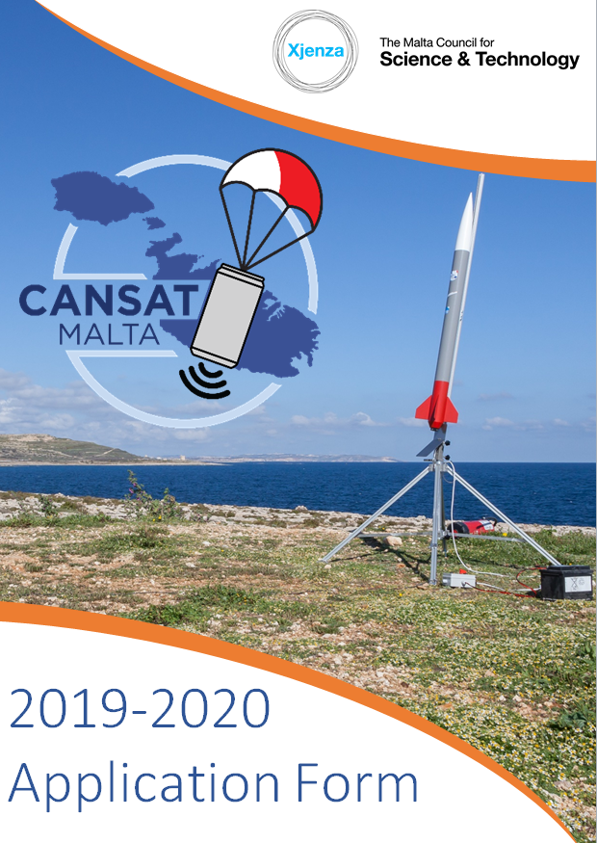

This Competition is coordinated by the Malta Council for Science and Technology with the support of the European Space Agency and the Ministry for Education and Employment. The initiative is financed by the National Space Fund 2018-2022.
Coordinated by:

Funded by:

Acknowledgments to:

CanSat Malta Competition Application Form
Before submitting your proposal, please ensure that you have carefully read the 2019 - 2020 Participation Guide available at http://mcst.gov.mt/space-directorate/sep/#cansat
The teacher is to send the completed application form to space.edu.mcst@gov.mt by Wednesday 13th November 2019 at 23:59 CET.
CanSat Team Name
Click or tap here to enter text.

Teacher’s Contact Details
Name and Surname: | Click or tap here to enter text.
E-mail (Work): | Click or tap here to enter text.
Phone Number (Work): | Click or tap here to enter text.
Mob No (optional but effective for communication): | Click or tap here to enter text.
Teaching Subject: | Click or tap here to enter text.
ID Card Number: | Click or tap here to enter text.
School’s Name (or any other club): | Click or tap here to enter text.
School Level :  (select one) | ☐Secondary  ☐Post-Secondary
School or Club Postal Address: | Click or tap here to enter text.

CanSat Team Members
Teams should be composed between 4 to 6 students.
The team shall be led by the teacher or mentor.
Student 1
Name and Surname | Click or tap here to enter text.
Age | Click or tap here to enter text.
Student 2
Name and Surname | Click or tap here to enter text.
Age | Click or tap here to enter text.
Student 3
Name and Surname | Click or tap here to enter text.
Age | Click or tap here to enter text.
Student 4
Name and Surname | Click or tap here to enter text.
Age | Click or tap here to enter text.
Student 5
Name and Surname | Click or tap here to enter text.
Age | Click or tap here to enter text.
Student 6
Name and Surname | Click or tap here to enter text.
Age | Click or tap here to enter text.
If your school, coding club or any other after school coding group requires that more than one teacher/mentor accompanies the students, the participating team needs to submit evidence of this. However, the total amount of participants must not exceed seven people (e.g. maximum of 6 students + 1 teacher or 5 students + 2 teachers) due to capacity limitations in the European CanSat Competition.
Scientific Mission
What is the secondary mission that you have chosen for your CanSat?  (In a few words) | Click or tap here to enter text.
Where did you get the idea from?  (e.g. from a real satellite mission, another CanSat project, a scientific publication, a book, etc…) | Click or tap here to enter text.
Outline the scientific or technical objective of your secondary mission.  Highlight any innovative aspects. | Click or tap here to enter text.
Describe your secondary mission in detail. This part should link the scientific objective to the experiment itself. Explain how in practice you are going to fulfill the scientific goal. | Click or tap here to enter text.
Which data will you measure, and how? | Click or tap here to enter text.
What do you plan to do with your results after the flight?  How will you analyze the obtained data? | Click or tap here to enter text.
Organisation
How will you distribute the work between the team members? Consider all aspects of your experiment (structure, software, data analysis, etc.) | Click or tap here to enter text.
Do you have access to a workshop or a laboratory? | Click or tap here to enter text.
How much time will your team have available to work on your CanSat, (total number of hours/hours per week), and how will you spend it? | Click or tap here to enter text.
How does your team plan to finance its expenses? Are you supported by your school or other sponsors? | If selected, the team shall be financed by the Malta Council for Science and Technology through the National Space Fund. Include here any other sponsors, if applicable:  Click or tap here to enter text.
Do you have all the material and equipment needed for your mission?  If not, how do you plan to obtain it? | All equipment associated with the primary mission will be provided by the Malta Council for Science and Technology. Secondary Mission components shall be purchased by the team and reimbursed by the Council up to the limits stipulated in the Participation Guide available at http://mcst.gov.mt/space-directorate/sep/#cansat  Provide details on how you plan to obtain the secondary mission components:  Click or tap here to enter text.

Outreach Programme
Describe your outreach programme for before, during, and after the CanSat competition.  (e.g. newspaper articles, local radio, website, presentation at school, etc…) | Click or tap here to enter text.

Please note that a sample application form is shown in Annex 1 of the 2019-2020 Participation Guide uploaded on the Space Education Programme webpage which should help the applicant filling this form.
The teacher or mentor is to send the completed application form to space.edu.mcst@gov.mt by Wednesday 13th November 2019 at 23:59 CET.
☐ | I acknowledge that I have read and understood the 2019-2020 Participation Guide uploaded on the Space Education Programme webpage in its entirety and am capable of performing all of the stated requirements.

