Internationalisation Partnership Awards Scheme 2018
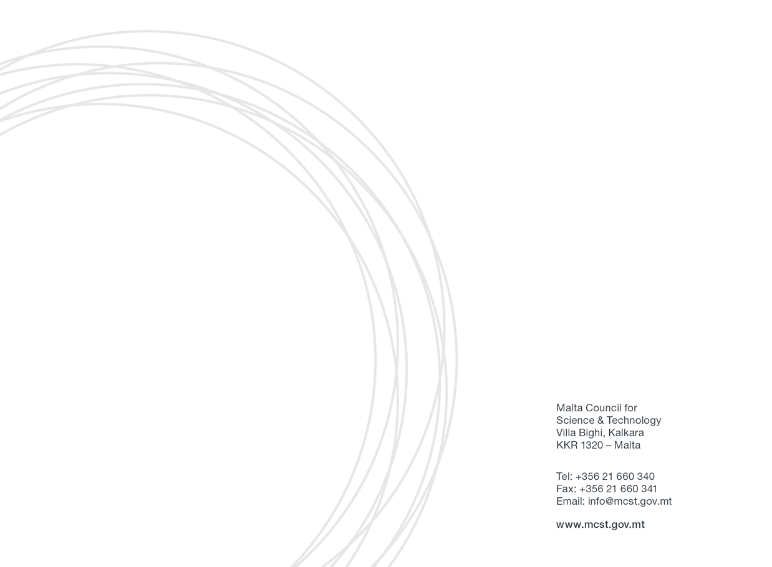
Application Form

SECTION ONE: APPLICANT’S DETAILS
Applicant Details:
(Please include details of the Malta-based applicant applying for the Award)
Name
Designation
Name of Academic Institution / Private Entity
Name of Department/Institute/Centre
Email
Tel. Number

Main Partner Organisation’s Details:
(Please include details of the primary contact person/partner from the foreign partner involved in the proposal)
Name of Foreign Academic Institution / Private Entity |  | Name of Department/ Institute/ Centre
Contact Details | Name: | Designation:
 |  | Email:
 | Address: | Tel. No.:
 |  | Mob. No.:

Secondary Partner Organisation’s Details (if any):
(Please include details of any other foreign partner involved in the proposal)
Name of Foreign Academic Institution / Private Entity |  | Name of Department/ Institute/ Centre
Contact Details | Name: | Designation:
 |  | Email:
 | Address: | Tel. No.:

Secondary Partner Organisation’s Details (if any):
(Please include details of any other foreign partner involved in the proposal)
Name of Foreign Academic Institution / Private Entity |  | Name of Department/ Institute/ Centre
Contact Details | Name: | Designation:
 |  | Email:
 | Address: | Tel. No.:

Secondary Partner Organisation’s Details (if any):
(Please include details of any other foreign partner involved in the proposal)
Name of Foreign Academic Institution / Private Entity |  | Name of Department/ Institute/ Centre
Contact Details | Name: | Designation:
 |  | Email:
 | Address: | Tel. No.:

Secondary Partner Organisation’s Details (if any):
(Please include details of any other foreign partner involved in the proposal)
Name of Foreign Academic Institution / Private Entity |  | Name of Department/ Institute/ Centre
Contact Details | Name: | Designation:
 |  | Email:
 | Address: | Tel. No.:

Internationalisation activity

(please select the area which is most applicable to your project)

Development of joint teaching curricula for Masters or PhD students

Placements for local researchers in foreign institutions for the purposes of furthering research & innovation collaboration

Arrangement of strategic and targeted visits by local academics/researchers and representatives of private entities to foreign entities in order to participate in research & innovation activities of an exploratory and developmental nature

Organisation of seminars or workshops on a particular research and innovation area in Malta that would benefit from the participation of foreign experts

Development of transnational research & innovation proposals for submission to third party-funders, e.g. H2020, etc.

SECTION TWO: PROJECT / ACTIVITY DETAILS
Project Title/Name of Activity

Quality of Project/Activity
Please provide the relevant information on this evaluation criterion. Proposals will be judged on the quality of the collaboration activities with the foreign partners. Activities must either be, or be supportive of, high quality international research & innovation with the potential to yield mutually beneficial results and demonstrate innovation and interdisciplinarity in the selected field of interest. The involvement of early career researchers (i.e. at Masters or PhD level) in the implementation of the internationalisation activities will be considered an advantage. (maximum number of words:500)
Strength of the Partnership and leadership
Please provide the relevant information on this evaluation criterion. Projects/activities must be led by recognised experts with a demonstrated track record in research and innovation and good leadership ability. Evidence of past collaborative work between the partnering institutions, for example, joint projects or publications, and any other relevant past achievements will be considered a testament to the strength of the partnership. New partnerships between local and foreign entities in the interest of furthering R&I collaboration are also encouraged with the aim of fostering closer ties between local and international institutions. A convincing case should be made for the benefits of the partnership(s). (maximum number of words:500)
Outcomes and Sustainability
Please provide the relevant information on this evaluation criterion. Proposed activities must have significant potential outcomes, including, for example, joint publications, subsequent grant bids, development of innovative products, etc., and will build longer term international relationships based on a genuine commitment by the partners to invest in a sustained successful partnership. Evidence of the potential to attract or generate external funding will be considered an asset. (maximum number of words:500)
Expected Timelines
Kindly provide a description of the time-frame and plan for the implementation of the activities funded through the Award Scheme. Please note that all activities funded through this Scheme would need to be completed by 30th September, 2019. (maximum number of words:250)

Total Amount of Funds Requested through Award Scheme (in €)
(Please keep in mind that funding for any one project is capped at €5000)
Breakdown of Costs covered through Award Scheme (estimate in €)
Kindly provide an estimated breakdown of costs i.e. how much of the Award you plan to use on:
Travelling?, Accommodation?, Research & Innovation?, Publication?, Host activities? etc.
NB: As stated in the call text costs for consumables are not eligible under this scheme. When subsistence costs are calculated your pre-approved entity or company subsistence allowances can be used as a guide.
Supplementary / Match Funding  Does the Partner organisation plan to provide any additional funding? | Yes |  | Name of institution that will be supplying the funds
 | No |  | Supplementary Fund Provided over duration of Award Scheme (in €)

SECTION THREE: DECLERATION BY APPLICANTS
Decleration by Researcher / Private Entity:

I confirm that:  The information given on this form is accurate to the best of my knowledge. I understand that if it is later established that I misrepresented myself and I am not eligible for this Scheme then I will be required to pay for the services received. | I agree
I accept and confirm that the personal data and project/activities proposal content information can be passed on to the Malta Council for Science and Technology to be used solely for the purposes of administering and review of the application. | I agree
I accept and confirm that the personal data and proposal content information can be passed on to third parties i.e. the Partner Organisation/s with whom I will be carrying out this project, solely for use in said project/activities, and that any misuse of the data or provision of data to parties outside this agreement will incur legal action. | I agree
I confirm that a Letter/s of Support or Collaboration letter/s from the partner institution has/have been attached to this application form. | I agree
I confirm that full Curriculum Vitae/s from the main partners from the local & foreign institution/s has/have been attached to this application form. | I agree
Signature & Stamp of CEO / Chairman / Rector of Local Partner Entity: | Date
Signature & Stamp of Local Applicant: | Date

N.B. Kindly ensure that you fill in the State Aid form (if you are a private entity) which is marked Appendix 1 on a separate attachment.

