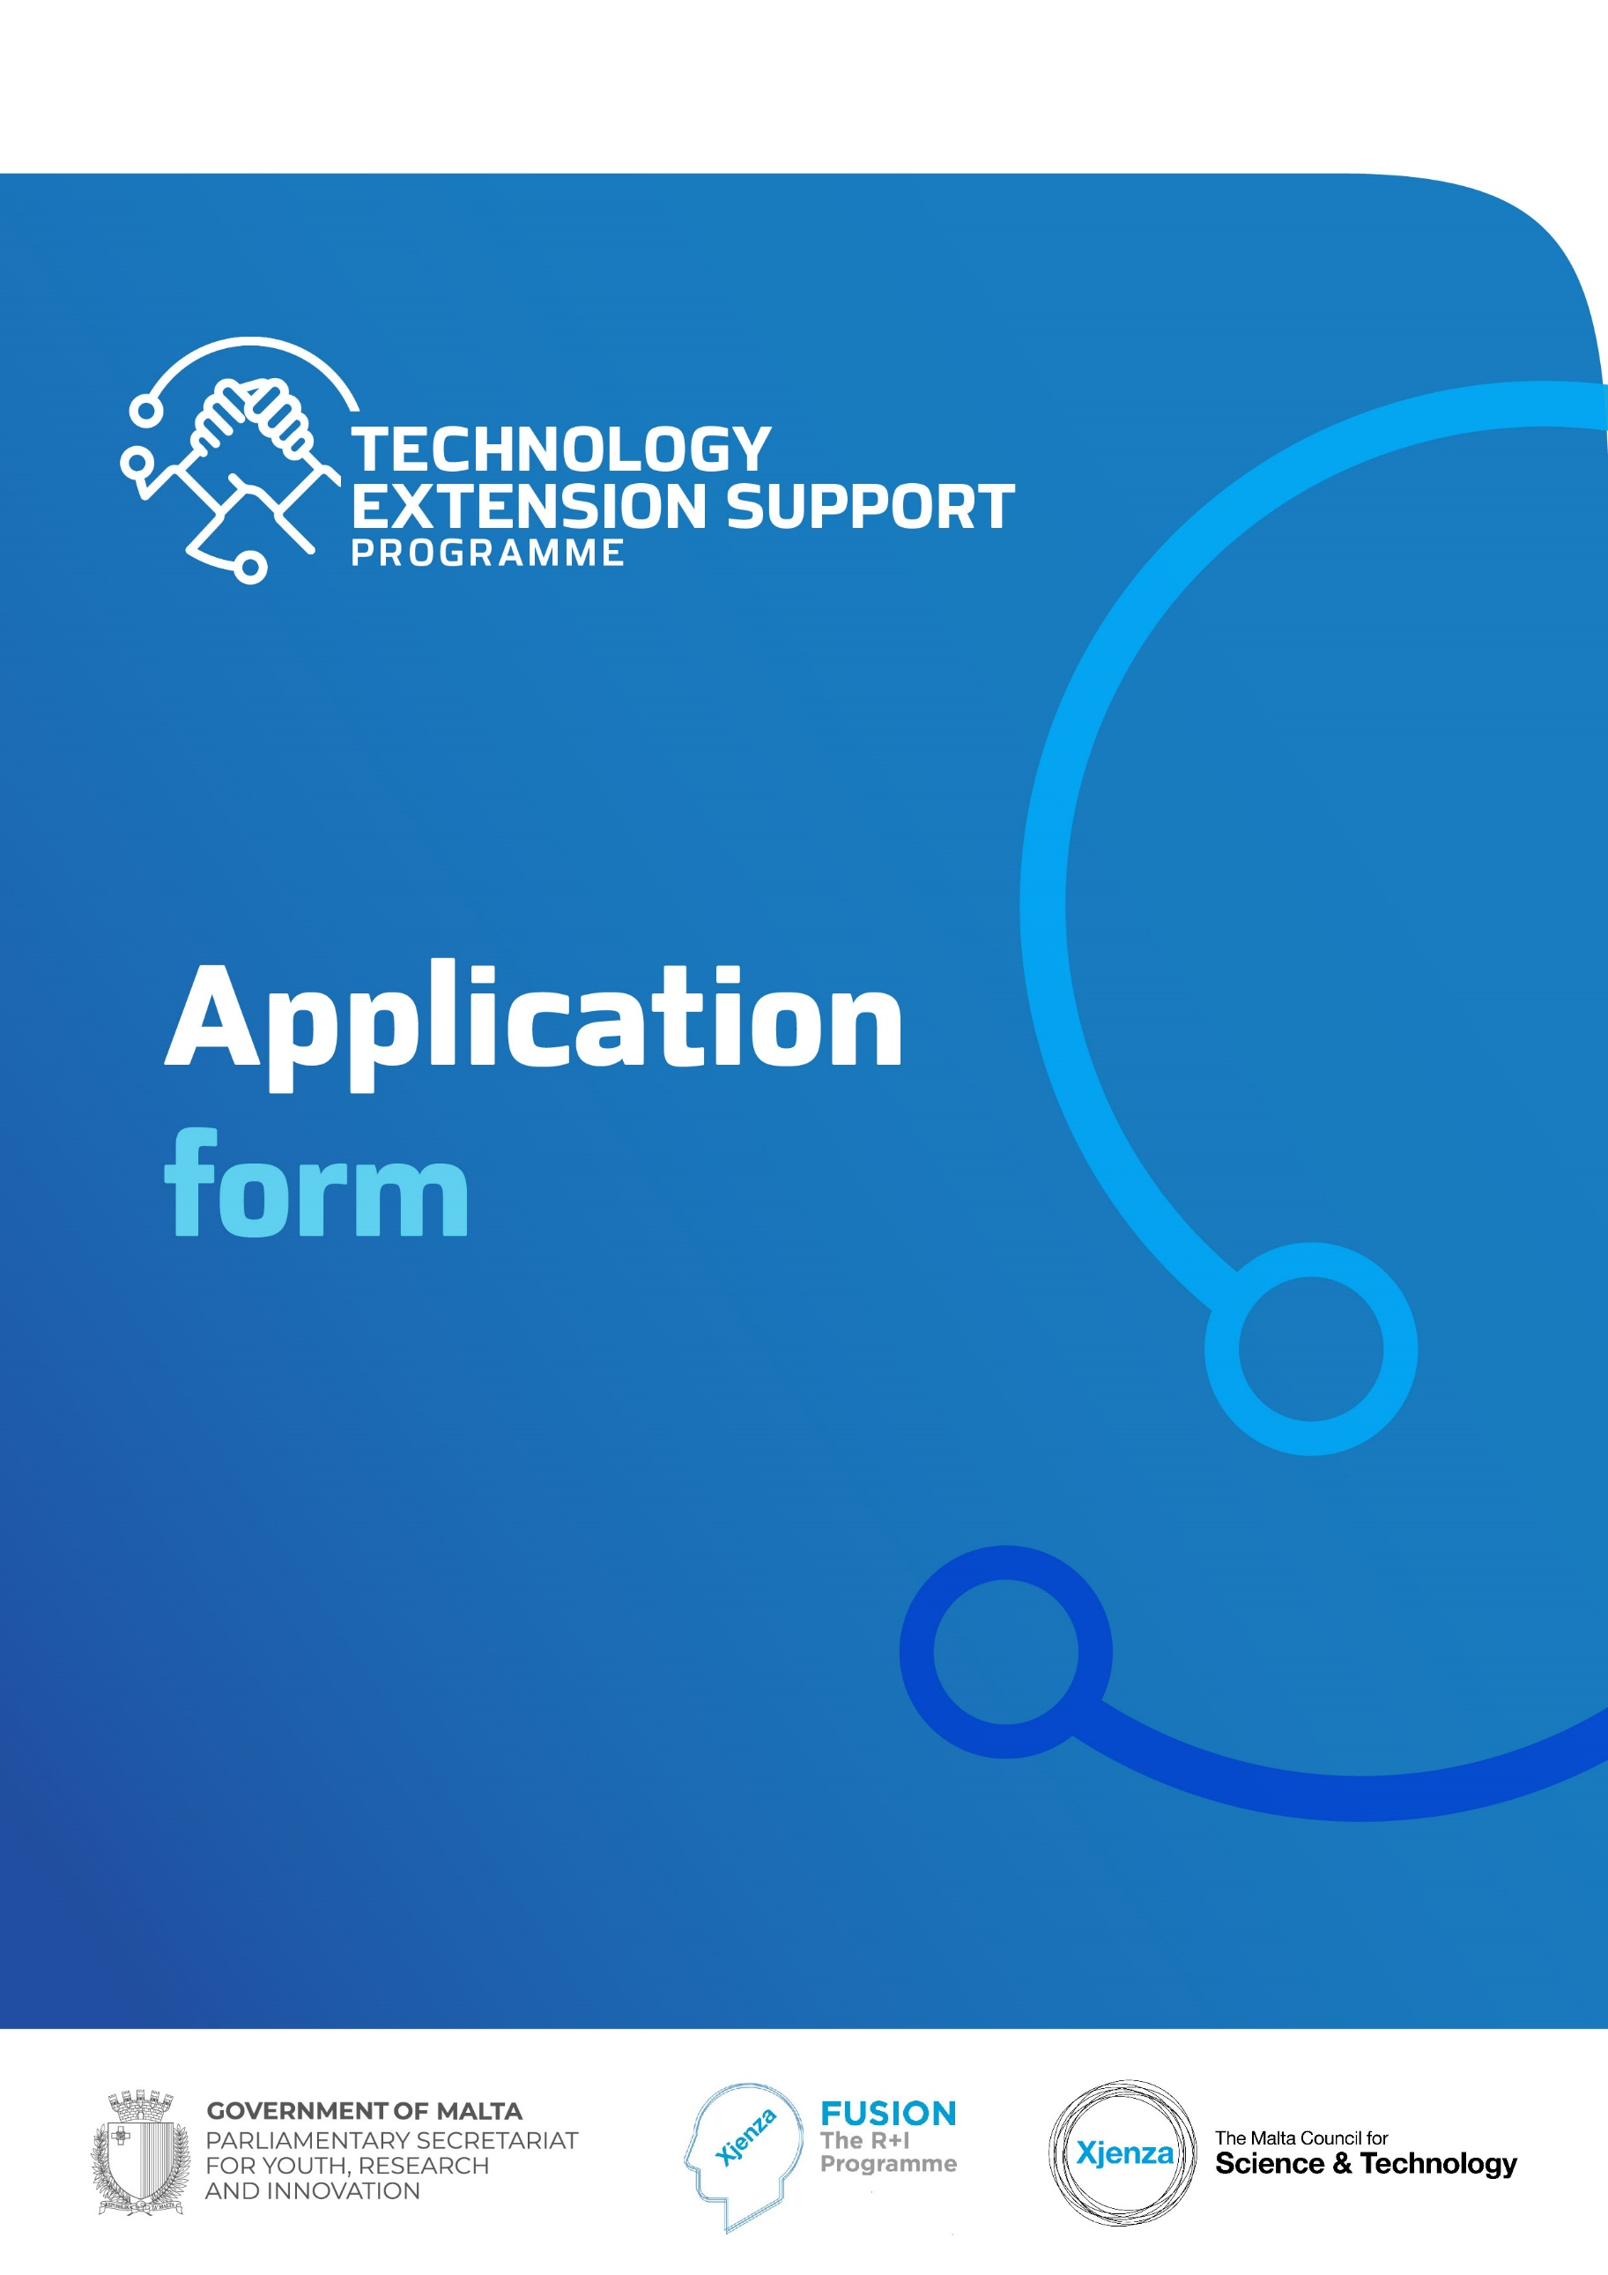

For Official Use Only
Application No:
SECTION ONE: APPLICANT’S DETAILS

Details of Entity
Name of Entity
Type of Entity |  | N.A.C.E Code (where applicable)
Contact Details: | Name and Surname
 | ID Card No./ Passport No.
E-mail |  | Tel. No.
Date of Birth |  | Mobile No.
Address
Website
No. of employees (FTE)
(where applicable)
Details of Higher Education Institute
Higher Education Institute

Name and Surname
(Contact Person)

Kindly make sure to:

- Submit the De Minimis State Aid Declaration

- Submit a Collaboration Agreement between the Private Entity and the Higher Education Institute

- Submit the Additional Declarations

- In case of Start Ups, kindly refer to the Rules of Participation for Financial Documents being Requested

SECTION TWO: PROPOSAL DETAILS

Kindly note that prior to filling in this application form, the applicant should have already discussed their requirements with the Higher Education Institute and agreed on a way forward (a Collaboration Agreement has to also be submitted).

Proposal Title and Acronym
Proposal Summary

Kindly provide a non-confidential summary of the project including a brief background, the problem to be resolved or the opportunity to be exploited and the approach to be undertaken (200 words limit).
Area of Product or Process Improvement – Refer to Appendix  (Scientific Areas as specific areas of Research)  Kindly include one specific scientific area of research, and the most applicable subarea/s (which do not necessarily pertain to the specific area selected, and should not exceed three different subareas) E.g. Health – Medical Devices | To include one specific scientific area of research, and the most applicable subarea/s (which do not necessarily pertain to the specific area selected and should not exceed three different subareas) by referring to the attached Appendix
Keywords | To include between three and five keywords to describe this proposal
Other Issues:

If applicable, briefly identify any gender considerations, ethical or legal issues that may be connected with the proposed project. Otherwise enter “N/A”.

- CHALLENGE IDENTIFICATION

- Provide background on how the proposed project came about, including what is the current state of the product/ process to be improved, and what was the trigger that resulted in this project being proposed for funding (500 words limit).

- Clearly define the challenge that the project seeks to address, including what is the reason why the product/ process improvement is required and how it is being planned to be addressed. Kindly include the main aim and any objectives pertaining to the project (500 words limit).

- PROPOSED SOLUTION

- What are the expected results from the Private – Higher Education Institute Partnership with respect to the current challenge identified? This should also include how the key results are expected to be measured and assessed (500 words limit).

- What influences and impacts can this improved product or process have on the applicant and consequently on the possible end-users? Is there the possibility for the proposed solution to result in further activity beyond the lifetime of the project? (500 words limit)

1.
Deliverables
List the deliverables of the proposed project, specifying the month of completion relative to start of project. Deliverable D1 to D4 are Mandatory deliverables. A maximum of 2 additional deliverables are allowed ie. deliverables D5 and D6.

Deliverables | Date
D1. Meeting with the MCST, which includes delivering a Presentation | Months 6, 12
D2. Article in local, public media | Month brian warrington
D3. End of Project Technical Report | Month 15
D4. End of Project Audited Financial Report | Month 17*
D5. brian warrington | Month brian warrington
D6. brian warrington | Month brian warrington

* Kindly note that this is the only deliverable allowed to exceed the project lifetime as per Rules for Participation.
Project Plan

Kindly note that a maximum of 3 work packages can be present in the project plan.
Work Packages

Work Package Description | Start Date | End Date | Duration
Overall Project | Month brian warrington | Month brian warrington | Month brian warrington
Work Package Number: 1  Work Package Leader: <Enter Name of Individual from Applicant Entity>  Work Package Title: Project Management  Work Package Description:  (max 100 words)  brian warrington  Deliverables pertaining to this Work Package:  (insert the number of the deliverable, ex. D1, and the description i.e.:  D1 Progress meetings with the Council  DX  brian warrington  Activities pertaining to this Work Package:  (provide a brief explanation on each activity – max. 50 words per activity)  brian warrington  Risks and mitigation strategies pertaining to this Work Package:  (provide a brief description on each activity – max. 200 words per work package)  brian warrington | Month 1 | Month brian warrington | Months  brian warrington
Work Package Number: 2  Work Package Leader: <Enter Name of Individual from Higher Education Institute>  Work Package Title: brian warrington  Work Package Description: brian warrington  Deliverables pertaining to this Work Package:  brian warrington  Activities pertaining to this Work Package:  brian warrington  Risks and mitigation strategies pertaining to this Work Package:  brian warrington | Month brian warrington | Month brian warrington | Month brian warrington

Information on experts within the private-HEI partnership who will work on the project

Applicant | Organisation  brian warrington
Brief Profile of the Applicant, including the principal activities and relevance to the project
brian warrington

 | CVs of the Individuals working on the Project are to be submitted as an Appendix

Collaboration with the Higher Education Institute

Higher Education Institute | Name of Higher Education Institute  brian warrington
Name of Contact Person
brian warrington

Department
brian warrington

Email and Mobile Number
brian warrington

Brief Outline of Expected Contribution to Project
brian warrington

 | CVs of the Individuals working on the Project are to be submitted as an Appendix

Project Costs
- Budget Summary
 | Eligible Direct Costs € | Eligible Indirect Costs € | Total Eligible Costs € | Requested Funding €
Applicant Entity  brian warrington | brian warrington | brian warrington | brian warrington | brian warrington
- Budget Details
Applicant Entity  brian warrington | Eligible Direct Costs € | Eligible Indirect Costs € | Total Eligible  Costs € | Requested Funding €
Personnel
(give details of position, duration, rate)
e.g. Researcher x 100 hours x €18.76/hr
brian warrington | brian warrington | brian warrington | brian warrington | brian warrington
Equipment (Purchase/Lease)  brian warrington | brian warrington | brian warrington | brian warrington | brian warrington
Consumables  brian warrington | brian warrington | brian warrington | brian warrington | brian warrington
Higher Education Institute Activities  Personnel  brian warrington  Replicate line items as necessary | brian warrington | brian warrington | brian warrington | brian warrington
Further Subcontracted Activities  brian warrington | brian warrington | brian warrington | brian warrington | brian warrington
Other Costs  brian warrington | brian warrington | brian warrington | brian warrington | brian warrington
Total | brian warrington | brian warrington | brian warrington | brian warrington
- Summary of Disbursements
Disbursements | Requested Funding (€)
Pre-Financing (75% of Total Requested Funding) | brian warrington
Retention (25% of Total Requested Funding) | brian warrington
Total | brian warrington

_________________________________________
Signature of Applicant Entity’s Legal Representative

<Insert Name of Applicant Entity’s Legal Representative>

_________________________________________
Signature of Principal Investigator from Higher Education Institute

<Insert Name of Principal Investigator from Higher Education Institute>

_________________________________________
Signature of HEI’s Legal Representative

<Insert Name of HEI’s Legal Representative>

The signatories to this application form are hereby confirming that the FUSION R&I: Technology Extension Support Programme ‘Rules for Participation’ are read and accepted.

Kindly make sure that the Appendices mentioned on Page 2 of the Application Form are submitted together with this document.

