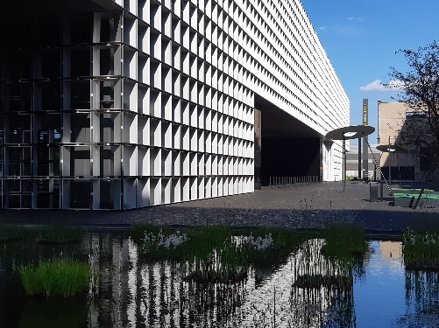 | 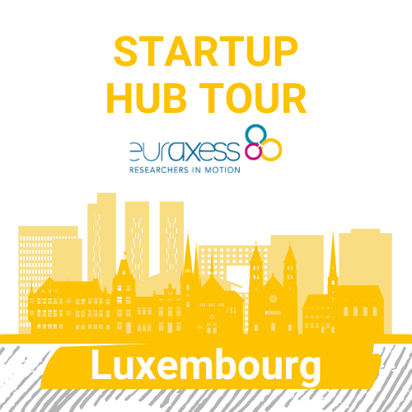 | 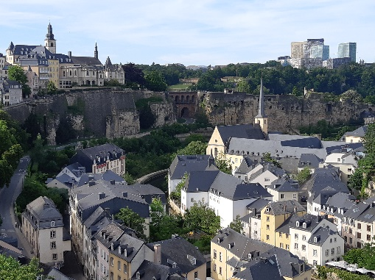

TOUR PROGRAMME OFFICIAL TOUR DATES (16th June 2022 tbc.)
29th June ESCH-BELVAL (City of Science)
9:00-9:45am | TECHNOPORT Incubator | Presentation of the tech incubator managing a.o. the Start-up Support Programme (SPP) of the European Space Resources Innovation Centre (ESRIC) (-> World’s first Space Resources Start-up Programme)
10:00-11:45am | University of Luxembourg Incubator | Presentation of the incubator supporting university students and staff across disciplines from idea generation for an entrepreneurial project to the go to market of their venture through events, mentoring and an acceleration programme,  Testimonial by Startup NIUM
noon | Lunch in Belval and travel to Luxembourg City by train/bus
2:00pm-3:45pm | Luxembourg City guided tour by foot
4:00-6:00pm | House of Startups | Presentation by Startup Luxembourg about Luxembourg’s Startup Ecosystem for startups visiting the ICT Spring Tech conference with networking cocktail
7:30pm | Dinner
30th June LUXEMBOURG CITY
8:30-9:30am | House of Entrepreneurship | Presentation of the one stop-shop and the Business mentoring programme of the Chamber of Commerce Luxembourg
10-10:45am | Interdisciplinary Center for Security, Reliability and Trust of the University of Luxembourg | TTO presentation of sciencepreneurship support through training and an acceleration programme followed by a startup testimonial
11:15-12:45 | House of Entrepreneurship | Presentation of the meta-incubator structure with visits of its individual incubators, the EU-Tribe initiative and the Luxembourg Business Angel Network (LBAN)
13:00 | Lunch

