Infectious Diseases Programme
Rules for Participation – Option B

Non-State Aid Regime

Version: 1.1
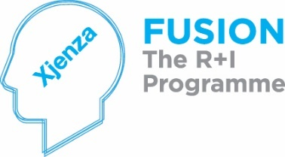
Issue Date: April 2021
Contents
1 Introduction 4
1.1 Designated Authority 4
1.2 FUSION 4
1.3 Infectious Diseases Programme Scope and Focus 4
1.4 Contact Point 6
1.5 Definitions 6
2 Eligibility for Participation 12
3 Funding Criteria 14
3.1 Project Duration 14
3.2 Application Process 14
3.3 Submission Deadline 15
3.4 Budget and Grant Value 15
3.5 Project Contact Point 15
3.6 Deliverables 15
3.6.1 Mandatory 15
3.6.2 Recommended 16
4 Eligible and Ineligible Costs 17
4.1 Eligible Costs 17
4.1.1 Categories 17
4.1.2 Additional Provisions 19
4.1.3 Aid Intensity 19
4.2 Ineligible Costs 19
5 Evaluation 21
6 Post Award Process 23
6.1 Grant Agreement 23
6,2 Start Date and End Date 23
6.3 Double Funding 23
6.4 Time Extensions 23
7 Funding, Management and Progress Monitoring 24
7.1 Allocation and Disbursement of Funding 24
7.2 Reporting 24
7.3 Accountability 26
7.4 Supervening Circumstances 26
7.5 Default 26
7.6 Interpretation of Rules 26
8 Confidentiality of Submissions 27
Appendix One 28
Appendix Two 29

Introduction

1.1 Designated Authority

This incentive is administered by the Malta Council for Science and Technology for an on behalf of the Foundation for Science and Technology (hereinafter referred to as the ‘Council’).

FUSION

FUSION is a national funding programme that drives and supports local Research and Innovation (R&I), as well as providing the necessary support for researchers and technologists to turn their innovative ideas into a market-ready reality. FUSION is supported through Malta Government funds and is managed by the Malta Council for Science and Technology (MCST) as the Managing Authority.

The main objectives of FUSION are: to raise the level and profile of locally funded research; to ingrain R&I at the heart of the Maltese economy; to spur knowledge-driven and value-added growth and; to sustain improvements in the quality of life. These can be achieved since research results and innovation have the potential of translating themselves into commercial activities which generate a multiplier effect on the economy, by increasing Malta’s competitiveness through the creation of additional high-value and knowledge intensive employment opportunities in Malta’s priority industries.

Infectious Diseases Programme Scope and Focus

As the current COVID-19 pandemic rages on, it is becoming clearer that the warning signs about pathogen threats were not heeded during the last decade. Using the COVID-19 R&D Fund as a launch pad, it is important to consider the lessons learnt and provide support for further infectious disease research in the local community. The Infectious Diseases Programme (IDP) will help funnel R&I investment to ensure we are better prepared for threats posed by infectious diseases.

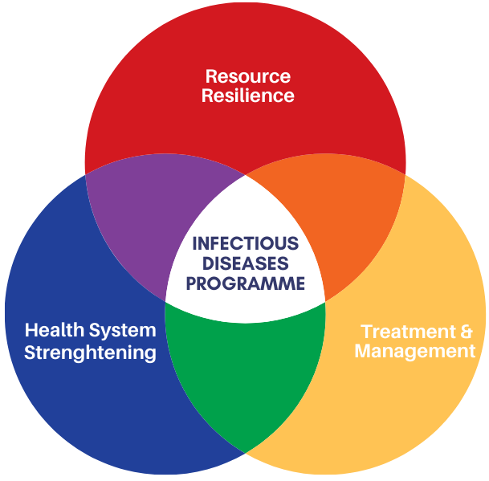

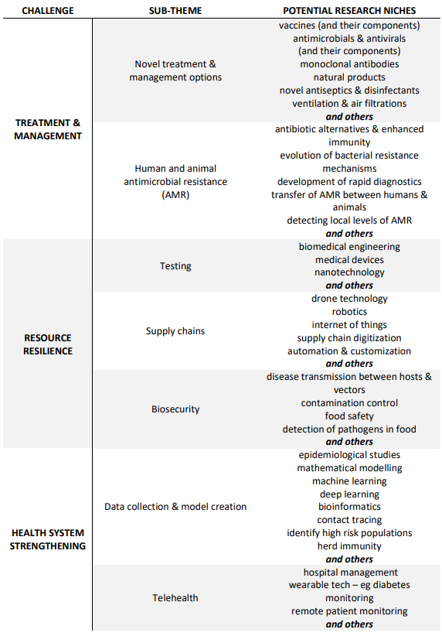

As we have seen, the effects of the pandemic not only had health implications but also socio-economic ones. Any plan to mitigate pandemics and infectious diseases has to take into consideration any R&I applied to the socioeconomic level as well. The biggest strength in these research areas lies in their interconnectedness. The research results can be amplified if multiple research areas are combined together. The proposed sub-themes below can be expanded even further and are by no means exhaustive. An attempt at expanding the sub-themes into research niches for the Infectious Diseases Programme has been summarised in the table above. The type of research applicable in this programme varies from basic to more applied types. A combination of both is needed to ensure effective outputs are produced in this research theme.

Contact Point

Correspondence should be directed to:

Mr Owen Zammit
R&I Programmes Executive
Email: owen.zammit.2@gov.mt
Tel: + 356 2360 2120

For escalated enquiries kindly contact:

Dr. Melchior Cini
Senior Executive, R&I Programmes Manager
Email: melchior.cini@gov.mt
Tel: +356 2360 2153

Definitions

Applicant means anyone eligible for participation in a Project in terms of these Rules for Participation and who consequently applies for funding under this Programme.
Arm's length means that the conditions of the transaction between the contracting parties do not differ from those which would be stipulated between independent enterprises and contain no element of collusion. Any transaction that results from an open, transparent and non-discriminatory procedure is considered as meeting the arm's length principle.
Council refers to the Malta Council for Science and Technology
Eligible direct costs are those costs incurred directly by the national beneficiaries during the duration of the project and used primarily for the purpose of achieving the objectives of the project. All eligible expenses must be incurred between the Start Date and the End Date of the Project and must be limited to the budgeted value.
End Date means the date when the Project Period, having commenced on the Start Date, expires. The Project Period is the time required to execute the Project as indicated in the grant agreement.
Innovation is defined as the internationally novel scientific/technological development of a technological process, product or service. Also, the definition of innovation within the same context can also be applied to non-novel, yet step-change/ground-breaking enhancement of existing technological processes, products or services, or even the application of existing knowledge to new novel applications of these solutions to deliver step-change competitiveness through such an application.
Project Value means the entire project budget including any co-financing.
Project Grant means the granted funding provided.
Partner is defined as a partner in a consortium of a funded national or transnational project
Personnel costs means the costs of researchers, technicians and other supporting staff to the extent employed on the relevant project or activity
Project Coordinator is one of the beneficiaries of a project consortium that is appointed as the single point of contact between the Lead Agency and/or the funding bodies and the consortium partners from proposal submission to project end. He/she will have the responsibility of ensuring that all the partners involved in the consortium are eligible and supervises the project workflow with the help of WP leaders. Additionally, he/she will be required to submit the project application on behalf of the consortium and must also compile and submit reports / deliverables to the funding bodies which in turn will relay these documents to the Lead Agency. Can also be referred to as Principal Investigator.
Project Contact Point is the individual, appointed to act on behalf of the National Applicant and who is responsible for communicating with the Council about the Project.
Public Entity is any Ministry, Department, Entity, Authority, Public Commission, Public Sector Foundation or similar organisation that does not carry out an economic activity within the meaning of Article 107 TFEU and that exercises public power, or else acts in its own capacity as public authority, where the activity in question forms part of the essential function of the State or is connected with those functions by its nature, its aim and the rules to which it is subject. However, the classification of a particular entity as an undertaking depends entirely on the nature of its activities, and the overriding criterion of consideration is whether it carries out an economic activity or not, e.g. an entity that is formally part of the public administration may nevertheless have to be regarded as an undertaking within the meaning of Article 107(1) of the Treaty. Thus, an entity that carries out both economic and non-economic activities is to be regarded as an undertaking only with regards to the former. In this case, if the economic activity can be separated from the exercise of public powers, than that entity acts as an undertaking in relation to that activity and the financing, the costs and the revenues of that economic activity shall be accounted for separately from the other non-commercial activities.
If an economic activity cannot be separated from the exercise of public power, the activities exercised by that entity as a whole, remain connected with the exercise of those public powers and therefore fall outside the notion of an undertaking.
Research and Development is defined as the systematic investigation, work or research carried out in any field of science or technology through experiment, theoretical work or analysis undertaken in order to acquire new knowledge, primarily directed towards a specific practical aim or objective, and includes:
- Fundamental Research means experimental or theoretical work undertaken primarily to acquire new knowledge of the underlying foundations of phenomena and observable facts, without any direct practical application or use in view
- Industrial Research means the planned research or critical investigation aimed at the acquisition of new knowledge and skills for developing new products, processes or services or for bringing about a significant improvement in existing products, processes or services. It comprises the creation of components parts of complex systems, and may include the construction of prototypes in a laboratory environment or in an environment with simulated interfaces to existing systems as well as of pilot lines, when necessary for the industrial research and notably for generic technology validation.
- Experimental Development means acquiring, combining, shaping and using existing scientific, technological, business and other relevant knowledge and skills with the aim of developing new or improved products, processes or services. This may also include, for example, activities aiming at the conceptual definition, planning and documentation of new products, processes or services.
Experimental development may comprise prototyping, demonstrating, piloting, testing and validation of new or improved products, processes or services in environments representative of real-life operating conditions where the primary objective is to make further technical improvements on products, processes or services that are not substantially set. This may include the development of a commercially usable prototype or pilot which is necessarily the final commercial product, and which is too expensive to produce for it to be used only for demonstration and validation purposes.
Experimental development does not include routine or periodic changes made to existing products, production lines, manufacturing processes, services and other operations in progress, even if those changes may represent improvements;
Research and Knowledge-dissemination Organisation means an entity (such as universities or research institutes, technology transfer agencies, innovation intermediaries, research-oriented physical or virtual collaborative entities), irrespective of its legal status (organised under public or private law) or way of financing, whose primary goal is to independently conduct fundamental research, industrial research or experimental development or to widely disseminate the results of such activities by way of teaching, publication or knowledge transfer. Where such entity also pursues economic activities, the financing, the costs and the revenues of those economic activities must be accounted for separately. Undertakings that can exert a decisive influence upon such an entity, in the quality of, for example, shareholders or members, may not enjoy preferential access to the results generated by it;
Start of Works means the earlier of either the start of construction works relating to the investment, or the first legally binding commitment to order equipment or any other commitment that makes the investment irreversible. Buying land and preparatory works such as obtaining permits and conducting feasibility studies are not considered start of works. For take-overs, ‘start of works’ means the moment of acquiring the assets directly linked to the acquired establishment; first firm commitment to the start of the project as per the contractual obligation/ MCST Grant agreement; feasibility studies are not considered start of works.
Start Date means the date which is stated in the grant agreement for the official start of the project.
Subcontracted Activity means any activity related to the project, (including but not limited to consultancy), which is not carried out directly by a Partner or its employees but is carried out by any third party (local or foreign) individual, company, partnership or entity, under arm’s length terms and conditions.

2 Eligibility for Participation

Any Public Entity or Public Research and knowledge-dissemination organisation based in Malta, and that does not carry out an economic activity within the meaning of Article 107 TFEU may apply and will be eligible for funding subject to the terms and conditions laid out in this document.
Any applicants that at the time of proposal submission are considered by MCST to be non-compliant with respect to Grant Agreement obligations on other active projects funded by MCST, may be immediately deemed ineligible at application stage or will not be awarded funding under this programme. This also applies to situations whereby the applicant is outside approved project timelines on other projects funded by MCST, and where the applicant is in recognised default.
Funding under this scheme is made available on the basis that the Applicant has not benefited and will not benefit from any other grant or financial incentive of whatever nature, applied for and/or utilised for the same costs and scope as that subject of the funding requested under this scheme.
Applicants under the non-state aid Option B regime must understand that, should they be found to be in breach of the conditions for being exempt from State Aid regulations, the Managing Authority will enforce the retrieval of disbursed funds with interest, in part or in full, as the case may necessitate.
The Applicant also undertakes to comply faithfully and immediately with any decision of the European Commission or a Maltese judicial authority declaring Article 107(1) TFEU to be applicable to this Agreement.
MCST also reserves the right to terminate any applications that have followed in part or in full the non-state aid Option B regime, should MCST not be satisfied with the segregation of work packages, activities, tasks and deliverables, as well as budgets.
All applications should be accompanied by the relevant Declarations duly completed within the Appendices of the Application Form with particular attention also being given to potential indirect state aid to undertakings within the same eventual project, should it be selected for funding.

3 Funding Criteria

3.1 Project Duration

Projects should last a minimum of one (1) year up to a maximum of two (2) years in 6-month increments. The possible project durations are 12, 18 or 24-month projects.

3.2 Application Process

The call will be open from the 29th of March 2021 till the 28th of May 2021 at 23:59 (CET).

Applications are required to be submitted electronically via email to ri.mcst@gov.mt. Only complete Application Forms will be considered. Applicants are to submit an application for assistance under this scheme before the start of works.

Submission, evaluation and selection of project applications will be in the form of a one-stage process. The applicant should ensure complete compliance to these ‘Rules for Participation’ prior to submission as no amendment or negotiations are allowed after submission and any unapproved deviations will result in the failure of the application during the administrative check.

Applications shall include the following:

- A complete Application Form in Word format (.docx)
- Curricula Vitae of the researchers involved
- IP Agreement (in the case of consortia)
- Declarations related to the non-state aid regime

All received applications shall be acknowledged by email to ri.mcst@gov.mt. Incomplete applications as at 28th of May 2021 23:59 (CET) will not be considered.

3.3 Submission Deadline

Deadline for application submission is Friday 28th May 2021 23:59 (CET).

3.4 Budget and Grant Value
The total maximum national budget for the call is €600,000.

The maximum amount that can be requested per project is €150,000.

3.5 Project Contact Point

The applicant/s shall appoint a Project Contact Point/s. The Project Contact Point/s shall have the following responsibilities:

- To ensure compliance with their obligations in terms of the Contractual Agreement;
- To compile Periodic Reports and Final Reports including their timely submissions and effective execution of the project;
- To ensure submission of all required financial reporting as per the contractual obligations for the partner.
- To execute the project activities according to set timeframes and deliverables.

3.6 Deliverables

3.6.1 Mandatory

The project plan must give details of certain activities which are required by the Council. These should be included as deliverables in the project proposal and include:

  - A showcase of the project to the general public by the national project partner through the publication of at least one (1) article per year in local newspapers, online platforms or magazines, including an acknowledgement to the Council. These should not contain intellectual property but should raise awareness about the project and its benefits.

  - By the end date of the project, the Applicant shall be required to provide a proof of submission of an article to an open access peer-reviewed journal. When included in the budget section, open-access fees will have to be incurred between the Start and End Date to be eligible.

Provided further that if the Beneficiary claims that such an attempt to publish this research paper will have been unsuccessful, the Beneficiary must prove to the satisfaction of the Managing Authority and through the submission of sufficient and adequate documentary evidence that such an attempt to publish a research paper in terms of the requirements of this Clause was in fact made. Sufficient and adequate documentary evidence includes evidence that the paper was actually submitted for publication and documentary evidence that the paper was rejected for publication. If the Managing Authority is satisfied with the evidence provided, then the Beneficiary will not be held in breach of this particular obligation.

A copy of all publications must be presented to MCST before any retention is disbursed.

  - Reporting on project progress as per the list hereunder in line with the templates provided by the Council;

- Hold a minimum of one meeting every 6 months to verbally update MCST on project progress;
- End of Stage Technical Report;
- End of Stage Financial Report;
- End of Project Technical Report;
- End of Project Audited Financial Report

The reports are to include sufficient evidence on the achievement of the project objectives as well as the parameters indicated in the application.

Changes to the project objectives, work packages and all the parameters committed in the applications are to be detailed, justified and approved by the Council.

3.6.2 Recommended

Further to the mandatory deliverables, the Council invites applications to also include deliverables as recommended below, subject to the nature of the research project:

- Monograph/s and/or peer-reviewed paper/s for accepted publication in international journal/s and/or conferences of repute based on the work carried out throughout the Project. The subscription levels, impact factor and open sources should be considered in the selection of journals and conferences. Similar papers published on open source media would also be considered favourably.

- Oral presentation/s at international conference/s on the work carried out through the Project.

- The attainment of undergraduate degrees and/or postgraduate degrees and/or post-doctoral research. In cases where the project duration is insufficient for the purpose of submitting a degree, there has to be a commitment to complete the degree outside the duration of the project utilising other sources of funding.

- Registration of a patent or other Intellectual Property Rights stemming from the Project, in Malta as well as in any other country.

- Commercial commitments such as technology innovations to be included in a partner’s existing product or service.

- Commercial commitments such as technology transfer licences.

- Dissemination activities, including but not limited to, local newspapers, conferences, publications, project exhibitions etc (preferably open access)

4 Eligible and Ineligible Costs

4.1 Eligible Costs

Eligible direct costs are those costs incurred directly by the project partner during the duration of the project and used primarily for the purpose of achieving the objectives of the project.

All expenses must be incurred between the Start Date and End Date of the project and must be limited to the budgeted value.

4.1.1 Categories

        - Personnel costs

Wages of researchers and technical personnel, and other supporting staff, to the extent and for the duration that they are directly engaged on the approved research project.

i) All employees in respect of whom wage costs are claimed must be registered with Jobsplus and covered by a valid contract of employment in terms of the national legislation on employment.
ii) Personnel Costs related to Project Management are further limited to 10% of the project value.
iii) Students can be engaged on the project and paid an annual stipend of €6,000 when reading for a master’s degree or an annual stipend of €8,000 when reading for a Doctoral degree. Note that for every engaged student, a full-time researcher must be employed by the applicant.
iv) Personnel costs are calculated as follows:
The hourly rate (z) is calculated using the formula:
€ z = (basic salary + allowances) / yearly weekday hours.
The total hours worked by a full-time employee shall not exceed 1760 hours per annum.

Role in Project | Hourly rates 2021 | Hourly rates 2022 | Hourly rates 2023 | Limits per project
Management | up to €41.49/hour | up to €43.56/hour | up to €45.74/hour | Max 4 per project
Senior Researcher[1] or equivalent | €23.96/hour to €33.68/ hour | €25.16/hour to €35.37/ hour | €26.42/hour to €37.14/ hour | No Limits
Researcher[2] or equivalent | €13.29 to €23.95/hour | €13.96 to €25.15/hour | €14.66 to €26.41/hour | No Limits
Operational, technician, research support assistant or equivalent | up to €13.28/hour | up to €13.95/hour | up to €14.64/hour | No Limits
[1] The term ‘senior researcher’ is to be used for a postdoctoral researcher with a specialist and high level of local and international experience in the field. Individuals possessing a high level of experience in industry can still be considered. The applicant is to confirm this judgement with MCST well in advance of submitting the application form.
[2] The term ‘researcher’ is to be used for a Bachelor’s, Master’s or a Ph.D. degree holder and hence the hourly rate should be equivalent to the degree held by the relevant individual.
Personnel in salary brackets that are higher than those noted above will still only be reimbursed at the rates of the eligible brackets above depending on their role in the project. The hourly rates will have to be noted in the application along with the number of hours on the project per individual.
- Filled time sheets are to be retained for all personnel, including students, as proof of number of hours spent on the project. Documentation of the utilisation of the employees’ internally funded research quota for other research activities is to be retained as this evidence may be required by the auditors.

        - Specialised equipment and research consumables

Purchase of specialised equipment including software. An explanation of the relevance of the equipment in relation to the project, including specification where applicable, is required. Overall value of consumables typically cannot exceed 30% of project value. Proposals with consumables exceeding 30% of the project value need to be discussed at application stage.

        - Other operating expenses

Other operating expenses incurred directly as a result of the project. These must be approved beforehand by the Council and must not fall under ineligible costs. Details shall need to be provided in the National Application Form and ideally would have been discussed with the National Contact Point before submission.

        - Overheads

Overheads (also known as eligible indirect costs) that are incurred directly as a result of the project will be covered at 10% of direct eligible costs, excluding the costs of subcontracting.

        - Subcontracted activities

Subcontracted Activity means any activity related to the project, (including but not limited to consultancy), which is not carried out directly by a Partner or its employees, but is carried out by any third party (local or foreign) individual, company, partnership or entity, under arm’s length terms and conditions.

Such expenses may include expenses incurred in relation to:

- costs of contractual research and other relevant research services, including costs for digital and computing services;
- knowledge and patents bought or licensed from outside sources in arm’s length transactions

It is understood that the applicant will be carrying out the main research and development of activity, however, the extent of eligible subcontracted activity will be evaluated on the merits and nature of the projects submitted. Subcontracting Activities totalling more than 25% of the project value, need to be justified.

4.1.2 Additional Provisions

Eligible Costs are to conform to the following and are subject to the final audit scrutiny:

- Any expenses incurred during the project must be consistent with the principles of economy, efficiency and effectiveness.
- Public entity partners are to follow Public Procurement Regulations in their entity.
- For personnel which are yet to be recruited for the project, a job description highlighting requirements of the role and role on the project, is to be submitted at the application stage.
- In the case of consortia, commercial transactions between any applicants or consortium partners, or between any applicants or a consortium partner and a company with similar shareholding to a consortium partner, is not allowed. All transactions need to be carried out in line with the arm’s length principle outlined in Section 1.5 of the National Rules for Participation.

4.1.3 Aid Intensity

The financial contribution to a Partner where State Aid is not applicable shall be 100% of the eligible costs incurred by that Partner. Should at any point in time the Council or any other relevant entity deems that the project constitutes State Aid, the beneficiary will be required to follow State Aid Regulations and this in turn may result in the recovery of funds.

4.2 Ineligible Costs

The following shall be considered as ineligible costs:

- Expenses related to loans, interest, etc
- Recoverable value added tax
- Expenses which are recoverable through other funding mechanisms
- Re-purchase of equipment originally procured through other funding mechanisms
- Purchase of equipment or services from partners or their subsidiaries within the consortium
- Opportunity costs related to foregone production and production downtime arising from the allocation of resources to the Project
- Any activity related to the reproduction of a commercial product or process by a physical examination of an existing system or from plans, blueprints, detailed specifications or publicly available information
- Standard office equipment & stationery
- Personnel hours for travelling
- Conference organisation
- Any other costs not listed down in Section 4.1

5 Evaluation

Project applications will be evaluated through a three-step process.

Primarily, projects will undergo an administrative compliance evaluation. At this stage, if any errors with the budget are noted the budget will be either considered as a major deviation or minor deviation. Major deviations refer to cases were ineligible costs amount to 10% or over of the project grant whereas minor deviations are under 10% of the project grant. For example, if the grant value requested is €100,000, any errors in the budget exceeding €10,000, would be considered as a major deviation. Major deviations will be considered administratively non-compliant whereas minor deviations will be amended by the Council and sent for external evaluation with the beneficiaries given the opportunity to approve or reject the new conditions following the external evaluation.

If successful, projects will be forwarded to three external evaluators for External Evaluation and then for Due Diligence. Further assurances, such as bank guarantees, may be required at the discretion of the Council. Failure to achieve a minimum of 60% pass from External Evaluation will lead to the termination of the project. For a project to be successful, it must pass from all three steps.

External Evaluators will be evaluating applications on the following criteria:

Criteria | Points | Questions | Scoring
Excellence | - Clear objectives pertaining to the programme  - Clear & detailed description of the challenges that the project addresses  - High quality research question investigated by the project together with an appropriate solution  - Clear description of the technological and scientific methods to be used  - Project originality and use/combination of new techniques | 1. Does the proposal address one or more sub-themes of the Infectious Diseases Programme? Are the objectives clear and pertinent to the programme?  2. Are the challenges that the project sets out to tackle, described in detail?  3. Are the research question and provided solution of high quality?  4. Is the scientific approach to be taken sound and credible?  5. Does the project provide innovative techniques to target the intended objectives? | 40  Threshold = 25
Impact | - The value creation for the country in the short, medium and long term  - The benefit/s is/are different from already existing solutions  - Key stakeholders  - Appropriate TRL values indicated  - Extra value creation that can benefit other fields | 1. What are the intended benefits for the country in the short and long term?  2. Has the applicant effectively distinguished their innovation from other available solutions? To what extent is the proposed idea better and/or significantly different to other alternatives?  3. Have key stakeholders been identified and elaborated upon, where these are key to the implementation of the outcomes of the project?  4. Does the project fall under the appropriate TRL? What is the TRL increment that can be achieved with such funding?  5. Is the value created, translatable to other research areas? | 35  Threshold = 20
Implementation | - Knowledge protection  - Personnel – diverse & experienced  - Realistic work packages containing measurable criteria  - Risk assessment  - Regulatory, legal and ethical aspects covered | 1. Does the proposal include a knowledge-protection strategy, including specific considerations to measures to safe-guard IPR?  2. Do the project personnel have enough experience and expertise to conduct the project effectively in a timely manner?  3. Are the proposed work packages realistic with regards to timelines and finances? Do the work packages have measurable criteria?  4. Have potential risks with the project been identified? What are the mitigation strategies have been outlined?  5. Have regulatory, ethical and standards requirements been addressed or at least considered? | 25  Threshold = 15

6 Post Award Process

6.1 Grant Agreement

For each project approved for funding, individual Grant Agreements will be signed between the beneficiaries and the Council.

The Grant Agreement will serve as a basis for the project funding and will regulate the transfer of funds to national beneficiaries, based on these regulations. The beneficiary is to sign the Grant Agreement within one (1) week of its presentation by the Council. Failure to comply with the stipulated timeframe, will result in a withdrawal of the offer for funding.

The Council reserves the right not to proceed with signing any Grant Agreement in the event that it results that doing so would be too high an exposure risk to the Council.

6.2 Start Date and End Date

The project will start on a pre-determined date as agreed by all the respective parties and determined in the Grant Agreement, which date shall be a date after the date of signature of this agreement by the Executive Chairman of the Malta Council for Science and Technology (hereinafter the “Agreement Date”).

Between the Agreement Date and the Start Date, the Project Contact should ensure that all activities required for a smooth project start are completed.

To be eligible for funding, all expenses must be incurred between the Start Date and the End Date of the Project.

6.3 Double Funding

Funding under this Programme is made available on the basis that none of the project Partners have benefited and will not benefit from any other grant or financial incentive of whatever nature, applied for and/or utilised for the same scope as that subject of the funding requested under this Programme. Provided that, in the case where the application covers work that is part of a larger project, the Partner must submit a table as an appendix to the application form that shows a comprehensive list of the items of work and the source of funding for each item.

By signing the Grant Agreement, project partners are automatically accepting and authorising MCST to exchange essential information related to the project with other funding agencies, both local and overseas, for any necessary checks. Any occurrence of double funding should be communicated in writing to the Unit Director prior to the signing of the Grant Agreement.

6.4 Time Extensions

Time extension requests are to be submitted electronically in a formal letter to ri.mcst@gov.mt, by not later than one (1) month before the original stage end date. Such extensions will be granted at the sole and unfettered discretion of MCST and may only be up to a maximum of six (6) months per project.

7 Funding, Management and Progress Monitoring

7.1 Allocation and Disbursement of Funding

For the purposes of funding and reporting, a project submission shall be divided into a number of Stages. Total financial contribution over the lifetime of the project shall not exceed the funding limit as established in the Grant Agreement, irrespective of actual expenditure.

The periodic funding will be allocated according to the following schedule:

- At the beginning of each stage, MCST will provide the relevant pre-financing to the lead beneficiary. This will include both direct and indirect eligible costs.

- A retention consisting of 20% of the project grant shall be withheld by MCST and only released upon successful completion of the project. This is deducted from the funds allocated for the last stage and from the preceding stage, if necessary.

- In the case of a single-Stage project (one 12-month period), the prefinancing will be equivalent to 80% of the project grant.

- The Project Coordinator will be required to submit a Technical Stage Report at the end of each stage and, within one month, a Financial Stage Report. The latter should contain details of actual expenditure over the past stage, together with an updated forecast of projected expenditure for the following stage. Such details must be broken down for each Project Partner.

- Normally underspends are retrieved by MCST following the financial audited report. However, MCST reserves the right to modify tranche payments if it deems that the underspend within the previous stage is considerable.

- In cases where an extension is required, beneficiaries are expected to notify MCST, in writing, at least one month prior to the deadline. Such notification should be sent to the Council keeping ri.mcst@gov.mt in copy.

7.2 Reporting

For all projects, the Project Contact will be required to submit a Final Technical Project Report together with a Final audited Financial Report covering the work and expenditure undertaken during the entire project, by not later than four (4) weeks from the stipulated end of project termination date.

The Final Financial Report is to be audited by a certified auditor. For the Final Financial Report, the beneficiary shall appoint an auditor to conduct a detailed financial audit, following the completion of the project. The audit will consist of, at least, the following checks:

- Accounts
- Physical inventory
- Timesheets and payslips / employee contracts
- Receipts for all equipment and consumables

The Council reserves the right to appoint an auditor to audit the Project Financial Audit as submitted.

For projects longer than twelve (12) months, the project is to be broken down into two Stages, with the end of Stage 1 and the beginning of Stage 2 coinciding with the mid-point of the project duration. For such projects, there is an additional interim reporting requirement, i.e. an end of Stage Technical report and an end of Stage Financial report. These must be submitted within two (2) weeks of the end of Stage 1.

The Interim Technical and Financial Reports shall contain the following details:

- An account of project activity and achievements over the past stage compared with the originally submitted application.
(ii) An account of actual expenditure over the past stage compared with the originally submitted budgeted expenditure. All financial reports must be signed by the person responsible for the financial management.
(iii) An updated forecast of project activity and projected achievements for the following stage.
(iv) An updated forecast of projected expenditure for the following stage.

The templates provided by the Council should be used to develop the End of Stage Technical and Financial Reports as well as the Final Technical and Financial Reports.

The Council may at any time request supplementary information and documentation on the projects and may request progress meetings. The Council may make such additional enquiries into a project as deemed necessary.

Any required documentation not submitted within Stage reports (interim reporting) or Final Reports, or documentation not submitted within the specified timeframes, may render the whole project ineligible and may result in the Council recovering all funds disbursed across the project.

In the event that a project is found to be in breach of the Grant Agreement or to materially depart from the submitted application, the Council reserve the right to discontinue the award and the applicant may be required to refund the Grant in part or in full. In any such event, the Council may also exclude an applicant from participating in future calls.

7.3 Accountability

The Beneficiaries shall keep a specific project bank account and records, clearly distinguishable from their other accounting records. All relevant expenses must be recorded in these accounts. All funding payments by the Council must be deposited in the project bank account.

Eligible expenses must have been determined in accordance with the usual accounting and management principles and practices of the applicant. Direct eligible costs must be backed up with the relevant documentation as specified in the Grant Agreement.

7.4 Supervening Circumstances

The Project Contact Point is obliged to immediately advise the Council of any internal or extraneous significant event which might affect the validity or implementation of the project. This obligation applies to the entire period between the submission of the Project Application and the completion of the project.

The Council, at its own discretion, shall either give such directives as it deems necessary for the furtherance of the project or re-assess the project in its entirety accordingly.

Failure on the part of the Project Contact Point to respect this obligation may lead the Council to suspend or terminate funding for the project and request a refund of funds already paid out.

If during the course of a project a partner withdraws from the Project Consortium, the Applicant will immediately advise the Council. In this event, the relevant articles of the Project Consortium Agreement and the National Grant Agreement shall apply.

7.5 Default

If the implementation of a project becomes impossible or if the Applicant fails to implement it, the Council shall be entitled to collect refunds of money already paid out.

7.6 Interpretation of Rules

This document endeavours to establish comprehensive and unambiguous rules governing participation in this initiative. However, should circumstances arise where the rules are inadequate, unclear, ambiguous or conflicting, the Council shall exercise its discretion in the interpretation of the rules through the setting up of an ad hoc committee.

8 Confidentiality of Submissions

Unless otherwise indicated, all project application submissions except for the abstract shall be treated in strict confidence.

The data collected by the Council via the application for the aid and its subsequent processing by the Council to evaluate data subject’s request for aid under the Scheme is in line with:

- The National Rules for Participation

- Data Protection Act, Chapter 586 of the Laws of Malta and Regulation (EU) 2016/679 of the European Parliament and of the Council of 27 April 2016 on the protection of natural persons with regard to the processing of personal data and on the free movement of such data, and repealing Directive 95/46/EC (General Data Protection Regulation).

- The legitimate basis to process personal data submitted by the data subject by virtue of his/her written application for aid is Regulation 6 (1)(b) of the General Data Protection Regulation (“GDPR”), as ‘processing is necessary in order to take steps at the request of the data subject prior to entering into a contract’.

Further information may be found within the Application Form.

Appendix One

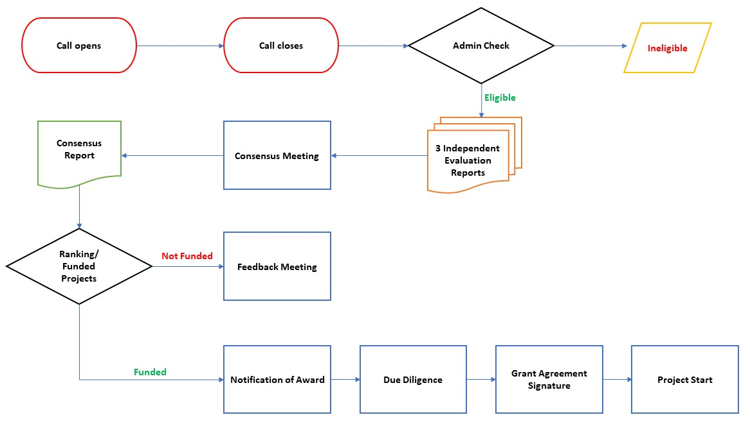

Appendix Two

TECHNOLOGY READINESS LEVELS (TRLs)- TRLs are a means to define endpoints of projects along the innovation axes from Basic Research to the Market, ranging from TRL 1 (Basic Concept) to TRL 9 (Market Entrance).
Technology Readiness Level | Definition | Explanation
TRL 1 | Basic principles observed and reported | Lowest level of technology readiness.  Process concept with basic scientific foundation
TRL 2 | Technology concept and/or application formulated | Scientific research begins to be translated into applied research and development. Applications are speculative and may be unproven.
TRL 3 | Analytical and experimental critical function and/or characteristic proof-of-concept | Active research and development is initiated, including analytical / laboratory studies to validate predictions regarding the technology.
TRL 4 | Scientific & process validation in laboratory environment | Basic technological components are integrated to establish  that they will work together.
TRL 5 | Scientific & process validation in intended environment | The basic technological components are integrated with reasonably realistic supporting elements so it can be tested in a simulated environment.
TRL 6 | System / subsystem model or prototype demonstration in an intended environment (ground or space) | A representative model or prototype system is  tested in an intended environment.
TRL 7 | System (full-scale) prototype demonstration in a real operational environment at pre-commercial scale | A prototype system that is at the planned operational system.
TRL 8 | Actual system completed and validated as capable commercial system | In an actual system, the technology has been proven to work in its final form and under expected conditions.
TRL 9 | Full commercial application and technology available for consumers | The system incorporating the new technology in its final form has been used under actual mission conditions.

