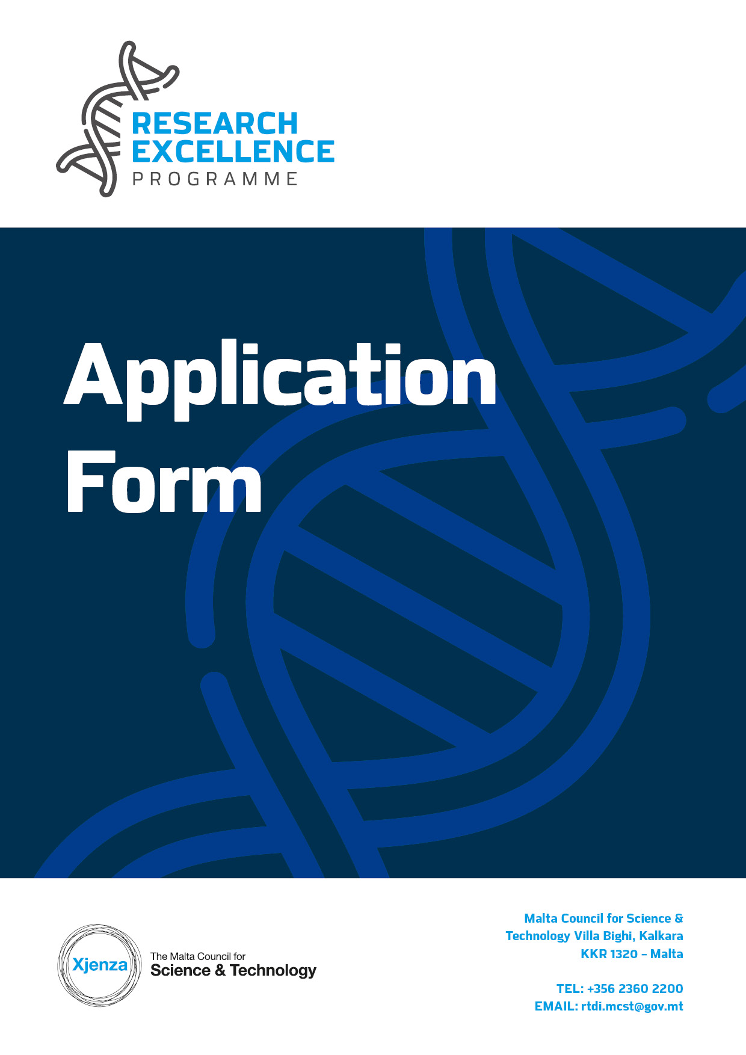

SECTION ONE: APPLICANT’S DETAILS
For Official Use Only
Application No:

Details of Entity
Name of Entity |  | Department/ Institute/Centre  Name (where applicable)
Type of Entity | (Choose between Maltese Public or Maltese Private Body) | N.A.C.E Code (where applicable)
Contact Details: | Name | Title
 | ID Card No.
E-mail |  | Tel. No.
 |  | Mobile No.
Address:
(Please provide full postal address and website)
No. of employees  (FTE) (where applicable) |  | Turnover of business in last financial year  (where applicable)

Provide a profile of the entity – principal activities and profile including resources relevant to the project.
Applicability of State Aid de minimis  Please note that this section is compulsory | Please tick whether your application falls under State Aid de minimis Regulation or State Aid Not Applicable.  Applicants may only opt for one option. Selecting more than one option will be ineligible.  State Aid de minimis – Please fill in de minimis Appendix 1  State Aid Not Applicable – Please fill in Appendix 2 (Public Research and Knowledge Dissemination Organisation that does not carry out an economic activity) or Appendix 3 (Public Entity that does not carry out an economic activity).  In the following space, please provide a justification if you selected the “State Aid Not Applicable” option.

SECTION TWO: PROPOSAL DETAILS
Proposal Title and Acronym
Hypothesis Question
Abstract

Kindly provide a non-confidential summary of the project including a brief background, the problem to be resolved or the opportunity to be exploited and the approach to be undertaken.
Area of Study

Kindly include the overarching field and specific area of research (Eg. Natural Sciences – Biochemistry).
Keywords

Kindly include between three and five keywords to describe this proposal
Other Issues: If applicable, briefly identify any gender considerations, ethical or legal issues that may be connected with the proposed project. Otherwise enter “n/a”.

1. EXCELLENCE
- What is the current relevant research in the field and how will your research go beyond it? Make reference to and distinguish your proposal from previous work / projects within the area.

- What are the specific project objectives and aims?

- Will the project make use of novel research, applications, theories, etc. as part of its method?
- Describe how the project has the potential to develop the organisation’s research base? Will the project upskill current or existing researchers?

2. | IMPACT
 | - Describe the potential impact of the proposed research? Will the research result in a disciplinary or interdisciplinary advancement?
- Does the project address National, European Union or Global Priorities? What influences and impacts can the research have on possible end-users, other researchers or society at large?

1.

- What is the mechanism for assessing success and evaluating outcomes? In the case of positive outcomes please describe the strategy for further research?
- Outline potential impacts generated from any dissemination measures and describe in detail the possibility of journal publications?

3. Implementation
  - Deliverables
List the deliverables of the proposed project, specifying the month of completion relative to start of project e.g. Month 6, Month 12 etc. Note that the deadline for any particular deliverable would be the end of the respective Month specified.
The deliverables should include:
- Those specific to the project for example tangible events and/or reports related to installation, testing, implemented procedures and so on;
- The ‘mandatory deliverables’ required by the Council as per the Rules for Participation ie.
- Meetings with the Council
- Reports to be submitted to the Council:
  - Final audited financial report
  - End of project technical report
Deliverables | Date
Dbrian warrington. 1 Meeting with the MCST with Presentation | Month 6
Dbrian warrington. Final Technical Report | Month 12
Dbrian warrington. Audited Financial Report | Month 13
Dbrian warrington. brian warrington | Month brian warrington
Dbrian warrington. brian warrington | Month brian warrington
Add as required | Add as required

  - High Level Project Plan

This section should include a list of deliverables and activities (tasks) that the applicant is responsible for, the start date, end date and duration of the task. There is one mandatory work package: Project Management and will be work package 1

Work Package Description | Start Date | End Date | Duration
Overall Project | Month brian warrington | Month brian warrington | Month brian warrington
Work package number 1  Work Package leader <Enter Name of Individual>  Work package title Project Management  Work package description (max 100 words)  brian warrington  Deliverables pertaining to this Work Package (insert the number of the deliverable, ex. D1)  D1 Progress meetings with the Council  D2 Progress monitoring and coordination with partner  D3 Recruitment  D4 Reporting  Activities pertaining to this Work Package (provide a brief explanation on each activity – max. 50 words per activity)  Risks and mitigation strategies pertaining to this Work Package: (provide a brief description on each activity – max. 200 words per work package)  brian warrington | Month 1 | Month brian warrington | Months  brian warrington
Work package number brian warrington  Work Package leader <Enter Name of Individual>  Work package title brian warrington  Work package description and Activities (max 250 words)  brian warrington  Risks and mitigation strategies pertaining to this Work Package: (provide a brief description on each activity – max. 200 words per work package)  brian warrington | Month brian warrington | Month brian warrington | Month brian warrington

  - Detailed information on experts who will work on the project.
This section should provide an overview of the applicant and establish their ability to carry out the project (e.g. track record, skills and competencies, etc.). Applicants should use this space to promote their expertise to external evaluators.
Relevant information on the individual should be submitted in order to show:
• If any of the individuals worked on a previous R&I Project that was successfully completed.
• If any of the individuals published any scientific papers or supervised graduates or post graduates as an outcome of an R&I Project in a related field.
Should there be any changes to the key researchers highlighted herein, the Council must be notified in writing with immediate effect. If a key researcher has not been employed prior to the submission of this application form, a profile of the expertise required should be noted herein.

Applicant | Organisation  brian warrington
Profile of Organisation including key researchers
brian warrington
 | CV of the Individuals working on the Project are to be submitted as an Appendix (an example can be found therein)

  - Collaborator (Optional).
If support is to be given from other entities, please provide the information in the table below. A specific letter of intent must also be submitted as evidence of support. Please replicate the table if necessary.

Collaborator | Organisation  brian warrington
Profile of Organisation including key researchers
brian warrington
Brief Outline of Expected Contribution to Project
brian warrington

  - Budget Section
  - Budget Summary
 | Eligible Direct Costs € | Eligible Indirect Costs € | Total Eligible Costs € | Requested Funding €
Lead Partner  brian warrington | brian warrington | brian warrington | brian warrington | brian warrington
  - Budget Detail by Organisation
Give an estimate of the project budget in Euros (€), broken down per participant per stage. An excel sheet is uploaded on the website together with the application form to assist in the calculations.
- Eligible direct costs:
  - Personnel
Give details of position, hourly rate, duration in number of hours, in the format of: research assistant x €18.76/hour x 100 hours. Hourly rates should include National Insurance and Inland Revenue and allowances. Please specify if existing or new and it Management, researcher or assistant.
  - Travel capped at €2,000
  - Consumables
  - Equipment
  - Subcontracted Activities
  - Scientific Information
  - Other
- Eligible indirect costs are calculated at 10% of the direct costs, excluding the costs of subcontracting.
- Audit fees must form part of the indirect costs and therefore should not be input as a separate budget line.
- Total eligible cost is the sum of eligible direct and indirect costs
- Requested Funding is calculated as a percentage of the total eligible cost
  - Maltese Public Entity or Maltese Public Research and Knowledge Dissemination Organisations, that do not carry out an economic activity, applying under the non-state aid route at 100%
  - Maltese undertakings that carry out an economic activity applying under the De minimis route at 90%

- All figures should be provided to the nearest Euro.

Applicant  brian warrington | Eligible Direct Costs € | Eligible Indirect Costs € | Total Eligible  Costs € | Requested Funding €
Personnel
(give details of position, duration, rate)
e.g. researcher x 100 hours x €18.76/hr
brian warrington | brian warrington | brian warrington | brian warrington | brian warrington
Equipment (Purchase/Lease)  brian warrington | brian warrington | brian warrington | brian warrington | brian warrington
Subcontracting  brian warrington | brian warrington | brian warrington | brian warrington | brian warrington
Travel  brian warrington | brian warrington | brian warrington | brian warrington | brian warrington
Scientific Information  brian warrington | brian warrington | brian warrington | brian warrington | brian warrington
Consumables  brian warrington | brian warrington | brian warrington | brian warrington | brian warrington
Other  brian warrington | brian warrington | brian warrington | brian warrington | brian warrington
Total | brian warrington | brian warrington | brian warrington | brian warrington

d. Summary of Disbursements

Disbursements | Requested Funding (€)
Pre-financing (75% of total requested funding) | brian warrington
Retention (25% of total requested funding) | brian warrington
Total | brian warrington

DECLARATION BY APPLICANTS
A legal representative of the Research Institution or the Company should complete this Declaration.
I confirm that:  The information given on this form is accurate to the best of my knowledge. I understand that if it is later established that I misrepresented this or related documentation and do wish to pursue this Programme then I will be required to pay for the services received up to that date. I have also read and fully understood the Rules for Participation in Fusion and the Guidelines for Applicants. | I agree
I accept and confirm that my personal data and proposal content information can be used by the Malta Council for Science and Technology for the purposes of  administering this application. | I agree
I accept and confirm that my personal data and proposal content information can be passed on to a third party i.e.:  - The proposal Evaluator/s and Voucher Evaluator/s for the review of the proposal and each stage in the programme.  - The Service Provider/s for the eventual undertaking of the activities | I agree
Name of Authorised Officer | Date
Stamp

APPENDIX 1

STATE AID DECLARATION (DE MINIMIS)
Research Excellence Programme

If the submitted application is approved, the Project will benefit from de minimis State aid in line with Commission Regulation (EU) No. 1407/2013 of 18 December 2013 on the application of Articles 107 and 108 of the Treaty on the Functioning of the European Union to de minimis aid, as amended by Commission Regulation (EU) 2020/972 of 2 July 2020 amending Regulation (EU) No 1407/2013 as regards its prolongation and amending Regulation (EU) No 651/2014 as regards its prolongation and relevant adjustments.

Commission Regulation (EU) No. 1407/2013 allows a ‘single undertaking’ to receive an aggregate maximum amount of de minimis aid of €200,000 under all de minimis aid measures, over a period of three fiscal years. This aggregate maximum threshold applies in principle to all economic sectors with the exception of a ‘single undertaking’ performing road freight transport for hire or reward for which a lower de minimis threshold of €100,000 over a period of three ‘fiscal years’ applies. The agriculture and fisheries sectors are subject to different thresholds and criteria. For the purpose of this declaration the term ‘single undertaking’ shall have the meaning as established in Commission Regulation (EU) No. 1407/2013. Moreover ‘fiscal year’ means the fiscal year as used for tax purposes by the undertaking concerned. This maximum threshold would include all State aid granted under this scheme and any other State aid measure granted under the de minimis rule. Any de minimis aid received in excess of the established threshold will have to be recovered, with interest, from the undertaking receiving the aid.

The following is an indicative list of the possible forms of State Aid:
- Grants from public bodies.
- Loans or loan guarantees at favourable rates.
- Tax benefits.
- Waiving or deferral of fees or interest normally due.
- Marketing and advertising assistance.
- Consultancy, training and other support provided either free or at a reduced rate.
- Aid for investment in environmental projects or research and development assistance.
- Purchase, rent or lease of immovable property at less than market rate.

Potentially any assistance from a public body may constitute State Aid. Should you have any doubts whether any public assistance received is de minimis aid, you should contact the agency or department from which the assistance was received in order to ascertain this.

DECLARATION

I declare that a comprehensive amount of de minimis aid received to date during the current fiscal year and the previous two fiscal years is:

Fiscal Year 201X | Fiscal Year 201X | Fiscal Year 201X | TOTAL
€ | € | € | €

A breakdown of the source, type and amount of all de minimis aid received as well as that applied for from any State aid grantor, is presented overleaf.

RULE.

Business Undertaking (Full Legal Name) |  | VAT Registration Number
Name and Surname (BLOCK CAPITALS) |  | Position in Establishment
Signature |  | Date

DETAILED INFORMATION CONCERNING APPLICABLE STATE AID UNDER THE DE MINIMIS
(Note: Information should include both State aid received as well as applications for de minimis State aid still pending approval by potential grantors)

Date | Source/Grantor | Type of State Aid | Amount in €
Eg: 2/01/2019 | Central Government | Soft Loan Scheme | 10,000

APPENDIX 2

DECLARATIONS WHERE STATE AID IS NOT APPLICABLE

PUBLIC RESEARCH AND KNOWLEDGE DISSEMINATION ORGANISATIONS THAT DO NOT CARRY OUT AN ECONOMIC ACTIVITY WITHIN THE MEANINIG OF ARTICLE 107 TFEU

Project Application: _____________________________

The Applicant, __________________________________, declares the following:

The planned research is to be carried out in the context of its activities as a “research and knowledge dissemination organisation” as defined in the Commission Framework for State aid for research and development and innovation (2014/C 198/01) paragraph 15(ee), which carries out a non-economic activity in line with the following:
- primary activities of research organisations and research infrastructures, in
particular:
- education for more and better skilled human resources.
- independent R&D for more knowledge and better understanding, including collaborative R&D where the research organisation or research infrastructure engages in effective collaboration;
- wide dissemination of research results on a non-exclusive and non-discriminatory basis, for example through teaching, open-access databases, open publications or open software;

(b) knowledge transfer activities, where they are conducted either by the research organisation or research infrastructure (including their departments or subsidiaries) or jointly with, or on behalf of other such entities, and where all profits from those activities are reinvested in the primary activities of the research organisation or research infrastructure. The non-economic nature of those activities is not prejudiced by contracting the provision of corresponding services to third parties by way of open tenders.

The Applicant intends to:
- Publicise widely the results of the research;
- License on non-discriminatory terms any Intellectual Property Rights (IPRs) resulting from the research at the market price for the said IPR;
- Any income from the licensing of IPR shall be reinvested in the primary educational and research activities of the Beneficiary;
- Appropriate procedures shall be established to prevent the direct or indirect support of economic activity in the meaning of Article 107of the Treaty on the Functioning of the European Union

The Applicant understands that, should it be found to be in breach of the conditions for being exempt from State Aid regulations, the Managing Authority will enforce the retrieval of funds with interest, in part or in full, as the case may necessitate.

The Applicant also undertakes to comply faithfully and immediately with any decision of the European Commission or a Maltese judicial authority declaring Article 107(1) TFEU to be applicable to this Agreement.

________________________________
Legal Representative

________________________________
Date

APPENDIX 3

DECLARATIONS WHERE STATE AID IS NOT APPLICABLE

PUBLIC ENTITIES WHOSE ACTIVITY DOES NOT CONSTITUTE AN ECONOMIC ACTIVITY WITH IN THE MEANING OF ARTICLE 107 OF THE TREATY ON THE FUNCTIONING OF THE EUROPEAN UNION (EXCLUDING PUBLIC RESEARCH AND KNOWLEDGE DISSEMINATION ORGANISATIONS)

Project Application: _____________________________

The Applicant, __________________________________, declares the following:

State Aid within the meaning of Article 107 TFEU is not applicable to the Applicant and/or the type of research being undertaken is claimed by the Applicant not to constitute an economic activity within the meaning of Article 107 of the Treaty on the Functioning of the European Union.

The Applicant intends to:
- Publicise widely the results of the research;
- License on non-discriminatory terms any Intellectual Property Rights (IPRs) resulting from the research at the market price for the said IPR;
- Any income from the licensing of IPR shall be reinvested in the primary educational and research activities of the Beneficiary;
- Ensure that no funds provided by this Agreement cross-subsidises any economic activities that may be carried out by the Beneficiary, other partners in the project, or third parties.

The Applicant understands that, should it be found to be in breach of the conditions for being exempt from State Aid regulations, the Managing Authority will enforce the retrieval of funds with interest, in part or in full, as the case may necessitate.

The Beneficiary undertakes to comply faithfully and immediately with any decision of the European Commission or a Maltese judicial authority declaring Article 107(1) TFEU to be applicable to this Agreement.

________________________________
Legal Representative

________________________________
Date

