Call for Ideas towards Start-Up Actions for a PlAstic fRee heAlthy meDIterranean SEa – PARADISE
Terms of Reference – Non-State Aid
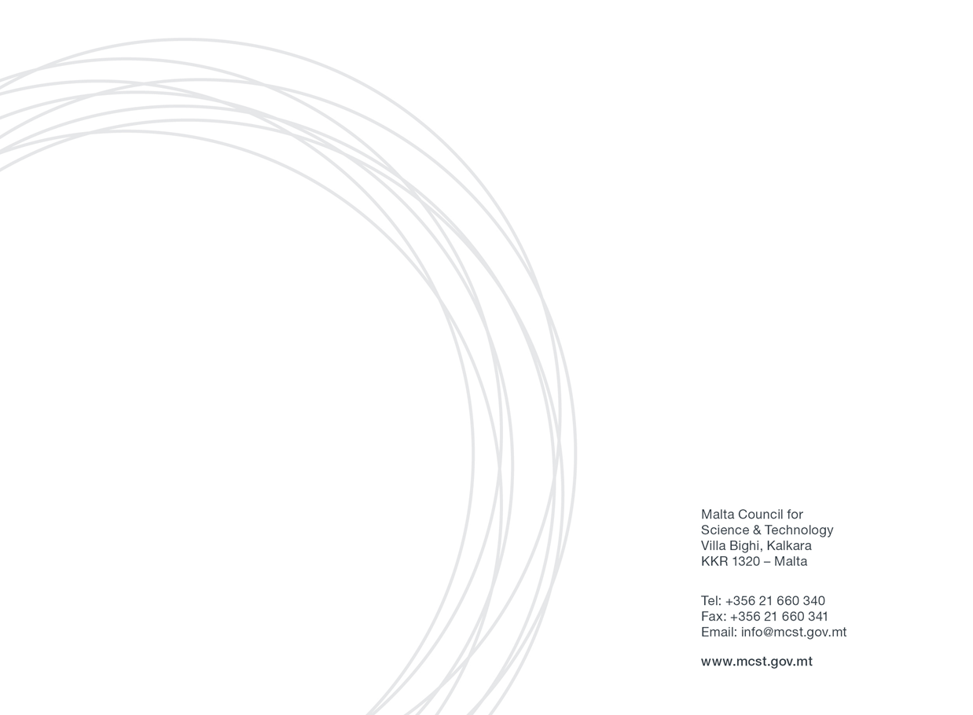
Contents
1. Key Information 3
2. Call context 3
3. Start-Up Actions 4
4. Definitions 6
5. Key Dates 8
6. Application 8
6.1. Eligibility 8
6.2. Requirements 8
6.3. Deadline 10
6.4. Grant Agreement 11
7. Deliverables, KPIs and Reporting 11
8. Eligible Costs and Funding Procedure 11
9. Evaluation and Selection Criteria 12
9.1. Evaluation 12
9.2. Selection Criteria 13
10. Confidentiality of Submissions 13
11. Contact Point 14

Key Information

The Malta Council for Science and Technology (MCST) understands that the current approach of consumption and use of plastics demands fundamental changes in which research and innovation (R&I), enabled and reinforced by policymaking, play a crucial role towards a circular economy. To this effect a broad range of collaborative research actions (including feasibility studies, economic models, etc.) are needed to determine the feasibility and generation of potential ideas that may provide solutions for the local (Maltese) context and beyond (Pan-European and the Mediterranean Region) to address the plastic waste problem.

The focus of this call is to explore new ideas, methods and innovations that can bring changes in the manufacturing/imports/distribution, consumption patterns and life cycle of plastics. Funding under this call will enable the interested party/ies to generate their ideas and carry out the necessary preparatory activities with the ultimate aim to lead or co-lead the idea into an enhanced project proposal for Horizon Europe calls.

Proposals may be put forward with respect to particular catchments of the Maltese islands, i.e. for Malta only, Gozo only or the entire Maltese archipelago, in view of the impacts on the Mediterranean Sea thereby encouraging collaboration with other Mediterranean partners.

The scheme is administered by MCST.

Call context

The call is aimed at Enabling Research in Plastics in a Circular Economy Context, it is intended to support applicant entities seeking to escalate the activities that will lead to an enhanced project proposal based on any actions they wish to carry out locally and may include activities overseas. To this effect, MCST is making available a limited number of Research and Development grants to offer financial support to entities that are interested in carrying out the necessary activities that will potentially lead to an enhanced project proposals for Horizon Europe (HE) calls, while also contributing to sustainable practices and data collection. In so doing, the entities will demonstrate that their activities have impact in the short term towards circular economy, showcasing that we can harness the benefits of plastics, while achieving better economic, environmental and social outcomes.
These terms of reference should be read in conjunction with the Directive (EU) 2019/904 and the forthcoming Single-Use Plastics Products Strategy for Malta 2020-2030 (in the interim referee to the Public Consultation Document) for a better understanding of the measures to give priority to sustainable and non-toxic re-useable products and re-use systems rather than to single -use products, and to reduce the quantity of plastic waste.

Moreover, reference is made the report – “A Circular economy for plastics, Insight from research and innovation to inform policy and funding decisions” ; which aims to inform policy and funding decisions on a circular economy for plastics by providing research and innovation insights from EU-funded projects and the wider scientific community. The report covers the entire plastics value chain, highlighting a broad range of challenges and opportunities. Based on scientific evidence, the insights presented contribute to the transition towards plastic production from renewable feedstock and product design for use, reuse, repair, and mechanical, chemical, or organic recycling. In addition, the report explains how this systemic change can be supported by innovation in business models, collection systems, and sorting and recycling technologies. In this way, plastics could circulate through our society with full transparency at high-value usage, while minimising the risks to human health and the environment.

Start-Up Actions

This call for applications for bottom-up Start-Up Actions (SUAs) is addressed at Maltese entity/ies to explore and tackle the plastics challenges in our seas. Although applicants may apply as mono-beneficiaries, it is encouraged to form partnerships with local and/or foreign partners ideally with the involvement of the private sector.

Each applicant or partnership will be expected to generate ideas and implement a series of activities (webinars/workshops/networking meetings) leading up to a feasibility, foresight, business plan or pilot study, which effectively will be the cornerstone of the concept to apply for relevant funding under a Horizon Europe call.

Activities to be carried out may include, but not limited to:
- feasibility studies that lead to the setting up of a local start-up;
- prototypes/integrated test cases/methodologies;
- forward-looking East-West/North-South strategies through the assessment of common features and differences;
- co-planning data retrieval/reuse for further exploitation driven by end-users (decision makers, entrepreneurs, etc.) and aimed at generating new economic activities;
- co-create R&I pilot projects, including citizen science;
- co-shaping practices to share capacities (e.g. infrastructures and human potential) and/or to enhance relevant skills;
- co-building science-to-policy strategies to provide solutions in support of policy makers;
- conducting match-making exercises towards the implementation of joint activities by aligning available instruments and tools.

The bottom-up SUAs represent concrete opportunities to explore innovative, knowledge-based pathways and forward-looking visions with a multidisciplinary, mission-oriented approach, for further uptake and developments. The proposed Research and Development activities of the SUA must be in line with the definition of Research and Development set out below.

In practice, they will be developed by the applicant or partnership through activities such as workshops, information-gathering, networking activities, etc. implemented at transnational level, complemented by deskwork and fieldwork, and knowledge transfer towards the preparation of creative, forward-looking studies on plastic challenges in our seas that are crucial for the future of the Mediterranean.

This is an open competitive call and MCST will undertake an independent evaluation of all proposals received. It will support the top ranked proposals (up to depletion of the available fund) which include a clear concept of idea/s, a robust plan (which includes engagement with local and relevant foreign stakeholders), at least three meetings/workshops/activities per Start-up Action to clearly demonstrate that it can act as an environment for the partners to discuss and plan their studies or act as a cluster for the relevant research community, and with clear deliverables expected.

Applicants are encouraged to show a strong sense of leadership with regards to their studies: ideally, additional funding sources (particularly for international partners to get engaged) are identified and secured, the intentions on how to secure future funding (e.g. identifying the Horizon Europe funding call and link with the relevant mission goals), and demonstrating that the concept can continue to developing into other actions upon completion of the Start-up Action.

The number of SUAs to be selected for funding are subject to the depletion of the available fund.

Definitions

- Applicant means anyone eligible to apply in terms of these terms of reference and who consequently applies for funding under this scheme.
- Council refers to the Malta Council for Science and Technology.
- Partner is defined as a partner in a consortium of a funded project.
- Project Coordinator is one of the beneficiaries of a project consortium that is appointed as the single point of contact between MCST and the consortium partners from proposal submission to project end. The Coordinator will have the responsibility of ensuring that all the partners involved in the consortium are eligible and supervises the project workflow. Additionally, the Coordinator will be required to submit the project application on behalf of the consortium and must also compile and submit reports / deliverables to the Council.
- Public Entity means any Maltese Public Service Department or Maltese Public Sector Entity, or any Maltese Legal Entity, which has more than 50% government shareholding. Public Service refers to all Ministries and Departments; and Public Sector Entities refers to authorities, corporations, agencies and commercial public-sector entities in which the Government has a majority shareholding and that are not listed on the stock exchange. Public Entities also include foundations, local councils and public academic entities. In the case of public academic entities, this includes but is not limited to a higher education entity or a research institute, whether as a whole body or as a component unit or department within such body, provided that the entity’s ongoing education and research is scientifically in line with the subject of the application being submitted during this call provided that the higher education entity must be in possession of a license for Higher Education according to the Further and Higher Education (Licensing, Accreditation and Quality Assurance) Regulations – Subsidiary Legislation 327.433. This does not include the license for a tuition center.
- Research and knowledge-dissemination organisation means an entity (such as universities or research institutes, technology transfer agencies, innovation intermediaries, research-oriented physical or virtual collaborative entities), irrespective of its legal status (organised under public or private law) or way of financing, whose primary goal is to independently conduct fundamental research, industrial research or experimental development or to widely disseminate the results of such activities by way of teaching, publication or knowledge transfer. Where such entity also pursues economic activities the financing, the costs and the revenues of those economic activities must be accounted for separately. Undertakings that can exert a decisive influence upon such an entity, in the quality of, for example, shareholders or members, may not enjoy preferential access to the results generated by it.
- Research and Development is defined as the systematic investigation, work or research carried out in any field of science or technology through experiment, theoretical work or analysis undertaken in order to acquire new knowledge, primarily directed towards a specific practical aim or objective, and includes:
  - Fundamental Research means experimental or theoretical work undertaken primarily to acquire new knowledge of the underlying foundations of phenomena and observable facts, without any direct commercial application or use in view.
  - Industrial Research means the planned research or critical investigation aimed at the acquisition of new knowledge and skills for developing new products, processes or services or for bringing about a significant improvement in existing products, processes or services. It comprises the creation of components parts of complex systems and may include the construction of prototypes in a laboratory environment or in an environment with simulated interfaces to existing systems as well as of pilot lines, when necessary for the industrial research and notably for generic technology validation.
  - Experimental Development means acquiring, combining, shaping and using existing scientific, technological, business and other relevant knowledge and skills with the aim of developing new or improved products, processes or services. This may also include, for example, activities aiming at the conceptual definition, planning and documentation of new products, processes or services.
Experimental development may comprise prototyping, demonstrating, piloting, testing and validation of new or improved products, processes or services in environments representative of real-life operating conditions where the primary objective is to make further technical improvements on products, processes or services that are not substantially set. This may include the development of a commercially usable prototype or pilot which is necessarily the final commercial product, and which is too expensive to produce for it to be used only for demonstration and validation purposes.
Experimental development does not include routine or periodic changes made to existing products, production lines, manufacturing processes, services and other operations in progress, even if those changes may represent improvements.

Key Dates

Call Open: | 1st October 2020
Deadline for proposal submission: | 18:00 hrs (CET) on 6th November 2020
Results Announced: | December 2020
Beginning of Start-up Actions: | January 2021
End of Start-up Actions: | December 2021
Submission of final studies: | By 31st January 2022

Application

Eligibility

The applicant must be an entity registered as one of the following:
- Public research and knowledge-dissemination organisation whose main activities are education which is not offered for remuneration and independent research whose results are widely disseminated on a non-discriminatory basis
- Public entity that does not offer goods or services on a market for remuneration
Applicants who have other funded projects with the Council and are in default, and/or have gone beyond the timelines of the project, are not eligible to participate.
Any application submitted by or including the participation of any legal person or legal entity having, in totality or in majority ownership, the same shareholders, partners or persons holding and / or exercising a controlling power in any other legal entity which will have been at any time prior to such application declares as non-compliant or defaulting on any other contract or agreement entered into with the Council, shall be automatically declared as inadmissible.
Funding under this scheme is made available on the basis that the Applicant has not benefited and will not benefit from any other grant or financial incentive of whatever nature, applied for and/or utilised for the same scope as that subject of the funding requested under this call.
Applications should be endorsed by the entity’s legal representative. Applicants already featuring on MCST’s non-compliance list will not be eligible to apply for this call.

Requirements

Funding is available to Maltese legal entities applying for this call. Costs incurred by non-Maltese legal entities will be self-financed.

The main applicant organization (the coordinator in case of a partnership), must be a Maltese legal entity. In case of a partnership, legal entities may be from both EU member states and Non-EU countries.

In case of a partnership with non-Maltese partners, the enhanced value of the established partnership, including the benefits added to the SUA, should be clearly demonstrated.

Preference is given to applicant / partnerships that have a proven track record and have been active in blue growth or circular economy, e.g. Institutes, Universities Departments or equivalent, Research Centers, Governmental Bodies or Agencies, Local Councils or association, private enterprises, SMEs, Foundations, or Non-Governmental Organisations (NGOs).

The call adopts a bottom-up approach with a focus on plastics, it is driven to support successful applicants to escalate their activities and capabilities addressing plastic challenges based on any actions whilst contributing to sustainable practices and data collection.

Each Start-up Action should bring together multinational actors from different disciplines. The applicant can involve experts/professionals from all relevant fields including, amongst others - economists, lawyers, ICT specialists, social scientists, graphic designers (e.g. for dissemination and exploitation purposes).

The Start-up Action must have a clear added value to Malta, the Mediterranean and Europe.

Beyond the scientific proposal, a budget breakdown and timeline are also required. The inclusion of Gantt chart is recommended.

The proposal is expected to include a roadmap of activities and goals pursued to ensure long term sustainability, beyond the immediate scope of the study, specifically focusing on the possibility to apply for a Horizon Europe call. Within the final report, the next milestones must be clearly set out and detailed information on how they will be reached are to be provided.

It is recommended that applicants highlight possible outcomes and achievements of previous or on-going related initiatives, if applicable.

Proposals are to consider any socioeconomic aspects, the cost-effectiveness of the actions, their impact and any legal issues/bottlenecks, if relevant.

Any publication ensuing from the Start-up Action must be made available in Open Access.

Every proposal must have a Lead Coordinator. In the case of partnerships, the Lead Coordinator will present the proposal on behalf of the partners. A preliminary description of roles within the partnership is required.

There is no limit on the number of participations as a partner, however:
- Each Legal entity may only submit one proposal as the Lead Coordinator.
- Each consortium needs to have different partners. It is not allowed to have the same consortium submitting more than one application.

Deadline

The Call, terms of reference and official application form is available on the MCST webpage https://mcst.gov.mt.

Questions should be sent in writing to paradise.mcst@gov.mt.

Correctly-filled applications should be submitted by 1800hrs on 6th November 2020 to paradise.mcst@gov.mt. Late applications will not be considered.

Any attempt to pre-judge the application and evaluation process in any way before or after the submission will automatically disqualify the proposal and the Legal entity from any submitted proposal.

Double funding:
Legal entities will be required to declare that the activities conducted under this call are not receiving funding from any other local or foreign Scheme or source.

Conflict of interest:
Individuals involved in the call preparation, evaluation & its subsequent administration, or member of the Framework Programmee unit of MCST may not submit an application. Their institutions/organisations, however, are not barred from participation.

Grant Agreement

Upon communication of the results, MCST will resolve to sign a Grant Agreement with the Coordinating entity . Any modification to the Grant Agreement will require the approval of MCSTs Board of Directors or its delegate. In case of a partnership, a consortium agreement signed by all partners will be required, and if applicable an IP agreement.

Deliverables, KPIs and Reporting

The SUA will be required to submit a short report after every workshop/meeting/webinar/activity.

A final feasibility or foresight study or pilot project, detailing the outcome of the Start-up Action and plans for future developments, will need to be submitted within three (3) months from the last workshop/meeting webinar/activity.

It will include a section on the implementation of the study, including, if applicable, a business plan and/or information on any co-financing leveraged or sought. Dissemination activities will also need to be listed, e.g. materials produced (posters, brochures, giveaways, infographics, etc.), webinars/ short on-line courses organised, etc. and a forward-looking statement on the next steps where this concept is to be taken to the next level.

In cases were complementary funding for the activities and funding for foreign partners is foreseen, letters of commitment should be included stating the nature and level of commitment foreseen.

A final cost report is required to be submitted to MCST together with the final report.

Eligible Costs and Funding Procedure

There is no minimum threshold for the budget requested, however every SUA can be awarded an estimated budget of up to € 35,000 for the implementation of its Start-up Action.

This sum will cover costs related to:
- The organization of a minimum three (3) meetings/workshops/activities
- Research and Personnel costs
- Subcontracting (up to a maximum of 25% of the requested budget)
- Development of ICT tools such as apps, databases and monitoring
- Costs for the feasibility or foresight studies
- Other actions directly related to the project outputs
- The related travel and subsistence costs for the partners and invited experts
The following restrictions apply:
Travel:
    - Only economy class airline tickets up to a maximum of €400 for flights per return trip.
- The use of one’s personal car is not eligible.
- Taxies are not eligible.
Accommodation:
    - Costs for accommodation and subsistence are eligible up to a maximum of € 200 per night.
- Costs related to the printing of dissemination material (reports, posters, brochures, giveaways, etc.) concerning the outcome of the Start-up Action.

Payments will be made as follows:
- Pre-financing of up to 60% of the requested budget;
- Payment of the eligible Balance will be made upon approval of the final report and relevant documentation.

Evaluation and Selection Criteria

Evaluation

The Start-up Action proposals will be evaluated and ranked by an independent evaluation committee and will be undertaken in two stages:

Stage 1: Administrative evaluation (internal evaluation by MCST)
Stage 2: Scientific evaluation (each proposal will be evaluated by at least two external independent experts)

For Stage 1 of the evaluation, all proposals will be assessed on the administrative requirements of the call. If deemed eligible, they will be passed on to stage two of the evaluation.

For Stage 2 of the evaluation, all proposals will be assessed on the basis of the criteria and points system laid out in the table set out in 9.2 Selection Criteria, below.

Selection Criteria

Proposal will be assessed and ranked on the basis of the following criteria:

- Excellence (10 points) | Proposals should be clear, coherent and realistic in terms of timelines and budgets. They will be assessed on their level of innovativeness, the quality of the partnership (qualifications, leadership, experience and variety of expertise), involvement of relevant/high-level stakeholders, and the methodology proposed.
- Level of integration of addressing the plastics issue and Maltese, Mediterranean and European added value (10 points) | Proposal should clearly show their understanding of the Plastics issue and define the contributions they will make to address this challenge in the Mediterranean. They will be assessed on the basis of their Mediterranean and European added Value, their level of relevance to improve and implement form from the current state of the art, their multi-disciplinary dimension and their geographical scope.
- Impact (10 points) | Proposals should have clear, defined objectives, leading to significant impact on the plastics issue in the Mediterranean region. They will be assessed on their level of uptake feasibility and sustainability over time, their ecological and social impact, their cost-effectiveness, as well as their plans for dissemination and leveraging of co-financing opportunities.

Other criteria that will be considered as strengthening the proposal are:
- Consideration of gender issues (in team and research content)
- International collaboration (partners with self-funding)

Confidentiality of Submissions

Unless otherwise indicated, all application submissions shall be treated in strict confidence.
The data collected by the Council via the application for the assistance and its subsequent processing by the Council to evaluate data subject’s request for assistance under the call is in line with:
- The Terms of Reference;
- Data Protection Act, Chapter 586 of the Laws of Malta and Regulation (EU) 2016/679 of the European Parliament and of the Council of 27 April 2016 on the protection of natural persons with regard to the processing of personal data and on the free movement of such data, and repealing Directive 95/46/EC (General Data Protection Regulation).
- The legitimate basis to process personal data submitted by the data subject by virtue of his/her written application for assistance is Regulation 6 (1)(b) of the General Data Protection Regulation (“GDPR”), as ‘processing is necessary in order to take steps at the request of the data subject prior to entering into a contract’.

Contact Point

For further information on the PARADISE call please contact:
Mr. George Bugeja
Executive (Horizon 2020)
The Framework Programmee Unit
The Malta Council for Science and Technology
Tel: +356 2360 2156 or 2360 2000
Email: paradise.mcst@gov.mt

Subject to MCST approval for overseas activities.
Directive (EU) 2019/ of the European Parliament and of the Council of 5 June 2019 on the reduction of the impact of certain plastic products on the environment.
Single-Use Plastic Products Strategy for Malta Public Consultation Document, 2020-2030 Rethink Plastic
A Circular Economy for Plastics, Insight from research and innovation to inform policy and funding decisions
An organisation/institute with administrative and financial autonomy.
MCST is willing to provide technical support for the production of dissemination material, including possible webinars or short and targeted online courses focusing on the results of the study/activities of the Start-up Action.
The recommended format is to use Meeting 1 to assess the topic and establish the working methodology, Meeting 2 to provide an intermediate assessment of developments, highlighting any gaps and bottlenecks, as well as preliminary findings and Meeting 3 to fine tune and conclude the study – meetings can be physical or virtual.
Subject to MCST approval.

