PARADISE Call - for Ideas towards Start-Up Actions for a PlAstic fRee heAlthy meDIterranean SEa
Application Form
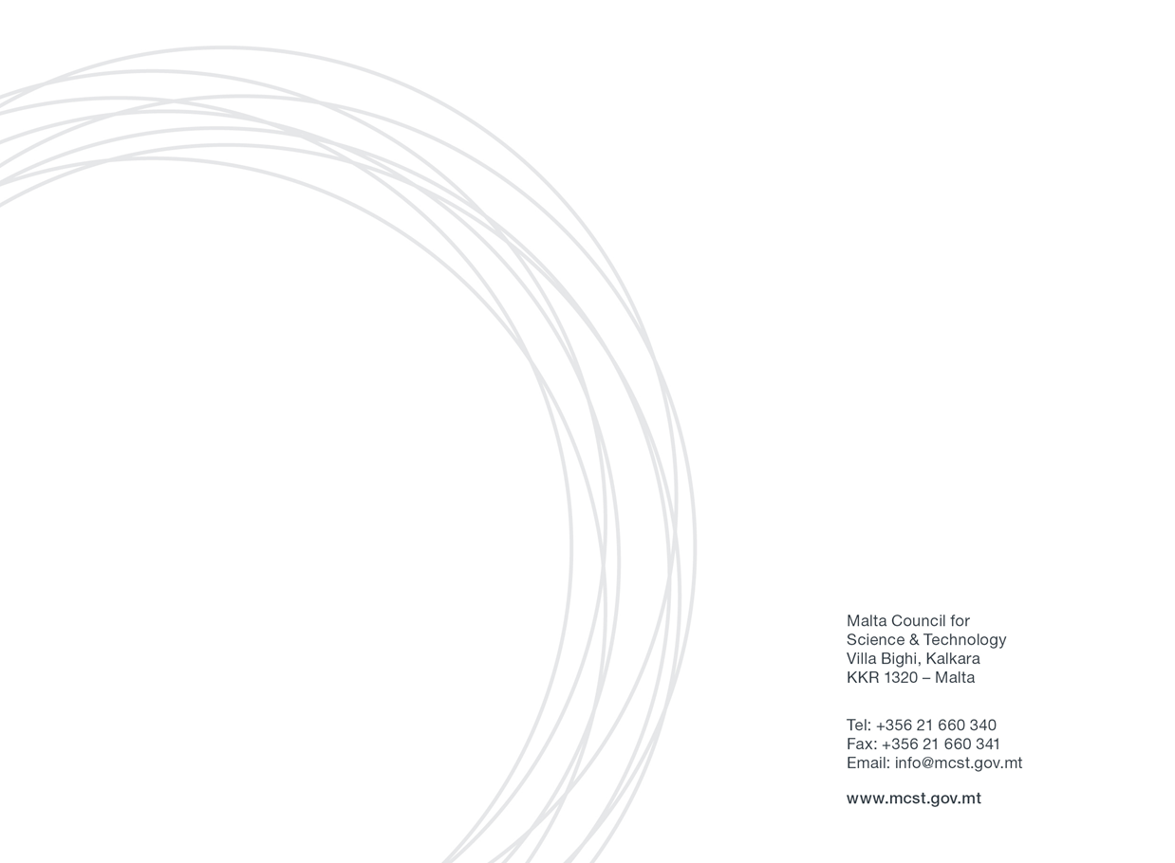
Section One: Applicant’s Details
Please fill in all section of the form.
Applicant Details
(Please include details of the Maltese legal entity applying for the call)
Name
Designation
Name of Entity /Academic Institution /Private Entity
Name of Department /Institute /Centre (if applicable)
Email
Tel. Number

Partner Organisation’s Details (if any):
(Please include details of the contact person/partner involved)
Name of Entity / Academic Institution / Private Entity |  | Name of Department/ Institute/ Centre (if applicable)
Contact Details | Name: | Designation
 |  | Email:
 | Address: | Tel. No.:
 |  | Mob. No.:

Additional Partner Organisation’s Details (if any):
(Please include details of the contact person/partner from the additional partner involved)
Name of Foreign Academic Institution / Private Entity |  | Name of Department/ Institute/ Centre (if applicable)
Contact Details | Name: | Designation:
 |  | Email:
 | Address: | Tel. No.:

Additional Partner Organisation’s Details (if any):
(Please include details of the contact person/partner from the additional partner involved)
Name of Foreign Academic Institution / Private Entity |  | Name of Department/ Institute/ Centre (if applicable)
Contact Details | Name: | Designation:
 |  | Email:
 | Address: | Tel. No.:

Additional Partner Organisation’s Details (if any):
(Please include details of the contact person/partner from the additional partner involved)
Name of Foreign Academic Institution / Private Entity |  | Name of Department/ Institute/ Centre (if applicable)
Contact Details | Name: | Designation:
 |  | Email:
 | Address: | Tel. No.:
Note: This page may be duplicated in case of additional partners. The Terms of Reference (state aid or non-state aid) document provides sets out partnership requirements.
Section Two: Project / Activity Proposal details
This call for applications for bottom-up Start-Up Actions (SUAs) is addressed at Maltese entity/ies to explore and tackle the plastics challenges in our seas. Although applicants may apply as mono-beneficiaries, it is encouraged to form partnerships with local and/or foreign partners ideally with the involvement of the private sector.
Each applicant or partnership will be expected to generate ideas and implement a series of activities (webinars/workshops/networking meetings) leading up to a feasibility, foresight, business plan or pilot study, which effectively will be the cornerstone of the concept to apply for relevant funding under a Horizon Europe call.
The bottom-up SUAs represent concrete opportunities to explore innovative, knowledge-based pathways and forward-looking visions with a multidisciplinary, mission-oriented approach, for further uptake and developments.
Note:
- Please keep proposals short: max. 10 pages (including existing titles and instructions, using the present fonts and font size).
- Reference is made to the Terms of Reference (state aid or non-state aid) document. The Terms of Reference can be retrieved from the following web page: https://mcst.gov.mt .

- SUA Title and Acronym
Full title of the SUA:
(Project Title/Name of Activity)
SUA acronym:
(abbreviation)

Keywords (up to 8)

- Quality of Project/Activity - Excellence
Please provide the relevant information on this evaluation criterion. Proposals will be judged on their level of innovativeness, the quality of the partnership (qualifications, leadership, experience and variety of expertise), involvement of relevant/high-level stakeholders, and the methodology proposed. Activities must either be, or be supportive of, high quality research & innovation with the potential to yield mutually beneficial cooperation, results and demonstrate innovation and interdisciplinarity in the selected field of interest.

- Foreseen participants (other than those listed under Section1)
Note: Applicants are expected to invite experts to participate; please refer to Terms of Reference for details and fill in the indicative table below, adding any rows as required]
Name | Organisation | Country | Contact details | Participation status
 |  |  |  | Choose an item.
 |  |  |  | Choose an item.
 |  |  |  | Choose an item.
 |  |  |  | Choose an item.
 |  |  |  | Choose an item.
 |  |  |  | Choose an item.
 |  |  |  | Choose an item.
Total number of participants (other than those already listed under Section 1):
Total number of participants (including those listed under Section 1):

- Level of integration of addressing the plastics issue and Maltese, Mediterranean and European added value
Note: Proposal should clearly show their understanding of the Plastics issue and define the contributions they will make to address this challenge in the Mediterranean. They will be assessed on the basis of their Mediterranean and European added Value, their level of relevance to improve and implement form from the current state of the art, their multi-disciplinary dimension and their geographical scope.

- Impact
Note: Proposals should have clear, defined objectives, leading to significant impact on the plastics issue in the Mediterranean region. They will be assessed on their level of uptake feasibility and sustainability over time, their ecological and social impact, their cost-effectiveness, as well as their plans for dissemination and leveraging of co-financing opportunities.

- Outcomes and Sustainability - Link / synergies / added value with respect to existing programmes of projects
Note:

- Proposed schedule and timeline, including date(s), preferred venue(s) and hosting organisation(s)
Note: Kindly provide a description of the timeline and plan for the implementation of the activities funded through the call. Please note that all activities funded through this call must be completed by end year 2021.

- Budget description
Note: Kindly provide an estimated breakdown of costs i.e. how much of the grant you plan to use on: Travelling?, Accommodation?, Research & Innovation?, Publication?, Other eligible activities? etc. .
Total Amount of Funds Requested (in €)
(Please keep in mind that funding for any one proposal is capped at €35,000)
Breakdown of Costs (estimate in €)

Supplementary / Match Funding  Does the Partner organisation plan to provide any additional funding? | Yes / No
Supplementary Fund Provided over duration of Award Scheme (in €)
(if applicable)
Name of institution that will be supplying the funds:

Other potential funding
Amount | Funding Source | Level of Funding | Status
 |  | Choose an item. | Choose an item.
 |  | Choose an item. | Choose an item.
 |  | Choose an item. | Choose an item.

Section Three: Applicability of State Aid rules
With regards to those applicants that are undertakings that carry out an economic activity within the meaning of Article 107 TFEU, this call will be implemented in line with the de Minimis Regulation. More information is provided in the applicable terms of reference and the Council can also be contacted for further clarifications.
If you are a public entity or a public research and knowledge dissemination organisation and you deem that State Aid is not applicable, a justification will need to be provided in the below section and by filling in Annex 1. If the activities undertaken by the applicant are found to have State Aid implications, the applicant would need to follow State Aid regulations, filling in Annex 2.
Please tick whether your application falls under State Aid de minimis Regulation or State Aid Not Applicable.
Applicants may only opt for one option. Selecting more than one option will be ineligible.
State Aid Not Applicable – Please fill in Annex 1- None-State Aid “Justification”.

State Aid de minimis – Please fill in Annex 2- State Aid Declaration (De Minimis).

In the following space, please provide a justification if you selected the “State Aid Not Applicable” option.

Section Four: Declaration
4.1 Personal Data Protection
- Contact email address of the Data Protection Officer: doyle.abela@gov.mt
- The legal basis and purpose of processing:
The personal data collected by the Malta Council for Science and Technology (hereinafter ‘the Council’) via this written application for the assistance and its subsequent processing by the Council to evaluate data subject’s request for assistance under the Scheme is in line with:
- The relevant National Rules for the Scheme;
- COMMISSION REGULATION (EU) No 1407/2013 of 18 December 2013 on the application of Articles 107 and 108 of the Treaty on the Functioning of the European Union to de minimis aid, as amended by Commission Regulation (EU) 2020/972 of 2 July 2020 amending Regulation (EU) No 1407/2013 as regards its prolongation and amending Regulation (EU) No 651/2014 as regards its prolongation and relevant adjustments (the de minimis Regulation) – where applicable;
- Data Protection Act, Chapter 586 of the Laws of Malta and Regulation (EU) 2016/679 of the European Parliament and of the Council of 27 April 2016 on the protection of natural persons with regard to the processing of personal data and on the free movement of such data, and repealing Directive 95/46/EC (General Data Protection Regulation).
The legitimate basis to process personal data submitted by the data subject by virtue of his/her written application for assistance is Regulation 6 (1)(b) of the General Data Protection Regulation (“GDPR”), as ‘processing is necessary in order to take steps at the request of the data subject prior to entering into a contract’.
- Data retention period:
The data collected by the Council as submitted by the data subject via this written application for assistance will be retained for a period of ten (10) years from the date when the last assistance was granted to the Entity represented by the data subject in relation to this written application for assistance , in line with the Scheme National Rules for Participation and Article 6 of the de minimis Regulation (where applicable).
- Pursuant to the GDPR Regulation, you have the right to access the personal data, rectify inaccurate personal data, request to erase personal data and request the Council to restrict the processing of personal data.
- To exercise such rights, you are to submit a written request to the Data Protection Officer via the contact e-mail address.
- Any erasing and/or rectification of personal data and/or restriction of processing as referred to above may:
- Render one or more cost items or the Entity ineligible for assistance under the Scheme or render void the Letter of Intent issued in favour of the Entity for assistance under the Scheme in relation to this written application for assistance ;
- Lead the Council to enforce a recovery of assistance granted to the Entity as part of this written application for assistance.
- Sharing of data where strictly necessary and required by law:
For the purpose of processing this written application for assistance in line with the Rules of Participation for the Call and the ‘de minimis Regulation’ (where applicable), the Council may share the data provided via this application with other Government Entities, subject that such processing satisfies at least one of the grounds listed under Regulation of the GDPR.
- For the purpose of monitoring of aid in line with Article 6 of the de minimis Regulation or where legally required, any data provided as part of this written application for assistance may be shared with the European Commission.
- If you feel that your data protection rights have been infringed, you have the right to lodge a complaint with the Information and Data Protection Commissioner.
- Authorisation to engage with the Council on matters related to this application.
I the undersigned, as legal representative of the Applicant Entity, authorise the following Legal Bodies and/or Natural Persons to act on my behalf with the Council with respect to matters related to this written application for assistance and any subsequent documentation exchanged between the two parties in relation to the same written application for assistance.

Name of Legal Entity | Name and Surname of Natural Person granted authorisation⁽¹⁾ | E-mail address of party granted authorisation⁽²⁾

Note 1: Leave empty if authorisation is intended to any natural person engaged with the Legal Entity. Otherwise, specify the name and surname of the person(s) working for the Legal Entity to whom the authorisation is intended.
Note 2: Written communication with the Legal Entity and/or Natural Person granted authorisation via email will only be accepted via the email address specified in the table above. The Undersigned should be copied (via the email address specified in this application) in any communication between the Council and the Person granted authorisation as per above table.
Name and Surname of person giving authorisation:
E-mail address of person giving authorisation:
Signature of person giving authorisation:
Designation:
Date:
The person giving authorisation should correspond to the data subject of personal data contained in this application as well as represent the Applicant Entity as its legal representative.

4.2 Double Funding
The undersigned confirms that there has not been any approval or has been granted any public funding, financing or fiscal benefit in respect to the cost items included in this request for assistance and will not seek funding or fiscal benefits for these cost items through other National and/or European Union measures.
4.3 Transparency Obligations
By submitting this application, I hereby acknowledge that the Council shall abide with any applicable transparency rules and may publish and make available to third parties’ information as required by such rules.
4.4 Additional declarations:
I confirm that:  The information given on this form is accurate to the best of my knowledge. I understand that if it is later established that I misrepresented myself and I am not eligible for this Scheme then I will be required to pay for the services received. | I agree
I accept and confirm that the personal data and project/activities proposal content information can be passed on to the Malta Council for Science and Technology to be used solely for the purposes of administering, processing, and review of the application. | I agree
I accept and confirm that the personal data and proposal content information can be passed on to third parties i.e. the Partner Organisation/s with whom I will be carrying out this project, solely for use in said project/activities, and that any misuse of the data or provision of data to parties outside this agreement will incur legal action. | I agree

Signature & Stamp of the Applicant:  The applicant needs to have sufficient authority to ensure the adequate degree of commitment and support for the activities. | Date:  Sign:
Signature & Stamp of CEO / Chairman / Rector of Applicants Entity:  Applications should be endorsed by the applicant’s CEO/Chairman/Rector, as the case may be.. | Date:  Sign:

Grant chart should be included here, if any.
Refer to Terms of Reference for eligible costs.
Kindly include any In-kind Contributions here (e.g. a free meeting venue).

