PARADISE Call
Application Form Annex 1 – Non-State Aid “Justification”
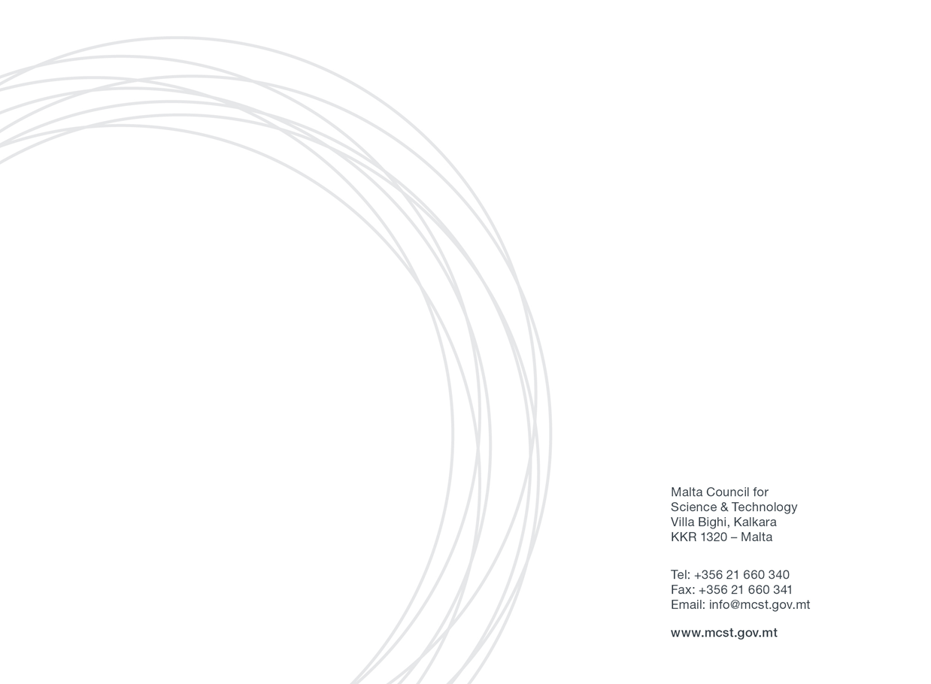

Annex 1

Non-State Aid Applications shall need to abide to one of the below justifications:

Non-State Aid justifications for – PUBLIC RESEARCH AND KNOWLEDGE DISSEMINATION ORGANISATIONS

PARADISE Call
Eligibility
Eligible public research and knowledge dissemination organisations (RO) are those whose main activities are education which is not offered for remuneration and independent research whose results are widely disseminated on a non-discriminatory basis.
Justifications
Any economic activities of the RO must consume the same inputs (such as material, equipment, labour and fixed capital) as the non-economic activities and the capacity allocated each year to such economic activities must not exceed 20% of the relevant entity’s overall annual capacity. Where this is not the case, and the same entity carries out activities of both economic and non-economic nature, the public funding of the non-economic activities will not fall under Article 107(1) of the Treaty if the two kinds of activities and their costs, funding and revenues can be clearly separated so that public funding of non-economic activities does not cross-subsidise any economic activities.

Project Application: _____________________________

The Applicant, __________________________________, declares the following:
The planned research is to be carried out in the context of its activities as a “research and knowledge dissemination organisation” as defined in the Commission Framework for State aid for research and development and innovation (2014/C 198/01) paragraph 15(ee), which carries out a non-economic activity in line with either of the following:
- primary activities of research organisations and research infrastructures, in
particular:
- education for more and better skilled human resources which is not offered for remuneration.
- independent R&D for more knowledge and better understanding, including collaborative R&D where the research organisation or research infrastructure engages in effective collaboration;
- wide dissemination of research results on a non-exclusive and non-discriminatory basis, for example through teaching, open-access databases, open publications or open software;

- knowledge transfer activities, where they are conducted either by the research organisation or research infrastructure (including their departments or subsidiaries) or jointly with, or on behalf of other such entities, and where all profits from those activities are reinvested in the primary activities of the research organisation or research infrastructure. The non-economic nature of those activities is not prejudiced by contracting the provision of corresponding services to third parties by way of open tenders.

The Applicant will be obliged to:
- publicise widely the results of the research;
- license on non-discriminatory terms any Intellectual Property Rights (IPRs) resulting from the research at the market price for the said IPR;
- any income from the licensing of IPR shall be reinvested in the primary educational and research activities of the Beneficiary;
- appropriate procedures shall be established to prevent the direct or indirect support of economic activity in the meaning of chapter 2 of the Commission Notice on the notion of State aid as referred to in Article 107(1) of the Treaty on the Functioning of the European Union (2016/C 262/01).
The Applicant understands that, should the eventual R&I activities be found to be in breach of the conditions for being exempt from State Aid rules, the Managing Authority will enforce the retrieval of funds provided under the PARADISE Call with interest, in part or in full, as the case may necessitate.
The amount of funding provided is at least equal to the market price and has been established by means of an open, transparent and non-discriminatory competitive procurement procedure. The RO shall need to demonstrate that it effectively negotiated the funding, at arm’s length conditions, in order to obtain the maximum economic benefit at the moment when the contract is concluded, while considering its statutory objectives. The third-party service provider will have no right on the IPR generated from the eventual R&I project.
The Applicant also undertakes to comply faithfully and immediately with any decision of the European Commission or a Maltese judicial authority declaring Article 107(1) TFEU to be applicable to this Agreement.

________________________________
Legal Representative
________________________________
Date

Non-State Aid justifications for – public entities whose activity DOES NOT CONSTITUTE AN ECONOMIC ACTIVITY IN THE MEANING OF ARTICLE 107 OF THE TREATY ON THE FUNCTIONING OF THE EUROPEAN UNION (EXCLUDING PUBLIC RESEARCH AND KNOWLEDGE DISSEMINATION ORGANISATIONS)

PARADISE Call
Eligibility
Eligible public entities are those that do not offer goods or services on a market for remuneration.

Justifications
Any secondary economic activities of the public entity must consume exactly the same inputs (such as material, equipment, labour and fixed capital) as the non-economic activities and the capacity allocated each year to such economic activities must not exceed 20% of the relevant entity’s overall annual capacity. Where this is not the case, and the same entity carries out activities of both economic and non-economic nature, the public funding of the non-economic activities will not fall under Article 107(1) of the Treaty if the two kinds of activities and their costs, funding and revenues can be clearly separated so that public funding of non-economic activities does not cross-subsidise any economic activities.
Project Application: _____________________________

The Applicant, __________________________________, declares the following:

The planned research being undertaken is claimed by the public entity not to constitute an economic activity within the meaning of Article 107 of the Treaty of the Functioning of the European Union.
The public entity will be obliged to:
a) publicise widely the results of the research;
b) license on non-discriminatory terms any Intellectual Property Rights (IPRs) resulting from the research at the market price for the said IPR;
c) any income from the licensing of IPR shall be reinvested in the primary educational and research activities of the Beneficiary;
d) ensure that no funds provided by this Agreement cross-subsidises any economic activities that may be carried out by the Beneficiary, other partners in the project, or third parties.

The public entity understands that, should the eventual R&I activities be found to be in breach of the conditions for being exempt from State Aid rules, the Managing Authority will enforce the retrieval of funds provided under the PARADISE Call with interest, in part or in full, as the case may necessitate.

The amount of funding provided is at least equal to the market price and has been established by means of an open, transparent and non-discriminatory competitive procurement procedure. The public entity shall need to demonstrate that it effectively negotiated the funding, at arm’s length conditions, in order to obtain the maximum economic benefit at the moment when the contract is concluded, while considering its statutory objectives. The third-party service provider will have no right on the IPR generated from the eventual R&I project.
The public entity also undertakes to comply faithfully and immediately with any decision of the European Commission or a Maltese judicial authority declaring Article 107(1) TFEU to be applicable to this Agreement.

________________________________
Legal Representative
________________________________
Date

