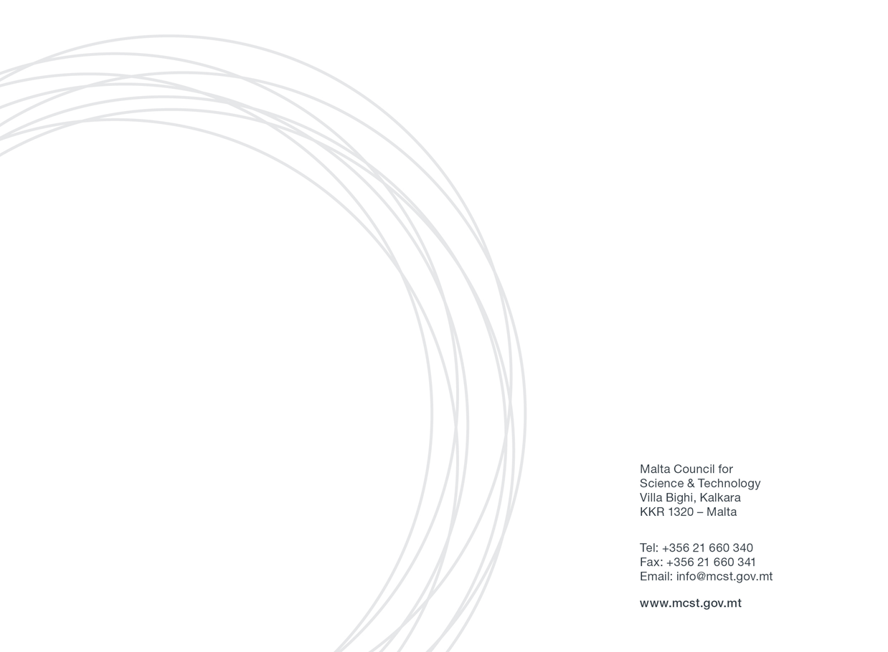
Horizon 2020 Awards Application Form:

Section One: Applicant’s Details
Please fill in all the sections of the below table.
Applicant Details
(Please include details of the Malta-based entity applying for the Award)
Name
Position/Designation
Name of Legal Entity (if applying as a legal entity)
Address
Email
Tel. Number

Section Two: Selection of Award Category

Kindly specify which award you are applying for. Select either one category from “Award for Legal Entities”, or the “Award for Researchers”

Award for Legal Entities:

Categories:

(Please select the award category you are applying for. Descriptions can be found in the application guide)

- Best Impact for Health, Security or Smart Mobility Award

- The Blue Award

- The Green Award

- The Climate Award

- Gender, Culture, Equality, Open Science or Citizen Science Award
- Best Innovative SME Award
- Best Promotion of STEM Award
- Best Technological Innovation Award

Award for Researchers:

- Most Active Researcher Award

Section Three: Application for Award
Kindly fill out the form in line with the selection of award category in Section Two.

Award for Legal Entities
Project title:

Project ID:
Start and end date of the project
Budget (NET eligible amount for the Maltese entity)
For Award Categories 1-5 (max. 400 words)
Please refer to the descriptions of the awards in the application guide and describe how your project had an impact, including results and after-project life (70% weighting).

For Award Categories 1-5 (max. 250 words)
Describe how your project has been taken up by end users, such as by policy makers, society and other stakeholders, as well as creating new standards (30% weighting).

For Award Category 6 (max. 400 words)
Please refer to the description of the award in the application guide and describe how your project and idea had any innovation and/or market potential (70% weighting).

For Award Category 6 (max. 250 words)
Demonstrate outputs from the project including patent applications/granted patents, exploitation of research results, or spin-off creations (30% weighting).

For Award Category 7 (max. 400 words)
Please refer to the description of the award in the application guide and describe effectiveness of outreach to the end users through activities and implementation of the project in the promotion of STEM (70% weighting).

For Award Category 7 (max. 250 words)
Describe innovative methods of outreach and creative approach in relation to promotion of STEM (30% weighting).

For Award Category 8 (max. 400 words)
Please refer to the descriptions of each award in the application guide and describe technological innovation and disruptiveness compared to current technologies. This includes improvement of an existing product or process, submission of patent applications and/or other intellectual property (70% weighting).

For Award Category 8 (max. 250 words)
Demonstrate how the R&D can be applied either to the local, European or global dimension (30% weighting).

Award for Researchers
List of funded project/s in which the researcher is/was involved in Horizon 2020 including
- Name of the project and Project ID
- Start and end date of the project/s
- Role of the researcher

For Award Category 9 (max. 400 words)
This award will be given to the principal researcher with a proven track record of activities within H2020 research projects. The research conducted by the principal investigator should be advanced and of state of the art quality. A description of projects that he/she has been involved in over the years in Horizon 2020 (2014-2020) should be also provided. (50% weighting).

For Award Category 9 (max. 400 words)
Describe the inventive and breakthrough nature of research carried out in the project/s. A list of published papers in line with science investigated in the Horizon 2020 project/s should be provided (50% weighting).

Section Three: Applicability of State Aid rules

With regards to those applicants that are undertakings that carry out an economic activity within the meaning of Article 107 TFEU, this call will be implemented in line with the de Minimis Regulation. More information is provided in the applicable Guide and the Council can also be contacted for further clarifications.
If you or your entity does not carry out an economic activity within the meaning of Article 107 TFEU, and you deem that State Aid is not applicable, a justification will need to be provided in the below section and by filling in Annex 1. If the activities undertaken by the applicant are found to have State Aid implications, the applicant would need to follow State Aid regulations, and will also be required to fill in Annex 2.
Please tick whether your application falls under State Aid de minimis Regulation or State Aid Not Applicable.
Applicants may only opt for one option. Selecting more than one option will be ineligible.
State Aid Not Applicable – Please fill in Annex 1- Non-State Aid “Justification”.

State Aid de minimis – Please fill in Annex 2- State Aid Declaration (De Minimis).

In the following space, please provide a justification if you selected the “State Aid Not Applicable” option.

Section Four: Declaration by Applications

Declaration by Researcher / Private Entity:

I confirm that:  The information given in this form is accurate to the best of my knowledge. I understand that if it is later established that I misrepresented myself and I am not eligible for this Scheme I will face disqualification and will incur legal action. | I agree
I accept and confirm that the personal data and project/activities proposal content information can be passed on to the Malta Council for Science and Technology to be used solely for the purposes of administering, processing, review and evaluation of the application. | I agree
I accept and confirm that in the case of a legal entity or as a researcher I have the authority to represent the project/s being submitted for the scheme. I understand that only one Maltese entity representing the other entities for the same project can apply for an award category. | I agree
I confirm that I am in the possession of a signed grant agreement with budget allocation of the Horizon 2020 project/s. | I agree

Privacy Policy
Any information and data collected in this form will only be used for statistical/audit purposes only and will not be made available to third parties or any other persons outside MCST.
Our Privacy Policy is available at: http://mcst.gov.mt/our-privacy-policy/
Date:_____________________________________________________________________

Signature:_________________________________________________________________

Stamp (if Applicable)

