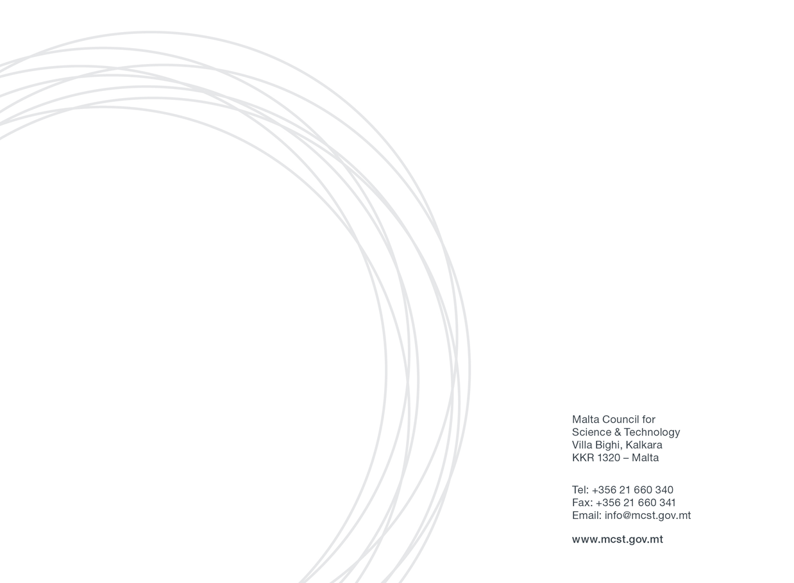
Horizon 2020 Awards Application Form Annex 2: State Aid (De Minimis)

Annex 2
State Aid Declaration (De Minimis)
Horizon 2020 Awards
If the submitted application is approved, the applicant will benefit from de minimis State aid in line with Commission Regulation (EU) No. 1407/2013 of 18 December 2013 on the application of Articles 107 and 108 of the Treaty on the Functioning of the European Union to de minimis aid.
Commission Regulation (EU) No. 1407/2013 allows a ‘single undertaking’ to receive an aggregate maximum amount of de minimis aid of €200,000 under all de minimis aid measures, over a period of three fiscal years. This aggregate maximum threshold applies in principle to all economic sectors with the exception of a ‘single undertaking’ performing road freight transport for hire or reward for which a lower de Minimis threshold of EUR 100,000 over a period of three ‘fiscal years’ applies. The agriculture and fisheries sectors are subject to different thresholds and criteria. For the purpose of this declaration the term ‘single undertaking’ shall have the meaning as established in Commission Regulation (EU) No. 1407/2013. Moreover ‘fiscal year’ means the fiscal year as used for tax purposes by the undertaking concerned.
This maximum threshold would include all State aid granted under this scheme and any other State aid measure granted under the de Minimis rule. Any de Minimis aid received in excess of the established threshold will have to be recovered, with interest, from the undertaking receiving the aid.
The following is an indicative list of the possible forms of State aid:
- Grants from public bodies
- Loans or loan guarantees at favourable rates
- Tax benefits
- Waiving or deferral of fees or interest normally due
- Marketing and advertising assistance
- Consultancy, training and other support provided either free or at a reduced rate
- Aid for investment in environmental projects or research and development assistance
- Purchase, rent or lease of immovable property at less than market rate.

Potentially any assistance from a public body may constitute State aid. Should you have any doubts whether any public assistance received is de Minimis aid, you should contact the agency or department from which the assistance was received in order to ascertain this.

Declaration
I declare that a comprehensive amount of de Minimis aid received to date during the current fiscal year and the previous two fiscal years is:

Fiscal Year 2018 | Fiscal Year 2019 | Fiscal Year 2020 | TOTAL
€ | € | € | €

A breakdown of the source, type and amount of all de Minimis aid received as well as that applied for from any State aid grantor, is presented overleaf.
Business Undertaking (Full Legal Name) |  | VAT Registration Number
Name and Surname (BLOCK CAPITALS) |  | Position in Establishment
Signature |  | Date

Detailed information concerning applicable State aid under the de minimis rule.

(Note: Information should include both State aid received as well as applications for de minimis State aid still pending approval by potential grantors)

Date | Source/Grantor | Type of State Aid | Amount in €
Eg: 12/01/2018 | Central Government | Soft Loan Scheme | 10,000

