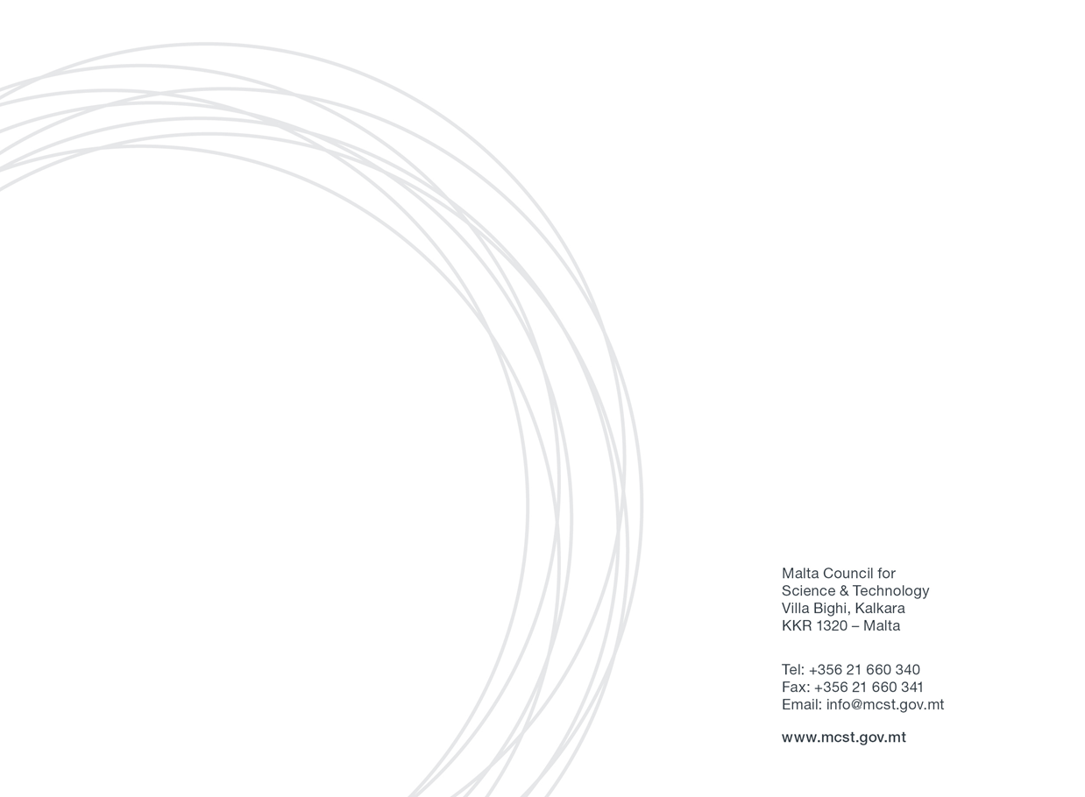
Horizon 2020 Awards Application Form Annex 1: Non State Aid Declaration

Annex 1

Non-State Aid justifications for – legal entities and researchers

Horizon 2020 Awards
Eligibility
Eligible Legal Entities and Researchers which have participated in a Horizon 2020 projects and do not carry out any economic activities within the Article 107 TFEU.
- Legal Entities: All Maltese registered legal entities which are beneficiaries and are in the possession of a signed grant agreement with budget allocation of their Horizon 2020 project/s. Entities can only apply with one project per award category. In the case where one project has multiple Maltese beneficiaries, a mutual agreement between the Maltese beneficiaries should be reached before the submission of the application. Only one Maltese entity representing the other entities can apply for an award category.

- Researchers: Individuals may apply to the award category allocated for the researchers. The researcher should work or should have been working with a Maltese Entity which is in possession of a signed grant agreement with their budget allocation of the Horizon 2020 project/s. The researcher/s must be or must have been performing the research in Malta.
Declaration
I, the undersigned, declare that the researcher or legal entity which I represent is not involved in any economic activity which falls under the under Article 107(1) of the Treaty, and I certify to fall within the scope of the non-state aid.
The Applicant understands that if found to be in breach of the conditions for being exempt from State Aid rules, the Managing Authority will enforce the retrieval of funds provided under the Horizon 2020 Awards with interest, in part or in full, as the case may necessitate. The Applicant also undertakes to comply faithfully and immediately with any decision of the European Commission or a Maltese judicial authority declaring Article 107(1) TFEU to be applicable to this Agreement.

The Applicant Name, __________________________________,
Legal Entity (where applicable), __________________________________,
The Applicant Signature, __________________________________,
Date, __________________________________,

