The Malta Council for Science and Technology
Research & Innovation Unit:
Research Excellence Programme

Call for Expressions of Interest for Evaluators

The Malta Council for Science and Technology is seeking the project and/or report evaluation services in research

DEADLINE: 26th October 2020

This measure falls under the Evaluators category under the Research Excellence Programme which is supported through Malta Government funds and is managed by the Malta Council for Science and Technology, on behalf of the Foundation for Science and Technology

Call for Expressions of Interest for Evaluators
1.0 General
This is a Call for Expressions of Interest for Evaluators to provide advisory support to the Malta Council for Science and Technology (hereinafter referred to as the Council) in the systematic and objective assessment of submitted project proposals, within the Research Excellence Programme. The aim is to determine the relevance of objectives, Scientific Excellence, implementation and impact as per guidelines stipulated by the Council for the proposals. Evaluators are expected to provide information that is credible, useful, and will be expected to determine the worth or significance of the relevant activity or project based on the guidelines provided. Upon selection, the Council will provide a defined set of criteria upon which projects or reports should be evaluated.
This Call is open to Evaluators with expertise in any research area including but not limited to:
- Natural sciences
- Engineering and Technology
- Medical and Health Sciences
- Agricultural and Veterinary Sciences
- Social sciences
- Humanities and the Arts
The purpose for evaluations and the main aim of this call is to ensure that national funding is utilised for notable research which could have a significant impact on the field of research or the society in general. It is therefore fundamental for the evaluator to ensure that all services are being tailored to the unique and specific requirements of each proposal, within a local, professional and, international context.
2.0 Background to the Research Excellence Programme
The Research Excellence Programme continues to widen the portfolio of research programmes offered by the Council. The Research Excellence Programme is a national funding programme which supports the early stage development of innovative projects proposed by public entities, higher education institutes and industry players.
In line with the “National Research and Innovation Strategy 2020”, the primary aim of the programme is to spur the growth of new knowledge through experimental evidence following scientific hypotheses. This programme was designed in response to the need and desire for public and private entities in Malta to focus on early conceptual research endeavours. The programme is intended to fund projects which are still in the early stages of research, but which nonetheless boast a high degree of excellence as well as national and international relevance.
The programme also aims to:
- Form a more comprehensive Maltese R&I system.
- Build capacity in new, multidisciplinary areas in the Maltese R&I sector.
- Fund the initial research in products or services that could have a significant impact on industry and which could ultimately lead to new avenues for economic growth.
- Generate knowledge and build capacity for future areas and contribute to smart specialisation strategies and policy development.
- Strengthen and contribute to existing collaborations.
The scope of the programme is to provide financial support for research, development and innovation through a bottom up approach, whereby excellence in areas other than those identified in the Smart Specialisation, may arise and be considered for future policy initiatives.

3.0 Service Requirements
The Council requests that interested Evaluators may assist in the following activities:
- Evaluation of project proposals submitted in response to calls for proposals in line with the Research Excellence Programme’s policies, criteria and related information packages.
- Evaluation of ongoing projects in cases where it becomes necessary to assess and re-evaluate their impact and feasibility based on specific information derived by the Council, Service Providers or Beneficiaries as well as other potential indicators.
- Any consensus meetings required (only if required by the Council)
4.0 Budget and Finances
In line with legislative measures, all Evaluators engaged by the Council should have a valid VAT number. It is essential that applicants either provide a copy of their VAT certificate or if this has not yet been provided by the VAT department, a declaration that an application for a VAT certificate has been submitted.
Please note that the Council will require an invoice for any work carried out and an official receipt for all payments affected.
The table below provides additional information on the remuneration provided for each area including consensus meetings.
Table 1
Activity | Description | Turnaround Required | Remuneration for proposal Evaluation | Remuneration for consensus meeting attendance
Project Application Stage
Scientific Opinion for New Projects | Evaluations of proposal | 7 days | €100 | €20 evaluator  + €20 for rapporteur

5.0 Duration of Contract and Conditions
Evaluators shall bind themselves to conduct such assignments in accordance with the terms of this Call. Any additional information or clarification, as may be requested by the Council, shall be deemed to form an integral part of the original assignment.
The Council may accept Evaluators who propose the provision of services in more than one domain. Applicants must have a proven and successful track record.
The selected Evaluators will be expected to sign a formal contractual undertaking for the provision of services within two weeks from being notified of the conclusion of the adjudication process.
With the exception of information that is already in the public domain, evaluators shall not divulge to third parties any of the information obtained in the course of this Call; or, in the event of a service allocation, during the course of evaluation, without the prior written consent of the Council. Information must be protected and used in accordance with the provisions of the Data Protection Act 2001.
The agreement shall run for one (1) year, from 1st November 2020 until 31st October 2021 and be of a maximum value of five thousand Euro (€5000) (excl. VAT). The place of work will be the place where the evaluator has his official (permanent) address or at the Council Premises. Evaluators will also be expected to sign a Non-disclosure Agreement.
In limited instances, the selected Evaluators may be asked to participate in evaluation meetings at Council premises or through Skype as part of their Service Agreement. This service is considered to form part of the Evaluation itself and will not necessitate additional remuneration.
The need for consensus meetings, which will be remunerated as per Table 1, will be held at the discretion of the Council. The decision will be taken on a case by case basis depending on the spread of scoring on a proposal and the technical aspects of the proposal.
Evaluation sheets with set criteria and guidelines will be provided per area upon the provision of an assignment.
Decisions taken by the Council with regards to the allocation of assignments to the selected Evaluators shall be binding and shall not be the subject of negotiation and/or discussion.
Evaluators must refuse work in the case of potential conflict of interest and may refuse work by providing reasonable justification.
The selected Evaluators shall ensure that all services are delivered within the time frames stipulated by the Council. Payment will be affected following the completion of the allotted assignment and upon presentation of an invoice. Evaluators are to produce an official receipt of payment within 5 working days. Failure to do so may lead to the termination of the contract.
If any disagreement or dispute arises out of the contract signed between the selected Evaluators and the Council, such matter may be referred to arbitration under the Arbitration Rules and Procedures established by the Laws of Malta.
The Council reserves the right to terminate the contract at any time without the need to provide justification.
6.0 Evaluation Guidelines
Evaluators should be guided by the following principles:
- Independence: Evaluation should be completed in one’s own personal capacity.
- Impartiality: All proposals should be treated equally and evaluated impartially on their merits, irrespective of their origin or the identity of the applicant or service provider.
- Objectivity: Each proposal should be evaluated as submitted and not based on potential changes and/or alterations.
- Accuracy: Judgements should be taken against the official evaluation criteria and the proposal in question.
- Consistency: The same standard of judgment should apply to all proposals.
- Confidentiality: It is essential that:
- Evaluation matters, such as: the content of proposals, the evaluation results or the opinions of fellow experts, are not discussed with anyone.
- Applicants, partners, sub-contractors, service providers or any third parties are not contacted.
- Confidentiality of documents is maintained at all times.
Upon completion of the evaluation, all documents should be deleted or destroyed.
6.1 Conflicts of Interest (COI)
A COI exists if the Evaluator:
- was involved in the preparation of the proposal or provision of service;
- stands to benefit directly / indirectly if the proposal is positively evaluated;
- has a family / personal relationship with any person representing an applicant or service provider;
- is a director / trustee / partner of an applicant or service provider or involved in the management of either;
- is employed or contracted by an applicant.
- involved in proposal writing with a beneficiary – in this case he/she has to immediately let the Council know so that his/her contract is terminated.
Any breach of the above will lead to the termination of the Evaluator’s contract. In such cases the evaluation will also be declared null and void and any invoices / expenses will also be rejected. It is the Evaluator’s responsibility to declare an actual or potential conflict of interest prior to commencing any assigned work.
6.2 Exclusion Criteria
Evaluators shall be excluded from application and participation if:
- they are currently beneficiaries of a programme administered by the Council.
- they are bankrupt or being wound up, are having their affairs administered by the courts, have entered into an arrangement with creditors, have suspended business activities, are the subject of proceedings concerning those matters, or are in any analogous situation arising from a similar procedure provided for in national legislation or regulations;
- they have been convicted of an offence concerning their professional conduct by a judgement which has the force of res judicata;
- they have been guilty of grave professional misconduct proven by any means which the Council may justify;
- they have been the subject of a judgement which has the force of res judicata for fraud, corruption, involvement in a criminal organisation or any other illegal activity;
- they are currently subject to an administrative penalty referred to in Article 16(8) of the Malta Financial Services Authority Act.
7.0 Instruction and Application
Evaluators are to submit one (1) copy of their application by electronic mail clearly marked “Call for Evaluators in [select preferred area(s)]” to rep.mcst@gov.mt
Applicants are to ensure that confirmation of receipt is provided in writing.
In the preparation, submission and any other process relevant to the submission and adjudication of this Call, potential Evaluators shall be guided by the following:
Each application should include the following items:
- A covering letter clearly listing relevant research areas;
- A detailed Europass Curriculum Vitae;
- A copy of certificates;
- A profile of the Entity (if applying as part on an entity);
- Copy of the VAT certificate.
- Company registration number (if applying as part of an entity);
- Annex 02;
- Annex 03 (Enterprises only); and
- Annex 04
Notes:
- Evaluators must, at minimum, hold a tertiary level of education.
- Evaluators must show proof of at least five years of professional experience in their research areas.
- Preference will be given to Evaluators holding prior evaluation experience at an international level.
- If the evaluation services are being provided under the auspices of an entity, a profile of the entity should be provided in addition to the professional profile and Curriculum Vitae of the person designated as the Evaluator within that entity.
- If the evaluation services are being provided under the auspices of an entity, the company’s registration and VAT number should be provided. With exception to this clause, if the Evaluator is self-employed, then only the VAT number is required.
Any requests for information or clarifications related to this Call are to be submitted via email at: rep.mcst@gov.mt

Interested Evaluators are requested to submit their response and all relevant documents by not later than midnight on 26th October 2020. All documents should be initialised on each page.

Data Protection Clause: The information collected through this Call shall be processed in accordance with the Data Protection Act 2001. The contents remain confidential and intended solely for the use of this purpose, and will not be disclosed or copied without your consent to anyone outside the Ministry for Employment and Education unless the law permits us to.

Annex 01 – Research Areas
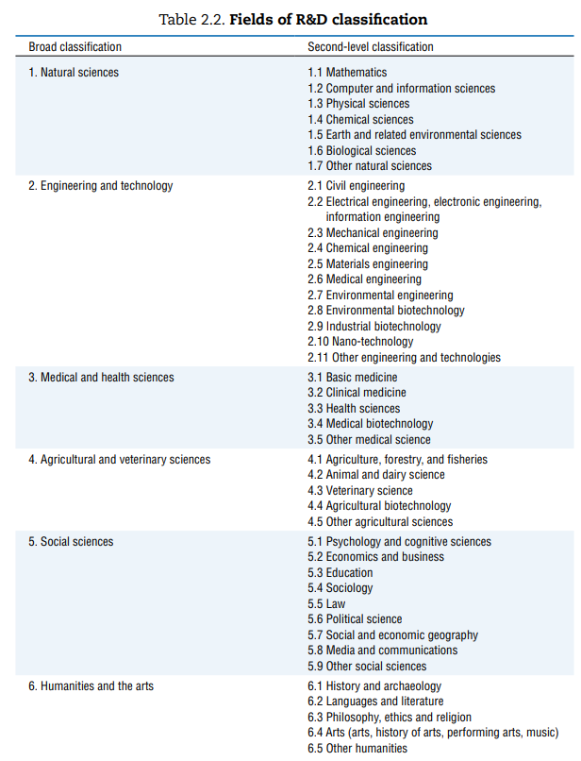
The Research Excellence Programme will take a bottom-up approach with no specified thematic areas. The intention is to allow research areas to build capacity organically and allow for new areas of expertise to arise. With that in mind, the below list of research areas obtained from Page 59 of the “Frascati Manual 2015” to be used as a guideline:
Annex 02 – Submission Checklist
This checklist is intended to facilitate submission. Candidates are requested to submit a copy of the checklist together with all relevant documents in sequence.
- Evaluators should hold at least five years of professional experience in their preferred areas.
- Preference will be given to Evaluators holding prior evaluation experience both at an international level.

Ref | Submission Task | Submission  Check Box
1 | A cover letter clearly listing the areas applied for
2 | A detailed Europass Curriculum Vitae
3 | A copy of certificates
4 | A profile of the Entity (if applying as part on an entity
5 | Copy of the VAT certificate.
6 | Company registration number (if applying as part on an entity)
7 | Annex 02;
8 | Annex 03 (Enterprises only); and
9 | Annex 04 (Scientific Opinion only)

Note: An inability to provide any of the above will lead to categorical exclusion.

Annex 03 – Statement on Conditions of Employment
- It is hereby declared that all employees engaged with the company shall enjoy working conditions including wages, salaries, vacation and sick leave, maternity and parental leave as provided for in the relative Employment Legislation. Furthermore, we shall comply with Chapter 424 of the Laws of Malta (Occupational Health and Safety Authority Act) as well as any other national legislation, regulations, standards and/or codes of practice or any amendment thereto in effect during the provision of services under this contract.
- It is hereby declared that the service being provided under this Call will be carried out by the bidding entity employees or bona fide self-employed individuals or subcontracted third parties. No work will be carried out by persons designated as self-employed where their actual employment status in terms of the Employment Status National Standard Order LN 44/2012 is that of an employee without prior notification to the Council. Such notification must reach the Council with 2 days of allocation of an assignment.
- It is hereby declared that all the employees of the bidder, whether providing services to the Council or not, have a written contract of service and are registered with the competent authority of Malta which is the Employment and Training Corporation. Copies of the written contracts of service of the employees or sub-contracted parties will be available at any time for inspection.
- It is hereby declared that if the bidder is found in breach of any of the above declarations it is accepted that this application will be nullified and that we will have no right to be compensated for any damage we may have suffered or will suffer in the future in respect to this termination.
- The Evaluator or legal representative agrees to all the conditions listed in this statement.

Signature...........................................................................
Name of Signatory............................................................
I.D. No. .............................................................................
Name of bidder/contractor..............................................

Annex 04 – Expertise in Research Areas
Using the recommendations in Annex 2, kindly provide a list of research fields in which you have the capacity to evaluate proposals. More than one research area may be selected. In the case where “Other [Research Field]” is selected kindly specify the unlisted research field.
Research Areas:

Payments are applicable when meetings are requested by the Council and they hold for meetings requiring physical presence by all evaluators or when not possible meetings over skype.

