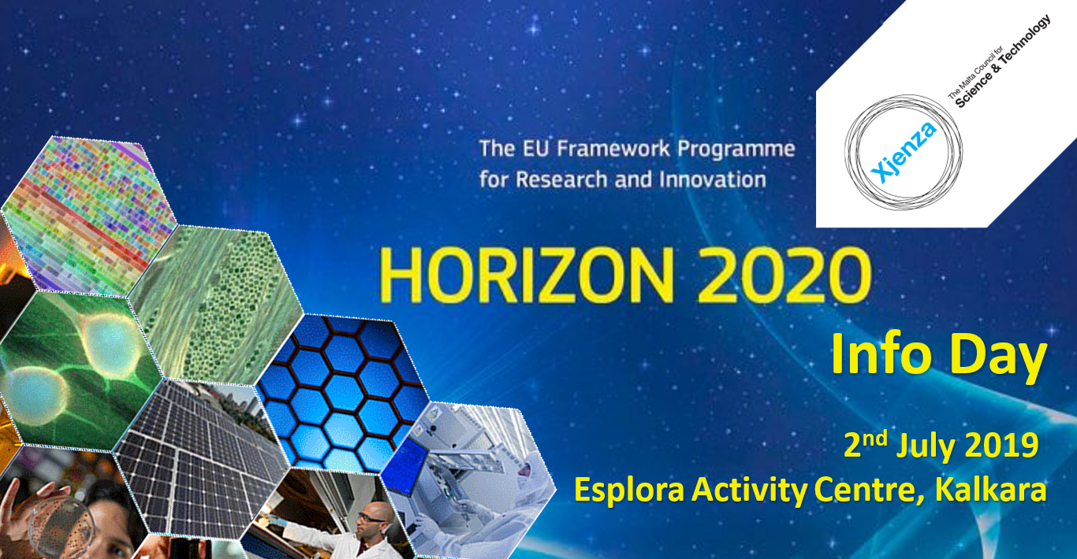

Draft Agenda
Moderator: Ian Busuttil Naudi

09:30 Registration and welcome coffee
10:00 Welcome Address - Dr Jeffrey Pullicino Orlando, Executive Chairman, MCST
10:10 Introductory speech - Elena Grech, Head of European Commission Representation
10:20 Introduction, what is Horizon 2020? Why an EU Framework Programme? – Anthea Fabri, Director, Horizon 2020 Unit, MCST
10:45 Panel discussion ‘Tips and tricks for a good proposal’
- Mario Balzan, MCAST -ReNature and Esmeralda projects
- Claire de Marco, University of Malta – VENTuRE project (tbc)
- Jenny Casingena Harper, MCST - evaluator
- Helen Grech, University of Malta - evaluator
- Philip Farrugia, University of Malta – PRIME-VR2 project
- Tamás Bardócz, AquaBioTech Group – iFishIENCi project
11:45 The role of EEN in Horizon 2020 – Steven Frigerio, Horizon 2020 NCP Executive, MCST
12:10 What’s next? The new Framework Programme - Horizon Europe - Matthew Lowell, Strategy and Policy Executive, MCST
12:30 Networking lunch

13:30 Parallel sessions round 1 – information on upcoming calls
Room 1: European Innovation Council, Research Infrastructures
Room 2: European Research Council, Marie Curie Actions, Widening
Room 3: Social Sciences and Humanities, Secure Societies
14:30 Parallel sessions round 2 – information on upcoming calls
Room 1: Bio-economy, Food, Health
Room 2: Space, ICT, NMBP
Room 3: Climate, Energy, Transport
15.30 ‘Science of Cocktail’ networking supported by EEN
16.30 End of event

