The Malta Council for Science and Technology
FUSION: The R&I Programme:
The Commercialisation Voucher Programme and Technology Development Programme

Call for Expressions of Interest for Evaluators

The Malta Council for Science and Technology is seeking the project and/or report evaluation services in the following areas:
Project Scientific Opinion | Maritime; Aquaculture; Health; High Value Added Manufacturing; Resource Efficient Buildings; ICT; Aviation and Aerospace and Tourism Product Development
Stage Report Evaluations | IP Check; Market Research; Product Development Costing; Economic Impact Assessments; Risk Profile and Business Plan
Due Diligence Evaluations | This includes but is not limited to: a check on the organization, a review on whether it is financially sound, a review of whether it has the capacity, capability and expertise to deliver and a check on its systems and processes to deliver.

DEADLINE: Noon on 20th November 2017

This measure falls under the Evaluators category under the FUSION Programme. FUSION is supported through Malta Government funds and is managed by the Malta Council for Science and Technology, on behalf of the Foundation for Science and Technology.

Call for Expressions of Interest for Evaluators

1.0 General
This is a Call for Expressions of Interest for Evaluators to provide advisory support to the Malta Council for Science and Technology (hereinafter referred to as the Council) in the systematic and objective assessment of submitted project proposals, stage reports and due diligence evaluations on both the Commercialisation Voucher Programme and Technology Development Programme. The aim is to determine the relevance and fulfilment of objectives, suitability, effectiveness, impact and sustainability as per guidelines stipulated by the Council for both projects and stages. Evaluators are expected to provide information that is credible and useful, and will be expected to determine the worth or significance of the relevant activity or project based on the guidelines provided. Upon selection, the Council will provide a defined set of criteria upon which projects or reports should be evaluated.
This Call is open to Evaluators with expertise in any of the following areas:
- Project Scientific Opinion (Smart Specialisation Areas) (Ref: Annex 1) namely: Maritime, Aquaculture, Health, High Value Added Manufacturing, Resource Efficient Buildings, ICT, Aviation and Aerospace and Tourism Product Development
- Stage Report Evaluations, namely in the fields of: Market Research; Product Development Costing; Economic Impact Assessments; Risk Profiles and Business Plans
- Due Diligence Evaluation
The purpose for evaluations and the main aim of this call is to ensure that national funding is utilised for commercially viable developments that, for the most part, are aligned with the Smart Specialisation Areas, and that, throughout the project, local researchers and industry players receive a high quality service and valuable knowledge from Service Providers. This supports them to meet the challenges which may result in the process of evolving their ideas to meet market requirements. It is therefore fundamental for the Evaluator to ensure that all services are being tailored to the unique and specific requirements of the beneficiaries, within the local context, and, as necessary, within the international market arena.

2.0 Background to FUSION
FUSION presents a funding programme that supports Research and Innovation with the ultimate goal of promoting and supporting local research and innovation, as well as providing the necessary handholding in order to enable researchers and technologists to turn their innovative ideas into a market ready reality. In doing so, it provides the fora in which public and private enterprises can invest in more innovative, eco-efficient products and services. This, in turn, enables the Maltese economy to become more resource-efficient, competitive and attractive to foreign investors. The programme prioritises projects that fall within the Smart Specialisation Areas, (for more information please refer to Annex 01).
FUSION is composed of two main programmes: the Fusion R&I Commercialisation Voucher Programme (CVP) and the Fusion R&I Technology Development Programme (TDP). The former consists of three stages (and hence three Vouchers), supporting the assessment of commercialisation potential prior to the actual undertaking of any research and development under the Technology Development Programme. It assists inventors, being researchers or industry players, to assess the commercial and market potential of their ideas. The Technology Development Programme, in turn, provides state financing in the form of grants for research, development and innovation in science and technology. It funds the actual development of the research and innovation proposal with the possibility of having a prototype of the proposed solution. To further supplement the research, a further three vouchers covering the initial patent application, the business plan, and investors meetings are also offered. These may be utilised during the project duration or within two years from the end of the project.
The diagram below provides a detailed step by step approach for FUSION, together with the related timelines for each stage.
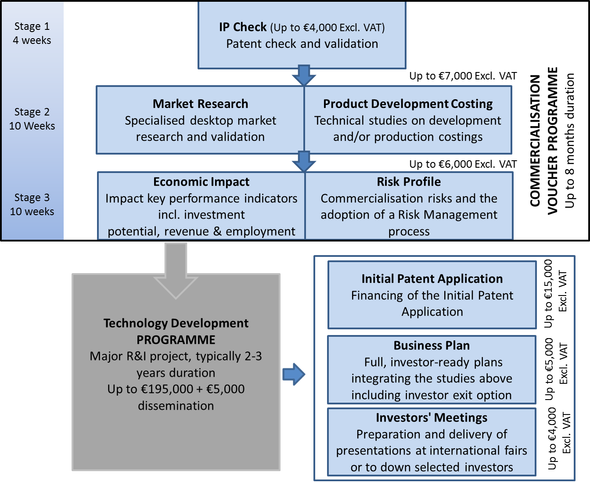

3.0 Service Requirements
The Council requests that interested Evaluators may assist in the following activities:
- Evaluation of project proposals submitted in response to calls for proposals in line with FUSION’s policies, criteria and related information packages (Project Scientific Opinion namely in: Maritime; Aquaculture; Health; High Value Added Manufacturing; Resource Efficient Buildings; ICT; Aviation and Aerospace and Tourism Product Development)
- Evaluation of completed stages under the above-mentioned programme in: IP Check; Market Research; Product Development Costing; Economic Impact; Risk Profile; and Business Plan
- Due Diligence Evaluation
- Evaluation of ongoing projects in cases where it becomes necessary to assess and re-evaluate their impact and feasibility based on specific information derived by the Council, Service Providers or Beneficiaries as well as other potential indicators.
- Any consensus meetings required (only if required by the Council)
4.0 Budget and Finances
In line with legislative measures, all Evaluators engaged on FUSION should have a valid VAT number. It is essential that applicants either provide a copy of their VAT certificate or if this has not yet been provided by the VAT department, declaration that it has been applied for.
Please note that the Council will require an invoice for any work carried out and an official receipt for all payments affected.
The table below provides additional information on the remuneration provided for each area including consensus meetings for CVP and TDP.
Table 1
Activity | Description | Turnaround Required |  | Remuneration Com. Voucher. Programme | Remuneration Tech. Dev. Programme
Project Application Stage
Scientific Opinion for New Projects | Evaluations for projects in the fields of: Maritime; Aquaculture; Health; High Value Added Manufacturing; Resource Efficient Buildings; ICT; Aviation and Aerospace and Tourism Product Development. |  | 7 days | €80 | €120
 |  |  |  | Consensus meetings
 |  |  |  | €20 evaluator  extra €20 for rapporteur | €20 evaluator  extra €20 for rapporteur
Stage Reports (includes one evaluation meeting required by the Council)
IP Check | Includes: Patent check;  validation and scientific  opinion and registration. |  | 7 days | €80
Market Research | Includes: desktop market research; specialised research data; primary source data including transcripts and analysis with potential technology buyers. |  | 7 days | €80
Product Development Costing | Includes: analysis of different production options including costings; analysis of resources, plant and equipment; and logistics. |  | 7 days | €80
Economic Impact | Includes: analysis of economic bearing; key performance indicators; investment potential; revenue and employment. |  | 7 days | €80
Risk Profile | Includes: the assessment of the different types and levels of risk involved if the technology were to be commercialised. |  | 7 days | €80
Stage Report: Technology Development Programme
Business Plans | Includes: full investor ready plans, integrating Stages 1 to 3 and including an investor exit option. |  | 7 days |  | €80
Due Diligence Evaluation
Due Diligence Evaluation | Includes but is not limited to: a check on the organization, a review on whether it is financially sound, a review of whether it has the capacity, capability and expertise to deliver and a check on its systems and processes to deliver. |  | 7 days |  | €120

5.0 Duration of Contract and Conditions
Evaluators shall bind themselves to conduct such assignments in accordance with the terms of this Call. Any additional information or clarification, as may be requested by the Council, shall be deemed to form an integral part of the original assignment.
The Council may accept Evaluators who propose the provision of services in more than one domain or stage. Applicants must have a proven and successful track record.
The selected Evaluators will be expected to sign a formal contractual undertaking for the provision of services within two weeks from being notified of the conclusion of the adjudication process.
With the exception of information that is already in the public domain, evaluators shall not divulge to third parties any of the information obtained in the course of this Call; or, in the event of a service allocation, during the course of evaluation, without the prior written consent of the Council. Information must be protected and used in accordance to the provisions of the Data Protection Act 2001.
The agreement shall run for one (1) year, from 1st January 2018 until 31st December 2018 and be of a maximum value of five thousand Euro (€5000) (excl. VAT). The place of work will be the place where the evaluator has his official (permanent) address or at the Council Premises. Evaluators will also be excepted to sign a Non-disclosure Agreement.
In limited instances, the selected Evaluators may be asked to participate in evaluation meetings at Council premises or through Skype as part of their Service Agreement. This service is considered to form part of the Evaluation itself and will not necessitate additional remuneration.
At CVP stage, when the project scientific opinion evaluations carried out by the evaluators differ by more than 20 marks, evaluators may be asked to attend a consensus meeting, which will be renumerated as per Table 1.
At TDP stage, consensus meetings are mandatory and renumerated as per Table 1.
Evaluation sheets with set criteria and guidelines will be provided per area upon the provision of an assignment.
Decisions taken by the Council with regards to the allocation of assignments to the selected Evaluators shall be binding and shall not be the subject of negotiation and/or discussion.
Evaluators must refuse work in the case of potential conflict of interest, and may refuse work by providing reasonable justification.
The selected Evaluators shall ensure that all services are delivered within the time frames stipulated by the Council. Payment will be effected following the completion of the allotted assignment and upon presentation of an invoice. Evaluators are to produce an official receipt of payment within 5 working days. Failure to do so may lead to the termination of the contract.
If any disagreement or dispute arises out of the contract signed between the selected Evaluators and the Council, such matter may be referred to arbitration under the Arbitration Rules and Procedures established by the Laws of Malta.
The Council reserves the right to terminate the contract at any time without the need to provide justification.
6.0 Evaluation Guidelines
Evaluators should be guided by the following principles:
- Independence: Evaluation should be completed in one’s own personal capacity.
- Impartiality: All proposals and stage reports should be treated equally and evaluated impartially on their merits, irrespective of their origin or the identity of the applicant or service provider.
- Objectivity: Each proposal and stage report should be evaluated as submitted and not based on potential changes and/or alterations.
- Accuracy: Judgements should be taken against the official evaluation criteria and the proposal or stage report in question.
- Consistency: The same standard of judgment should apply to all proposals and stage reports.
- Confidentiality: It is essential that:
- Evaluation matters, such as: the content of proposals/stage reports, the evaluation results or the opinions of fellow experts, are not discussed with anyone.
- Partners in the consortium, sub-contractors, service providers or any third parties are not contacted.
- Confidentiality of documents is maintained at all times.
Upon completion of the evaluation, all documents should be deleted or destroyed.

6.2 Conflicts of Interest (COI)
A COI exists if the Evaluator:
- was involved in the preparation of the proposal or provision of service;
- stands to benefit directly / indirectly if the proposal or stage report is positively evaluated;
- has a family / personal relationship with any person representing an applicant or service provider legal entity;
- is a director / trustee / partner of an applicant or service provider or involved in the management of either;
- is employed or contracted by an applicant or service provider for the purpose of FUSION or a subcontractor for the same.
- involved in proposal writing with a beneficiary – in this case he/she has to immediately let the Council know so that his/her contract is terminated.
Any breach of the above will lead to the termination of the Evaluator’s contract. In such cases the evaluation will also be declared null and void and any invoices / expenses will also be rejected. It is the Evaluator’s responsibility to declare an actual or potential conflict of interest prior to commencing any assigned work.

6.3 Exclusion Criteria
Evaluators shall be excluded from application and participation if:
- they are currently beneficiaries of a project under the FUSION programme.
- they are bankrupt or being wound up, are having their affairs administered by the courts, have entered into an arrangement with creditors, have suspended business activities, are the subject of proceedings concerning those matters, or are in any analogous situation arising from a similar procedure provided for in national legislation or regulations;
- they have been convicted of an offence concerning their professional conduct by a judgement which has the force of res judicata;
- they have been guilty of grave professional misconduct proven by any means which the Council may justify;
- they have been the subject of a judgement which has the force of res judicata for fraud, corruption, involvement in a criminal organisation or any other illegal activity;
- they are currently subject to an administrative penalty referred to in Article 16(8) of the Malta Financial Services Authority Act.

7.0 Instruction and Application
Evaluators are to submit one (1) copy of their application by electronic mail clearly marked “Call for Evaluators in [select preferred area(s)]” to voucher.mcst@gov.mt
Applicants are to ensure that confirmation of receipt is provided in writing.
In the preparation, submission and any other process relevant to the submission and adjudication of this Call, potential Evaluators shall be guided by the following:
Each application should include the following items:
- A covering letter clearly listing the areas applied for;
- A detailed Europass Curriculum Vitae;
- A copy of certificates;
- A professional Profile (include proof of experience);
- A profile of the Entity (if applying as part on an entity);
- Copy of the VAT certificate.
- Company registration number (if applying as part of an entity);
- Two reference letters (an exemption is made in the case of IP Check only);
- Annex 02;
- Annex 03 (Enterprises only); and
- Annex 04 (Scientific Opinion only)

Notes:
- Evaluators must, at minimum, hold a tertiary level of education.
- Evaluators must show proof of at least five years of professional experience in all their preferred areas.
- Preference will be given to Evaluators holding prior evaluation experience at an international level.
- If the evaluation services are being provided under the auspices of an entity, a profile of the entity should be provided in addition to the professional profile and Curriculum Vitae of the person designated as the Evaluator within that entity.
- If the evaluation services are being provided under the auspices of an entity, the company’s registration and VAT number should be provided. With exception to this clause, if the Evaluator is self-employed, then only the VAT number is required.
Any requests for information or clarifications related to this Call are to be submitted via email at: voucher.mcst@gov.mt

Interested Evaluators are requested to submit their response and all relevant documents by not later than noon on 20th November 2017. All documents should be initialised on each page.

Data Protection Clause: The information collected through this Call shall be processed in accordance with the Data Protection Act 2001. The contents remain confidential and intended solely for the use of this purpose, and will not be disclosed or copied without your consent to anyone outside the Ministry for Employment and Education unless the law permits us to.

Annex 01 – Smart Specialisation Areas
FUSION prioritises the Smart Specialisation Areas as identified in the National R&I Strategy 2020, though not exclusively. This business driven process aims to concentrate efforts on a few select areas chosen on the bases of unique selling points and indigenous strengths. The selected thematic areas, identified through a rigorous process involving a variety of inputs, will be the focus on investments due to their potential for research & innovation, thus giving the country a competitive edge over others. These are:
Maritime Services | Focus on more integrated, new and improved services, in particular innovation in maritime engineering, ICT, design and services. Presently there are a variety of existing services with a world level profile however the sector remains fragmented.
Aviation and Aerospace | The scope for this area is that further investments are made to raise the level of achievement, by venturing into high value-added engineering in order to move up the value chain in specific niches.
Health with a focus on healthy living and active ageing and e-health | The approach is to cultivate a multi-disciplinary approach, innovative e-health solutions as well as the integration of medical science and solutions for active and healthy ageing.
Resource-efficient buildings | Focus on innovative solutions in the sector which addresses water scarcity and energy (dependence on fossil fuels, take up of renewable energy sources, etc.). Resource efficient buildings would transform the sector by increasing value added growth and green jobs.
Tourism Product Development | A key pillar of economic activity in Malta, this sector is not R&D intensive but must innovate in order to remain attractive and competitive.
High value-added manufacturing with a focus on processes and design | Manufacturing is a predominant sector for R&I investment, however, it should focus more on innovation niches such as process innovation, through the optimisation of resource use, energy efficiency and product design.
Aquaculture | Malta has a good degree of know how in this sector however there is scope for exploring further consolidation of existing strengths through focus on areas of common interest.
The Role of ICT | ICT has been identified as a horizontal enabler for technology in all economic sectors, particularly, health, financial services and tourism product development. In addition ICT plays an important role in research, development and innovation.
Annex 02 – Submission Checklist
This checklist is intended to facilitate submission. Candidates are requested to submit a copy of the checklist together with all relevant documents in sequence.
- Evaluators should hold at least five years of professional experience in their preferred areas.
- Preference will be given to Evaluators holding prior evaluation experience both at an international level.

Ref | Submission Task | Submission  Check Box
1 | A cover letter clearly listing the areas applied for
2 | A detailed Europass Curriculum Vitae
3 | A copy of certificates
4 | A professional Profile (include proof of experience)
5 | A profile of the Entity (if applying as part on an entity
6 | Copy of the VAT certificate.
7 | Company registration number (if applying as part on an entity)
8 | Two reference letters (an exemption is made in the case of IP Check only)
9 | Annex 02;
10 | Annex 03 (Enterprises only); and
11 | Annex 04 (Scientific Opinion only)

Note: An inability to provide any of the above will lead to categorical exclusion.

Annex 03 – Statement on Conditions of Employment
- It is hereby declared that all employees engaged with the company shall enjoy working conditions including wages, salaries, vacation and sick leave, maternity and parental leave as provided for in the relative Employment Legislation. Furthermore, we shall comply with Chapter 424 of the Laws of Malta (Occupational Health and Safety Authority Act) as well as any other national legislation, regulations, standards and/or codes of practice or any amendment thereto in effect during the provision of services under this contract.
- It is hereby declared that the service being provided under this Call will be carried out by the bidding entity employees or bona fide self-employed individuals or subcontracted third parties. No work will be carried out by persons designated as self-employed where their actual employment status in terms of the Employment Status National Standard Order LN 44/2012 is that of an employee without prior notification to the Council. Such notification must reach the Council with 2 days of allocation of an assignment.
- It is hereby declared that all the employees of the bidder, whether providing services to the Council or not, have a written contract of service and are registered with the competent authority of Malta which is the Employment and Training Corporation. Copies of the written contracts of service of the employees or sub-contracted parties will be available at any time for inspection.
- It is hereby declared that if the bidder is found in breach of any of the above declarations it is accepted that this application will be nullified and that we will have no right to be compensated for any damage we may have suffered or will suffer in the future in respect to this termination.
- The Evaluator or legal representative agrees to all the conditions listed in this statement.

Signature...........................................................................
Name of Signatory............................................................
I.D. No. .............................................................................
Name of bidder/contractor..............................................

Annex 04 – Expertise in SMART Specialisation Area

SMART Specialisation Areas | Please tick the preferred area(s)
Maritime
Aquaculture
Tourism Product Development
High value-added manufacturing with a focus on processes and design
Aviation and Aerospace
Health with a focus on healthy living and active ageing and e-health
ICT
Resource Efficient Buildings

Payments are applicable when meetings are requested by the Council and they hold for meetings requiring physical presence by all evaluators or when not possible meetings over skype.

