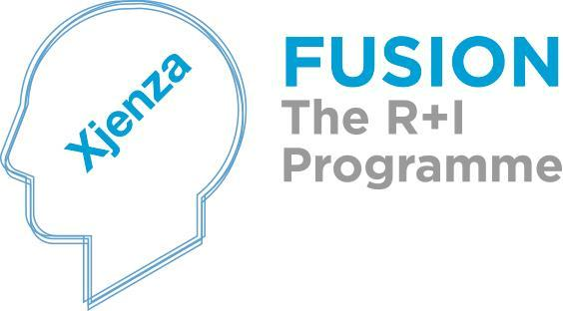

FUSION R&I Commercialisation Voucher Programme 2014-2020
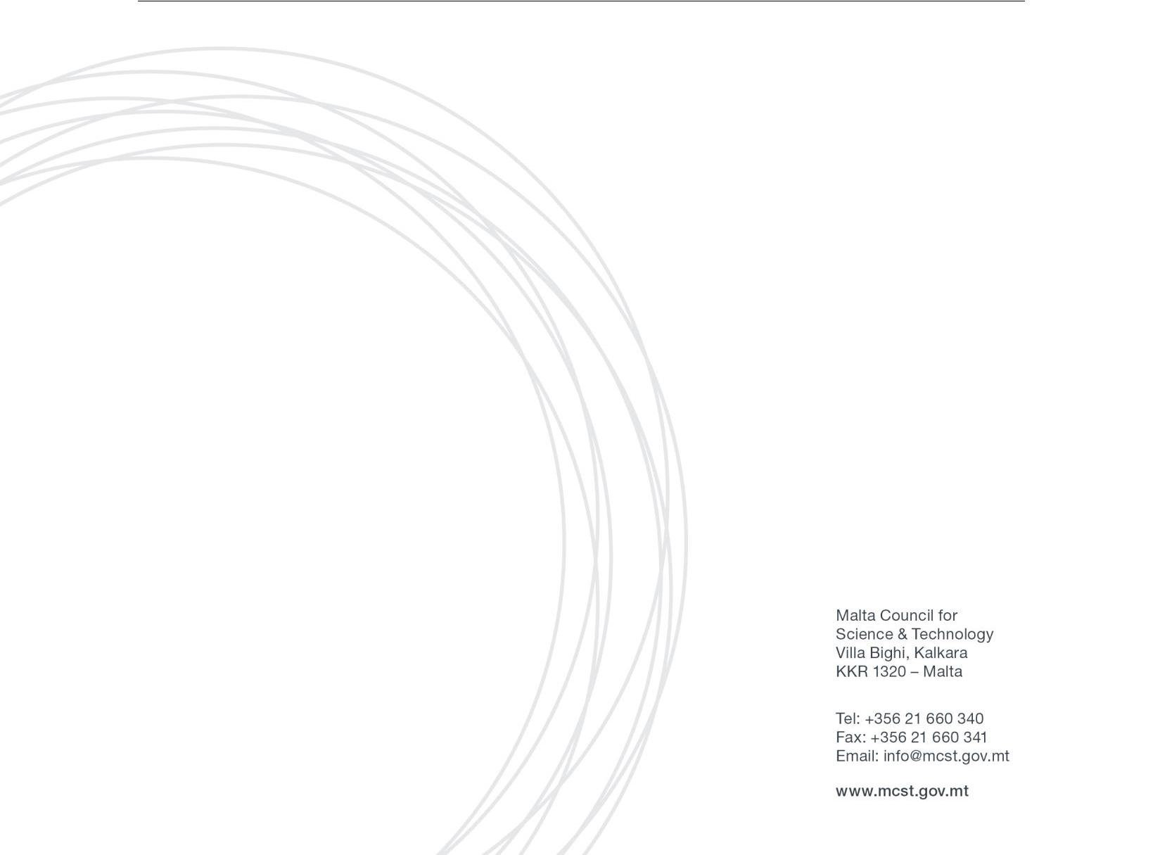
Rules for Participation

Version 5.0

Jan 2016

Table of Contents
1.0 Introduction 4
1.1 FUSION the R&I Programme 4
1.2. The Commercialisation Voucher Programme 4
1.3. Contacts 5
1.4. Definitions 6
2.0 Eligibility Criteria and Applications 9
2.1. Eligibility for Participation 9
2.2. Priority Sectors 9
2.3. Eligibility under the State Aid Regime 10
3.0 The Application Process 12
3.1. Application Submission 12
3.2. Submitting the Application Form 12
3.3. The Process 12
3.4 Phases of FUSION. 13
3.5 Considerations at Application Stage 14
3.5.1 Respecting Lead Times 14
3.5.2. Assistance with Applications 14
3.5.3. Confidentiality of Submissions 14
3.6 Programme Parameters 14
3.6.1 Commercialisation Voucher Value 14
3.6.2. Deliverables 15
3.6.3. Eligible Costs 15
3.6.4. Ineligible Costs 15
3.6.5. Co-Financing 15
3.6.6. Acceptance Criteria 15
4.0 Post Selection Process 16
4.1. The Commercialisation Voucher 16
4.2. Duration and Expiry 16
4.3. Double Funding 16
5.0 Funding, Management and Progress Monitoring 18
5.1. Allocation and Disbursement of Funding 18
Smart Specialisation Areas 20
The Identified Thematic Specialisation Areas 20
a. Tourism product development 20
b. Maritime Services 21
c. Aviation and aerospace 21
d. Health with a focus on healthy living and active ageing, and e-health 21
e. Resource-efficient buildings 21
f. High value-added manufacturing with a focus on processes and design 21
g. Aquaculture 22
The role of ICT 22

1.0 Introduction

1.1 FUSION the R&I Programme
FUSION, the R&I Programme, presents a funding programme that supports Research and Innovation with the ultimate goal of promoting and supporting local research and innovation as well as providing the necessary handholding in order to enable researchers and technologists to turn their innovative ideas into a market ready reality. FUSION is supported through Malta Government funds managed by the Malta Council for Science and Technology and will run from 2014 to 2020.
The main objectives of FUSION are: to raise the level and profile of locally funded research, to ingrain research and innovation at the heart of the Maltese economy, to spur knowledge-driven and value-added growth and to sustain improvements in the quality of life. This can be obtained since research results and innovation have the potential of translating themselves into commercial activities which generate a multiplier effect on the economy at large by, increasing Malta’s competitiveness, through the creation of additional high-value and knowledge intensive employment in Malta’s priority industries.
FUSION is composed of two main programmes, the Commercialisation Voucher Programme and the Technology Development Programme. These two programmes are designed in a way to offer the necessary mentoring and financial support to researchers and technologists to take their ideas to the market.

1.2. The Commercialisation Voucher Programme
The aim of the Commercialisation Voucher Programme is to offer financial support in order to improve the development and commercialization potential of ideas, be it technological and non-technological, for researchers and enterprises. The Commercialisation Voucher system is to act as a demand side measure and entice user driven innovation, with the ultimate aim of increasing research, technological development and innovation activities for the eventual implementation in industry.
Many a times enterprises can be creative and have innovative ideas, however, they lack the in-house expertise and innovation management skills to perform the required research activities and eventually develop these ideas into new products and services. In addition their capacity to hire skilled people for innovative projects and activities is also limited. All these factors may prevent them from accessing external knowledge, a crucial element if they are to maintain their level of competitiveness. On the other hand, researchers often have the knowledge and technical expertise to transform a concept or idea into an innovative technology, product or service however require assistance to identify the market potential and actually commercialise their discovery.
This Commercialisation Voucher Programme aims primarily at addressing these two issues and offering support to local researchers and enterprises. This will facilitate the access of firms to external knowledge and ultimately improving their level of competitiveness. In addition, it will help researchers to seek the market potential for their ideas. The programme supports knowledge transfer between organizations and offers researchers the possibility to develop their ideas into products and/or services which have market applicability.
These Commercialisation Vouchers are primarily intended to assist prospective applicants of the FUSION Technology Development Programme in order to better prepare themselves in terms of project proposal and validation. In some cases it could also assist beneficiaries of previous R&I Programmes.

The Commercialisation Vouchers will fund the following activities:

Figure 1: Sequential Phases of FUSION

1.3. Contacts
Correspondence should be directed to:
Dr. Melchior Cini
R&I Programmes Executive
R&I Programmes Unit
The Malta Council for Science & Technology
Villa Bighi, Bighi,
Kalkara KKR 1320
Email: melchior.cini@gov.mt
Tel: +356 2360 2153

1.4. Definitions

Research and Development is defined as the systematic investigation, work or research carried out in any field of science or technology through experiment, theoretical work or analysis undertaken in order to acquire new knowledge, primarily directed towards a specific practical aim or objective, and includes:
- Basic Research comprising activities undertaken for the advancement of scientific or technological knowledge that may draw on existing knowledge gained from research and practical experiences and is directed to produce new materials, products and devices, the implementation of new processes, systems or services, or to substantially improve those already produced, installed or existing;
- Applied Research where a final specific application is in view;
- Development involving the use of the results of basic or Applied Research as aforesaid for the purpose of creating new or of improving existing material, devices, products or processes, but excludes routine or periodic design, testing and analysis of equipment or products for the purposes of quality or quantity control, routine or periodic alterations to existing products or processes, or routine activities where there is no appreciable novelty or problem resolution.
Innovation is defined as the renewal and enlargement of the range of services and the associated markets; the establishment of new methods of design, production, supply and distribution; the introduction of changes in management, work organisation, and working conditions and skills of the workforce and covers technological, non-technological and organisational innovation.
Knowledge Transfer is defined as the transfer of technology or know-how generated by basic research institutions, such as universities, to the commercial sector for development into useful products and services. This may be achieved through licensing or marketing agreements, spin-offs, co-development arrangements, training or the exchange of personnel.

Academia is defined as an entity included but not limited to a higher education entity or a research institute, whether as a whole body or as a component unit or department within such body, whose primary goal is to conduct Research and Development and to disseminate research results and other knowledge by way of teaching, publication or Knowledge Transfer, the surplus / profits of which entity are reinvested in these activities, the dissemination of their results or teaching; and which entity is structured in such a manner that undertakings that can exert influence upon such an entity, in the quality of, for example, shareholders or members, shall enjoy no preferential access to the research capacities of such an entity or to the research results generated by it.
Provided that the higher education entity must be in possession of a license for Higher Education according to Article 8(3) of the Act of Education, Chapter 327 of the Laws of Malta. This does not include the license for a tuition center.
Provided further that the University of Malta and the Malta College of Arts, Science and Technology are deemed a priori as Academia in terms of the above and any Academic Institution shall be construed accordingly.
Industrial Entity is defined as a Maltese Legal Entity, included but not limited to, a Maltese Private Body or commercial enterprise the objects and activities of which include the output of a specified product and service. In addition to research and innovation contributions and knowledge transfer, the entity may contribute to the consortium by developing, testing, commercializing or using such a product or service. Provided that a Public Sector Entity, a registered NGO, or a Professional Body as defined in this Section is considered as forming part of this definition.
Maltese Legal Entity means any entity created under the law of Malta which has legal personality and which may, acting under its own name, exercise rights and be subject to obligations.
Maltese Private Body means any Maltese Legal Entity which has more than 50% private shareholding.
Maltese Public Body means any Maltese Public Service Department or Public Sector Entity, or any Maltese Legal Entity which has more than 50% government shareholding.
NGO means any Voluntary or Non-Governmental Organisation set up in accordance with The Voluntary Organisations Act (Cap. 492 of the Laws of Malta).
Professional Body may be an organisation, an association, a chamber, society, institute or a group of professional persons not being enrolled or registered in terms of The Voluntary Organisations Act (Cap. 492 of the Laws of Malta) or not being otherwise recognised in terms of Law, and which is generally recognised and acknowledged by the professional persons it seeks to represent as their representative Body. For the purposes of this Definition, a professional person is one who has undergone a period of study at a university or a recognised institution of higher learning and has obtained the formal qualification entitling the person to practise the respective profession; and who provides a specialised service to the public, based primarily on a fiduciary relationship between himself and the party to whom he provides such service on his own personal credibility and responsibility.
Public Sector Entity means the Public Service and Entities. For the purposes of this definition (i) Public Service refers to all Ministries and Departments; and (ii) Entities refers to authorities, corporations, agencies and commercial public sector entities in which the Government has a majority shareholding and that are not listed on the stock exchange. Entities also include foundations and local councils,
Intellectual Property (IP) means statutory and other proprietary rights and includes patents, trademarks, designs, confidential information / trade secrets, copyright.
Beneficiary can be a research institution or a micro and SME, which is eligible for the Commercialisation Voucher.
Commercialisation Voucher is a document that entitles the Beneficiary to contact an approved Service Provider to carry out activities funded through this Programme. The fees are agreed beforehand by the Council. The Beneficiary pays for the service by a cash grant from MCST.
Service Providers are the consultants who have accepted the Council’s invitation to offer the Beneficiaries the list of Activities funded through this Programme subject to a set of terms and conditions.
Activity can be defined as the tasks which will be performed and funded through the Commercialisation Voucher Programme.

2.0 Eligibility Criteria and Applications
This section provides details as to the criteria which must be checked in order to assess the eligibility to apply for the Programme.

2.1. Eligibility for Participation
Any Entity as described in Section 1.4, which has the intention of being a Beneficiary in a project funded through the FUSION R&I Technology Development Programme is eligible for funding subject to the terms and conditions laid out in this document.
Foreign entities are eligible to participate in this Programme, but are not eligible for funding.
Professional Bodies and NGOs are eligible to participate in this Programme, but will only be eligible for funding under the Programme in respect of an activity which has not been previously funded and does not itself fall within the normal sphere of activity, or within the services and consultancy normally carried out or provided, by the said Professional Body or NGO in their ordinary course of operation.
Any application submitted by or including the participation of any legal person or legal entity having, in totality or in majority ownership, and/or the same shareholders, and/or partners or persons holding and/or exercising a controlling or management power in any other legal entity or being the same legal person which will have been at any time prior to such application declared as non-compliant or defaulting on any other contract or agreement entered into with the Council, shall be automatically declared as inadmissible.
The term “defaulting” includes but is not limited to cases in which all parties participating in Council-funded projects have been deemed as being outside of the project stage timelines and have thus been or are in delay, and/or have not had technical deliverables, scientific and/or financial reporting and audits duly compiled and accepted by the Council for the said project.
In addition, the Council reserves the right at its discretion to request a Bank Guarantee to address its concerns with regards to potential risks identified by the Council as being posed by any one or more particular applicants.

2.2. Priority Sectors
Preference will be given to project proposals which are in line with the Smart Specialisation Areas as outlined in the National Research and Innovation Strategy 2020. However, if the allocated funding quota for the Call is not achieved, submissions for funding outside these areas may also be considered.

The identified priority areas are the following:
- ICT as an enabler
- ICT based innovation
- Tourism Product Development
- Maritime Services
- Aviation and Aerospace
- Health with a focus on healthy living and active ageing, and e-health
- Resource-efficient buildings
- High value-added manufacturing with a focus on processes and design
- Aquaculture

For more information about the Smart Specialisation Areas refer to Appendix 1.

2.3. Eligibility under the State Aid Regime
This Programme operates under the de minimis State Aid regime, which stipulates that a single undertaking cannot receive more than €200,000 in aid over any 3-year period through schemes operating under this regime. Applicants are required to ensure they are eligible for the requested grant under State Aid rules before submitting an application.
For the purposes of this Section, an “undertaking” shall mean any entity engaged in an economic activity, regardless of its legal status and the way in which it is financed.
Each undertaking must complete and execute the State Aid de minimis declaration form given to them by the Council prior to benefitting from the relative Commercialisation Voucher under this Programme.
For the purposes of the de minimis Regulation, “Single Undertaking” includes all enterprises having at least one of the following relationships with each other:
- One enterprise has a majority of the shareholders’ or members’ voting rights in another enterprise;
- One enterprise has the right to appoint or remove a majority of the members of the administrative, management or supervisory body of another enterprise;
- One enterprise has the right to exercise a dominant influence on another enterprise pursuant to a contract entered into with that enterprise or to a provision in its memorandum or articles of association;
(d) One enterprise, which is a shareholder in or member of another enterprise, controls alone, pursuant to an agreement with other shareholders in or members of that enterprise, a majority of shareholders’ or members’ voting rights in that enterprise.
Enterprises having any of the relationships referred to in points (a) to (d) above through one or more other enterprises shall be considered to be a single undertaking.
The terms and conditions set out in these guidelines are in line with the Commission Regulation (EU) No 1407/2013 of 18 December 2013 on the application of Articles 107 and 108 of the Treaty on the Functioning of the European Union to de minimis aid*.
Specific sectors (agriculture†, fisheries and aquaculture‡) are excluded from this regime and applications in these sectors are therefore outside the scope of this programme. The successful applicants are expected to sign the necessary forms before any funds are transferred and provide the necessary reports in accordance with de minimis State Aid regulations.
This Scheme is not available to undertakings in difficulty within the meaning of the Community guidelines on State Aid for rescuing and restructuring firms in difficulty.

* http://finance.gov.mt/image.aspx?site=MFIN&ref=De%20Minimis%20Regulation

† Undertakings active in the sector of agricultural production means undertakings active in the primary production of agricultural products. Agricultural products are those products listed in Annex I to the Treaty.

‡ Undertakings active in the fisheries and aquaculture sector means undertakings active in the production, processing and marketing of fisheries products which covers both products caught at sea and the products of aquaculture. Fishery products are listed in Article 1 of Council Regulation (EC) No 104/2000 of 17 December 1999 on the common organisation of the markets in fishery and aquaculture products.

3.0 The Application Process

3.1. Application Submission
Submission, evaluation and selection of application submissions will be in the form of a one-stage process in which a legal representative of the applicant will be asked to submit all the necessary information, which will then be accepted or otherwise.

3.2. Submitting the Application Form
Only completed application forms will be accepted. The application form must be fully finalised, dated, signed and initialised (stamped or signed) on each page by the entity’s legal representative. The application should also include a signed State Aid declaration and VAT Form, completed by all private, public and academic entities. The State Aid Declaration and the VAT Form are obligatory and the applicant retains ultimate responsibility for the veracity of their content.
All electronic submissions should include, both a word version and a signed PDF version, and may be sent to melchior.cini@gov.mt, keeping voucher.mcst@gov.mt in copy. Alternatively, interested parties may submit their application by hand at the Malta Council for Science and Technology, Villa Bighi Kalkara. In the case of the latter, a CD including a copy of the application form in word format should be annexed to the application form.
It is the responsibility of the applicant to ensure the timely and correct delivery of the application to the Council. The Council shall provide a return email or written acknowledgement as proof of receipt. The applicant should contact the Council if acknowledgement of receipt has not been communicated within 2 working days.
It should be noted that emails larger than 6MB shall be automatically rejected by the system.

3.3. The Process
The Council will issue two calls for applications on an annual bases. The objective of the application is primarily to assess the merit and potential benefit of the proposal. Once an application is received, it will be forwarded to an independent and external evaluator for a scientific opinion evaluation, the outcome of which is final. A threshold of 65/100 is required. The top scoring proposals within each Smart Specialisation area shall be selected. Priority will be given to even coverage of applications across the different areas. In cases where the total Call Financial Allocation has not been reached, the Council may, at its discretion, consider applications which are not aligned to the Smart Specialisation Areas.
The scientific opinion external evaluators are bound by confidentiality through a non-disclosure clause in their contract of engagement with the Council.

3.4 Phases of FUSION.
These activities will have to be typically undertaken sequentially one after each other. To this end for a proposal to be able to be funded for a Market Research and Product Development Costing Exercise, it needs to positively make it through the IP Check.
Following submission and selection of the application the Council will issue a Voucher Agreement and request the completion of an Inventor Disclosure Form. The Council will also appoint a Service Provider for the Beneficiary to work with and, upon agreement the activity will be undertaken within the pre-established timeframes between the Council and the Service Provider. At this stage an Acceptance Meeting will be held to confirm the engagement with a Service Provider and a voucher letter will be granted.
At the end of the study a report needs to be submitted. This is then forwarded to an external evaluator. The Council may thereafter call an Examination Meeting at its discretion. The Service Provider and the applicant would need to be present for this meeting. Once the Council approves the report, the applicant can pay the Service Provider and seek reimbursement of the Commercialisation Voucher from the Council. Reimbursements will be provided against proof of payments (receipts).
It is important to note that the funding for accepted proposals is based on a Commercialisation Voucher, which value is already agreed between the Council and the Service Provider and is regulated through an Agreement establishing the terms and conditions governing the financing of the activity.

Considerations at Application Stage

Respecting Lead Times
All organisations have their internal procedures for approval and signing off on legally binding documents. Participants are to ensure that they are aware of these lead times in their organisation as well as in the other organisations which they can be teaming up with. Participants should take these times, personal commitments, vacation leave etc, into account when planning to submit an application. All application submissions must reach the Council by the deadline and must include signatures of the legal representative of the participating organisation/s.

3.5.2. Assistance with Applications
Prospective applicants are encouraged to seek the advice of the Council in the preparation of the application. This should help identify any areas of concern prior to the submission of the application and lead to a better quality of submission. Advice shall only be given in respect to these Rules for Participation and not on technical grounds.

3.5.3. Confidentiality of Submissions
Unless otherwise indicated, all application submissions shall be treated in strict confidence. However, all project applications will be passed on in their entirety to the evaluators who shall be bound by confidentiality and shall also be required to declare that they do not have any conflict of interest in reviewing the individual proposals. Stage reports are also sent in their entirety to the external evaluators appointed by the Council. These evaluators are also bound by confidentiality.

Programme Parameters

3.6.1 Commercialisation Voucher Value

The value of each Commercialisation Voucher is subject to the activity undertaken. Such values are predetermined and agreed to by the Council and the different Service Providers undertaking the activities. These will be specified when the call for applications is issued.

3.6.2. Deliverables
The deliverables are as agreed by the Council and the approved Service Provider. The deliverables will vary for each activity. The final report of the activity, including all the deliverables need to be submitted to the Council at the end of each stage.

3.6.3. Eligible Costs
The maximum eligible costs are those specified in each Commercialisation Voucher and depend on the activity being undertaken. The Council has outlined the list of maximum costs which will be covered under each activity. The service provider may have opted to request a lower amount in their contracts with the Council.

3.6.4. Ineligible Costs
The following are the costs which will not be eligible under the Commercialisation Voucher Programme:
- standard training courses;
- software purchases;
- aid that would promote / subsidise the cost of exports;
- internships for students of knowledge institutions;
- design and production of advertising materials; and
- sales activities.

3.6.5. Co-Financing
The following rates of co-financing shall be applicable:
- The programme’s financial contribution to a Beneficiary which falls under the definition of Academia, Maltese Public Body, NGO or Professional Body shall be 100% of the Voucher value.
- The programme’s financial contribution to a Beneficiary which falls under the definition of Maltese Private Body shall be limited to 75% of the Voucher value. Therefore, such a Beneficiary must contribute the remaining 25% to the Voucher. It is not possible for a Beneficiary to cover the contribution of 25% ‘in-kind’.

3.6.6. Acceptance Criteria
Applications will primarily undergo Scientific Opinion Evaluation. The top scoring proposals within each smart specialisation area shall be selected.

4.0 Post Selection Process

4.1. The Commercialisation Voucher
Once an application is selected for funding, the beneficiary will be given an Acceptance letter, two copies of the Voucher Agreement and an Inventor Disclosure Form covering all or, where applicable, part of the first three stages. The last two documents must be returned to the Council, signed and initialised or stamped on each page within 5 working days. The Voucher Agreement is valid for all three stages, subject to the previous stage having been successfully completed and approved by the Council.
Failure to return these documents in time, will automatically nullify and render the Voucher Agreement invalid.
Subsequently the first acceptance meeting will be set-up by the Council. This meeting is chaired by a Council representative and brings together the applicant and the assigned service provider.
During the acceptance meeting, beneficiaries will be asked to provide a confidential overview of their project to the Service Provider. The latter is bound by confidentiality through a non-disclosure agreement within their contract with the Council. A copy of this NDA may be provided to the beneficiary upon request.
Should the beneficiary put forth any objections towards the assigned service providers, these will be taken in due consideration and a new service provider will be assigned. The objections must be justified and are restricted to maximun of two per stage.
.

4.2. Duration and Expiry
Depending on each activity a pre-determined timeframe between the Council and the Service Provider is established for when the submission of the findings, for each voucher, is to be provided from the date of the award. The duration and expiry will be specified on each Commercialisation Voucher.

4.3. Double Funding
Funding under this Programme is made available on the basis that none of the Participants have benefited and, will not benefit, from any other grant or financial incentive of whatever nature, applied for and / or utilized, for the same scope as that subject of the funding requested under this Programme. Provided that, in the case where the application covers work that is part of larger proposals, the Participant must submit a table as an appendix to the application form that shows a comprehensive list of the items of work and the source of funding for each item.
Participants will be required to sign a declaration to this effect and authorising the Council to exchange essential information related to the proposal with other funding agencies, both local and overseas, for any necessary checks.

5.0 Funding, Management and Progress Monitoring

5.1. Allocation and Disbursement of Funding
Funding for the list of activities indicated above will be granted after the Council is satisfied with the full completeness of work and submission of the necessary reports and, where applicable, the presentation at the examination meeting, together with the Service Provider. Upon successful completion of the activity and confirmation of receipt of payment by the Service Provider, the beneficiary can obtain reimbursement for the Voucher from the Council. Typically, each applicant will receive only one Commercialisation Voucher at a time and each activity will be undertaken sequentially one after each other.
The total financial contribution over the lifetime of the activity shall not exceed the funding limit as established in the Commercialisation Voucher, irrespective of actual expenditure.

5.2. Dissemination & Externalisation
Any reference to the Commercialisation Voucher Programme in any website or printed material should include the following:
‘Activity <Activity Name> financed by the Malta Council for Science & Technology through the FUSION R&I Commercialisation Voucher Programme’.
These should also include the Council logo, the FUSION logo as well as that of the Ministry for Education and Employment and any other logo related to the Commercialisation Voucher Programme as provided by the Council. Such material should follow the specifications described in the Council’s Guidelines.
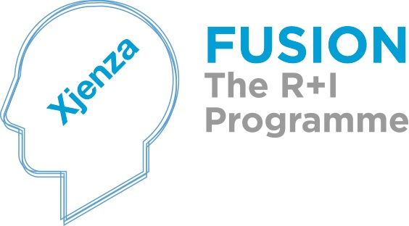

5.3. Supervening Circumstances
The Applicant is obliged to immediately advise the Council and the Service Provider of any internal or extraneous significant event which might affect the disbursement and redemption of the Commercialisation Voucher. This obligation applies to the entire period between the submission of the application and the completion of the activity.
The Council shall then, at its own discretion either give directives as it deems necessary for the furtherance of the activity or re-assess the activity in its entirety accordingly. In any such event, any contracts concluded between the Service Provider and the Beneficiary relative to Activities funded under this Programme shall be governed in accordance with the terms and conditions stipulated therein and shall be given priority and the Service Provider shall accordingly have the right to request payment of any expenses already incurred.
Failure on the part of the Applicant to respect this obligation may lead the Council to suspend or cancel the Commercialisation Voucher.

5.4. Default
If the implementation of an activity becomes impossible or if the Applicants fail to provide the necessary information for the activity to be undertaken, the Council shall be entitled to withdraw the Commercialisation Voucher, and the Service Provider has the right to recover any expenses incurred, if this is the case.
In the event that an applicant is found to be in breach of the Voucher Agreement, the Council reserves the right to discontinue the award and to apply procedures in line with its related policy.

5.5. Interpretation of Rules

This document endeavors to establish comprehensive and unambiguous rules governing participation in the Commercialisation Voucher Programme. However, should circumstances arise where the rules are inadequate, unclear, and ambiguous or conflicting, the Council shall exercise its discretion in the interpretation of the rules or will extrapolate the rules as necessary through the setting up of ad hoc committees.

Appendix 1

A1.1 Smart Specialisation Areas

The following thematic areas were identified in the National Research and Innovation Strategy 2020:

Tourism product development
Tourism is a key pillar of economic activity in Malta. The sector is well established and mature and there is a good degree of collaboration among operators. The sector is not R&D intensive but must innovate in order to remain attractive and competitive. Consultations yielded several avenues for innovation activity, however innovation in tourism product development was repeatedly highlighted as a key niche where Malta has potential for growth through innovation. In addition to linkages with other specialisation areas such as ICT and health, this specialisation area should involve extensive collaboration with the creative industries.

Maritime Services
This is a mature economic sector in which Malta has a historic legacy and world-level profile. The sector has diversified over time to provide a wide range of services to the maritime sector, but the variety of services remain fragmented. There is therefore scope for improved clustering of maritime services in order to provide more integrated, new and improved services. Malta’s drive towards becoming a maritime hub should include a drive to foster innovation in maritime engineering, ICT, design and services.

Aviation and aerospace
This is a relatively new economic sector which has grown rapidly, attracted several foreign investors, and has diversified to include a number of niches such as maintenance, repair and overhaul and aircraft registration among others. Malta has also built a strong portfolio in avionics research, a relatively high critical mass of human resources as well as numerous established international R&D links in the area. There is scope for further investment to raise the level of achievement to the next level by venturing into the high value-added engineering market in order to move up the value chain in specific niches within the aerospace sector.

Health with a focus on healthy living and active ageing, and e-health
Various data sources (such as public R&D expenditure, participation in the European Cooperation in Science and Technology – COST, and publications) indicate that ‘health and medical research’ is a significant component of Malta’s R&D investment. However, there appears to be significant fragmentation within it and there is scope for further exploration of innovation potential in this area. Within this context and in line with this Strategy’s approach to cultivate a multidisciplinary approach, innovative e-health solutions as well as solutions for active and healthy ageing will be given particular consideration because both of these focus areas benefit from the integration of medical sciences with other areas where Malta has a strong knowledge base; such as ICT, social sciences and engineering. Both have a clear economic objective and the potential for a strong economic impact.

Resource-efficient buildings
The construction sector in Malta accounts for 4% of GVA and 5.4% in terms of employment (2012 data) however these figures have been decreasing over the past years. There is scope for exploring innovative solutions in the sector which address water scarcity and energy (dependence on fossil fuels, take up of renewable energy sources, etc.), both of which remain two of Malta’s major economic challenges. Innovation in resource efficient buildings would transform the sector by increasing value-added, increasing green jobs and growth while at the same time addressing a societal challenge which is in itself a business opportunity. This specialisation area will focus on solutions for improved resource efficiency in new and existing buildings through, inter alia, demonstration projects and optimisation.
The importance of innovation in this area stems from legal obligations which Malta has in this field, coupled with the fact that solutions developed abroad may not be easily transposed locally due to climatic variances and differences in building materials, among others. This specialisation area should involve extensive collaboration among architectural design, engineering, materials science and energy technology among others.

High value-added manufacturing with a focus on processes and design
While its share of GVA as a percentage of total GVA has decreased over time, the GVA in real terms of the manufacturing sector has increased over the past years. This sector remains the predominant sector for research and innovation investment. Statistics for 2010 indicate that manufacturing activity encompassed 65.4% of all innovation expenditure and 62.2% of intramural R&D expenditure. This indicates clearly that, in spite of shifts towards the services sector, the manufacturing sector is still strong and should therefore be sustained through a greater focus on innovation niches within this sector. To this end, two focus areas for innovation are process innovation (through optimisation of resource use, energy efficiency, automation etc.) and innovation in product design (product development, prototyping, etc.)

Aquaculture
Malta’s aquaculture industry has developed to its present status over a period of around twenty years. R&D is carried out both within the public and the private sector. Malta has developed a good degree of know-how in this sector and has participated in a number of EU-funded R&D projects. There is a good degree of collaboration between the public and private sector, however there is scope for exploring further consolidation of existing strengths by focusing on areas of common interest among different players. Infrastructural investments in the area include plans for a local hatchery. Maltese aquaculture can therefore capitalise on these strengths and differentiate itself as a leading innovator in aquaculture.

The role of ICT
ICT as an enabler: ICT is identified as an enabling technology for all economic sectors and disciplines through its role as a tool for technological change. Digital Malta, Malta’s national ICT Strategy 2014-2020, provides a roadmap for ensuring that ICT remains a pivot of economic growth in Malta. Investments in people, infrastructures and regulation/legislation for the benefit of business, citizens and government provide a basis for growth through the digital economy.
ICT–based innovation: ICT plays an important role in R&D and innovation in all sectors by facilitating the development of new goods, processes and services to modernise the economy and transform it to a knowledge-based one.
Computer and related activities constituted 11.7% of the intramural R&D expenditure recorded in 2010 and 5.4% of the total innovation expenditure for the same year. The main research expenditure was on software consultancy and supply. In addition, ICT is one of the areas where Malta’s participation in FP7 is strongest (around 14% of FP projects involving a Maltese participant were in the ICT field). Malta’s participation in COST actions also indicates significant activity, with around 14% of Actions in which Malta participates being in the ICT Domain. All consultations undertaken in the preparation of the present Strategy acknowledged the crucial role of ICT innovation in all sectors of the economy.
This Strategy reconfirms the role of ICT as a crucial component of building Malta’s knowledge economy and stresses the importance of continued investment in specialised skills coupled with extended integration of ICT based innovation in the following sectors: Health; Digital Gaming; Financial Services; and Tourism product development.
Other thematic specialisations will also be encouraged to identify and pursue ICT-based innovation. However, the above areas are prioritized.

