Internationalisation Partnership Awards Scheme – 2015/2016
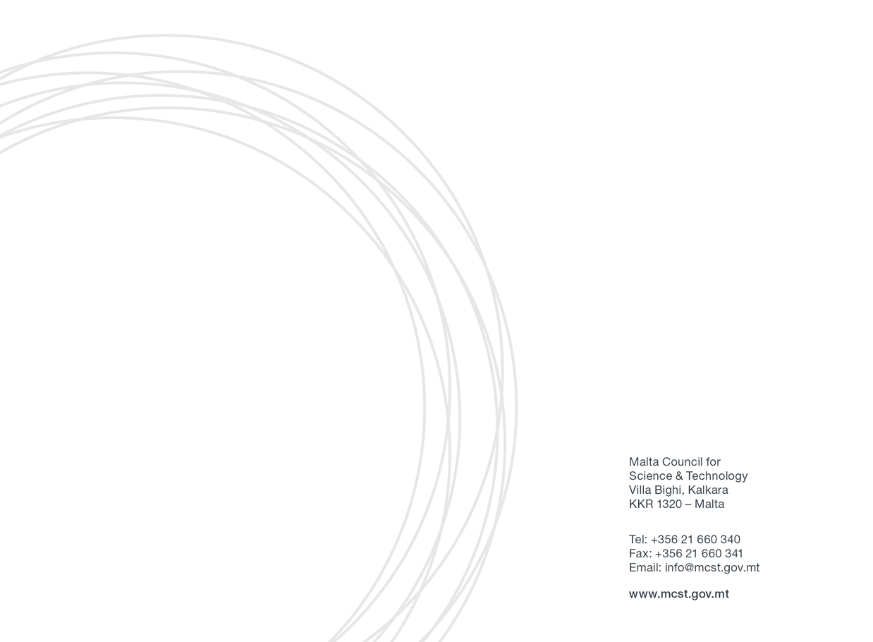
Application Form

SECTION ONE: APPLICANT’S DETAILS
Applicant Details:
(Please include details of the Malta-based applicant applying for the Award)
Name
Designation
Name of Academic Institution
Name of Department/Institute/Centre
Email
Tel. Number

Main Partner Organisation’s Details:
(Please include details of the primary contact person/partner from the foreign centre of academic excellence involved in the proposal)
Name of Academic Institution |  | Name of Department/ Institute/ Centre
Contact Details | Name: | Designation:
 |  | Email:
 | Address: | Tel. No.:
 |  | Mob. No.:

Secondary Partner Organisation’s Details (if any):
(Please include details of any other contact person/partner from the same or different foreign centre of academic excellence involved in the proposal)
Name of Academic Institution |  | Name of Department/ Institute/ Centre
Contact Details | Name: | Designation:
 |  | Email:
 | Address: | Tel. No.:

SECTION TWO: PROJECT/ ACTIVITY DETAILS
Project Title/Name of Activity

Quality of Project/Activity
Kindly provide a description of the project or activities that you intend to finance through the Award Scheme e.g. research, publications, workshop/s, international placement/s etc. Proposals will be judged on the quality of the collaboration activities with the foreign centre/s of academic excellence. Activities must either be, or be supportive of, high quality international research with the potential to yield mutually beneficial results and demonstrate innovation and interdisciplinarity in the selected field of research. Keep in mind that the involvement of early career researchers (i.e. at Masters or PhD level) in the implementation of the internationalisation activities will be considered an advantage.
(maximum number of words:500)
Strength of the Partnership and leadership
Please describe the nature of the partnership with the foreign centre/s of academic excellence highlighting previous collaborations if any. It is also requested to highlight the partnering institution’s track record of research excellence in the field of collaboration, as well as any of the partners’ past achievements in the selected field of research. A convincing case should be made for the benefits of the partnership/s. (maximum number of words:500)
Outcomes and Sustainability
Please describe the expected outcomes that will result from collaboration with the foreign centre of academic excellence, for example, joint publications or, subsequent grant bids, or networks, and how the partnership will enable the establishment of longer term international relationships based on genuine commitment by the research partners and the potential to attract or generate external funding. (maximum number of words:500)
Expected Timelines
Kindly provide a description of the time-frame and plan for the implementation of the activities funded through the Award Scheme. Please note that all activities funded through this Scheme would need to be completed by 30th July, 2016. (maximum number of words:250)

Total Amount of Funds Requested through Award Scheme (in €)
(Please keep in mind that funding for any one project is capped at €5000)
Breakdown of Costs covered through Award Scheme (estimate in €)
Kindly provide an estimated breakdown of costs i.e. how much of the Award you plan to use on:
Travelling?, Accommodation?, Research?, Publication?, Host activities? etc.
Supplementary / Match Funding  Does the Partner organisation plan to provide any additional funding? | Yes |  | Name of institution that will be supplying the funds
 | No |  | Supplementary Fund Provided over duration of Award Scheme (in €)

SECTION THREE: DECLERATION BY APPLICANTS
Decleration by Researcher:

I confirm that:  The information given on this form is accurate to the best of my knowledge. I understand that if it is later established that I misrepresented myself and I am not eligible for this Scheme then I will be required to pay for the services received. | I agree
I accept and confirm that the personal data and project/activities proposal content information can be passed on to the Malta Council for Science and Technology to be used solely for the purposes of administering and review of the application. | I agree
I accept and confirm that the personal data and proposal content information can be passed on to third parties i.e. the Partner Organisation/s with whom I will be carrying out this project, solely for use in said project/activities, and that any misuse of the data or provision of data to parties outside this agreement will incur legal action. | I agree
I confirm that a Letter/s of Support or Collaboration letter/s from the partner institution has/have been attached to this application form. | I agree
I confirm that Curriculum Vitae/s from the main partners from the foreign institution/s has/have been attached to this application form. | I agree
Signature: | Date

